chmProcessor. A Html / Word converter to Compiled HTML Help / Java Help
chmProcessor is a tool that allows generating a help project and a compiled HTML help (CHM file) from a MS Word or HTML 4 file. If the file is a word document, the section titles must use the “Title 1”, “Title 2”, etc styles that offers by default Word. If the file is a HTML 4 file, the titles must use the <H1>, <H2>, etc. tags.

From this original file, each section of the document is split to different HTML files. Each of these files will be a topic page at the help. From the original document, you can generate:

- A Microsoft Help Workshop project.
- A compiled HTML help (CHM file).
- A web site like this.
- An Adobe PDF file.
- A Microsoft XPS file.
- A Java Help JAR file.

Requirements

To use this program, you must to have installed the following programs:

- Microsoft Windows. Tested versions: Windows 2000 (32 bits), Windows XP (32 bits), Windows 7 (32 and 64 bits). Console interface will not work over windows 2000. Versions 1.4 and earlier of chmProcessor do not work on 64 bits operating systems.
- Internet Explorer 6 or above.
- Microsoft .NET Framework 3.5 or above. You can download the runtime version here: http://www.microsoft.com/downloads/es-es/details.aspx?FamilyID=333325FD-AE52-4E35-B531-508D977D32A6
- HTML Help Workshop. If you don’t have it, you cannot compile the help, you can generate a web site only. You can it download from here: http://msdn2.microsoft.com/en-us/library/ms669985.aspx
- Microsoft Word if you will work with Word files. Ms Word 2003 and 2007 has been tested.

Optionally, you can generate PDF and XPS files. To generate a PDF, there is two ways: Use PDFCreator or use the Microsoft Office 2007 Add-in to generate PDF and XPS. The last one is the recommended. To generate a XPS file, the MS Office 2007 Add-in is mandatory:

- PDFCreator. Version 1.2 ONLY. You can download it from here: http://www.pdfforge.org/products/pdfcreator/download. This kind of generation will not be supported on the future.
- Microsoft Office 2007 Add-in. It’s an optional tool of the Office suite to generate PDF / XPS. You can download it from http://www.microsoft.com/downloads/details.aspx?FamilyID=4D951911-3E7E-4AE6-B059-A2E79ED87041&displaylang=en.

If you want to generate a Java Help, you will need the following software:

- Sun JDK. 1.4 or upper. Only 1.6 has been tested. You can download it from here: http://www.oracle.com/technetwork/java/javase/downloads/index.html.
- Java Help 2.0 or upper. You can download from here: http://javahelp.java.net/.

Limitations

- There are limitations about the characters you can use into the titles. All characters at the Windows-1252 set with code lower than 256 are supported (see http://en.wikipedia.org/wiki/Windows-1252 ), and some that are upper than 256 ( characters as Š , Ÿ, ‰ , “ , and more ) but not all. This means that all usual western characters are supported but Greek math symbols, as example, will not work. It’s not tested but probably Cyrillic and other kind of character sets will not work.
- Not all kind of documents will be well formatted, especially HTML documents. Try to avoid put titles into tables, put images with title styles, and such kind of things, because the application will be confused about how to split and index the document.
- Keep in mind that if you use more than one Word source files, the text styles used should be equal on all documents. So, if some style is different on some document, it can be overwritten by the definition of other document.
- Only version 4 of HTML has been tested for source files. Other versions (=5) probably don’t work.

Interface

Win Interface

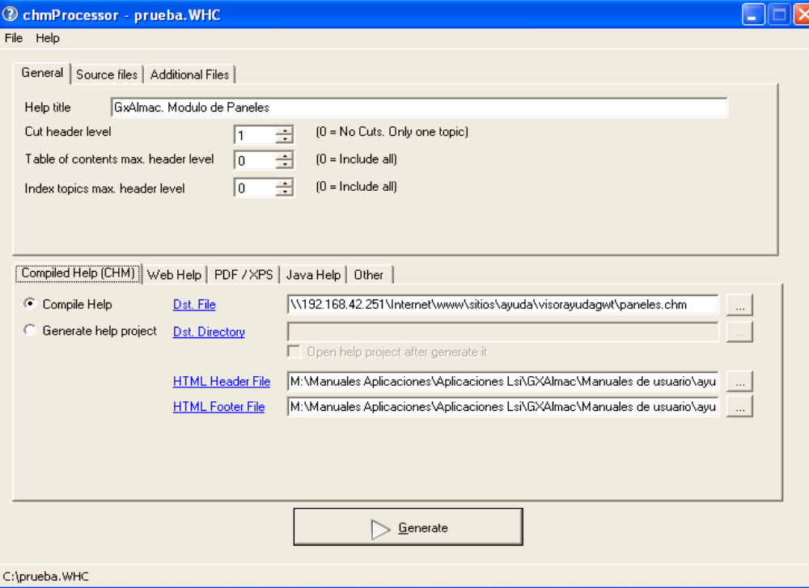

General

Help Title | Title of the generated help.
Cut level | Level of sections that is used to split the document on topics. As example, if a level 2 is set, the document will be split on many topics as paragraphs with “Title 1” or “Title 2” ( or tags <H1> / <H2> is the document is HTML) are found. If is zero, only a topic page will be generated for the entire document.
Table of contents max. level | Maximum level of the sections that will appear on the table of contents of the help. If is zero, all the titles will appear on the table. As example, if a level 3 is set, Titles 1, 2 and 3 will appear on the table of contents.
Index topics max. level | Maximum level of the sections that will appear on the index of the help. If is zero, all the titles will appear on the index. As example, if a level 3 is set, Titles 1, 2 and 3 will appear on the index.
Source files | List of HTML or Word file sources to generate the help. Only one HTML file can be used as source, but multiple Word documents can be used. No HTML and Word documents can be mixed on the list.
Additional files | List of other files / directories that must be included on the compiled help. For example if the source file is an HTML, and it contains images, these images, or the directory with the images must be included in this list.
Execute this command line after generate | If you need to make something after the generation, as copy the CHM to other place, put it on a web site by ftp…, you can do it by a command line here.
Generate button | If the source file is a word document, you MUST NOT be editing the file, when you press this button. When this button is pressed, the project / help generation will start and a new window will be opened, logging the generation process:  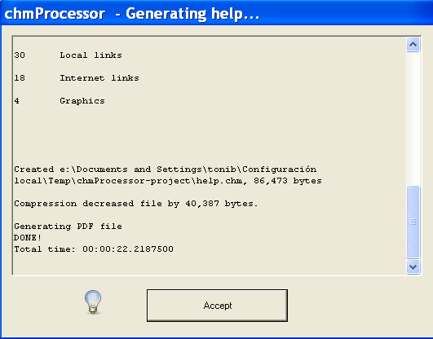

Menu File

Here you can load and save the current help generation configuration from / to a “project” file, to access to the last open projects, and edit the settings of the application.

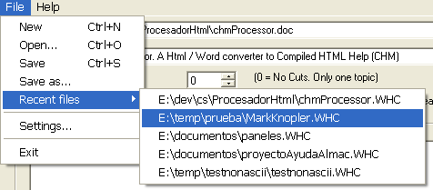

Compiled Help

Compile help / Dst. File | If it’s checked, the help will be compiled on a CHM file, on the path selected at the Dst. File field.
Generate help project | If it’s checked, a help project for the Microsoft Help Workshop will be generated at the directory selected on Dst. Directory, and it will not be compiled.
Generate web / Dst. Web directory / Description meta / Keywords meta | If “Generate” it’s checked, a simple web with the help content will be generated on the Dst. directory. The description and meta fields are the values of this “meta” tags at the index of the web page generated.
HTML Header File | Can be null. If not, the content of this file will be added to the start of each topic page as header. The content must be HTML code. As example, this file can contain an IMG tag with the banner of the application title.
HTML Footer File | Can be null. If not, the content of this file will be added to the end of each topic page as footer. The content must be HTML code. As example it can be a <BR> tag to add an end bar to the page or a script to count visits at the generated web.

Web Help

Generate Web / Dst. Web directory | If “Generate” it’s checked, a simple web with the help content will be generated on the Dst. directory.
Description meta / Keywords meta | Values of the “meta” tags at the web pages generated. They should explain to the web indexers (as Google) the topic of the document.
HTML Header File | Can be null. If not, the content of this file will be added to the start of each topic page as header. The content must be HTML code. As example, this file can contain an IMG tag with the banner of the application title. This can be different to the header of the CHM.
HTML Footer File | Can be null. If not, the content of this file will be added to the end of each topic page as footer. The content must be HTML code. As example it can be a <BR> tag to add an end bar to the page or a script to count visits at the generated web, or a javascript code to register the visits. This can be different to the footer of the CHM.
Language | Language used on the texts of the web site. If your favourite language is not here, you can create your own translation. To do this check at the “webTranslations” folder of the program. Copy the “English.txt” to your “mylanguage.txt”, open it with the notepad, and change the text of each second line. Example:  “English.txt” file:  Contents  Contents  Topics  Topics  …  “mylanguage.txt”:  Contents  <translation of Contents>  Topics  <translation of Topics>  …  If you do this, please send me your file to my mail address at sourceforge, and it will be added to the application.
Make Full Text Search (Require ASP.NET application) | If it’s checked, a full text index of the document will be created, and all the document text can be searched. To run the searches, the web site must be hosted into an ASP.NET server. Only Microsoft IIS 6 and 7 has been test, but probably will work with the Mono server (only over Windows). Before run the web application, install the “Microsoft Primary Interoperability Assemblies 2007” at the web server machine. You can download it from here. If you don’t install this, you will get an “ERROR: Could not load file or assembly Microsoft.mshtml” message and the searches will not work.  If this field it’s not checked, a simple search at the web help will allow you to search at the topic titles of the document only.
<head> include file | Can be null. If not, the content of this file will be added into the <head> tag of each topic page. The content must be valid HTML code for that head.  As example, it can be the javascript tag needed by Google Analytics to register the visits.
Make Sitemap / Web Base / Change Freq. | If “Make sitemap” is checked, a file called “sitemap.xml.gz” will be added to the web site. This file is a help for the web indexers as Google to know what pages contains your web site. See http://www.google.com/webmasters/sitemaps/ to know more about this file. If you check this field, you must to put the root of your web site at the field “Web base” (as example, “http://chmprocessor.sf.net”). At the field “Change freq.” you say the frequency of change of the document: daily, monthly, etc.

The “template” pages for the web help are stored at the “webFiles” folder into the chmProcessor installation. If you want to change the look of the web help, you can edit them, but don’t change the texts %XXX% because they are replaced by the application during the generation process.

PDF / XPS

Generate PDF / Dst. File | If it’s checked, a PDF file will be generated with the printing of the source Word / Html document at the file on Dst. File. You will need to have the PDFCreator or the “MS Office 2007 Add-in: Save as PDF / XPS” installed to use this.
Generate with PdfCreator / Generate with Office 2007 add-in (recommended) | Choose of how to generate the PDF file: With PDFCreator o with the MS Office 2007 Add-in. The last one is the recommended. Only version 1.2 of PdfCreator is supported, and sometimes hangs up the PDF print.
Generate XPS / Dst. File | If it’s checked, a XPS file will be generated with the printing of the source Word / Html document at the file on Dst. File. You will need to have the the “MS Office 2007 Add-in: Save as PDF / XPS” installed to use this.

Java Help

Generate Java Help / Dst. File | If it’s checked, the help will be compiled Java Help JAR file, on the path selected at the Dst. File field. You will need to have the JDK and the Java Help installed to use this.

Settings

Going to the menu File > Settings..., you can access to the settings of the program:

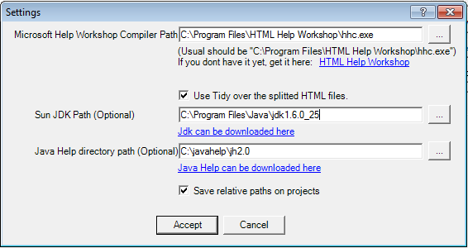

MS Help Workshop Compiler Path | Path to the compiler exe contained into the HTML Help Workshop. It must to point to the installation directory of this package.
Use Tidy over the splitted HTML files | Tidy is software than cleans and repair HTML files, according to the W3C standards. If it’s checked, when a HTML page of the help is generated, tidy is executed over this file. Usually works VERY well, but I have found some problem with some XHTML files. If you have troubles with the generated HTML (strange characters, javascript errors, etc) try to uncheck this field.
Sun JDK Path | Installation path of the Sun JDK. It’s needed if you want to generate Java Help.
Java Help directory path | Installation path of the Sun Java Help. It’s needed if you want to generate Java Help.
Save relative paths on projects | If is checked, when you save a project, the paths to directories and files of the project will be stored relative to the location of the project file. So, if you store your source files and the project file on the same folder, you will can move that folder safely to other locations, and reopen the project and the reference to the source files will still work.  If is not checked, paths will be saved as absolute, so, if you move your source files, they will not be found.

Console Interface

Use chmProcessor.exe [<projectfile.WHC> | <wordfile.DOC> |<wordfile.DOCX> | <wordfile.HTM> | <wordfile.HTML>] [/g] [/e] [/y] [/?][/q] [/l1] [/l2] [/l3]
Options:
/g Generate help sets (chm, javahelp, pdfs,…) specified by the project
/e Exit after generate
/y Dont ask for confirmations
/? Print help and exit
/q Prevents a window being shown when run with the /g command line and logs messages to stdout/stderr
/l1 /l2 /l3 Lets you choose how much information is output, where /l1 is minimal and /l3 is all the information

Web Site Generation
The application can generate a simple web site with a similar format to the compiled help. An example is http://chmprocessor.sf.net. Any topic indexed at the help can be opened directly using the URL, with the “topic” parameter. As example, if you have a topic called “Download”, you can open it like this: http://chmprocessor.sf.net/index.html?topic=Downloads.

License
The license of chmProcessor is GPL. It uses the following software:

- Tango icons
- Tidy
- SQLite

Downloads
You can download the chmProcessor installation binaries and sources from here. You can get this document as a PDF here.

Info for developers
Here come some tips if you want to open a help file generated with chmProcessor from your application. Usually there is tree ways to show a help topic on your application:

- Open directly the help file.
- Open a help topic by its title.
- Open a help topic by its HTML file name.

The last one is discarded, because you cannot control how chmProcessor will generate the file names, and more, those file names can change if you add more titles to your source help document. So, if you want to open a topic help directly you should use the topic text titles to open the help. Here are the functions you can use to open the help by one topic name on C# and Java:

JavaHelp

Your code should look something like this, without any warranty:

// The generated JAR must to be on your class path.
ClassLoader cl = this.getClass().getClassLoader();
URL hsURL = HelpSet.findHelpSet(cl, “help.hs”); // help.hs if the fixed name for the generated help.
HelpSet hs = new HelpSet(null, hsURL);
HelpBroker hb = hs.createHelpBroker();
hb.setCurrentID(“The topic title to show”);
hb.setDisplayed(true);

Much, much more info on the JavaHelp documentation.

CHM file with C#

System.Windows.Forms.Help.ShowHelp(null, “C:\pathtomyhelpfile.CHM” , System.Windows.Forms.HelpNavigator.KeywordIndex , “The topic title to show”);

