Input flinger
1.InputReader
(1) scan device
EventHub::EventHub(void) :
mNeedToScanDevices(true) {
}

EventHub对象在初始化的时候mNeedToScanDevices表明需要进行device的scan。

size_t EventHub::getEvents(int timeoutMillis, RawEvent* buffer, size_t bufferSize) {
for (;;) {
if (mNeedToScanDevices) {
mNeedToScanDevices = false;
scanDevicesLocked();
mNeedToSendFinishedDeviceScan = true;
}
}
}

InputReader 线程在启动的时候调用到getEvents函数对/dev/input下的设备进行扫描

status_t EventHub::openDeviceLocked(const char *devicePath) {
// Register with epoll.
struct epoll_event eventItem;
memset(&eventItem, 0, sizeof(eventItem));
eventItem.events = EPOLLIN;
if (mUsingEpollWakeup) {
eventItem.events |= EPOLLWAKEUP;
}
eventItem.data.u32 = deviceId;
int fd = open(devicePath, O_RDWR | O_CLOEXEC);
if (epoll_ctl(mEpollFd, EPOLL_CTL_ADD, fd, &eventItem)) {
ALOGE("Could not add device fd to epoll instance. errno=%d", errno);
delete device;
return -1;
}
addDeviceLocked(device);
}

将对应device的fd添加到epoll的fd中，对其进行input event的监听,创建对应的
Device对象，保存在mDevices容器中。

size_t EventHub::getEvents(int timeoutMillis, RawEvent* buffer, size_t bufferSize) {
RawEvent* event = buffer;
for (;;) {
while (mOpeningDevices != NULL) {
Device* device = mOpeningDevices;
mOpeningDevices = device->next;
event->when = now;
event->deviceId = device->id == mBuiltInKeyboardId ? 0 : device->id;
event->type = DEVICE_ADDED;
event += 1;
mNeedToSendFinishedDeviceScan = true;
if (--capacity == 0) {
break;
}
}
}
}

Reporting device：
通过mOpeningDevices 链表将Device对象保存到RawEvent数组中。
InputReader::processEventsLocked(const RawEvent* rawEvents, size_t count) {
for (const RawEvent* rawEvent = rawEvents; count;) {
int32_t type = rawEvent->type;
if (type < EventHubInterface::FIRST_SYNTHETIC_EVENT) {
......
} else {
switch (rawEvent->type) {
case EventHubInterface::DEVICE_ADDED:
addDeviceLocked(rawEvent->when, rawEvent->deviceId);
break;
}
}
}

遍历读取出RawEvent数组中的type为DEVICE_ADDED的数据创建InputDevice对象保存在
mDevices容器中。

(2)wait input event
size_t EventHub::getEvents(int timeoutMillis, RawEvent* buffer, size_t bufferSize) {
int pollResult = TEMP_FAILURE_RETRY(epoll_wait(mEpollFd, mPendingEventItems, EPOLL_MAX_EVENTS, timeoutMillis));
}

Inputreader 线程sleep在mEpollFd，等待其上所有的I/O事件。
epoll_ctl(mEpollFd, EPOLL_CTL_ADD, mINotifyFd, &eventItem);
epoll_ctl(mEpollFd, EPOLL_CTL_ADD, mWakeReadPipeFd, &eventItem);

等待三种类型的I/O event：
mINotifyFd：
mWakeReadPipeFd：
DeviceFD：input device上的event。

(3)read input event
size_t EventHub::getEvents(int timeoutMillis, RawEvent* buffer, size_t bufferSize) {
for (;;) {
mPendingEventIndex = 0;
int pollResult = TEMP_FAILURE_RETRY(epoll_wait(mEpollFd, mPendingEventItems, EPOLL_MAX_EVENTS, timeoutMillis));
if (pollResult < 0) {
......
} else {
mPendingEventCount = size_t(pollResult);
}
}
}

typedef union epoll_data
{
void *ptr;
int fd;
unsigned int u32;
unsigned long long u64;
} epoll_data_t;
struct epoll_event
{
unsigned int events;
epoll_data_t data;
};

Events 为监听fd上读写事件的类型。
FD的I/O事件保存在mPendingEventItems数组中。
size_t EventHub::getEvents(int timeoutMillis, RawEvent* buffer, size_t bufferSize) {
struct input_event readBuffer[bufferSize];
RawEvent* event = buffer;
for (;;) {
while (mPendingEventIndex < mPendingEventCount) {
const struct epoll_event& eventItem = mPendingEventItems[mPendingEventIndex++];
ssize_t deviceIndex = mDevices.indexOfKey(eventItem.data.u32); ---->u32保存的是deviceID
Device* device = mDevices.valueAt(deviceIndex);
if (eventItem.events & EPOLLIN) {
int32_t readSize = read(device->fd, readBuffer,
sizeof(struct input_event) * capacity);
if (readSize == 0 || (readSize < 0 && errno == ENODEV)) {
.......
} else {
int32_t deviceId = device->id == mBuiltInKeyboardId ? 0 : device->id;
size_t count = size_t(readSize) / sizeof(struct input_event);
for (size_t i = 0; i < count; i++) {
struct input_event& iev = readBuffer[i];
event->deviceId = deviceId;
event->type = iev.type;
event->code = iev.code;
event->value = iev.value;
event += 1;
capacity -= 1;
}
}
}
}
}

从device的fd中读取出input_event放入到readBuffer数组中，遍历该数组保存input event到RawEvent数组中。
struct input_event {
struct timeval time;
__u16 type;
__u16 code;
__s32 value;
};
struct RawEvent {
nsecs_t when;
int32_t deviceId;
int32_t type;
int32_t code;
int32_t value;
};

input_event -------------------------->RawEvent

(4)process input event
void InputReader::processEventsLocked(const RawEvent* rawEvents, size_t count) {
for (const RawEvent* rawEvent = rawEvents; count;) {
int32_t type = rawEvent->type;
size_t batchSize = 1;
if (type < EventHubInterface::FIRST_SYNTHETIC_EVENT) {
int32_t deviceId = rawEvent->deviceId;
while (batchSize < count) {
if (rawEvent[batchSize].type >= EventHubInterface::FIRST_SYNTHETIC_EVENT
|| rawEvent[batchSize].deviceId != deviceId) {
break;
}
batchSize += 1;
}
processEventsForDeviceLocked(deviceId, rawEvent, batchSize);
}
}
}

void InputReader::processEventsForDeviceLocked(int32_t deviceId,
const RawEvent* rawEvents, size_t count) {
ssize_t deviceIndex = mDevices.indexOfKey(deviceId);
if (deviceIndex < 0) {
ALOGW("Discarding event for unknown deviceId %d.", deviceId);
return;
}
InputDevice* device = mDevices.valueAt(deviceIndex);
device->process(rawEvents, count);
}

以Motion event为例InputDevice最终调用到MultiTouchInputMapper的process，收集从input device fd中Rawevent。

(5)map input event
在scan device的时候创建每种device的mapper.
status_t EventHub::openDeviceLocked(const char *devicePath) {
if (test_bit(ABS_MT_POSITION_X, device->absBitmask)
&& test_bit(ABS_MT_POSITION_Y, device->absBitmask)) {
if (test_bit(BTN_TOUCH, device->keyBitmask) || !haveGamepadButtons) {
device->classes |= INPUT_DEVICE_CLASS_TOUCH | INPUT_DEVICE_CLASS_TOUCH_MT;
}
}
}

通过absBitmask、keyBitmask确认device的class。
InputDevice* InputReader::createDeviceLocked(int32_t deviceId, int32_t controllerNumber,
const InputDeviceIdentifier& identifier, uint32_t classes) {
if (classes & INPUT_DEVICE_CLASS_KEYBOARD) {
keyboardSource |= AINPUT_SOURCE_KEYBOARD;
}
if (keyboardSource != 0) {
device->addMapper(new KeyboardInputMapper(device, keyboardSource, keyboardType));
}
if (classes & INPUT_DEVICE_CLASS_TOUCH_MT) {
device->addMapper(new MultiTouchInputMapper(device));
}
}

Key event format：
Type：#define EV_KEY 0x01
Down：value
Code：key code
Motion event format：
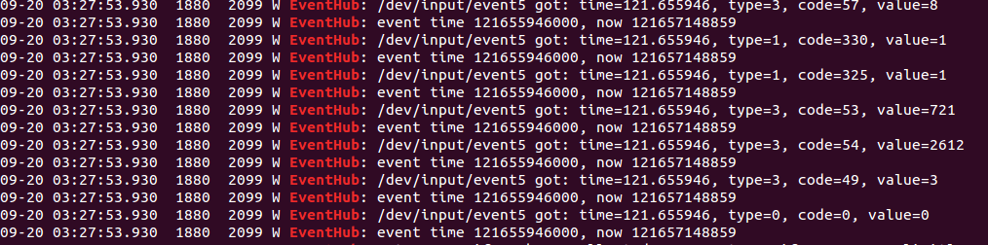
顺序：type：EV_ABS EV_KEY EV_KEY EV_ABS EV_ABS EV_ABS EV_ABS EV_SYN（一次input event结束）
void MultiTouchInputMapper::process(const RawEvent* rawEvent) {
TouchInputMapper::process(rawEvent);
mMultiTouchMotionAccumulator.process(rawEvent);
}

Muti motion使用MultiTouchInputMapper来解析motion event。
void TouchInputMapper::process(const RawEvent* rawEvent) {
mCursorButtonAccumulator.process(rawEvent);
mCursorScrollAccumulator.process(rawEvent);
mTouchButtonAccumulator.process(rawEvent);
if (rawEvent->type == EV_SYN && rawEvent->code == SYN_REPORT) {
sync(rawEvent->when);
}
}

TouchInputMapper::process使用TouchButtonAccumulator累加器收集EV_KEY类型的值。
MultiTouchInputMapper中的MultiTouchMotionAccumulator累加器收集EV_ABS类型的值保存在Slot* mSlots数组中。
void MultiTouchMotionAccumulator::process(const RawEvent* rawEvent) {
ALOGD("MultiTouchMotionAccumulator::process");
if (rawEvent->type == EV_ABS) {
if (mUsingSlotsProtocol) {
......
} else {
Slot* slot = &mSlots[mCurrentSlot];

switch (rawEvent->code) {
case ABS_MT_POSITION_X:
slot->mInUse = true;
slot->mAbsMTPositionX = rawEvent->value;
break;
}
}
}

RawEvent -------------------------->Slot

void TouchInputMapper::sync(nsecs_t when) {
const RawState* last = mRawStatesPending.isEmpty() ?
&mCurrentRawState : &mRawStatesPending.top();
mRawStatesPending.push();
RawState* next = &mRawStatesPending.editTop();
syncTouch(when, next);
processRawTouches(false /*timeout*/);
}

当rawEvent->type == EV_SYN时候调用sync方法，调用子类MultiTouchMotionAccumulator
的syncTouch方法。
void MultiTouchInputMapper::syncTouch(nsecs_t when, RawState* outState) {
size_t inCount = mMultiTouchMotionAccumulator.getSlotCount();
for (size_t inIndex = 0; inIndex < inCount; inIndex++) {
const MultiTouchMotionAccumulator::Slot* inSlot =
mMultiTouchMotionAccumulator.getSlot(inIndex);
RawPointerData::Pointer& outPointer = outState->rawPointerData.pointers[outCount];
outPointer.x = inSlot->getX();
outPointer.y = inSlot->getY();
if (mHavePointerIds) {
int32_t trackingId = inSlot->getTrackingId();
int32_t id = -1; //id 根据ABS_MT_TRACKING_ID（code 57）来决定当前是的touch id
if (trackingId >= 0) {//大于0 是down ，move的时候没有不变，up的时候是-1
}
if (id < 0) {
mHavePointerIds = false;
outState->rawPointerData.clearIdBits();
newPointerIdBits.clear();
} else {
outPointer.id = id;
outState->rawPointerData.idToIndex[id] = outCount;
outState->rawPointerData.markIdBit(id, isHovering);
newPointerIdBits.markBit(id);
}
}
outCount += 1;
}
//outCount 决定当前motion有几个point
outState->rawPointerData.pointerCount = outCount;
mPointerIdBits = newPointerIdBits;
}

Slot-------------------------->RawState::RawPointerData::Pointer

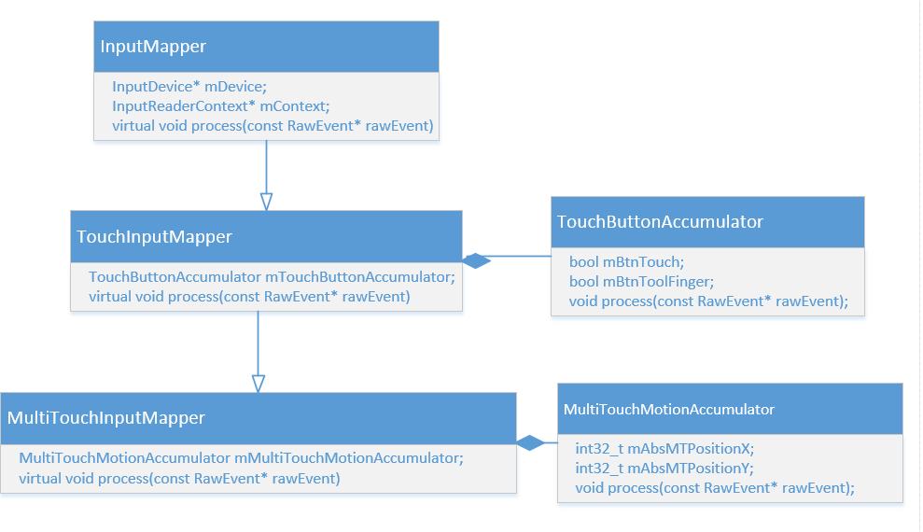
- cook and dispatch
void TouchInputMapper::processRawTouches(bool timeout) {
const size_t N = mRawStatesPending.size();
size_t count;
for(count = 0; count < N; count++) {
const RawState& next = mRawStatesPending[count];
mCurrentRawState.copyFrom(next);
cookAndDispatch(mCurrentRawState.when);
}
}
void TouchInputMapper::cookAndDispatch(nsecs_t when)
void TouchInputMapper::cookPointerData()
void TouchInputMapper::dispatchTouches(nsecs_t when, uint32_t policyFlags)
getListener()->notifyMotion(&args);

将mCurrentRawState容器中的RawPointerData：Pointer（in）数据处理过后保存在CookedState的PointerCoords（out）数组中。

RawState::RawPointerData::Pointer----------->CookedState::CookedPointerData::PointerCoords

（7）Dispatch Cycle：
newGesture Down:
int32_t InputDispatcher::findTouchedWindowTargetsLocked(nsecs_t currentTime,
const MotionEntry* entry, Vector<InputTarget>& inputTargets, nsecs_t* nextWakeupTime,
bool* outConflictingPointerActions) {
int32_t displayId = entry->displayId;
int32_t action = entry->action;
int32_t maskedAction = action & AMOTION_EVENT_ACTION_MASK;
bool newGesture = (maskedAction == AMOTION_EVENT_ACTION_DOWN
|| maskedAction == AMOTION_EVENT_ACTION_SCROLL
|| isHoverAction);
if (newGesture) {
//新的一次input动作重置mTempTouchState
bool down = maskedAction == AMOTION_EVENT_ACTION_DOWN;
mTempTouchState.reset();
mTempTouchState.down = down;
mTempTouchState.deviceId = entry->deviceId;
mTempTouchState.source = entry->source;
mTempTouchState.displayId = displayId;
isSplit = false;
}
if (newGesture || (isSplit && maskedAction == AMOTION_EVENT_ACTION_POINTER_DOWN)) {
bool isTouchModal = false;
size_t numWindows = mWindowHandles.size();
for (size_t i = 0; i < numWindows; i++) {
sp<InputWindowHandle> windowHandle = mWindowHandles.itemAt(i);
const InputWindowInfo* windowInfo = windowHandle->getInfo();
if (windowInfo->visible) {
if (! (flags & InputWindowInfo::FLAG_NOT_TOUCHABLE)) {
isTouchModal = (flags & (InputWindowInfo::FLAG_NOT_FOCUSABLE
| InputWindowInfo::FLAG_NOT_TOUCH_MODAL)) == 0;
//当窗口处于可touch模式或者当前坐标在窗口区域中
if (isTouchModal || windowInfo->touchableRegionContainsPoint(x, y)) {
newTouchedWindowHandle = windowHandle;
break; // found touched window, exit window loop
}
}
//将FLAG_WATCH_OUTSIDE_TOUCH标志的窗口加入到mTempTouchState
if (maskedAction == AMOTION_EVENT_ACTION_DOWN
&& (flags & InputWindowInfo::FLAG_WATCH_OUTSIDE_TOUCH)) {
mTempTouchState.addOrUpdateWindow(
windowHandle, InputTarget::FLAG_DISPATCH_AS_OUTSIDE, BitSet32(0));
}
}

prepareDispatchCycleLocked
enqueueDispatchEntriesLocked
enqueueDispatchEntryLocked (outboundQueue.enqueueAtTail)
startDispatchCycleLocked (outboundQueue.dequeue、waitQueue.enqueueAtTail)
connection->inputPublisher.publishMotionEvent
handleReceiveCallback
finishDispatchCycleLocked
onDispatchCycleFinishedLocked
doDispatchCycleFinishedLockedInterruptible (waitQueue.dequeue)
startDispatchCycleLocked

