valgrind
1.代码下载
http://valgrind.org/downloads/current.html
2.代码编译
sudo apt-get install autoconf
./autogen.sh
./configure --prefix=/usr/local/valgrind
make
sudo make install
生成结果：
/usr/local/valgrind/bin
gedit ~/.bashrc
export PATH=$PATH:/usr/local/valgrind/bin
touch ~/.bashrc

3.体系结构
Valgrind是一套Linux下，开放源代码（GPL V2）的仿真调试工具的集合。Valgrind由内核（core）以及基于内核的其他调试工具组成。内核类似于一个框架（framework），它模拟了一个CPU环境，并提供服务给其他工具；而其他工具则类似于插件 (plug-in)，利用内核提供的服务完成各种特定的内存调试任务。Valgrind的体系结构如下图所示：
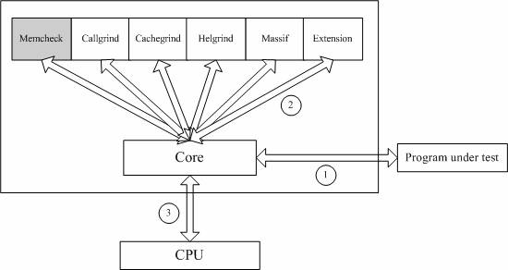
Memcheck。这是valgrind应用最广泛的工具，一个重量级的内存检查器，能够发现开发中绝大多数内存错误使用情况，比如：使用未初始化的内存，使用已经释放了的内存，内存访问越界等。这也是本文将重点介绍的部分。
Callgrind。它主要用来检查程序中函数调用过程中出现的问题。
Cachegrind。它主要用来检查程序中缓存使用出现的问题。
Helgrind。它主要用来检查多线程程序中出现的竞争问题。
Massif。它主要用来检查程序中堆栈使用中出现的问题。
Extension。可以利用core提供的功能，自己编写特定的内存调试工具。
algrind --leak-check=full ./memory
==13414==
==13414== HEAP SUMMARY:
==13414== in use at exit: 296 bytes in 2 blocks
==13414== total heap usage: 2 allocs, 0 frees, 296 bytes allocated
==13414==
==13414== 8 bytes in 1 blocks are definitely lost in loss record 1 of 2
==13414== at 0x4C2B4A3: operator new(unsigned long) (vg_replace_malloc.c:334)
==13414== by 0x400873: main (main.c:32)
==13414==
==13414== 288 bytes in 1 blocks are possibly lost in loss record 2 of 2
==13414== at 0x4C2CF99: calloc (vg_replace_malloc.c:752)
==13414== by 0x4012E24: allocate_dtv (dl-tls.c:296)
==13414== by 0x4012E24: _dl_allocate_tls (dl-tls.c:460)
==13414== by 0x5144DA0: allocate_stack (allocatestack.c:589)
==13414== by 0x5144DA0: pthread_create@@GLIBC_2.2.5 (pthread_create.c:500)
==13414== by 0x400846: main (main.c:25)
==13414==
==13414== LEAK SUMMARY:
==13414== definitely lost: 8 bytes in 1 blocks
==13414== indirectly lost: 0 bytes in 0 blocks
==13414== possibly lost: 288 bytes in 1 blocks
==13414== still reachable: 0 bytes in 0 blocks
==13414== suppressed: 0 bytes in 0 blocks
==13414==
==13414== For counts of detected and suppressed errors, rerun with: -v
==13414== ERROR SUMMARY: 2 errors from 2 contexts (suppressed: 0 from 0)

使用未初始化的内存
内存读写越界
内存覆盖
动态内存管理错误
内存泄露

