**Hardware render**

1. **系统中三个关于ui库的介绍**

**GUI：**用来和surfaceflinger进行通信

**HWUI：**App用来进行hardrender

**UI：**Surfaceflinger 使用的工具

**2.RenderProxy类有三个重要的成员变量:**

mRenderThread、mContext和mDrawFrameTask，它们的类型分别为RenderThread、CanvasContext和DrawFrameTask。其中，mRenderThread描述的就是Render Thread，mContext描述的是一个画布上下文，mDrawFrameTask描述的是一个用来执行渲染任务的Task。

RenderProxy::RenderProxy(bool translucent, RenderNode* rootRenderNode, IContextFactory* contextFactory)

: mRenderThread(RenderThread::getInstance())

, mContext(nullptr) {

SETUP_TASK(createContext);

args->translucent = translucent;

args->rootRenderNode = rootRenderNode;

args->thread = &mRenderThread;

args->contextFactory = contextFactory;

mContext = (CanvasContext*) postAndWait(task);

mDrawFrameTask.setContext(&mRenderThread, mContext);

}

(1)**.ThreadedRenderer对象的创建：**

mRenderThread创建：RenderThread::getInstance()。

1. 调用ThreadedRenderer类的成员函数nCreateRootRenderNode在Native层创建了一个Render Node，并且通过Java层的RenderNode类的静态成员函数adopt将其封装在一个Java层的Render Node中。这个Render Node即为窗口的Root Render Node。

2. 调用ThreadedRenderer类的成员函数nCreateProxy在Native层创建了一个Render Proxy对象。该Render Proxy对象以后将负责从Main Thread向Render Thread发送命令。

3. 调用AtlasInitializer类的成员函数init初始化一个系统预加载资源的地图集。通过这个地图集，可以优化资源的内存使用。

**(2).MethodInvokeRenderTask 来创建CanvasContext。**

**1.CREATE_BRIDGE4宏的解析：**

CREATE_BRIDGE4(createContext, RenderThread* thread, bool translucent,

RenderNode* rootRenderNode, IContextFactory* contextFactory) {

return new CanvasContext(*args->thread, args->translucent,

args->rootRenderNode, args->contextFactory);

}

转化：

**CREATE_BRIDGE4：**

typedef struct {

RenderThread* thread;

bool translucent;

RenderNode* rootRenderNode;

IContextFactory* contextFactory;

} createContextArgs;

static void* Bridge_createContext(createContextArgs* args){

return new CanvasContext(*args->thread, args->translucent,

args->rootRenderNode, args->contextFactory);

}

**2.SETUP_TASK**

**SETUP_TASK(createContext)；**

MethodInvokeRenderTask* task = new MethodInvokeRenderTask((RunnableMethod) Bridge_createContext);

createContextArgs* args = createContextArgs* task->payload();

**3.postAndWait函数的解析：**

创建一个包含MethodInvokeRenderTask的SignalingRenderTask，将该task 加入到RenderThread的TaskQueue中，同时唤醒renderthread 线程对该RenderTask进行处理。最终会调用MethodInvokeRenderTask的Bridge_createContext函数将创建的CanvasContext对象返回给mContext成员变量。

**4.DrawFrameTask ：**

setContext，该对象的作用是app通过nSyncAndDrawFrame函数来请求renderthread进行绘制的动作。

1. **Surface绑定到renderthread**

1.最终在renderthread线程中调用CanvasContext类的initialize函数，在该函数中使用ANativeWindow来创建EGLSurface。

CREATE_BRIDGE2(initialize, CanvasContext* context, ANativeWindow* window) {

return (void*) args->context->initialize(args->window);

}

bool RenderProxy::initialize(const sp<ANativeWindow>& window) {

SETUP_TASK(initialize);

args->context = mContext;

args->window = window.get();

return (bool) postAndWait(task);

}

1. 关于ANativeWindow的数据结构：

struct ANativeWindow

{

struct android_native_base_t common;

/* flags describing some attributes of this surface or its updater */

const uint32_t flags;

/* min swap interval supported by this updated */

const int minSwapInterval;

/* max swap interval supported by this updated */

const int maxSwapInterval;

/* horizontal and vertical resolution in DPI */

const float xdpi;

const float ydpi;

/* Some storage reserved for the OEM's driver. */

intptr_t oem[4];

int (*setSwapInterval)(struct ANativeWindow* window,

int interval);

int (*dequeueBuffer_DEPRECATED)(struct ANativeWindow* window,

struct ANativeWindowBuffer** buffer);

int (*lockBuffer_DEPRECATED)(struct ANativeWindow* window,

struct ANativeWindowBuffer* buffer);

int (*queueBuffer_DEPRECATED)(struct ANativeWindow* window,

struct ANativeWindowBuffer* buffer);

int (*query)(const struct ANativeWindow* window,

int what, int* value);

int (*perform)(struct ANativeWindow* window,

int operation, ... );

int (*cancelBuffer_DEPRECATED)(struct ANativeWindow* window,

struct ANativeWindowBuffer* buffer);

int (*dequeueBuffer)(struct ANativeWindow* window,

struct ANativeWindowBuffer** buffer, int* fenceFd);

int (*queueBuffer)(struct ANativeWindow* window,

struct ANativeWindowBuffer* buffer, int fenceFd);

int (*cancelBuffer)(struct ANativeWindow* window,

struct ANativeWindowBuffer* buffer, int fenceFd);

}

3.初始化时创建的openGL的对象：

EGLDisplay mEglDisplay;

EGLConfig mEglConfig;

EGLContext mEglContext;

EGLSurface mPBufferSurface;

1. **AssetAtlas的创建（AssetAtlasService）：**

**1.获取从zygot中PreloadedDrawables的image图片资源。**

1. **GraphicBuffer的创建：**

Java层使用从native层创建的nativeobj来创建对象。

public static GraphicBuffer create(int width, int height, int format, int usage) {

long nativeObject = nCreateGraphicBuffer(width, height, format, usage);

if (nativeObject != 0) {

return new GraphicBuffer(width, height, format, usage, nativeObject);

}

return null;

}

使用surfaceflinger创建一个GraphicBufferAlloc对象，使用该对象创建GraphicBuffer。

static jlong android_view_GraphiceBuffer_create(JNIEnv* env, jobject clazz,

jint width, jint height, jint format, jint usage) {

sp<ISurfaceComposer> composer(ComposerService::getComposerService());

sp<IGraphicBufferAlloc> alloc(composer->createGraphicBufferAlloc());

status_t error;

sp<GraphicBuffer> buffer(alloc->createGraphicBuffer(width, height, format, usage, &error));

GraphicBufferWrapper* wrapper = new GraphicBufferWrapper(buffer);

return reinterpret_cast<jlong>(wrapper);

}

**3.gralloc简图：**

Gralloc 中的两个device：

1.GRALLOC_HARDWARE_GPU0 图形缓冲设备。

2.GRALLOC_HARDWARE_FB0，帧缓冲设备。

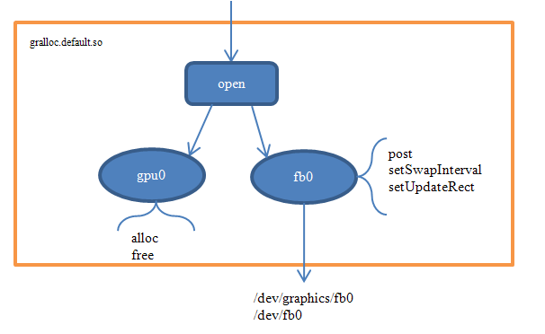

**1.图形缓冲设备GraphicBuffer结构：**

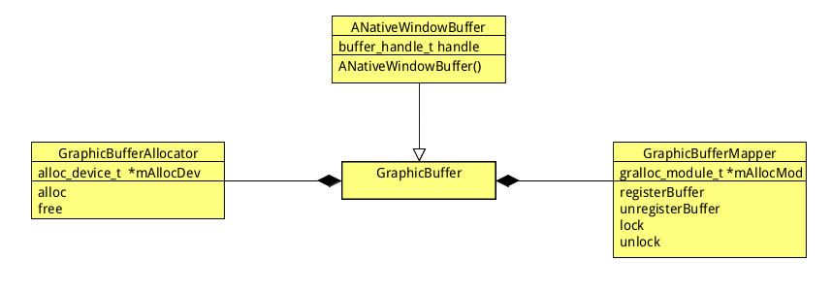

Galloc 中private_module_t赋值过程：

struct private_module_t HAL_MODULE_INFO_SYM = {

.base = {

.common = {

.methods = &gralloc_module_methods

},

.registerBuffer = gralloc_register_buffer,

.unregisterBuffer = gralloc_unregister_buffer,

.lock = gralloc_lock,

.unlock = gralloc_unlock,

},

};

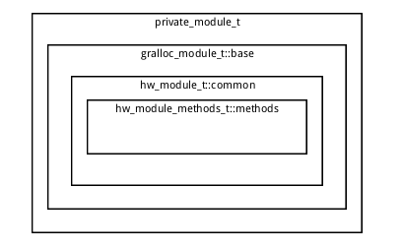

GraphicBufferMapper 就是使用gralloc_module_t中的方法对buffer_handle_t进行操作.

GraphicBufferMapper::GraphicBufferMapper(): mAllocMod(0)

{

hw_module_t const* module;

int err = hw_get_module(GRALLOC_HARDWARE_MODULE_ID, &module);

mAllocMod = reinterpret_cast<gralloc_module_t const *>(module);

}

GraphicBufferAllocator使用函数gralloc_open来打开alloc_device_t.

gralloc_open最终调用private_module_t.common.methods.open函数，也就是gralloc_device_open。

alloc_device_t *mAllocDev;

**GraphicBufferAllocator::GraphicBufferAllocator(): mAllocDev(0)**

{

hw_module_t const* module;

int err = hw_get_module(GRALLOC_HARDWARE_MODULE_ID, &module);

gralloc_open(module, &mAllocDev);

}

**static inline int gralloc_open(const struct hw_module_t* module, struct alloc_device_t** device) {**

return module->methods->open(module,GRALLOC_HARDWARE_GPU0,(structhw_device_t**)device);

}

**int gralloc_device_open(const hw_module_t* module, const char* name,hw_device_t** device)**

{

if (!strcmp(name, GRALLOC_HARDWARE_GPU0)) {

gralloc_context_t *dev;

dev = (gralloc_context_t*)malloc(sizeof(*dev));

dev->device.common.module = const_cast<hw_module_t*>(module);

dev->device.common.close = gralloc_close;

dev->device.alloc = gralloc_alloc;

dev->device.free = gralloc_free;

*device = &dev->device.common;

} else {

status = fb_device_open(module, name, device);

}

}

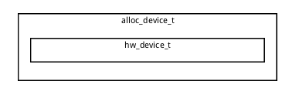

1. **帧缓冲设备：**

**Open：**

**static inline int framebuffer_open(const struct hw_module_t* module,**

**struct framebuffer_device_t** device) {**

return module->methods->open(module,

GRALLOC_HARDWARE_FB0, (struct hw_device_t**)device);

}



**int fb_device_open(hw_module_t const* module, const char* name,**

hw_device_t** device)

{

int status = -EINVAL;

if (!strcmp(name, GRALLOC_HARDWARE_FB0)) {

fb_context_t *dev = (fb_context_t*)malloc(sizeof(*dev));

memset(dev, 0, sizeof(*dev));

dev->device.common.tag = HARDWARE_DEVICE_TAG;

dev->device.common.version = 0;

dev->device.common.module = const_cast<hw_module_t*>(module);

dev->device.common.close = fb_close;

dev->device.setSwapInterval = fb_setSwapInterval;

dev->device.post = fb_post;

dev->device.setUpdateRect = 0;

private_module_t* m = (private_module_t*)module;

status = mapFrameBuffer(m);

}

return status;

}

**static int mapFrameBuffer(struct private_module_t* module)**

{

int err = mapFrameBufferLocked(module);

return err;

}

mapFrameBufferLocked 函数的主要行为是：

1. 打开帧缓冲设备
2. 获取帧缓冲设备的信息
3. 将帧缓冲设备的地址空间映射到用户进程空间为显示做好准备。

帧缓冲设备是在surfaceflinger中打开进行管理的，对应的管理类为HWComposer。

**int mapFrameBufferLocked(struct private_module_t* module)**

{

char const * const device_template[] = {

"/dev/graphics/fb%u",

"/dev/fb%u",

0 };

fd = open(name, O_RDWR, 0);

struct fb_fix_screeninfo finfo;

if (ioctl(fd, FBIOGET_FSCREENINFO, &finfo) == -1)

struct fb_var_screeninfo info;

if (ioctl(fd, FBIOGET_VSCREENINFO, &info) == -1)

size_t fbSize = roundUpToPageSize(finfo.line_length * info.yres_virtual);

module->framebuffer = new private_handle_t(dup(fd), fbSize, 0);

module->numBuffers = info.yres_virtual / info.yres;

module->bufferMask = 0;

void* vaddr = mmap(0, fbSize, PROT_READ|PROT_WRITE, MAP_SHARED, fd, 0);

if (vaddr == MAP_FAILED) {

ALOGE("Error mapping the framebuffer (%s)", strerror(errno));

return -errno;

}

module->framebuffer->base = intptr_t(vaddr);

}

GraphicBuffer在创建的过程中会使用图形缓冲设备来alloc一块buffer保存在buffer_handle_t中。

typedef const native_handle_t* buffer_handle_t;

typedef struct native_handle

{

int version; /* sizeof(native_handle_t) */

int numFds; /* number of file-descriptors at &data[0] */

int numInts; /* number of ints at &data[numFds] */

int data[0]; /* numFds + numInts ints */

} native_handle_t;

将所有的Bitmap画在创建的Canvas上，通过nUploadAtlas函数上传到GPU中。

至此服务端地图集的创建完成。

**Client使用地图集：**

在ThreadedRenderer对象的创建的第三步中，ProcessInitializer对象的初始化中获取地图集。

private static class ProcessInitializer {

synchronized void init(Context context, long renderProxy) {

if (mInitialized) return;

mInitialized = true;

initGraphicsStats(context, renderProxy);

initAssetAtlas(context, renderProxy);

}

}

private static void initAssetAtlas(Context context, long renderProxy) {

IBinder binder = ServiceManager.getService("assetatlas");

IAssetAtlas atlas = IAssetAtlas.Stub.asInterface(binder);

GraphicBuffer buffer = atlas.getBuffer();

if (buffer != null) {

long[] map = atlas.getMap();

if (map != null) {

nSetAtlas(renderProxy, buffer, map);

}

}

}

通过GraphicBuffer和map数组，将地图集中的资源保存在AssetAtlas的数组mEntries中：

private static void initAssetAtlas(Context context, long renderProxy) {

IBinder binder = ServiceManager.getService("assetatlas");

IAssetAtlas atlas = IAssetAtlas.Stub.asInterface(binder);

GraphicBuffer buffer = atlas.getBuffer();

if (buffer != null) {

long[] map = atlas.getMap();

if (map != null) {

nSetAtlas(renderProxy, buffer, map);

}

}

}

void CanvasContext::setTextureAtlas(RenderThread& thread,

const sp<GraphicBuffer>& buffer, int64_t* map, size_t mapSize) {

thread.eglManager().setTextureAtlas(buffer, map, mapSize);

}

void EglManager::setTextureAtlas(const sp<GraphicBuffer>& buffer,

int64_t* map, size_t mapSize) {

mAtlasBuffer = buffer;

mAtlasMap = map;

mAtlasMapSize = mapSize;

if (hasEglContext()) {

initAtlas();

}

}

void AssetAtlas::init(sp<GraphicBuffer> buffer, int64_t* map, int count) {

mImage = new Image(buffer);

Caches& caches = Caches::getInstance();

mTexture = new Texture(caches);

mTexture->width = buffer->getWidth();

mTexture->height = buffer->getHeight();

createEntries(caches, map, count);

}

**5.构建displaylist**

1.DecorView的mRenderNode树的构建过程：