1.boot:
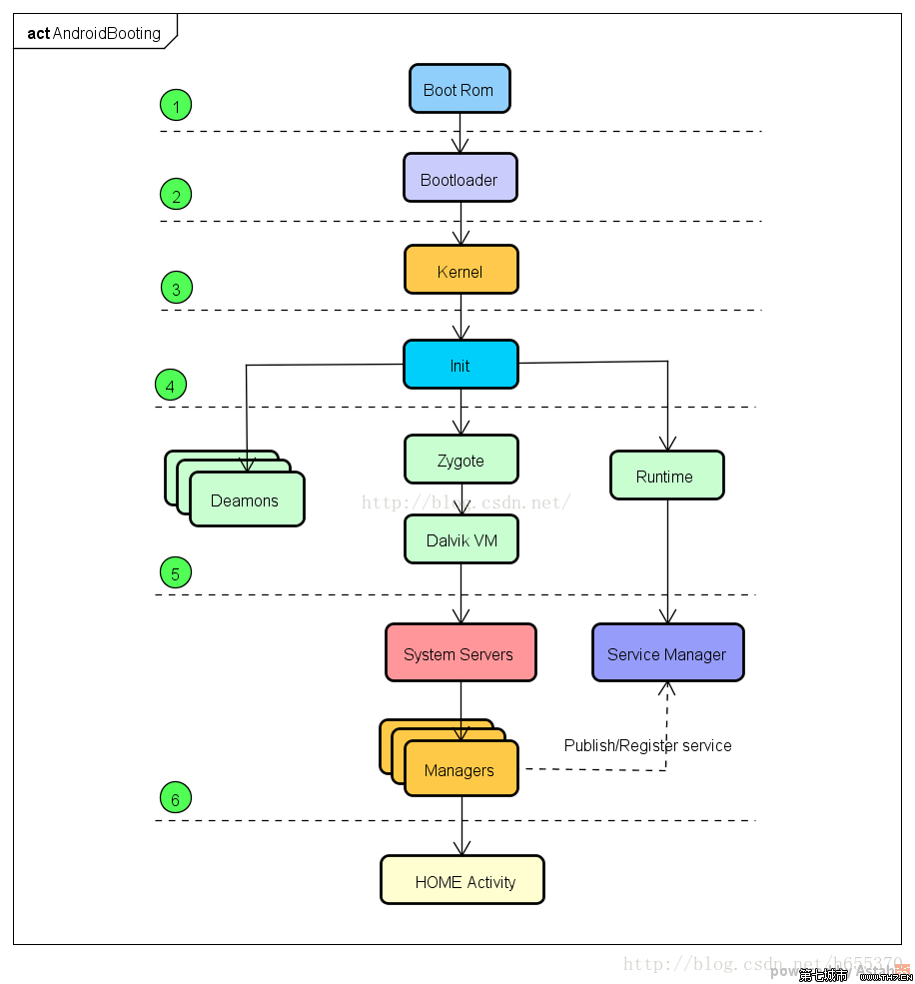
- boot rom

- Bootloader

- Startkernel
Kernel start logo:

- Init main
Init logo

- Android_service
bootanimation

2.shutdown

参考：
https://blog.csdn.net/h655370/article/details/77727554
https://www.cnblogs.com/pepsimaxin/p/6702945.html

