1. Log的种类

1.kernel log

2.user space log

1. kernel log的使用和抓取

printk的使用方法：

printk(KERN_ALERT"This is the log printed by printk in linux kernel space.");

抓取：

root@android:/ # cat /proc/kmsg；

klogctl (KLOG_READ_ALL, kbuf, sizeof (kbuf) - 1);

1. 用户空间log系统：

Log的使用：

1.native：

包含#include <cutils/log.h>头文件：

ALOGI("SurfaceFlinger is starting");

2.java：

架构：

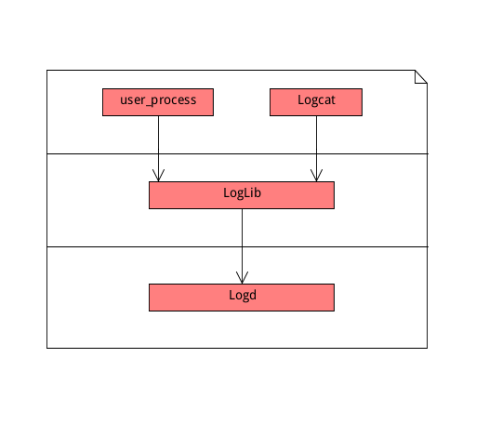

Log种类：

typedef enum log_id {

LOG_ID_MIN = 0,

#ifndef LINT_RLOG

LOG_ID_MAIN = 0,

#endif

LOG_ID_RADIO = 1,

#ifndef LINT_RLOG

LOG_ID_EVENTS = 2,

LOG_ID_SYSTEM = 3,

LOG_ID_CRASH = 4,

LOG_ID_SECURITY = 5,

LOG_ID_KERNEL = 6, /* place last, third-parties can not use it */

#endif

LOG_ID_MAX

} log_id_t;

ALOG：

android_printLog---->__android_log_print

使用LOG_ID_MAIN作为bufID。

所有log的buffer不能超过1024的长度。

LIBLOG_ABI_PUBLIC int __android_log_print(int prio, const char *tag,

const char *fmt, ...)

{

va_list ap;

char buf[LOG_BUF_SIZE];

va_start(ap, fmt);

vsnprintf(buf, LOG_BUF_SIZE, fmt, ap);

va_end(ap);

return __android_log_write(prio, tag, buf);

}

LIBLOG_ABI_PUBLIC int __android_log_write(int prio, const char *tag,

const char *msg)

{

return __android_log_buf_write(LOG_ID_MAIN, prio, tag, msg);

}

SLOGV：

使用LOG_ID_SYSTEM作为bufferID。

__android_log_buf_print(LOG_ID_SYSTEM, ANDROID_LOG_VERBOSE, LOG_TAG, __VA_ARGS__))

RLOGV：LOG_ID_RADIO

__android_log_buf_write函数的解析：

LIBLOG_ABI_PUBLIC int __android_log_buf_write(int bufID, int prio,

const char *tag, const char *msg)

{

struct iovec vec[3];

char tmp_tag[32];

if (!tag)

tag = "";

vec[0].iov_base = (unsigned char *)&prio;

vec[0].iov_len = 1;

vec[1].iov_base = (void *)tag;

vec[1].iov_len = strlen(tag) + 1;

vec[2].iov_base = (void *)msg;

vec[2].iov_len = strlen(msg) + 1;

return write_to_log(bufID, vec, 3);

}

构造3个元素的iovec的数组分别保存优先级、tag、message.

最后调用write_to_log函数指针。

write_to_log函数指针的初始化：

第一次调用的时候调用__write_to_log_init函数，在该函数中调用__write_to_log_initialize进行初始化动作和调用__write_to_log_daemon函数开始写入log，同时将write_to_log函数指针指向__write_to_log_daemon。

static int (*write_to_log)(log_id_t, struct iovec *vec, size_t nr) = __write_to_log_init;

static int __write_to_log_init(log_id_t log_id, struct iovec *vec, size_t nr)

{

__android_log_lock();

if (write_to_log == __write_to_log_init) {

int ret;

ret = __write_to_log_initialize();

if (ret < 0) {

__android_log_unlock();

if (!list_empty(&__android_log_persist_write)) {

__write_to_log_daemon(log_id, vec, nr);

}

return ret;

}

write_to_log = __write_to_log_daemon;

}

__android_log_unlock();

return write_to_log(log_id, vec, nr);

}

__write_to_log_daemon函数的解析：

struct android_log_transport_write {

struct listnode node;

const char *name;

unsigned logMask; /* cache of available success */

union android_log_context context; /* Initialized by static allocation */

int (*available)(log_id_t logId);

int (*open)();

void (*close)();

int (*write)(log_id_t logId, struct timespec *ts, struct iovec *vec, size_t nr);

};

LIBLOG_HIDDEN struct android_log_transport_write logdLoggerWrite = {

.node = { &logdLoggerWrite.node, &logdLoggerWrite.node },

.context.sock = -1,

.name = "logd",

.available = logdAvailable,

.open = logdOpen,

.close = logdClose,

.write = logdWrite,

};

通过logdWrite函数使用/dev/socket/logdw作为域套接口进行通信，将log的信息发送到logd进程中。

**Logd的解析：**

1.logd进程通过init进程在开机的时候启动。

1.创建 LogBuffer对象：

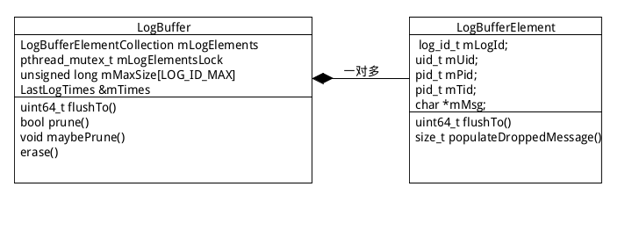

为每种的类型的LOG_ID设置buffer的size。

2.创建LogReader对象：

在/dev/socket目录下创建logdr socket并且启动一个name 为logd.reader的线程在该socket进行监听。当有client端连接该socket返回到onDataAvailable函数。

在该函数中通过FlushCommand为每个client创建一个name 为logd.reader.per线程进行通信，比如一个logcat的连接就创建一个FlushCommand。

在logd.reader.per线程中通过不断的将LogBuffer中的log信息发送给client，也就是logcat。

LogReader *reader = new LogReader(logBuf);

if (reader->startListener()) {

exit(1);

}

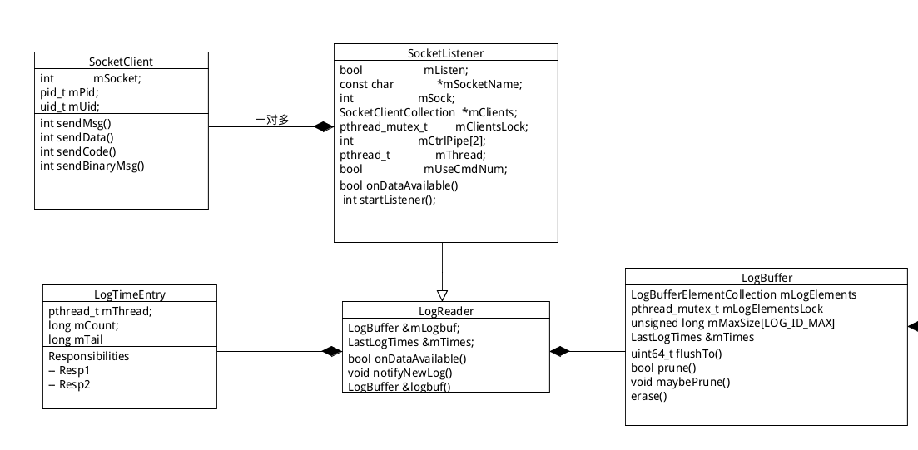

1. 创建LogListener对象：

// LogListener listens on /dev/socket/logdw for client

// initiated log messages. New log entries are added to LogBuffer

// and LogReader is notified to send updates to connected clients.

LogListener *swl = new LogListener(logBuf, reader);

// Backlog and /proc/sys/net/unix/max_dgram_qlen set to large value

if (swl->startListener(600)) {

exit(1);

}

LogListener和LogReader一样继承于SocketListener，最终创建一个name 为logd.writer的监听线程对创建的/dev/socket/logdw进行监听。当app端由log需要打印出来的时候，将log信息保存到LogBuffer中，同时调用LogReader::notifyNewLog函数通知LogReader中所有的client有读事件。

总结：

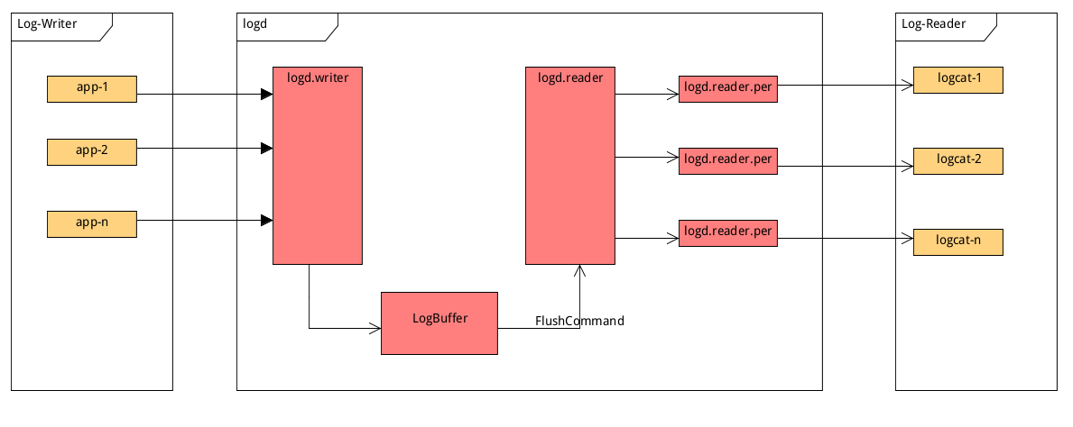

Log系统的优化以及log工具的制作：

优化：

<0001-logd-fix-Adjust-socket-parameter-to-fine-tune-LOGD-l.patch>

<0001-logd-feature-Simplify-logd-for-better-performance-an.patch>

工具：

logd 595 1 22976 5044 sigsuspend 0000000000 S /system/bin/logd

root 838 1 5844 1368 do_wait 0000000000 S /system/bin/htcpreloader

root 913 838 30932 3096 inet_csk_a 0000000000 S /system/bin/htcserviced

root 12961 913 6044 1656 __skb_recv 0000000000 S /system/bin/logcat

root 12970 913 6064 1632 __skb_recv 0000000000 S /system/bin/logcat

root 12974 913 6044 1652 __skb_recv 0000000000 S /system/bin/logcat

system 5572 816 1672048 85080 SyS_epoll_ 0000000000 S com.htc.android.ssdtest

Logd、htcpreloader、htcserviced在init进程中启动，当htcserviced检查到user打开log开关（通过com.htc.android.ssdtest app写入到system属性中）启动logcat抓取从logd获取的log。

1.log开关的控制

2.输出log类型

3.输出log的格式

root@archermind:/work/log/PERFUME_UHL_O80_SENSE90GP_MR_R/log pme 按后台键，回到锁屏界面# adb shell ps -t 913

USER PID PPID VSIZE RSS WCHAN PC NAME

root 913 838 30932 3192 inet_csk_a 7f97e73250 S /system/bin/htcserviced

root 3975 913 30932 3192 poll_sched 7f97e733d0 S uevent

root 3977 913 30932 3192 inet_csk_a 7f97e73250 S ghost

root 3978 913 30932 3192 inet_csk_a 7f97e73250 S dumpstate

root 3979 913 30932 3192 inet_csk_a 7f97e73250 S logctl

root 3980 913 30932 3192 poll_sched 7f97e733d0 S htc_if

root 3981 913 30932 3192 poll_sched 7f97e733d0 S dumpstate:key

root 3982 913 30932 3192 poll_sched 7f97e733d0 S ghost:monitor

root 3983 913 30932 3192 futex_wait 7f97e24330 S logctl:monitor

root 3984 913 30932 3192 futex_wait 7f97e24330 S logctl:killer

root 8822 913 30932 3192 inet_csk_a 7f97e73250 S proctrl

root 8842 913 30932 3192 futex_wait 7f97e24330 S proctrl

root 9016 913 30932 3192 inet_csk_a 7f97e73250 S lognet

root 9017 913 30932 3192 futex_wait 7f97e24330 S lognet:monitor

root 12962 913 30932 3192 pipe_wait 7f97e73df0 S logdevice:route

root 12964 913 30932 3192 futex_wait 7f97e24330 S logkmsg:logger

root 12965 913 30932 3192 hrtimer_na 7f97e73ce8 S logkmsg:timegen

root 12971 913 30932 3192 pipe_wait 7f97e73df0 S logevents:route

root 12975 913 30932 3192 pipe_wait 7f97e73df0 S logradio:router

root 12977 913 30932 3192 futex_wait 7f97e24330 S logmeminfo:logg

root 12978 913 30932 3192 do_wait 7f97e743c0 S system:am broad