**需求：**

一个微服务部署多个节点，所有节点都要消费到监听的rabbitmq消息。

**实现：**

Fanout 类型Exchange + Anonymous Queue。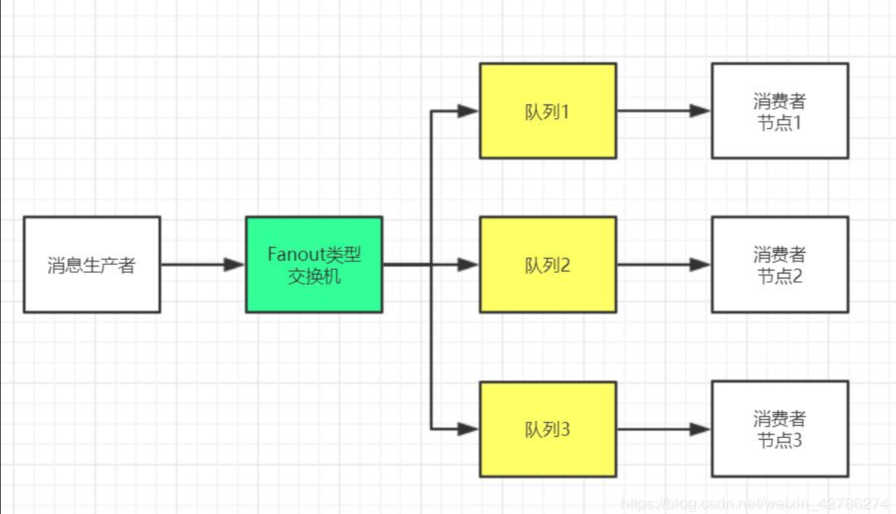

**监听端：**

配置：

**public static final** String ***MIDDLE_TEST_EXCHANGE*** = **"exchange_test_middle"**;  
@Bean(name = **"middleTestExchange"**)  
**public** FanoutExchange middleTestExchangeOta() {  
 **return new** FanoutExchange(***MIDDLE_TEST_EXCHANGE***);  
}  
@Bean(name = **"queueMiddleTestDeviceOta"**)  
**public** Queue queueMiddleTestDeviceOta() {  
 **return new** AnonymousQueue();  
}  
@Bean(name = **"bindingMiddleTestDeviceOta"**)  
**public** Binding bindingMiddleTestDeviceOta() {  
 **return** BindingBuilder.*bind*(queueMiddleTestDeviceOta()).to(middleTestExchangeOta());  
}

接收：

@Component  
@RabbitListener(queues = **"#{queueMiddleTestDeviceOta.name}"**)  
@Slf4j  
**public class** MsgReceiverService {

@RabbitHandler  
**public void** process(String content, Channel channel, Message message) {

......

}

}

**发送端：**

**public static final** String ***MIDDLE_TEST_EXCHANGE*** = **"exchange_test_middle"**;  
**public void** sendMiddleDevice(String content) {  
 CorrelationData correlationId = **new** CorrelationData(UUID.*randomUUID*().toString());  
 **rabbitTemplateOta**.convertAndSend(***MIDDLE_TEST_EXCHANGE***, **null**, content, correlationId);  
}