Spring-framework
1.各个模块依赖图

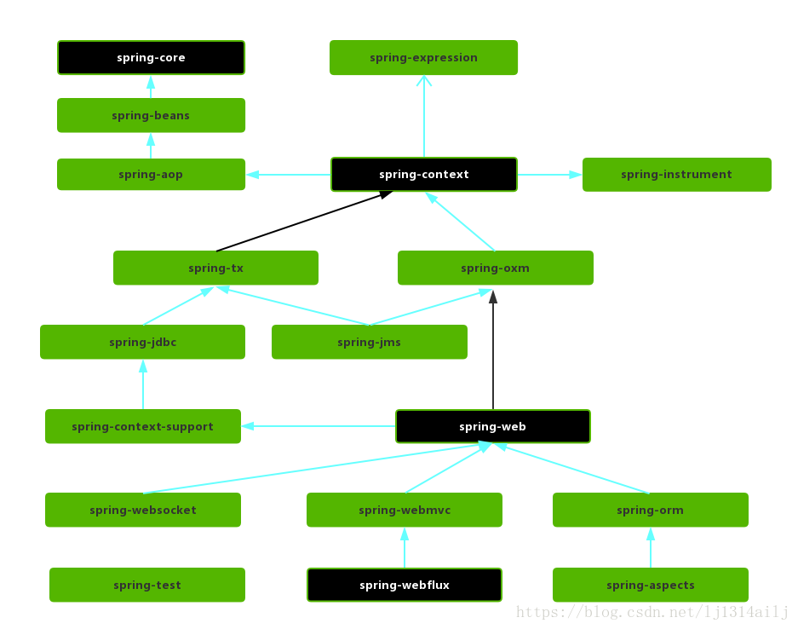

2.ApplicationContext和BeanFactory总体类关系图
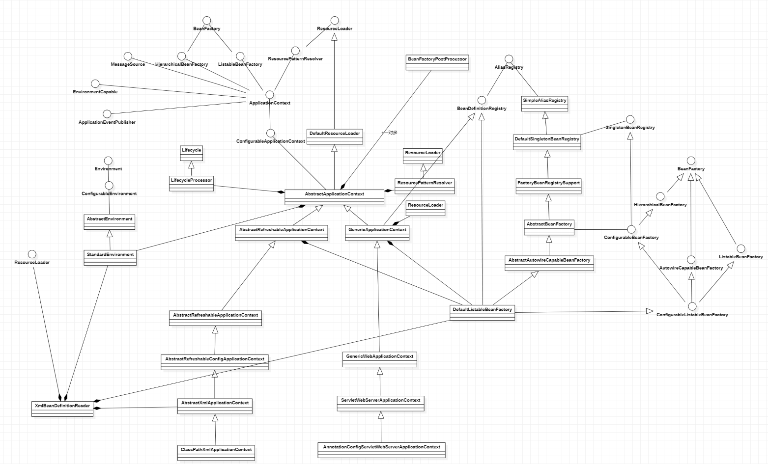
ApplicationContext对应的实现类是AbstractApplicationContext。
BeanFactory对应的实现类是DefaultListableBeanFactory。

AbstractApplicationContext包含DefaultListableBeanFactory，
共同继承的接口有BeanFactory

DefaultListableBeanFactory:
Map<String, BeanDefinition> beanDefinitionMap = new ConcurrentHashMap(256);
List<String> beanDefinitionNames = new ArrayList(256);

不同的Context使用不同的BeanDefinitionReader来创建BeanDefinnition注册到BeanFactory。通过context或者beanFactory方法getbean来创建bean对象。

2.ApplicationContext的refresh函數：
@Override
public void refresh() throws BeansException, IllegalStateException {
synchronized (this.startupShutdownMonitor) {
// Prepare this context for refreshing.
prepareRefresh();
// Tell the subclass to refresh the internal bean factory.
ConfigurableListableBeanFactory beanFactory = obtainFreshBeanFactory();
// Prepare the bean factory for use in this context.
prepareBeanFactory(beanFactory);
try {
// Allows post-processing of the bean factory in context subclasses.
postProcessBeanFactory(beanFactory);
// Invoke factory processors registered as beans in the context.
invokeBeanFactoryPostProcessors(beanFactory);
// Register bean processors that intercept bean creation.
registerBeanPostProcessors(beanFactory);
// Initialize message source for this context.
initMessageSource();
// Initialize event multicaster for this context.
initApplicationEventMulticaster();
// Initialize other special beans in specific context subclasses.
onRefresh();
// Check for listener beans and register them.
registerListeners();
// Instantiate all remaining (non-lazy-init) singletons.
finishBeanFactoryInitialization(beanFactory);
// Last step: publish corresponding event.
finishRefresh();
}
catch (BeansException ex) {
// Destroy already created singletons to avoid dangling resources.
destroyBeans();
// Reset 'active' flag.
cancelRefresh(ex);
// Propagate exception to caller.
throw ex;
}
finally {
// Reset common introspection caches in Spring's core, since we
// might not ever need metadata for singleton beans anymore...
resetCommonCaches();
}
}
}

3.obtainFreshBeanFactory
创建BeanFactory完成BeanDefinition的注册
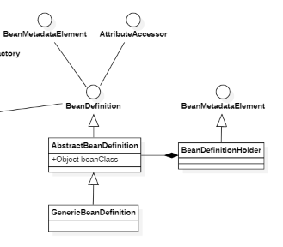
将创建的BeanDefinition对象放入到beanFactory的容器中。
DefaultListableBeanFactory.java
@Override
public void registerBeanDefinition(String beanName, BeanDefinition beanDefinition)
throws BeanDefinitionStoreException {
BeanDefinition existingDefinition = this.beanDefinitionMap.get(beanName);
if (existingDefinition != null) {
}
else {
if (hasBeanCreationStarted()) {
else {
// Still in startup registration phase
this.beanDefinitionMap.put(beanName, beanDefinition);
this.beanDefinitionNames.add(beanName);
removeManualSingletonName(beanName);
}
this.frozenBeanDefinitionNames = null;
}
}

4.prepareBeanFactory
为beanFactory添加一些默认的BeanPostProcessor和注册一些系统默认registerSingleton单列对象。

5.postProcessBeanFactory

6.invokeBeanFactoryPostProcessors
protected void invokeBeanFactoryPostProcessors(ConfigurableListableBeanFactory beanFactory) {
PostProcessorRegistrationDelegate.invokeBeanFactoryPostProcessors(beanFactory, getBeanFactoryPostProcessors());
if (beanFactory.getTempClassLoader() == null && beanFactory.containsBean(LOAD_TIME_WEAVER_BEAN_NAME)) {
beanFactory.addBeanPostProcessor(new LoadTimeWeaverAwareProcessor(beanFactory));
beanFactory.setTempClassLoader(new ContextTypeMatchClassLoader(beanFactory.getBeanClassLoader()));
}
}

6.1通过beanFactory.getBeanNamesForType方法获取继承BeanDefinitionRegistryPostProcessor的BeanFactoryPostProcessor列表，进行排序，最终遍历列表调用BeanFactoryPostProcessor的postProcessBeanDefinitionRegistry
方法.
6.2通过beanFactory.getBeanNamesForType方法获取继承BeanFactoryPostProcessor
的BeanFactoryPostProcessor列表并且创建对应的对象，进行排序(PriorityOrdered
,Ordered, none)，最终遍历调用postProcessBeanFactory方法.

7.registerBeanPostProcessors
通过beanFactory.getBeanNamesForType方法将继承BeanPostProcessor的bean查询出来，
调用registerBeanPostProcessors方法将bean对象注册到beanFactory的beanPostProcessors容器内。

BeanPostProcessor的postProcessBeforeInitialization和postProcessAfterInitialization方法调用时机：
doCreateBean创建bean时候initializeBean。
protected Object initializeBean(String beanName, Object bean, @Nullable RootBeanDefinition mbd) {
Object wrappedBean = bean;
if (mbd == null || !mbd.isSynthetic()) {
wrappedBean = applyBeanPostProcessorsBeforeInitialization(wrappedBean, beanName);
}
try {
invokeInitMethods(beanName, wrappedBean, mbd);
}
if (mbd == null || !mbd.isSynthetic()) {
wrappedBean = applyBeanPostProcessorsAfterInitialization(wrappedBean, beanName);
}
return wrappedBean;
}

遍历目前beanFactory的beanPostProcessors容器内所有的BeanPostProcessor,调用对应的
postProcessBeforeInitialization和postProcessAfterInitialization方法。

8.initMessageSource
将DelegatingMessageSource对象加入到bean容器中。

9.initApplicationEventMulticaster
将SimpleApplicationEventMulticaster对象加入到bean容器中。

10.onRefresh

11.registerListeners
将当前系统初始化时候加入的ApplicationListener添加进applicationEventMulticaster中。

AbstractApplicationContext对ApplicationListener的处理
void addApplicationListener(ApplicationListener<?> listener)

Collection<ApplicationListener<?>> getApplicationListeners()

void publishEvent(ApplicationEvent event)

addApplicationListener：
将用户自定义的ApplicationListener添加到context的applicationListeners
容器中和applicationEventMulticaster的defaultRetriever.applicationListeners
容器中。

publishEvent：
调用applicationEventMulticaster的multicastEvent方法，遍历defaultRetriever.applicationListeners调用listener.onApplicationEvent
方法。

12.finishBeanFactoryInitialization
protected void finishBeanFactoryInitialization(ConfigurableListableBeanFactory beanFactory) {
// Instantiate all remaining (non-lazy-init) singletons.
beanFactory.preInstantiateSingletons();
}

通过getBean方法创建non-lazy-init的单列bean对象，保存到BeanFactory的容器中。
注：创建bean对象的时候会调用beanPostProcessors的postProcessBeforeInitialization和postProcessAfterInitialization方法。

13.finishRefresh

14.GenericWebApplicationContext和注解bean的使用
14.1 ConfigurationClassPostProcessor的添加：
在创建AnnotationConfigServletWebServerApplicationContext 这个web的ApplicationContext对象的时候,初始化AnnotatedBeanDefinitionReader成员对象的时候调用AnnotationConfigUtils.registerAnnotationConfigProcessors方法将ConfigurationClassPostProcessor这个BeanFactoryPostProcessor添加到ioc容器中。
14.2 prepareContext SpringApplication中将Application主类以AnnotatedGenericBeanDefinition注册到ioc容器中。

AnnotatedBeanDefinitionReader.java
private <T> void doRegisterBean(Class<T> beanClass, @Nullable String name, @Nullable Class<? extends Annotation>[] qualifiers, @Nullable Supplier<T> supplier, @Nullable BeanDefinitionCustomizer[] customizers) {
AnnotatedGenericBeanDefinition abd = new AnnotatedGenericBeanDefinition(beanClass);
BeanDefinitionHolder definitionHolder = new BeanDefinitionHolder(abd, beanName);
definitionHolder = AnnotationConfigUtils.applyScopedProxyMode(scopeMetadata, definitionHolder, this.registry);
BeanDefinitionReaderUtils.registerBeanDefinition(definitionHolder, this.registry);
}
}

public AnnotatedGenericBeanDefinition(Class<?> beanClass) {
this.setBeanClass(beanClass);
this.metadata = AnnotationMetadata.introspect(beanClass);
}

static AnnotationMetadata introspect(Class<?> type) {
return StandardAnnotationMetadata.from(type);
}

14.3 ConfigurationClassPostProcessor的使用：
在refresh函数的invokeBeanFactoryPostProcessors过程中调用ConfigurationClassPostProcessor的postProcessBeanDefinitionRegistry方法。

processConfigBeanDefinitions:
处理所有持有Configuration注解的bean。
1.获取BeanDefinitionNames列表进行遍历，将非BeanFactoryPostProcessor、
BeanPostProcessor、AopInfrastructureBean、EventListenerFactory这些bean过滤出来
检查bean是否有Configuration注解。

public void processConfigBeanDefinitions(BeanDefinitionRegistry registry) {
List<BeanDefinitionHolder> configCandidates = new ArrayList();
String[] candidateNames = registry.getBeanDefinitionNames();
String[] var4 = candidateNames;
int var5 = candidateNames.length;
//遍历所有注册的bean
for(int var6 = 0; var6 < var5; ++var6) {
String beanName = var4[var6];
BeanDefinition beanDef = registry.getBeanDefinition(beanName);
if (beanDef.getAttribute(ConfigurationClassUtils.CONFIGURATION_CLASS_ATTRIBUTE) != null) {
//检查AnnotatedBeanDefinition注解bean是否包含@Configuration
} else if (ConfigurationClassUtils.checkConfigurationClassCandidate(beanDef, this.metadataReaderFactory)) {
configCandidates.add(new BeanDefinitionHolder(beanDef, beanName));
}
}
}

2.扫描项目包下面的class文件中所有注解bean
ConfigurationClassParser parser = new ConfigurationClassParser(this.metadataReaderFactory, this.problemReporter, this.environment, this.resourceLoader, this.componentScanBeanNameGenerator, registry);
Set<BeanDefinitionHolder> candidates = new LinkedHashSet(configCandidates);
HashSet alreadyParsed = new HashSet(configCandidates.size());
do {
parser.parse(candidates);
parser.validate();
Set<ConfigurationClass> configClasses = new LinkedHashSet(parser.getConfigurationClasses());
configClasses.removeAll(alreadyParsed);
if (this.reader == null) {
this.reader = new ConfigurationClassBeanDefinitionReader(registry, this.sourceExtractor, this.resourceLoader, this.environment, this.importBeanNameGenerator, parser.getImportRegistry());
}

ClassPathScanningCandidateComponentProvider.java
private Set<BeanDefinition> scanCandidateComponents(String basePackage) {
Set<BeanDefinition> candidates = new LinkedHashSet<>();
try {
String packageSearchPath = ResourcePatternResolver.CLASSPATH_ALL_URL_PREFIX +
resolveBasePackage(basePackage) + '/' + this.resourcePattern;
Resource[] resources = getResourcePatternResolver().getResources(packageSearchPath);

