One Way Analysis of Variance - Balanced Design

When one wishes to compare more than two treatments or sample means, the null hypothesis to be tested is usually that the k treatment or sample means are the same, and that the alternative hypothesis is that they are not. Analysis of variance (ANOVA) is a useful technique for making decisions about these hypotheses. In an analysis of variance it is actually the variation in the k treatment or sample responses which is used to decided whether or not treatment effects are significant. The techniques are usually justified on the supposition that the data can be treated as random samples from k normal populations all having the same variance, σ2, and differing, if at all, only in their means.

Example

The following values were obtained for trace amounts of Cd2+ from shoots of plants grown in soil which had been amended with different amounts of sewage sludge (50, 100 and 150 grams of sludge per kilogram of soil). Because of the complex nature of ion uptake by plant roots from soil and translocation into the shoots it does not automatically follow that increasing the amount of metal bearing sludge will increase the shoot Cd2+ concentrations. Four plants were taken from each soil. We wish to find out whether there is a significant difference between the mean plant cadmium values for the three soils at the 5% probability significance level.

Grams of sludge added per kg soil
 | 50 (A) | 100 (B) | 150 (C)
Shoot Cd2+ conc. (μg g-1) | 33.0 | 35.5 | 42.2
 | 35.4 | 37.0 | 38.8
 | 34.0 | 36.0 | 40.5
 | 36.2 | 37.4 | 40.0

A statistical model which incorporates the assumptions above can be written

The alphas (αi) are treatment effects, and will all equal zero if there is no difference between the groups.
Select the One-Way-ANOVA option from the Stat menu item in MINITAB.

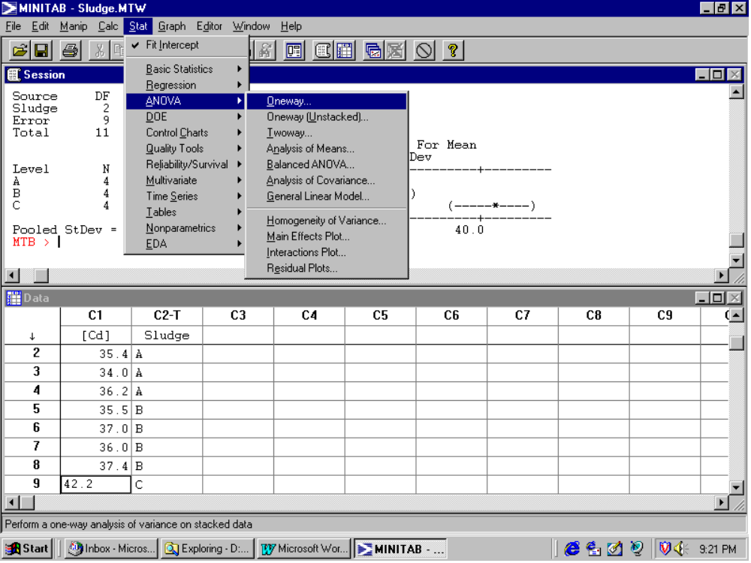

You should be presented with the following dialogue box.

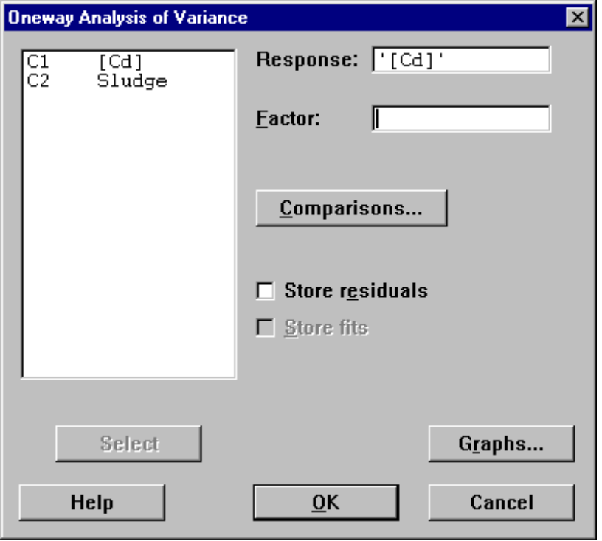
After selecting [Cd] as the response variable, you must specify a variable defining the factor levels at which each measurement was obtained, in this example the column ‘Sludge’. Other options such as storing fitted values / residuals, or drawing up diagnostic plots are also available. After clicking ‘OK’ you obtain the following output.

Analysis of Variance for [Cd]
Source DF SS MS F P
Sludge 2 68.42 34.21 21.40 0.000
Error 9 14.39 1.60
Total 11 82.81
Individual 95% CIs For Mean
Based on Pooled StDev
Level N Mean StDev --------+---------+---------+--------
A 4 34.650 1.427 (-----*----)
B 4 36.475 0.877 (-----*-----)
C 4 40.375 1.410 (-----*----)
--------+---------+---------+--------
Pooled StDev = 1.264 35.0 37.5 40.0

Fisher's pairwise comparisons

Family error rate = 0.113
Individual error rate = 0.0500

Critical value = 2.262

Intervals for (column level mean) - (row level mean)

A B

B -3.847
0.197

C -7.747 -5.922
-3.703 -1.878

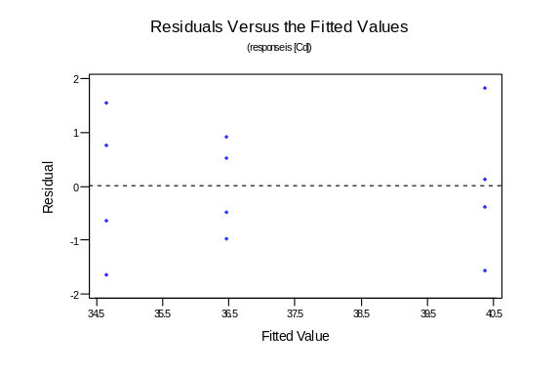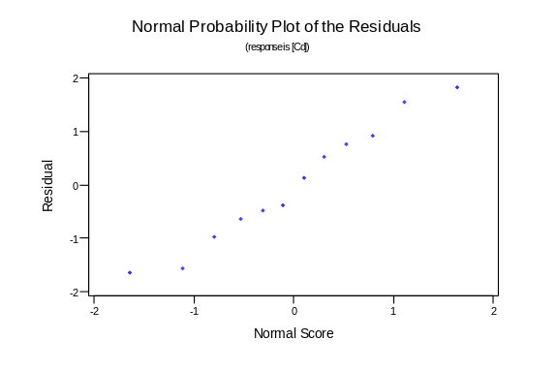

The diagnostic plots should be always be examined before even looking at the computer output. The scatterplot on the left is a plot of residuals against fitted values. The residuals are randomly scattered around zero and display no obvious pattern. The variance of the three groups (indicated by the spread of the residuals in the vertical direction) seems to be equal. The second scatterplot is a plot of the residuals against Nscores (idealised values we would expect if indeed the data were a sample from a normal population). The points on the Nscore are approximately straight indicating no obvious departure from normality. These diagnostic plots are quite satisfactory.

Next we consider the computer output. The F ratio (21.40) is test the hypothesis that the three treatment population means are equal (i.e. the treatment effects αi are all zero) against an alternative that at least one of the three differs from the other two. A large F ratio (greater than the appropriate cut-off value from an F distribution on 2 and 9 degrees of freedom) indicates that the treatment population means differ and the null hypothesis should be rejected. The value from an F distribution which excludes 5% of value to the upper tail is 4.26. As our test statistic (F* = 21.40) greatly exceeds this value we reject the null hypothesis and conclude that the means differ. Alternatively the p-value for the test (probability of getting the results we observed or a result more extreme) is 0.000, indicating that an F ratio of 21.40 is practically impossible if the null hypothesis were true. Again we conclude to reject the null hypothesis.

ANOVA tells us if the treatment means differ - it tells us nothing about where any evidence for a significant difference comes from. To do this various post-hoc tests are proposed. The Fisher LSD (least significant difference) helps identify the largest difference in the group means. These confidence intervals are constructed as

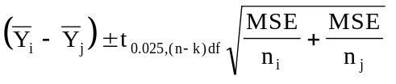

Calculating this fir the first group (sludge conc. = 50g) against the second group (sludge conc. = 100g), we get…
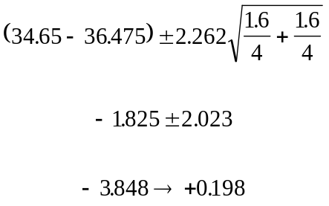

This interval is indicated in bold on the computer output of the last page. Note that this interval include zero indicating no significant difference between the first and second treatment groups.
One Way Analysis of Variance - Unbalanced Design

The silver content (% Ag) of a number of Byzantine coins discovered in Cyprus was determined. Nine of the coins came from the first coinage of the reign of King Manuel I, Comnenus (1143-1180); there were seven from the second coinage minted several years later and four from the third coinage (later still); and another seven were from a fourth coinage (most recent). The raw data are given below and the sample mean and sample standard deviation reported at the end of each column. Historians believe that the Silver content is not equal for each of the four coinages.

First Coinage | Second Coinage | Third Coinage | Fourth Coinage
5.9 | 6.9 | 4.9 | 5.3
6.8 | 9.0 | 5.5 | 5.6
6.4 | 6.6 | 4.6 | 5.5
7.0 | 8.1 | 4.5 | 5.1
6.6 | 9.3 |  | 6.2
7.7 | 9.2 |  | 5.8
7.2 | 8.6 |  | 5.8
6.9
6.2
6.744 | 8.243 | 4.875 | 5.614
0.5434 | 1.0998 | 0.4500 | 0.3625

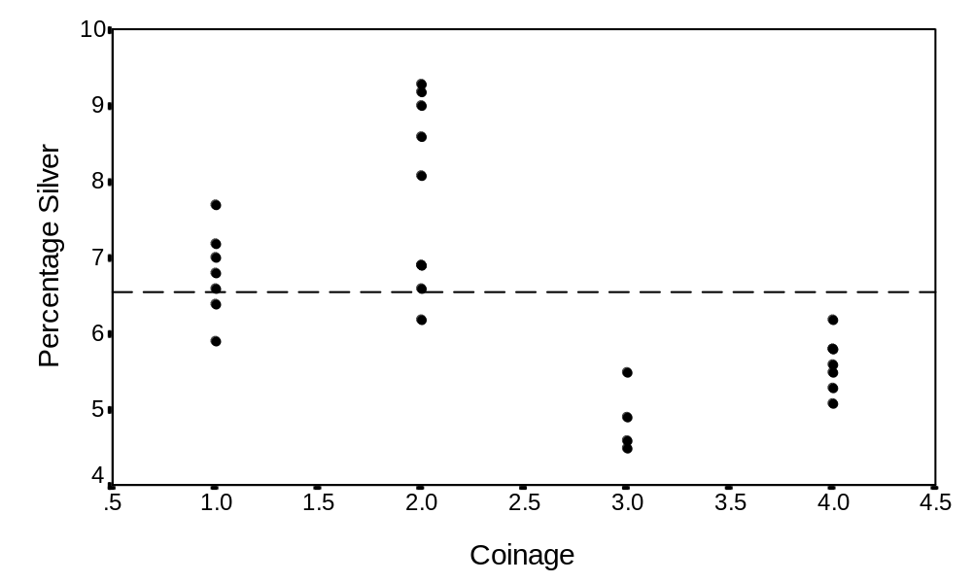
Analysis of variance is a method for dividing the variation observed in experimental data into different sources. These are classified as assignable sources of variation, which arise because of the application of different treatments to the data, and random sources of variation which remain ‘unexplained’. Distinguishing between these sources of variation is a central activity in much statistical analysis.

Three types of variation can be identified in the figure overleaf. These break-down into two assignable sources of variation (total variation and between group variation) and within group variation, or random variation.

Total variation is attributed to the deviations of all the data about the overall sample mean of the percentage silver concentration. The overall mean is calculated as

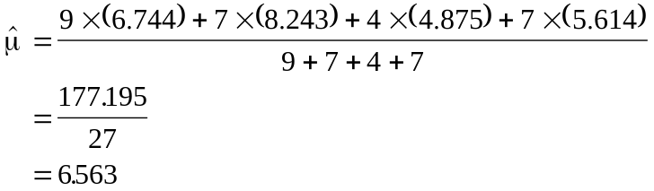

and is represented by the dashed line in figure 1. The total sum of squares (SSTO) is calculated as
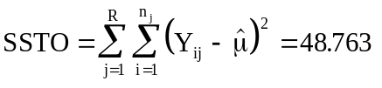

SSTO measures the sum of the squared deviations of 27 data points about one estimate, , and hence has 26 degrees of freedom associated with it. The other assignable source of variation is the treatment sum of squares. Denoted SSTR, the treatment sum of squares is constructed from the deviations of the factor level means (’s) about the overall mean, .

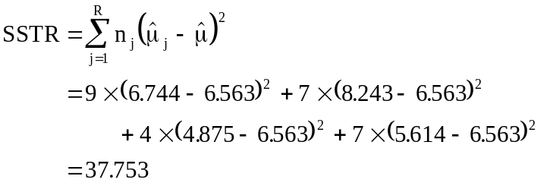

Here four group means are varying about one common mean, implying 4-1 = 3 degrees of freedom.
The within group variation is calculated from the deviations of the observations about their group means. This is also called residual variation, variation which can not be attributed to any assignable cause. The residual sum of squares is denoted SSE and may be calculated as

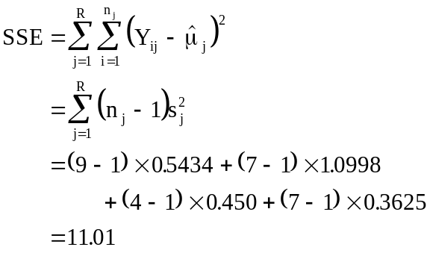

SSE measures the sum of the squared deviations of 27 data points about the four estimates of the group means, the ’s, and as a result has 23 degrees of freedom associated with it. In practice the SSE would not be calculated from the group standard deviations but would be obtained from the addition rule SSTO = SSTR + SSE.

Theoretically the mean sum of squares have the following expectations

E(MSE) = 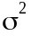
and
E(MSTR) = 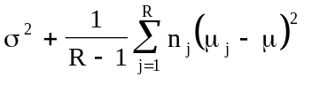.

where Yij ~ i.i.d N(μj,σ2).

Computer Output

Typically these sums of squares and associated degrees of freedom are gathered together in an ANOVA table with an F-ratio test statistic.

Analysis of Variance for percentage silver
Source | DF | Sum of Squares | Mean Square | F-ratio
Coinage | 3 | 37.753 | 12.584 | 26.3
Error | 23 | 11.010 | 0.479
Total | 26 | 48.763
Under the null hypothesis where all the factor level means are assumed equal, the within group variation should be indistinguishable from the between group variation. Under this null hypothesis E(MSE) = E(MSTR) = σ2, so that E(F* = MSTR/MSE) = 1. The ratio F* is also a random variable and follows an F-distribution on 3 df above and 23 df below. Large values of F indicate that the null hypothesis should be rejected. The 5% cut-off point from an F-distribution on 3 and 23 degrees of freedom is 3.42. As the F* = 26.3 calculated from the data exceeds the critical value we reject the null hypothesis of equal means and conclude that some treatment effect exists.

H0: MSR ≤ MSE
or
all μj‘s = μ (all αj‘s = 0, i.e. no treatment effect exists)

H1: MSR > MSE
or
at least one μj ≠ μ (at least one αj ≠ 0, treatment effect not all 0)

The question arose of whether there were significant differences in the silver content of coins minted early (first and second coinage) and late (third and fourth coinage) in Manuel’s reign. This issue can be tackled using linear contrasts, but it is necessary that contrast was suggested by archaeological belief and not by data snooping!!

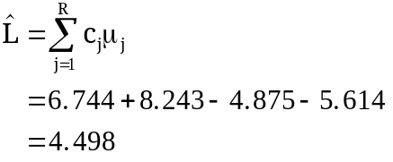

with standard error
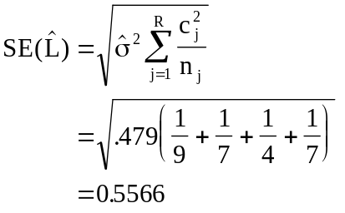

Hence, a 95% CI for this linear contrast is {3.346, 5.496}.

Q1. The data give sets of salinity values (parts per thousand) for the three separate water masses in the Bimini Lagoon, Bahamas. Several samples were drawn at each site. The output from a one-way ANOVA is also given.

I | II | III
37.54 | 40.17 | 39.04
37.01 | 40.80 | 39.21
36.71 | 39.76 | 39.05
37.03 | 39.70 | 38.24
37.32 | 40.79 | 38.53
37.01 | 40.44 | 38.71
37.03 | 39.79 | 38.89
37.70 | 39.38 | 38.66
37.36 |  | 38.51
36.75 |  | 40.08
37.45
38.85

ANOVA
Source DF SS MS F p
Factor 2 38.801 19.400 66.02 0.000
Error 27 7.934 0.294
Total 29 46.735

(i) Plot the data. Calculate the group means and overall means and indicate these on the plot.

(ii) Construct 95% confidence intervals for each group using a suitable pooled estimate of a common variance σ2. Indicate these on the plot produced in part (i). Comment.

(iii) Carry out the usual F test stating the hypothesis under consideration.

(iv) Water mass II was collected in the Northern part of the lake, while water masses I and II were collected in the southern part. Contrast the two regions.

Q2. Four students were each asked to perform three replicate titrations using the same titrimetric procedure. The end-points obtained by each student are shown in the following table. Analyse the data.

Student A B C D
25.03 24.95 25.13 25.16
Titres 25.09 24.90 25.20 25.25
(ml) 25.06 24.89 25.08 25.10

