Question 3
(a) Suppose 40% of employees in a large company favour unionisation. A poll of 10 employees in this company is taken.

(i) What is the probability that 4 or more employees polled favour unionisation?
(ii) What is the probability that less than 2 employees polled favour unionisation?
(iii) What is the probability that exactly 5 employees polled favour unionisation?
- What is the mean and variance for this distribution?

Solution

Binomial distribution with n=10 p=0.4
Using Murdoch Barnes Table 1

1) P( X ≥ 4) = 0.6177

2) P( X < 2) P( X < 2) = 1 - P( X ≥ 2)
= 1 – (0.9536)
= 0.0464

3) P(X=5) P(X=5) = P( X ≥ 5) - P( X ≥ 6)
= 0.3669 – 0.1662
= 0.2007

4) mean = np = 10×0.4 = 4 employees
Variance = np(1-p) = 10×0.4×0.6 = 2.4 employees

(c) Telephone calls coming in to a busy switchboard follow a Poisson distribution with 3 calls expected in a one minute period. The switchboard operator can answer at most 3 calls in a one minute period; the fourth and succeeding calls receive a busy signal.

- Find the probability of receiving a busy signal.
- The switchboard operator leaves the switchboard unattended for 2 minutes. What is the probability that exactly 1 call will be missed during that 2 minute period?

Solution
Poisson distribution with mean m = 3 calls per minute
Using Murdoch Barnes tables 2

- Busy signal – four or more calls in given time period

Find P( X ≥ 4) for m=3

Answer 35.28%

- Find P(X=1) for 2 minute period (m=6)
P( X=1) = P( X ≥ 1) - P( X ≥ 2)
= 0.9975 -0.9826
= 0.0149
Answer 1.49%
A Health and Safety survey of 200 industrial accidents revealed that 53
were due to untidy working conditions.

(i) Calculate a 95% confidence interval for the true proportion of industrial accidents that are due to untidy working conditions. Interpret this interval.

Solution

Quantile for 95% confidence intervals : 1.96

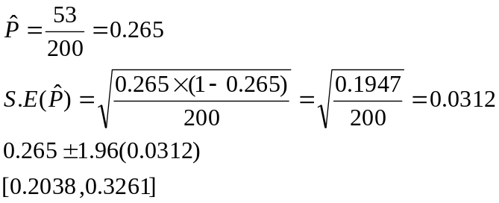

(ii) Calculate the sample size that the Health and Safety researchers should select if the proportion of industrial accidents due to unsafe working conditions is to be estimated to within plus or minus 10% with 90% confidence.

Solution
Quantile for 90% confidence intervals : 1.645
Half length = 0.1
Choose an initial value of the proportion of 0.5
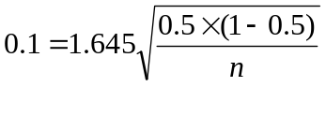
Re-arranging the above equation
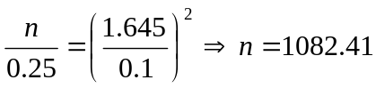

Rounding this up we get n = 1083

(iii) A factory manager claims that the above sample is just a “one off”, and that less than 20% of accidents are a result of untidy working conditions. Use the sample proportion of 53 out of 200 to test the manager’s claim at the 5% level of significance. Clearly state your null and alternative hypotheses and your conclusion
1) Hypotheses
The null hypothesis states the true percentage is less than or equal to 20%. The alternative hypothesis states that the true value may be greater than 20%.

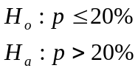

N.B. One tailed test

2) Test Statistic
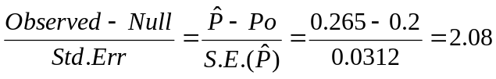

3) Critical Value

Large sample , 1 tailed test, significance 5% 1.645

4) Decision Rule

Is the absolute value of the test statistic greater than the critical value? Yes

We reject the null hypothesis. The study is conclusive in suggesting that the true accident rate due to untidy working conditions is greater than 20%.

