First year: Basic integration

- Integration: areas

The symbol
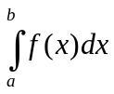
means “area of the set situated between the graph of , the axis, the line of equation and the line of equation 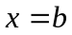”.

It’s easier to understand this notion through an example:

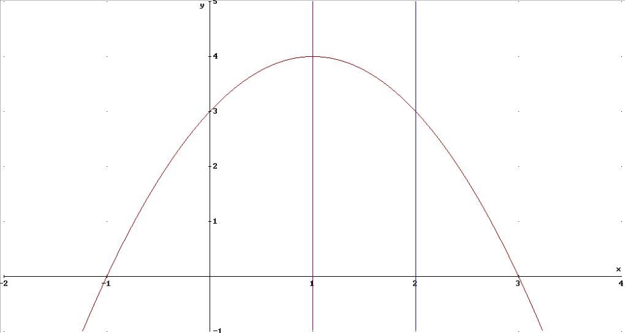

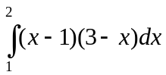 is the area of the set situated between the axis, the graph of and the vertical lines of equation 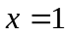, 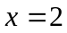.

- Basic Rules

Integration is, intuitively, the opposite of differentiation. Mathematically, we say that if there exists a function  such that

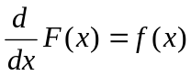 then 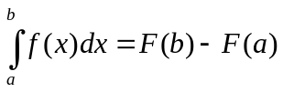.

The result above is sometimes called the fundamental theorem of calculus.

When you are asked to integrate a function , the trick is to find this function .

If such a function exist, then instead of saying “a function such that ”, we usually say

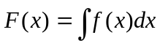

Let’s have a look at an example:

Calculate: 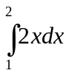.

The first step is to find 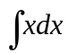.
We know that the derivative of 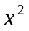 is 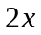, so that we have 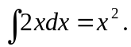
It remains now to calculate the actual value of the integral:

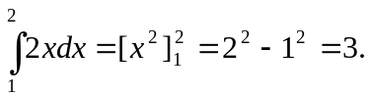

So far so good? Now try to calculate the following integral:

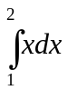.

Here are a few examples:

- 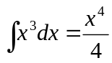
- 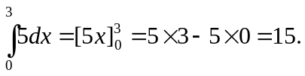
- 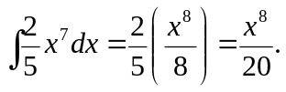

The general rule is

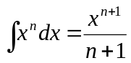.

- Exercises

Find the following integrals:

- 

 