Question A
An analyst of the retail trade uses as analytical tools the concepts of ‘Footfall’ (the daily number of customers per unit sales area of a shop) and ‘Ticket Price’ (the average sale price of an item in the shop’s offer).

Shops are classified as offering Low, Medium or High price items and, during any sales period, as having Low, Medium or High footfall.

During the January Sales the analyst studies a sample of shops and obtains the
following frequency data for the nine possible combined classifications:

 | Low Price | Medium Price | High Price
Low Footfall | 45 | 75 | 23
Medium Footfall | 37 | 126 | 25
High Footfall | 22 | 43 | 16

• Construct the percentage table normalized along columns (i.e. use percentages within each column with respect to their totals).
• Conduct a suitable test for association between Ticket classification and Footfall level
• Formulate the conclusion of your test.

Question B
The table below shows the relationship between gender and party identification in
a US state.

 | Democrat | Independent | Republican | Total
Male | 279 | 73 | 225 | 577
Female | 165 | 47 | 191 | 403
Total | 444 | 120 | 416 | 980

Test for association between gender and party affiliation at two appropriate levels
and comment on your results.

• Construct the percentage table normalized along columns (i.e. use percentages within each column with respect to their totals).
• Conduct a suitable test for association gender and party affiliation
• Formulate the conclusion of your test.

Question C
• Construct the percentage table normalized along columns (i.e. use percentages within each column with respect to their totals).
• Conduct a suitable test for association social class and atiitudes to the proposal
• Formulate the conclusion of your test.

Question D

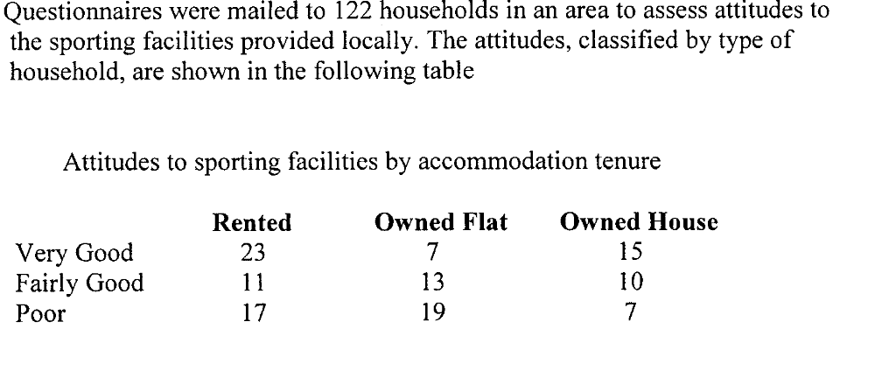
Test for association between gender and party affiliation at two appropriate levels
and comment on your results.

Question E
