**Case 1: No Bias**

|  |
| --- |
| > mean(dat.new[,1])  [1] 102.0944  > sd(dat.new[,1])  [1] 10.1025  >  > mean(dat.std[,1])  [1] 98.30283  > sd(dat.std[,1])  [1] 7.577236 |

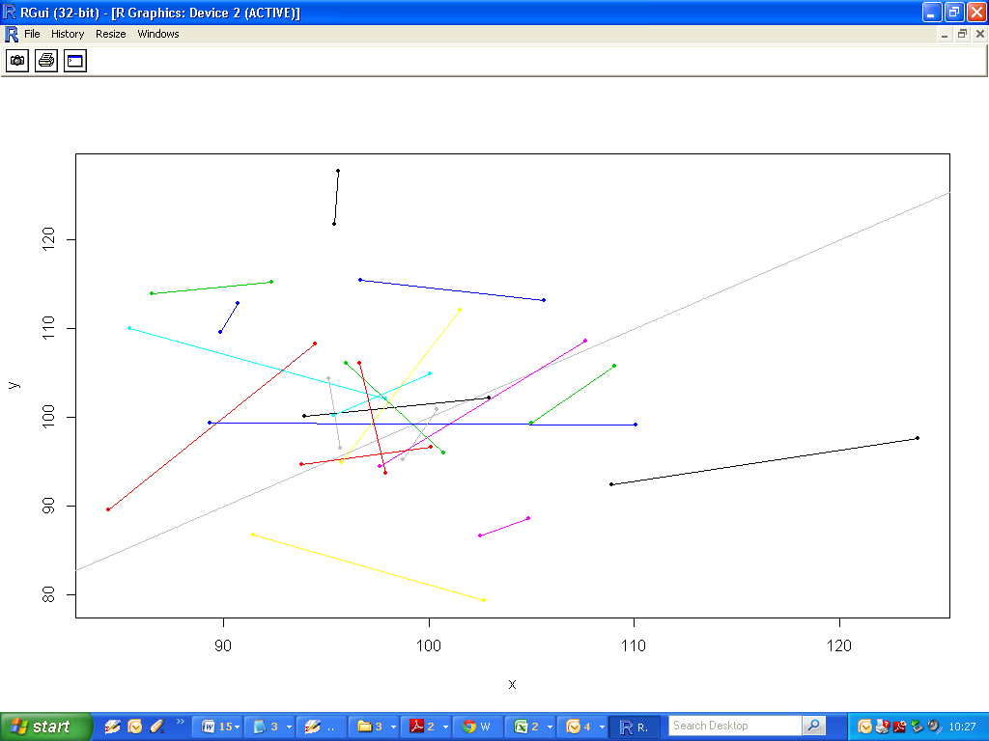

**Case 2**

|  |
| --- |
| > mean(dat2.new[,1])  [1] 111.0445  > mean(dat2.std[,1])  [1] 101.0908  >  > sd(dat2.new[,1])  [1] 12.32461  > sd(dat2.std[,1])  [1] 8.301212 |

