**Part 1 - Normal Probability**

1. The gestation period is approximately normally distributed with a mean of 275 days and a standard deviation of 4.5 days.

Estimate the probability that the gestation period is

1. greater than 280 days
2. less than 265 days
3. between 272 and 282 days.
4. What gestation period is surpassed by 2.5% of the population?
5. The length of the jump of an athlete has a normal distribution with mean 7m and standard deviation 0.1m.

Calculate the probability that he jumps

1. at least 7.15m
2. between 6.9 and 7.05m
3. Find the probability that if he jumps 3 times all the jumps will be less than 7.15m (assume the lengths of the jumps are independent and use the answer to part i).
4. A blood factor measurement is defined to have a normal distribution with mean 100 and standard deviation 15.

Calculate the probability that a person’s blood factor is

i) greater than 130

ii) less than 110

iii) between 82 and 120

Also, calculate the blood factor leve that is exceeded by 15% of the population.

Question 4 ( old exam question )

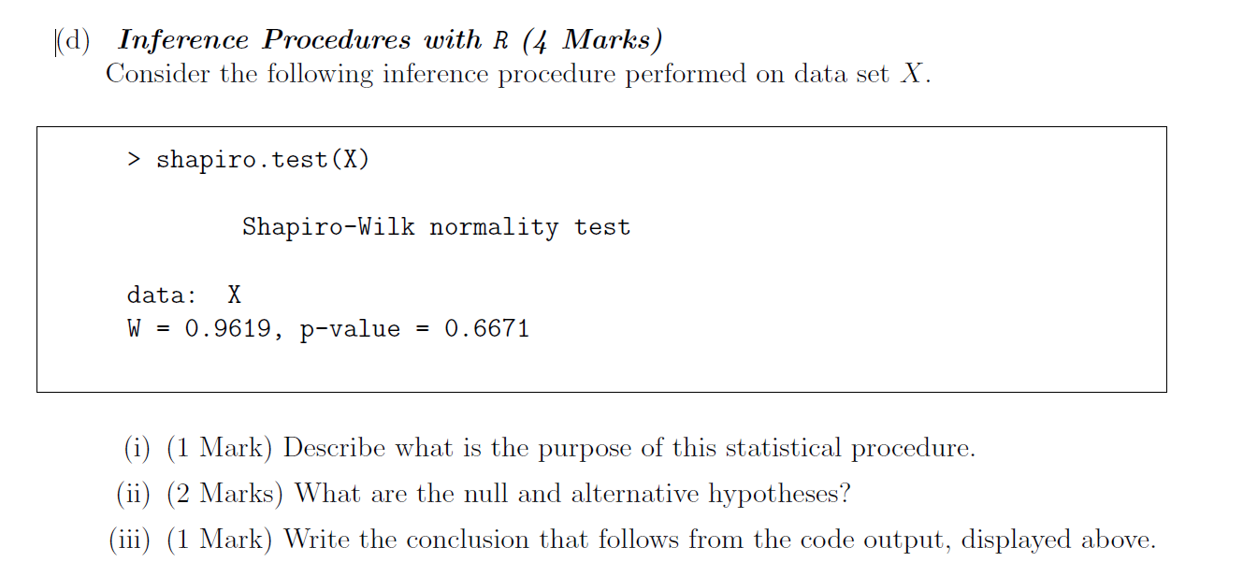

Question 5 ( old exam question )

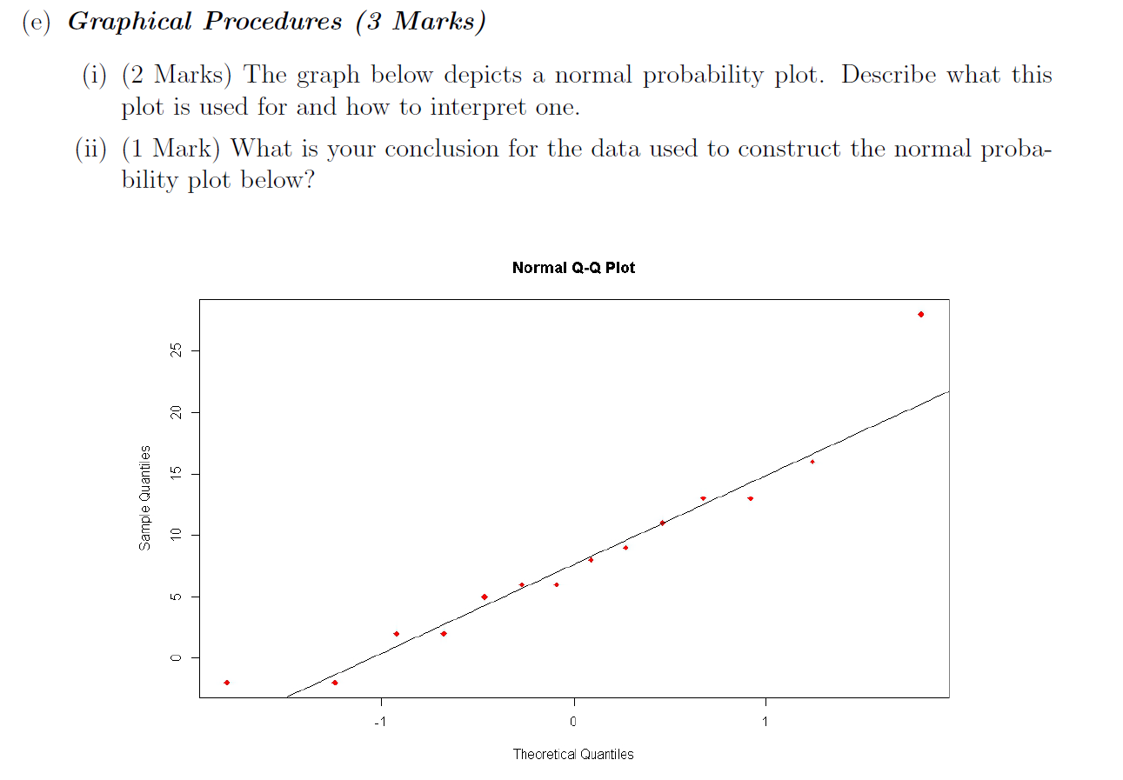

Question 6 ( Grubbs’ Test )

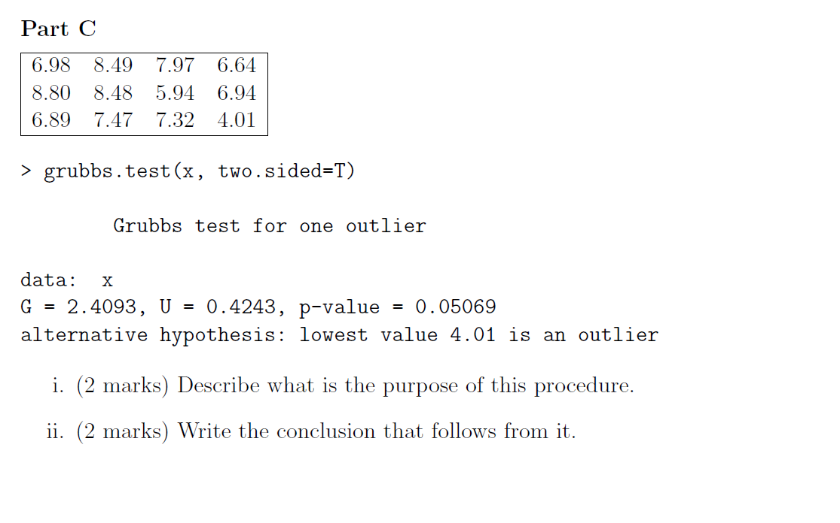

Question 7 ( Outlier Testing Procedures )

1. For the data set in question 6, Compute the test statistic for the Dixon Q’ Test.
2. There are three variants of the Grubbs Test. Provide a brief description for all three.
3. What are the required assumptions for the Grubb’s Test and the Dixon Test, if any?

Question 8 - Transforming Data

What is the purpose of the following Analysis?

|  |
| --- |
| > Y  [1] 307.92 235.61 198.95 63.46 253.24 175.82  [7] 1595.03 81.57 354.25 102.88 316.36 169.86  [13] 219.99 200.69 1216.13 1018.16 84.93 382.34  [19] 56.15 5224.33  >  >  >  > **shapiro.test(Y)**  Shapiro-Wilk normality test  data: Y  W = 0.4831, p-value = 2.244e-07  >  >  > **shapiro.test(log(Y))**  Shapiro-Wilk normality test  data: log(Y)  W = 0.9226, p-value = 0.1113  > |