**Working with Nihongo Dera** ! First, select a japanese text

Go to <https://nihongodera.com/tools/text-analyzer>

Paste your text, and click Analyze,

Include in results: Word only

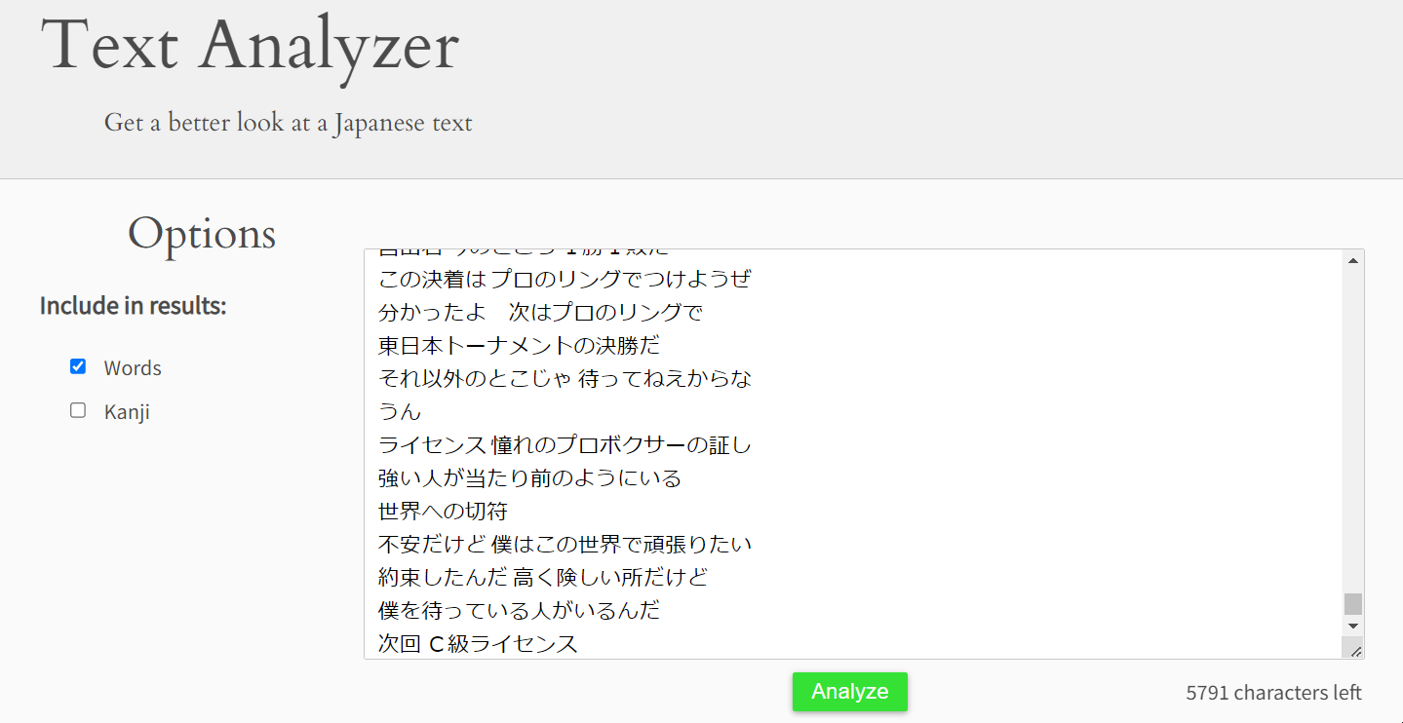

Then Scroll down the Analyzer Results and copy only what’s below the “Words” section

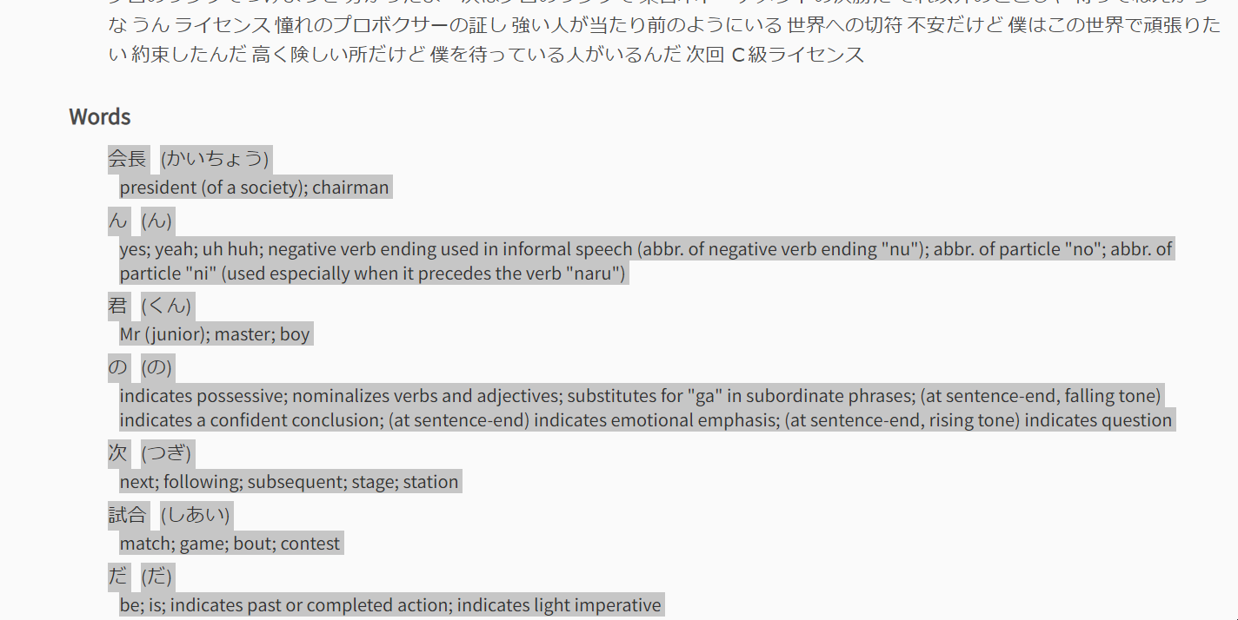

Then go to the Excel worksheet provided and press “Ctrl-N”! Ready!

If you see a word you already know, press Ctrl-D on that word, and the word will go from the “Words” sheet to the “Known” sheet.

**Excel sheets**

**Words sheet:**

Adding words from NihongoDera and using a frequency list to add frequency to each word

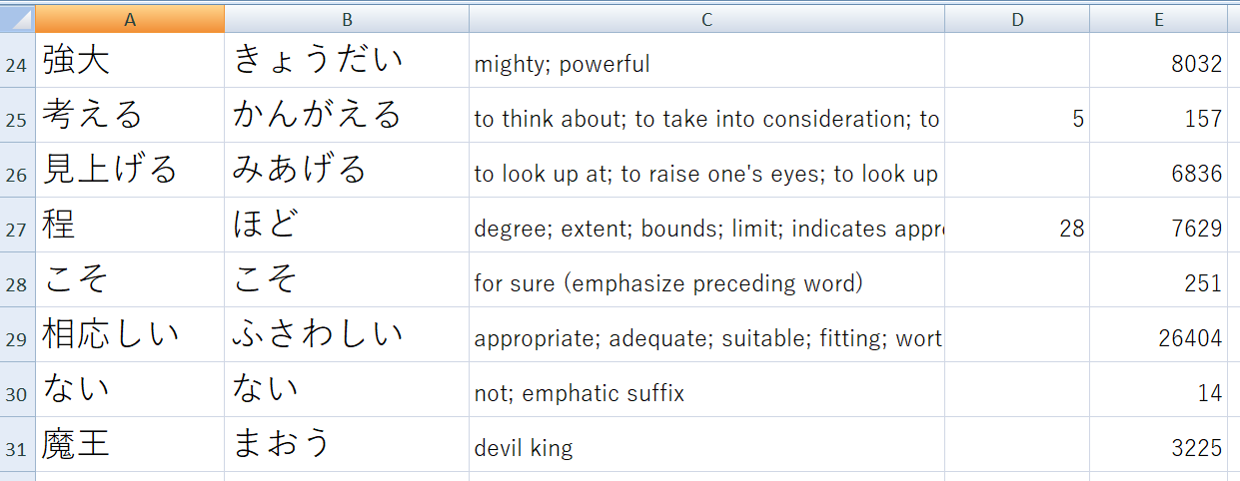

Column D is the Wanikani Level (if the word exits) and column E is the frequency of the word.

**Known: Sheet**

Words you’ve sent from the Words sheet and that you already know

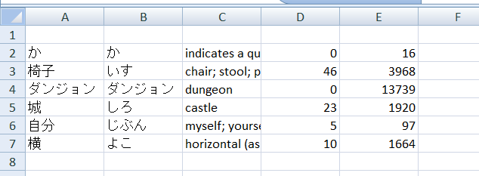

Tips and tricks

Don’t forget you can already go to the Wanikani tab and import words you already know

Simply copy/paste the rows into the Known tab.

To get you started

Select the Known sheet and delete everything

Put just the words you already know into it.

Next go the Unknown sheet, paste from NihongoDera website using the specific macro (default: Ctrl-N) and you’re ready to go. You’ll only see what you don’t know.

If you know a word in that list, use the other Macro (default Ctrl-D) and the word will be moved from the Unknown to the Known sheet. Happy Word – Hunting!