Kevin Kelly

CIT 230:12

Website Planning Document

Site Name

Local Climate Channel

Purpose of the Site

Weather, community events, sharing of local new stories and local hero’s.

Target Audience

Everyone from 8 to 100 would want to use this site.

1. Parents of children would like to know what to dress their children in that day for school.
2. What the weather will be like at the local community concert.
3. The elderly would like to know if the weather is good for a stroll to the community senior center.
4. The family would like to know if the local baseball game will be rained out or not.
5. The kids would like to know if it is a good day for the pool or building a snowman.

Site Map

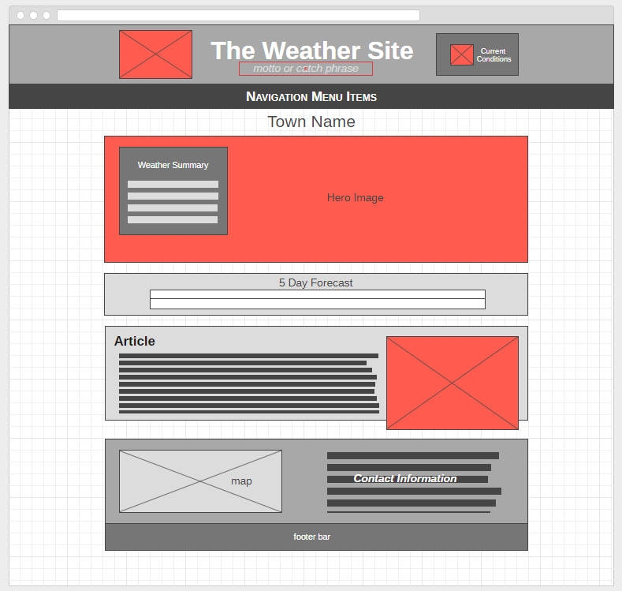

Color scheme

Light Yellows and Oranges to give it a bright happy feel to the site.

Typography selections

*Cardo*, for the main body of the document and *Frank Ruhl Libre* for the Titles and menu items. I like the feel of these fonts. They seemed to jump out at me.