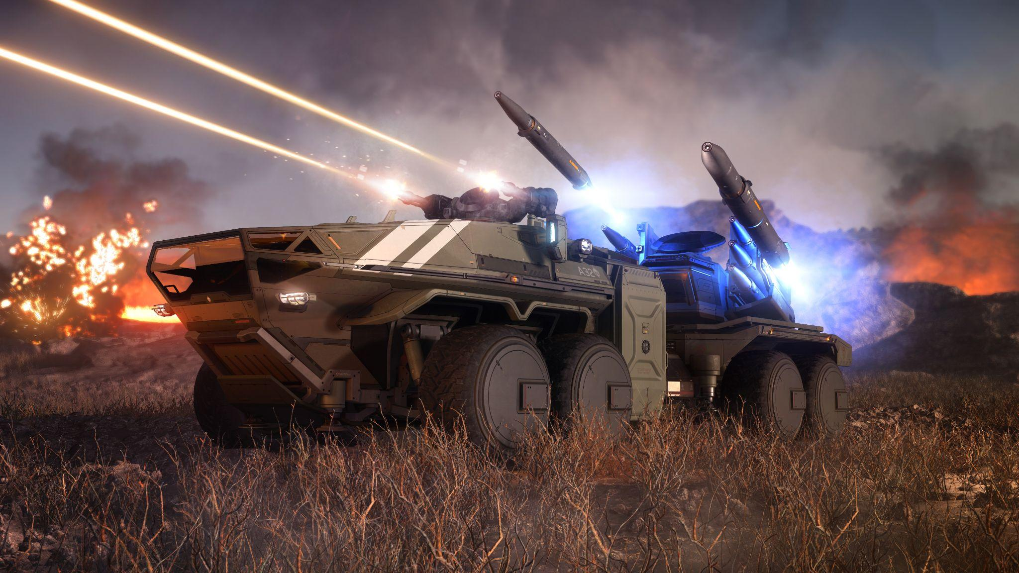

**Ballista SOP**

# **Overview**

This document will cover the Standard Operating Procedures (SOP) for the use of Ballistas within the Skunkworks Rhino Corps. This is a living document and will be updated as Star Citizen and Skunkworks continue to develop.

# **Table of Contents**

1. **Communications Protocol**
   1. SRS
   2. Contacts Sighted
   3. Support
2. **Insertion Procedures**
   1. Loading
   2. Unloading
   3. Positioning
3. **Combat Tactics**
   1. Standard Configuration
   2. Targeting
   3. Firing
4. **Important Statistics**

# **Communication Protocol**

1. Multi-Crew Ballista Drivers / Torpers
   1. Torper is the vehicle commander and is usually the most experience of the 2 and will give directions to the driver
   2. Driver should focus on driving/positioning and looking for ground threats
2. SRS.
   1. It is expected of all Rhino leaders to be in and listening to SRS channels during Operations (OPS)
   2. All other members would benefit from being in designated SRS channels as well, however it is not required.
   3. During OPS where SRS is being used, if you hear comms being transmitted you will stop all non mission critical discussions to ensure the information over radio is delivered successfully
3. Contacts sighted.
   1. When relaying contact information you will utilize the “3D’s”
      1. Description
         1. Name of player or ship/vehicle/Infantry
            1. Use brevity codes
      2. Direction
         1. Bearing if ballista has been zero’d, meaning it is facing North
         2. Clock direction/position from a select locations, this may have been decided before the OP has began
      3. Distance
         1. Approximate distance from you or POI you reference
            1. Best estimate if not displayed
4. Support
   1. Calling for support from other ballistas should be done whenever you are being attacked by hostile air or ground troops and should be relayed by your leader if it cannot be handled within your Rhino group
5. Common Brevity codes.
   1. Unidentified Vehicle = Vic
   2. Enemy ground troops = Packs.
   3. Unidentified Ships (Blue engine glow in the distance) = Blueberry(s)
   4. Position at an angle = Nose up/down

# **Insertion Procedures**

1. Loading.
   1. All Atlas frames currently fit in these ships and this amount per ship safely
      1. C2 x2
      2. M2 x2
      3. A2 x1
      4. 890J x1
   2. ballistas should always be done ahead of time in preparation for any OPS when possible.
   3. Hot drops should have all vehicles parked facing the rear of the ship
2. Unloading.
   1. Standard landing and deployment
   2. Hot Dropping
      1. Max speed 300m/s
      2. De-coupled with landing gear down
      3. Drive forwards out of the rear of the ship.
      4. No recorded limit on altitude
   3. Emergency drops
      1. Emergency drop only when it is necessary to ensure as many Skunks survive as possible to reach the AO (Area of Operation)
      2. All vehicles will roll out of the dropship as quickly and safely as possible upon hearing the call for emergency drop.
      3. This should only be called when 100% necessary as it can cause issues that may lead to Rhinos being to far from the AO or lead to deaths of other members.
3. Positioning
   1. When setting up ballistas defensively
      1. Have raptor or raven help point you towards due north (Zero)
      2. If possible position the ballista in a cardinal direction of POI i.e Jumptown.
      3. Look for medium sized rocks to park near for concealment
      4. Try to find dark/black spots in the terrain to hide wheels being seen in the distance
      5. Park approximately 1000m from other friendly ballistasso you are able to cover one another while being safe from being taken out in one A2 bomb or being spotted due to the others person being engaged.
      6. Shoot and move whenever possible as the ballista missiles are extremely easy to track back to a start position
      7. Try to position ballista at an angle to reduce blindspot above you
   2. When using Ballistas offensively
      1. Coordinate with other assets on movement
      2. Try to stay behind the front line unless baiting
      3. When baiting get friendly assets to pass close to your ballista

# **Combat Tactics**

1. Standard Configuration
   1. Replace driver weapons to laser repeaters (Badgers)
   2. Put full power to shields if driver weapons are not in use or if operating solo
2. Pinging
   1. Actively ping every few seconds and keep scanning the air for targets.
3. Targeting
   1. When to lock
      1. If hostiles are low to the ground lock them to try and bait them into wasting their flairs
      2. Try not to hold locks on for too long unless you plan on firing at the target.
   2. Coordinate target priorities to ensure HVT (high value targets) are removed first
      1. Air assets should inform us on HVT
4. Firing
   1. Locked on firing
      1. Max firing distance should be no greater than 3km, unless it would be too risky to not fire sooner i.e A2 inbound
      2. Optimal firing distance is <2km to have a higher chance of connecting with the target.
      3. Try to only fire at targets during the approach.
      4. Alway try to fully lock on before firing unless the target is extremely close and you’re at risk.
   2. Dumb firing
      1. Dumb firing should be done when the operator finds it necessary to do so
      2. Should only be done on slow moving or stationary targets
   3. Driver
      1. Should focus on ground primarily
      2. Recommend setting up 3rd person to be zoomed out and raised slightly
      3. I would also recommend that the driver stays in 3rd person most of the time unless told to do otherwise as it can be impossible to spot railgun fire impacting the Ballista

# **Important Statistics**

1. Ballista
   1. 6k-10k Main battery turret HP
      1. Approximately 3 seconds of sustained Inferno fire or 1 S3 missile to render ballista combat ineffective
   2. Speed is 25m/s
   3. Radar detection range with full power to shields is approximately 450m
2. S5 Torpedo
   1. Speed: 750m/s
   2. Range: 50-15000m
   3. Damage: 16383
   4. Explosion Radius: 10.13m
3. S7 Torpedo
   1. Speed: 650m/s
   2. Range: 50-30000m
   3. Damage: 94562
   4. Explosion Radius: 15.75m
4. Secondary Guns (Badger)
   1. Projectile Speed: 1400m/s
   2. Range: 1540m
   3. DPS: 400
   4. Fire Rate: 600rpm

# 

-Have everyone set spawn on a Carrack.

-Go to “ArcCorp Mining 157” on Yela.

-Have TA pull out Balistas.

-Have OPFOR fly to a point 5km away, SE mountains.

-Rhinos drive out.

-Rhinos then swap pilots and drive another 5km to my position, which will be another 5km in the opposite direction of the facility.

- Have them hide. Raptors then come over and search for them.

- They do this until all are found or until it’s been 10 minutes.

-Then do the same but they can engage.

-Take a group photo.