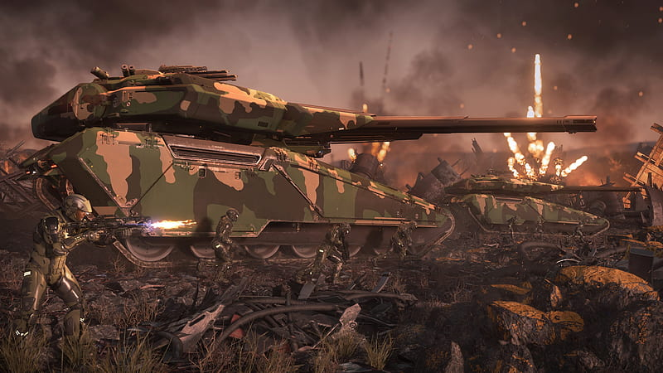**Nova Tank SOP**

# **Overview**

This document will cover the Standard Operating Procedures (SOP) for the use of Nova Tanks within the Skunkworks Rhino Corps. This is a living document and will be updated as Star Citizen and Skunkworks continue to develop.

# **Table of Contents**

1. **Communications Protocol**
   1. SRS
   2. Contacts Sighted
   3. Support
2. **Insertion Procedures**
   1. Loading
   2. Unloading
   3. Positioning
3. **Combat Tactics**
   1. Standard Configuration
   2. Targeting
   3. Firing
4. **Important Statistics**

# **Communication Protocol**

1. Multi-Crew Nova Drivers / Co-Pilots / Cannon Operator
   1. The cannon Operator is the vehicle commander if you have a full crew and is usually the most experienced of the 3 and will give directions to the driver. If the Nova is only manned by 2 people the commander will both drive and operate the Cannon.
   2. Driver should focus on driving/positioning and the co-pilot/commander will be looking for ground threats (3 man).
2. SRS.
   1. It is expected of all Rhino leaders to be in and listening to SRS channels during Operations (OPS)
   2. All other members would benefit from being in designated SRS channels as well, however it is not required.
   3. During OPS where SRS is being used, if you hear comms being transmitted you will stop all non mission critical discussions to ensure the information over radio is delivered successfully.
3. Contacts sighted.
   1. When relaying contact information you will utilize the “3D’s”
      1. Description
         1. Name of player or ship/vehicle/Infantry
            1. Use brevity codes
      2. Direction
         1. Bearing if Nova has been zero’d, meaning it is facing North
         2. Clock direction/position from a select locations, this may have been decided before the OP has began
      3. Distance
         1. Approximate distance from you or POI you reference
            1. Best estimate if not displayed
4. Support
   1. Calling for support from other Nova’s should be done whenever you are being attacked by hostile air or ground troops and should be relayed by your leader if it cannot be handled within your Rhino group.
5. Common Brevity codes.
   1. Unidentified Vehicle = Vic
   2. Enemy ground troops = Packs.
   3. Unidentified Ships (Blue engine glow in the distance) = Blueberry(s)
   4. Position on a flat surface.

# **Insertion Procedures**

1. Loading.
   1. Crawler tracks currently fit in these ships and this amount per ship safely
      1. C2 x2
      2. M2 x2
      3. A2 x1
      4. 890J x1
   2. Nova’s should always be done ahead of time in preparation for any OPS when possible.
2. Unloading.
   1. Standard landing and deployment
   2. Emergency drops
      1. Emergency drop only when it is necessary to ensure as many Skunks survive as possible to reach the AO (Area of Operation)
      2. All vehicles will roll out of the dropship as quickly and safely as possible upon hearing the call for emergency drop.
      3. This should only be called when 100% necessary as it can cause issues that may lead to Rhinos being too far from the AO or lead to deaths of other members.
3. Positioning
   1. When setting up Nova’s defensively
      1. Have raptor or raven help point you towards due north (Zero)
      2. If possible position the Nova in a cardinal direction of POI i.e Jumptown.
      3. Look for medium sized rocks to park near for concealment
      4. Park approximately 1000m from other friendly Nova’s you are able to cover one another while being safe from being taken out in one A2 bomb or being spotted due to the other person being engaged.
      5. Shoot and move whenever possible as the Nova can be easy to spot on the ground.
      6. Try to position Nova’s on flat surfaces as they tend to roll or move when firing the cannon. You can not park on a slope due to the Nova rolling.
   2. When using Nova’s offensively
      1. Coordinate with other assets on movement
      2. You will be on the front line offering protection for ground assets. Coordinate with ground assets and call out/engage opposing forces.
      3. When baiting, get friendly assets to watch around your Nova for opposing fire and location.

# **Combat Tactics**

1. Standard Configuration
   1. (Optional) replace missiles to Rattler II’s
2. Pinging
   1. Actively ping every few seconds and keep scanning the ground for targets.
3. Targeting
   1. When to lock
      1. If hostiles are seen on the ground in opposing vehicles you can lock them at less than 1.5m and engage. Currently there is no splash damage with the cannon. Be sure to call out opposing forces to ground troops when seen.
      2. Try not to hold locks on for too long unless you plan on firing at the target.
   2. Coordinate target priorities to ensure HVT (high value targets) are removed first
      1. Ground assets should inform us on HVT
4. Firing
   1. Locked on firing
      1. Max firing distance should be no greater than 1.5m, unless it would be too risky to not fire sooner i.e opposing tonks/ballistas, or if ground assets are taking heavy fire.
      2. Optimal firing distance is <1.5km to have a higher chance of connecting with the target.
      3. Try to only fire at targets directly due to no splash damage.
   2. Co-Pilot
      1. Should focus on the ground primarily.
      2. Recommend setting up 3rd person to be zoomed out and raised slightly.
      3. I would also recommend that the co-pilot stays in 3rd person most of the time unless told to do otherwise as it can be impossible to spot railgun fire impacting the Nova.

# **Important Statistics**

1. Nova
   1. 40k Body HP
      1. Approximately how much damage does it take to make it inoperable?
   2. Speed is about 30m/s
   3. Radar detection range with full power to shields is approximately 1200m
2. Slayer Cannon
   1. Range: 50-1500m
   2. Damage: 3700 sustained dps
3. Rattler II
   1. Speed: 1300m/s
   2. Range: 1000-10000m
   3. Damage: 1970
4. Secondary Guns (Badger)
   1. Projectile Speed: 1400m/s
   2. Range: 1540m
   3. DPS: 400
   4. Fire Rate: 600rpm

# 

-Have everyone set spawn on a Carrack.

-Go to “Shubin Mining Facility-SCD1” on Daymar.

- Instructor pull out a cyclone.

-Have TA and OPFOR pull out Nova’s.

-Have OPFOR position Nova’s and other ground vehicles in rock valley over hills to the left of the ground vehicle pads out of armistice zone. .

-Rhinos drive out through the valley to a designated point. The instructor will drive out first to the said point in the Cyclone.

-Rhinos then swap pilots and drive back to the instructor's position. Which will be back to the starting position.

- Have Rhinos practice shooting the cannon at stationary targets set up by the OPFOR.

- For the final round once all stationary targets have been shot by both Rhinos. Have the OPFOR man Nova Tanks and simulate live fire scenarios in the valley against opposing OPFOR.

-Take a group photo.