## horizontal line

Plog app.

V.01

**─**

Dragons

**G3_Team.**

**Let’s take a tour…**

# Outline…

**I. Introduction**

Overview of the Blog Application

Purpose and target audience

**II. Installation and Setup**

Prerequisites

Installation instructions

**III. Database Schema**

Models (BlogPost and Comment)

CRUD operations for models

Database migrations

**IV. Authentication and Authorization**

Authentication levels (Admin, Writer, Viewer)

Permissions for each level

**V. Frontend Development**

Bootstrap integration

Styling the application

**VI. Views and Templates**

Explanation of views (create, publish, view, comment)

Template structure

**VII. Development and Testing**

Developing views and functionality

Unit testing and functional testing

**VIII. Admin Interface**

Managing user groups

Content management using the admin interface

**IX. Bug Fixes and Best Practices**

Documenting and addressing bugs

Documentation best practices

**X. Sprint Review Meetings**

Purpose and conduct of review meetings

Feedback and decisions.

# 1. Introduction

# Project Overview…

# The Simple Blog Application is a web-based platform designed to allow users to create, publish, view, and comment on blog posts. This documentation provides comprehensive guidance on how to set up, use, and maintain the application. It also covers the implementation of authentication levels (viewer, writer, and admin).

# Purpose…

"The primary purpose of this documentation is to guide students and learners through the understanding, creation, and utilization of the Simple Blog Application. It serves as a structured learning resource, assisting students in comprehending the software's key concepts, features, and implementation. This document is designed to facilitate a step-by-step journey, ensuring clarity and accessibility in every aspect of the project. It aligns with educational goals by encouraging hands-on learning, promoting good documentation practices, and fostering collaboration among learners. Through straightforward language and illustrative visuals.”

# Scope…

1. **Models and CRUD Operations:**
   1. An introduction to the two core models, BlogPost, and Comment.
   2. Step-by-step instructions for implementing Create, Read, Update, and Delete (CRUD) operations for both models, making it suitable for students
2. **Authentication and Authorization:**
   1. Explanation of the authentication system, including three authorization levels (Admin, Writer, Viewer), designed to teach students about access control.
   2. Permissions management, including:
      1. Viewer Level:
         1. Reading blog posts.
         2. Reading comments.
      2. Writer Level:
         1. Creating, reading, updating, and deleting their own posts.
         2. Creating and reading comments on any post.
      3. Admin Level:
         1. Accessing the Admin Panel.
         2. Viewing, modifying, adding blog posts or comments.
         3. Accessing user profiles and adding new Writers or Admins.
3. **Frontend Development with Bootstrap:**
4. **Development and Testing:**
5. **Project Review Meeting:**

This scope is designed to provide students with a hands-on educational journey, allowing them to learn essential concepts of web development, authentication, authorization, and frontend design while building a functional Simple Blog Application.

**Getting Started…**

First, determine the basic info about the model and users in this mind map…

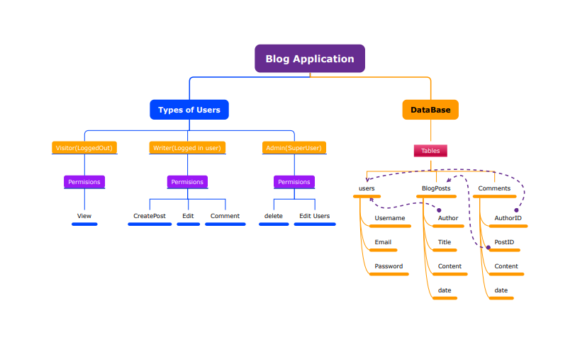

**Installation and Setup**

Prerequisites

Before you begin, ensure you have the following installed:

Python

Django

Virtual Environment

**Installation**

To set up the project, follow these steps:

**Clone the project from the repository.**

**Create a virtual environment.**

**Install project dependencies.**

**Configure database settings.**

**Apply database migrations.**

**Project Structure**

**The project follows this directory structure:**

blog_project/

├── blog_app/

│ ├── migrations/

│ ├── templates/

│ ├── views.py

│ ├── models.py

│ └── ...

├── blog_project/

│ ├── settings.py

│ ├── urls.py

│ └── ...

└── ...

**Database Schema**

**Models**

BlogPost Model

title: CharField - Title of the blog post.

content: TextField - Content of the blog post.

pub_date: DateTimeField - Publication date.

author: ForeignKey to User model - Author of the post.

Comment Model

text: TextField - Text of the comment.

post: ForeignKey to BlogPost model - The post to which the comment is associated.

author: ForeignKey to User model - Author of the comment.

**Views and Templates**

**Views**

Create View

The create view allows users to create new blog posts.

* URL: /create/
* Authentication: Writer or Admin

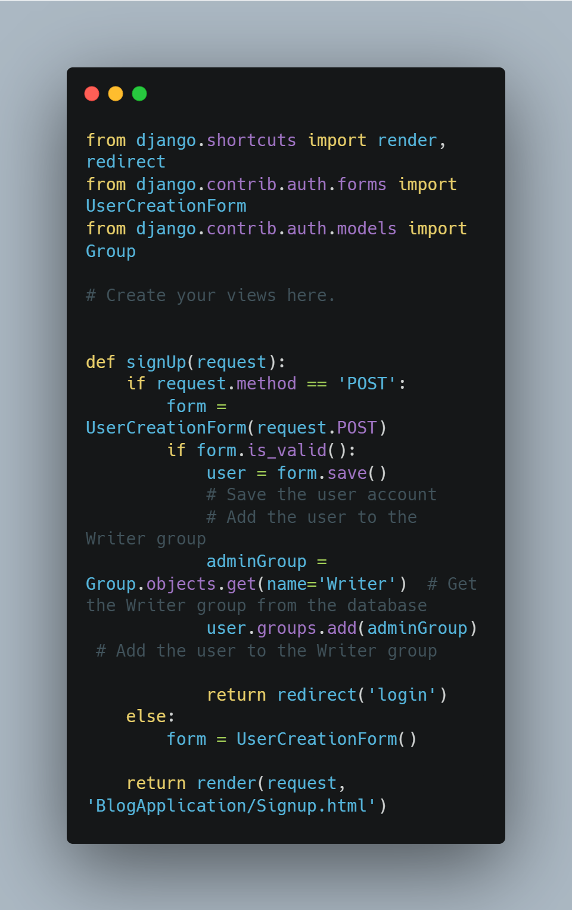

Publish View

The publish view allows authors to publish their draft posts.

* URL: /publish/<post_id>/
* Authentication: Writer or Admin

View Post View

The view post view displays an individual blog post and its comments.

* URL: /post/<post_id>/
* Authentication: Viewer, Writer, or Admin

Comment View

The comment view allows users to add comments to a blog post.

* URL: /comment/<post_id>/
* Authentication: Viewer, Writer, or Admin

Templates

* blog_post_list.html: Template for displaying a list of blog posts.
* blog_post_detail.html: Template for displaying an individual blog post and its comments.

Here is a the HTML for the home page.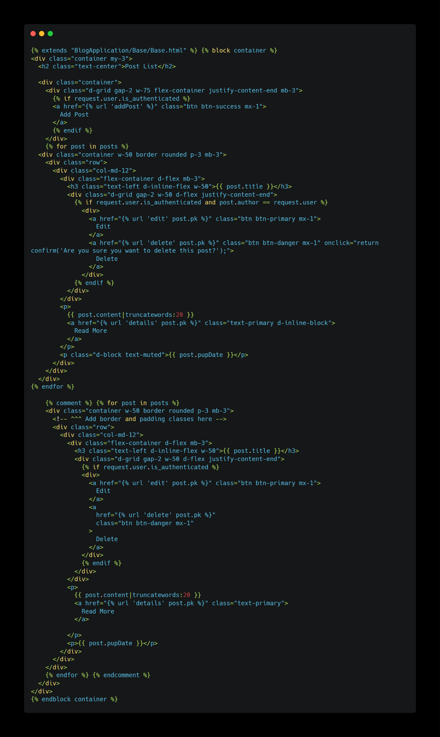

**Authentication and Authorization**

**User Groups.**

Viewer:

Permissions: Read-only access to blog posts and comments.

Writer:

Permissions: Create, edit, and publish blog posts. Comment on blog posts.

Admin:

Permissions: Full control over blog posts, comments, and user management.

**User Profiles**

The user profile model includes a field for the user's auth group

(viewer, writer, or admin).

**Access Control**

Authorization checks are implemented in views using decorators and middleware.

**Development and Testing**

**Developing Views**

* Views are developed following Django's class-based views pattern.
* Authentication and authorization checks are integrated into views using built-in decorators.

**Unit Testing**

* Unit tests are written using Django's testing framework (TestCase class).
* Example unit test cases for views, models, and forms.

**Functional Testing**

* Functional tests ensure the application works as expected.
* Test cases for user authentication, authorization, and sorting of blog posts.

**Admin Interface**

**Managing Groups and Users**

* Create and manage user groups (viewer, writer, admin).
* Assign groups to user accounts.

**Managing Blog Content**

* Use the Django admin interface to manage blog posts and comments.
* Create, edit, and delete blog posts and comments.
* Assign authors and publication dates.

**Bug Fixes**

**All details in GitHub repo…**

Please check it…

<https://github.com/DragonsEG/Blog_App_G3_Team>

**Documentation Best Practices**

Effective documentation is crucial for understanding and maintaining the Simple Blog Application. Here are some best practices to ensure that the documentation is clear, useful, and well-structured:

**Use Clear and Concise Language:**

Write in a straightforward manner, avoiding unnecessary technical jargon.

**Include Visuals:**

Enhance the documentation with visuals such as screenshots and diagrams.

**Edit:**

Carefully review the documentation to eliminate errors, typographical mistakes, and inconsistencies. Ensure that the content flows logically and is easy to follow.

**Review Meeting**

Sprint review meetings play a vital role in assessing the project's progress and ensuring alignment with goals.

**Feedback and Decisions**

The review meeting also serves as an opportunity to collect feedback From team members. It is a collaborative space where discussions may lead to decisions such as adjusting project priorities.

**Conclusion**

In conclusion, this documentation has provided a comprehensive overview of the Simple Blog Application, covering various aspects of its development and usage. Key points covered include:

* Our start and setup instructions.
* Database schema and CRUD operations.
* Authentication and authorization levels.
* Frontend development using Bootstrap.
* Views, templates, and testing procedures.
* Admin interface usage.
* Bug fixes and documentation best practices.
* The purpose and content of review meetings.

**Appendix**

The appendix section includes additional resources and links to further enhance understanding and support the use of the Simple Blog Application.

**Links:**

**Auth**

[**https://youtube.com/playlist?list=PLLxk3TkuAYnryu1lEcFaBr358IynT7l7H&si=tpVHHFx9FNeE3zaY**](https://youtube.com/playlist?list=PLLxk3TkuAYnryu1lEcFaBr358IynT7l7H&si=tpVHHFx9FNeE3zaY)

[**https://youtu.be/yqWaa5yegmI?si=FXhXtOqgwaNrTpLe**](https://youtu.be/yqWaa5yegmI?si=FXhXtOqgwaNrTpLe)

[**https://www.youtube.com/watch?v=5ZoGy46kHMw&ab_channel=ProgrammingSecrets-Tips%26Tricks**](https://www.youtube.com/watch?v=5ZoGy46kHMw&ab_channel=ProgrammingSecrets-Tips%26Tricks)

**Django unit testing**

[**https://www.youtube.com/playlist?list=PLbpAWbHbi5rMF2j5n6imm0enrSD9eQUaM**](https://www.youtube.com/playlist?list=PLbpAWbHbi5rMF2j5n6imm0enrSD9eQUaM)

**Agile**

[**https://youtube.com/playlist?list=PLcdCk5ljWQ-p3t9E_vPcGzZMGLoAeRUO5&si=Ro2rZm5NHOS-L35G**](https://youtube.com/playlist?list=PLcdCk5ljWQ-p3t9E_vPcGzZMGLoAeRUO5&si=Ro2rZm5NHOS-L35G)

**Permissions**

[**https://youtu.be/eBsc65jTKvw?si=vwA83C7ZpgM-Tue1**](https://youtu.be/eBsc65jTKvw?si=vwA83C7ZpgM-Tue1)

**Customize the Django admin (Watch till the end of the playlist)**

[**https://www.youtube.com/watch?v=3P78wNcEviI&list=PLknwEmKsW8OtK_n48UOuYGxJPbSFrICxm&index=35&ab_channel=AbdelrahmanGamal**](https://www.youtube.com/watch?v=3P78wNcEviI&list=PLknwEmKsW8OtK_n48UOuYGxJPbSFrICxm&index=35&ab_channel=AbdelrahmanGamal)