Initially Given Testcases
TestCase: #1
2
5
3 5
-1 2
2 4
-1 3
-1 1
7
2 3
4 5
6 7
-1 1
-1 4
-1 3
-1 2

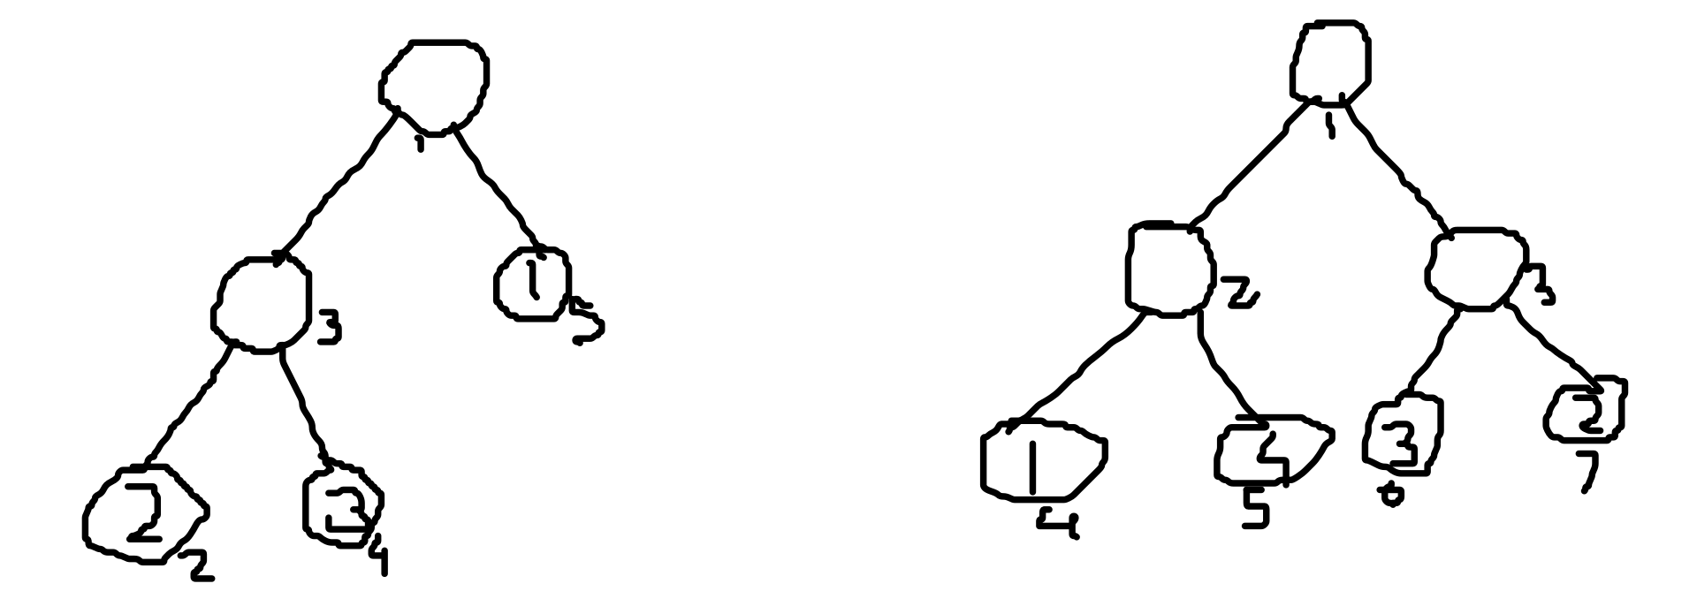

OUTPUT:
1
-1

TestCase: #2
1
7
2 7
3 6
4 5
-1 3
-1 1
-1 6
-1 8

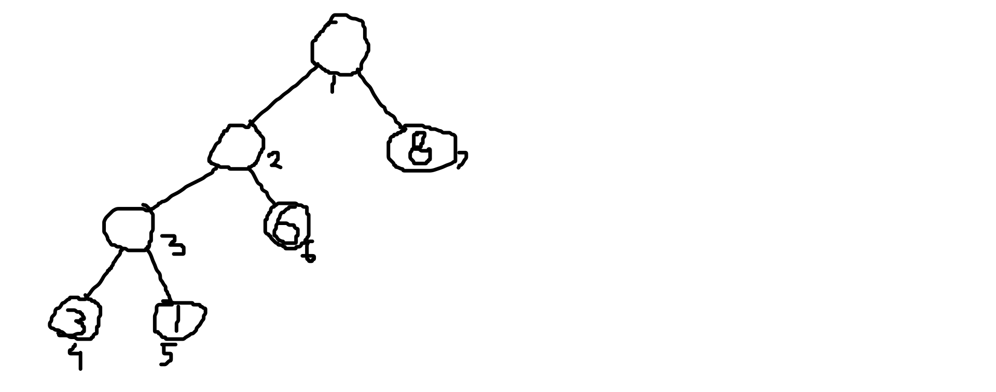

OUTPUT:

1

Base Testcases:

TestCase #3

1
1
-1 4


OUTPUT:

0

TestCase #4
1
3
2 3
-1 6
-1 3


OUTPUT:

1

More Complex Testcases:

TestCase #5

Faulty TestCase (came because we didn’t take boundary conditions now corrected it:
(Realized we only need to switch when right sub tree has some elements lesser then the left sub tree and corrected it by adding equal sign in our switching conditions)

1
9
2 7
3 6
4 5
-1 10
-1 4
-1 10
8 9
-1 4
-1 2

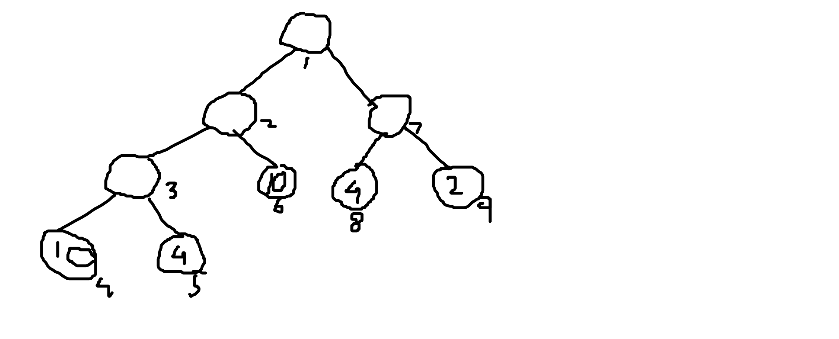

OUTPUT:

3 (gave a faulty output of -1 earlier)

TestCase #6

1
4
2 3
3 4
-1 8
-1 7

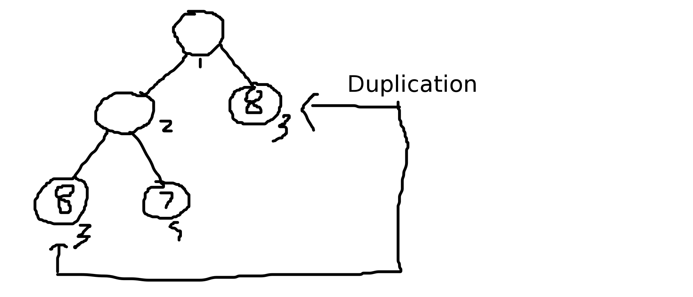

OUTPUT:

1 (But the tree is not the desired graph as
there is duplication of entire sub tree 3 here)

TestCase #7

1
11
2 3
4 5
6 7
8 9
-1 10
-1 56
10 11
-1 12
-1 45
-1 32
-1 51

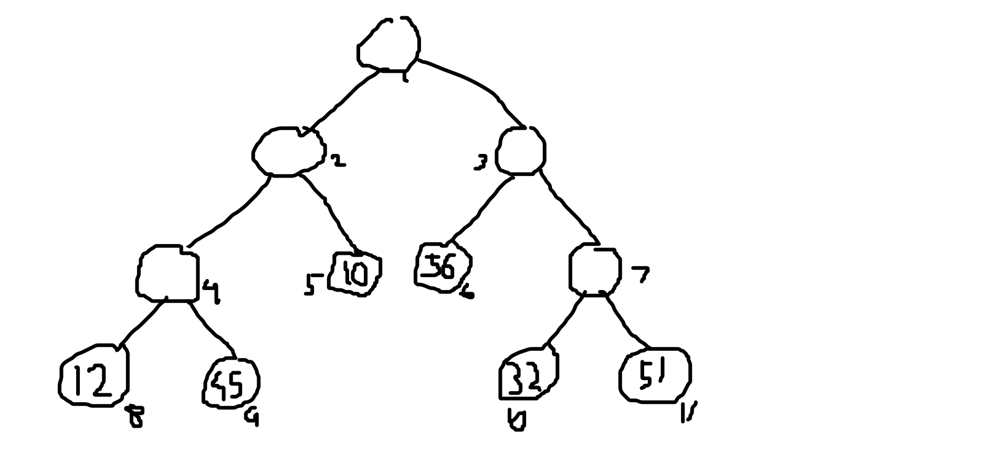

OUTPUT:

-1

TestCase #8

1
11
2 3
4 5
6 7
8 9
-1 10
-1 56
10 11
-1 12
-1 45
-1 48
-1 54

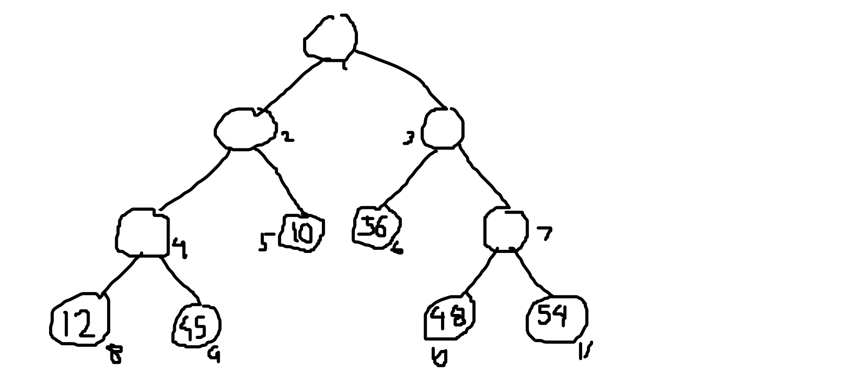

OUTPUT:

2

