**CHAPTER 2**

**METHDOLOGY**

* 1. **HASHING**

A hash function is like a black box that produces an address every time you drop in a key. More formally, it is a function h(K) that transforms a key K into an address. The resulting address is used as the basis for storing and retrieving records. In Fig. 2. 1, the key LOWELL is transformed by the hash function to the address 4. That is, h(LOWELL) = 4. Address 4 is said to be the home address of LOWELL. Hashing is like indexing in that it involves associating a key with a relative record address. Hashing differs from indexing in two important ways:

* With hashing, the addresses generated appear to be random-there is no immediately obvious connection between the key and the location of the corresponding record, even though the key is used to determine the location of the record. For this reason, hashing is sometimes referred to as randomizing.
* With hashing, two different keys may be transformed to the same address so two records may be sent to the same place in the file. When this occurs, it is called a collision and some means must be found to deal with it.

Consider the following simple example. Suppose you want to store 75 records in a file, where the key to each record is a person's name. Suppose also that you set aside space for 1,000 records. The key can be hashed by taking two numbers from the ASCII representations of the first two characters of the name, multiplying these together, then using the rightmost three digits of the result for the address. Table 10.1 shows how three names would produce three addresses. Note that even though the names are listed in alphabetical order, there is no apparent order to the addresses. They appear to be in random order.

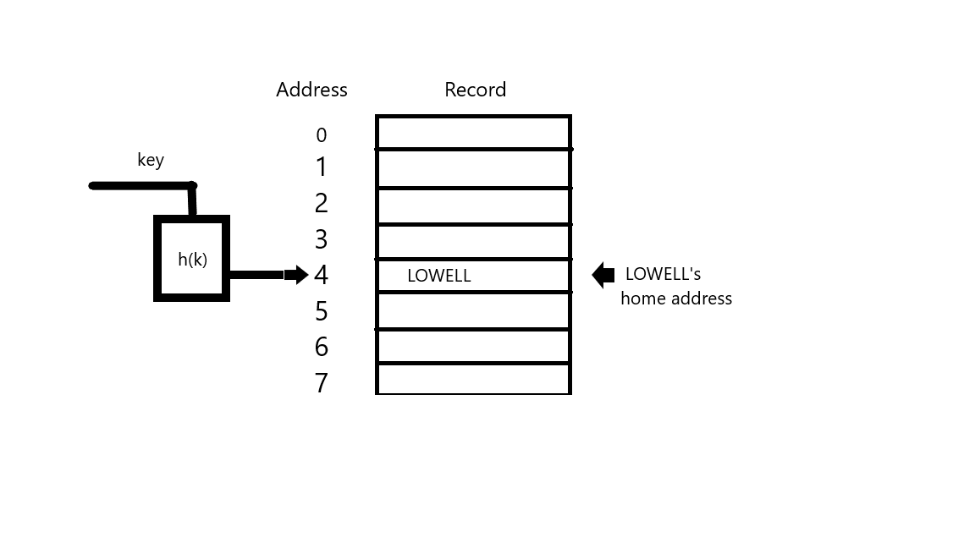

**Fig 2.1** **Hashing the key LOWELL to address**

* 1. **TOOLS**

**Python**

**Python** is an interpreted, high-level, general-purpose programming language. Created by Guido van Rossum and first released in 1991, Python's design philosophy emphasizes code readability with its notable use of significant whitespace. Its language constructs and object-oriented approach aim to help programmers write clear, logical code for small and large-scale projects. Python is dynamically typed and garbage-collected. It supports multiple programming paradigms, including structured (particularly, procedural), object-oriented, and functional programming. Python is often described as a "batteries included" language due to its comprehensive standard library.

**CSS**

**Cascading Style Sheets** (**CSS**) is a style sheet language used for describing the presentation of a document written in a markup language like HTML. CSS is a cornerstone technology of the World Wide Web, alongside HTML and JavaScript. CSS is designed to enable the separation of presentation and content, including layout, colors, and fonts. This separation can improve content accessibility, provide more flexibility and control in the specification of presentation characteristics, enable multiple web pages to share formatting by specifying the relevant CSS in a separate .css file, and reduce complexity.

#### **FLASK**

Flask is a lightweight WSGI web application framework. It is designed to make getting started quick and easy, with the ability to scale up to complex applications. It began as a simple wrapper around Werkzeug and Jinja and has become one of the most popular Python web application frameworks.

* Flask uses thread-local objects internally so that you don’t have to pass objects around from function to function within a request in order to stay threadsafe. This approach is convenient, but requires a valid request context for dependency injection or when attempting to reuse code which uses a value pegged to the request.
* Werkzeug implements WSGI, the standard Python interface between applications and servers.
* Jinja is a template language that renders the pages your application serves.
* ItsDangerous securely signs data to ensure its integrity. This is used to protect Flask’s session cookie.
* The debug support the server will reload itself on code changes, and it will also provide you with a helpful debugger if things go wrong.
* Flask provides a really simple way to give feedback to a user with the flashing system. The flashing system basically makes it possible to record a message at the end of a request and access it on the next (and only the next) request. This is usually combined with a layout template to expose the message.

**HTML**

Hypertext Markup Language (HTML) is the standard markup language for creating web pages and web applications. With Cascading Style Sheets (CSS) and JavaScript it forms a triad of cornerstone technologies for the World Wide Web. HTML elements are the building blocks of HTML pages.

The definition of HTML is Hypertext Markup Language:

* Hypertext is the method by which one can move around on the web-by clicking on special text called hyperlink, which brings to the next page. The fact that it is hyper just means it is not linear-i.e., one can go to any place on the Internet whenever they want by clicking on links-there is no set order to do things in.
* Markup is what HTML tags do to the text inside them. They mark it as a certain type of text (italicized text, for example).
* HTML is a Language, as it has code words and syntax like any language.

**BOOTSTRAP**

Bootstrap is an open source toolkit for developing with HTML, CSS, and JS. Quickly prototype the user’s idea or build an entire app with the help of Sass variables and mixings, responsive grid system, extensive prebuilt components, and powerful plugins built on jQuery.