**CHAPTER 4**

**SYSTEM DESIGN AND DEVELOPMENT**

Hashing is the process of converting a given key into another value. A hash value is used to generate new value according hash function. It is a computationally and storage space efficient form of data access which avoids the non-linear access time of ordered and unordered lists and structured trees and the often-exponential storage requirements of direct access of state spaces of large variable length keys.

**4.1 ARCHITECTURAL DESIGN**

There are different notations to draw data flow diagrams, defining different visual representations to processes, data stores, data flow, and external entities that is shown in Figure 4.1

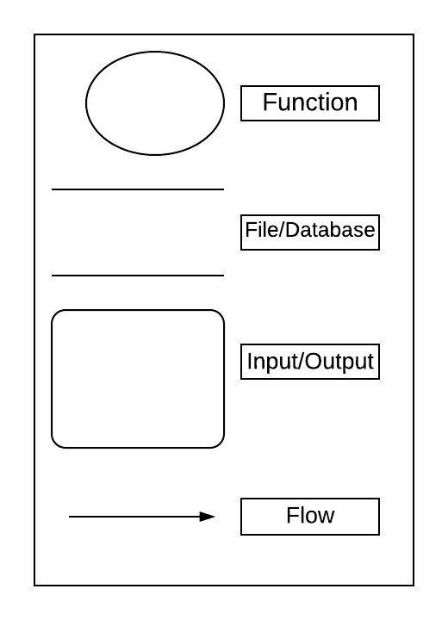

# Figure 4.1 – Data Flow Diagram Notations

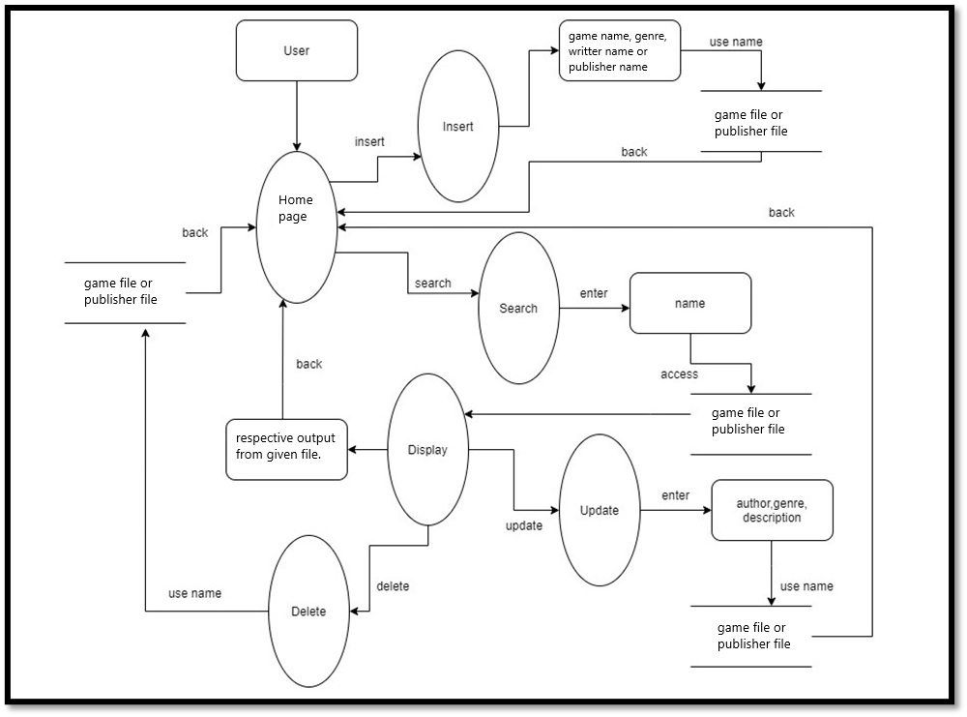

# Figure 4.2 – Architecture diagram of Fortress of gamers.

The above Figure 4.2 shows the flow of the mini project that the user will experience. Based on the Figure 2.3, System user has three options in the menu page-insert, search and display. When the user opts for insert option, the details are taken from the user and insert function is implemented on it. The primary key is sent to the hash function which will produce a hash value. All details along with the primary key is entered into the data file by seeking the hash value as position in the file. After which, the current record information is displayed on the gui. Similarly, when user opts for search option the name is taken from the user and search function **is** implemented on it. The name is sent to the hash function and respective hash value is produced using which the file is seeked for the position where the record is looked up on and its respective details are displayed. There the user has the option to either delete the current record or update the current record. If the user opted for update, the corresponding details has to be provided for the record, then the update function is implemented on it and the updated information of the current record is displayed on the gui. The same works for delete. The game details of the entered game name is deleted from the file and the user is redirected to the home page.