**Isle Royale Worksheet 3**

Saturday, August 31, 2013

Last author: Kurt VanLehn

# Modeling the wolf population

Wolves are just like any other animal species in that there are only four general ways that their population can change: births, deaths, immigration and emigration. On Isle Royale, immigration and emigration are nearly zero, so only births and deaths need to be modeled. In this respect, the wolves are just like the moose. Thus, the wolf population model can have assumptions similar to the ones stated earlier:

* The wolf population is 2 in the first year (1950).
* Births and deaths are the only change in the population. Immigration and emigration do not occur.
* The number of deaths each year is… what?
* The number of births each year is… what?

As with the moose, it wouldn’t make sense to assumption that a fixed number of wolves (e.g., 1) are born each year. As the population gets larger, this wouldn’t match reality. Similarly, it wouldn’t make sense to assume that the same number of wolves (e.g., 1) die each year. Thus, let us assume

* The number of wolf births each year is proportional to the number of wolves. Let the number of births per wolf be called the *wolf birth rate*.
* The number of wolf deaths each year is proportional to the number of wolves. Let the number of deaths per wolf be called the *wolf death rate*.

Let’s construct a model of the wolf population ignoring the fact that they prey on moose. Later we will add a model of the moose population and its interaction with the wolf population.

* Please go to <http://dragoon.asu.edu/> and click on More Problems
* Enter your name, select Student Mode, and type Wolves as the name of the problem.
* Create a model for the wolf population as described above.

# Modeling the effect of moose population on wolf population

Now we need to model how the populations of the two species, wolves and moose, interact with each other. Let’s start with how the size of the moose population affects the size of the wolf population. As mentioned earlier, all animal populations are changed only by births, deaths, immigration and emigration. Moreover, for Isle Royale, immigration and emigration are nearly zero. Thus, we need to look at how the moose population affects wolf births and wolf deaths.

Let’s start with wolf births. Here are some facts about the birth rates of wolves. Female wolves typically produce one litter of pups each year, starting in their third year and continuing for their whole life. A litter typically has 5 or 6 pups. However, the size of the litter depends on the abundance of food. A half-starved mother wolf will have fewer pups than a well-fed mother wolf. The later fact is extremely important for our purposes. It suggests that wolf birth rate is a function of the abundance of food. On Isle Royale, moose are the main source of wolf food. So the wolf birth rate depends on the moose population – the more moose, the more pups per liter and the higher the wolf birth rate. This suggests that we assume:

* Wolf birth rate = effect of predation on wolf birth rate * moose population

The constant, *effect of predation on wolf birth rate*, indicates how much the birth rate rises as the moose population rises. We can guess at its value. Suppose this constant is really small: 0.15% (i.e., 0.0015). When it is multiplied by the moose population, which is a large number, then wolf birth rate is an intuitively satisfying size. For instance, if there were 500 moose, then the wolf birth rate would be 0.75 (which is 500* 0.0015) , which means that 10 wolves would have about 7 or 8 pups per year.

Now let’s consider *wolf death rate*. On the one hand, it might seem that *wolf death rate* would be sensitive to the moose population, because when moose become scarce, wolves may starve to death. On the other hand, many wolves are killed by other wolves: estimates range from 14% to 65% of the wolf deaths are due to fights amongst wolves. This contribution to the wolf death rate may not be affected by the moose population. Let’s just keep the model as simple as possible and assume that *wolf death rate* does not depend on the moose population. Let’s assume it is a constant, e.g.,

* wolf death rate = 0.67

# The effect of wolves on the moose population

Now let’s consider how the wolves affect the moose population. As mentioned earlier, the only influences on moose (or other animal) populations are births, deaths, immigration and emigration. In the case of Isle Royale, immigration and emigration are nearly zero, so we are looking for ways that wolves can impact either moose births or moose deaths.

Clearly, wolves eat moose, so the more wolves the more moose deaths. This can be simply modeled as

* moose death rate = effect of wolves on moose * wolf population

Because the constant *effect of wolves on moose* is going to be multiplied by some large numbers, and we don’t want moose deaths to be extremely high, the constant needs to be a small number: 0.3% (i.e. 0.003).

Now let’s consider the birth rate of moose. Just like wolves, the nutritional condition of a female moose determines how many children (called calves) she will have that year. A healthy female moose may have one or two calves. A half-starved one may have none. However, moose eat vegetation, so the moose nutritional condition does not depend on the wolf population, and hence the moose birth rate does not depend on the wolf population. Thus, for simplicity, let us assume

* moose birth rate = 0.1

As shown on the graph below for 1959, the moose population should start at 500 and the wolf population should start at 20.

* Please go to <http://dragoon.asu.edu/> and click on More Problems
* Enter your name, select Student Mode, and type Moose and Wolves.
* You will see it already contains a model of the moose population from yesterday and a model of the wolf population from today. You need to edit them and add some new nodes in order to create the model described above.

Your model should show cycles similar to the ones in the systems actual behavior, which is in the resources and (for convenience) also shown as Figure 1.

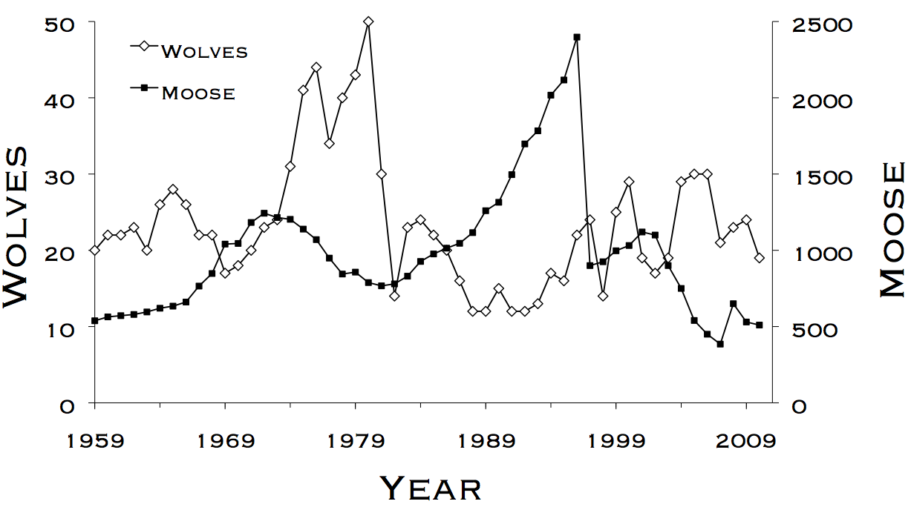

Figure 1

# Explorations

We have now created a model whose predictions come close to matching the actual Isle Royale curves. There are no obvious patterns left to explain, although perhaps the reader can find some non-obvious ones and try modeling them.

During the development of these models, we have touched upon some classic models in biology. The initial model of the moose population produced exponential growth, so such models are called *exponential growth models.* The moose population with only carrying capacity and not wolf predation is call a *logistic growth model*, because the curve it produces is a logistic curve. The model we finally produced is a famous early model of predation called the Lotka-volterra model. The Lotka-volterra model lacks the carrying capacity constraint on the moose population, and it often does not match real data well. When carrying capacity is added to the Lotka-Volterra model, then its accuracy improves. Using Author mode in Dragoon, you can try this yourself.