**Code:**

from copy import deepcopy

from re import sub

O_REL = ['A', 'B', 'C', 'D']

FD = [

['AB', 'B'],

['B', 'C'],

['C', 'D'],]

NEW_REL = [

['A', 'B'],

['B', 'C'],

['C', 'D'],]

def in_count(_itr: list[str], elem: str):

return sum([1 for i in _itr if elem in i])

def initialize(old_rel, new_rel):

table: list[list[str]] = [["" for _ in old_rel] for _ in new_rel]

for row_index, row in enumerate(table):

for col_index, col in enumerate(row):

if old_rel[col_index] in new_rel[row_index]:

table[row_index][col_index] = f"a({col_index})"

else:

table[row_index][col_index] = f"b({row_index},{col_index})"

return table

def attrs_intersection(attrs: list[str]) -> str:

for s in attrs:

# remove content inside parenthesis

s = sub(r'\([^)]*\)', '', s)

s = s.replace(" ", "")

return 'a' if all([True if 'a' in attr else False for attr in attrs]) else 'b'

def get_lhs_values(dep, table, old_rel):

check_lhs: list[str] = []

compound_attr: list[list[str]] = []

for attr in dep[0]:

compound_attr.append([row[old_rel.index(attr)] for row in table])

for i, c_attr in enumerate(map(list, zip(*compound_attr))):

check_lhs.append(attrs_intersection(c_attr))

# at this point we have a comparison list, that we can use to check for the step 2 conditions

return check_lhs

def print_table(table: list[list[str]]):

pretty_table = ""

for row in table:

pretty_table += "|"

for columns in row:

pretty_table += f"{columns}\t|"

pretty_table += "\n"

length = len(pretty_table.split("\n")[0].expandtabs())

print("_" * length)

print(pretty_table)

def woolman_algorithm_test(old_rel: list[str], new_rel:list[list[str]], fd: list[list[str]]) -> bool:

# Step 1: Initialize

table = initialize(old_rel, new_rel)

print("Initial Table: ")

print_table(table)

while True:

compare_table = deepcopy(table)

for dep in fd:

print(f"Checking FD: {dep[0]} -> {dep[1]}")

check_lhs = get_lhs_values(dep, table, old_rel)

rows_to_change = [i for i, x in enumerate(check_lhs) if x == "a"]

columns_to_change = [old_rel.index(attr) for attr in dep[1]]

column_values = ["X" for _ in columns_to_change]

if check_lhs.count("a") <= 1:

print("No common attributes found")

continue

for column_index in columns_to_change:

test_column = [row[column_index] for row in table if table.index(row) in rows_to_change]

# Find if there is "A" in the columns we wish to update, else get the first "B" value

if in_count(test_column, "a") >= 1:

column_values[columns_to_change.index(column_index)] = f"a({column_index})"

else:

column_values[columns_to_change.index(column_index)] = test_column[0]

# Update

for row_index, row in enumerate(table):

for col_index, col in enumerate(row):

if col_index in columns_to_change and row_index in rows_to_change:

table[row_index][col_index] = column_values[columns_to_change.index(col_index)]

# Print Table

print_table(table)

if compare_table == table:

for row in table:

if in_count(row, "a") == len(row):

print(f"Found a row with all 'a' values. Row: {table.index(row) + 1}")

return True

print("No more changes possible.")

return False

if __name__ == '__main__':

if woolman_algorithm_test(O_REL, NEW_REL, FD):

print("The given relation decomposition is LOSSLESS.")

else:

print("The given relation decomposition is LOSSY.**")**

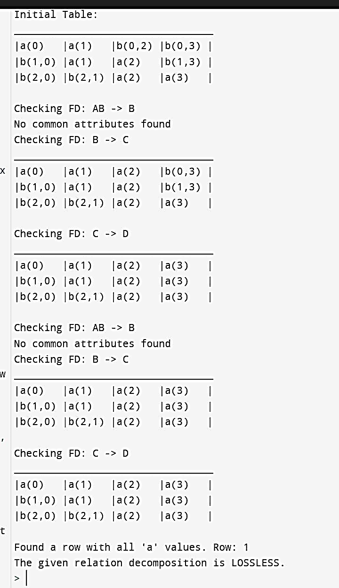**Output:**