***DATABASE***

*CODE FOR TABLES :-*

CREATE TABLE Employee (ename varchar2(10),city varchar2(10));

INSERT INTO Employee VALUES('Abhishek','Los Angeles');

INSERT INTO Employee VALUES('Sunil','Delhi');

INSERT INTO Employee VALUES('Vijay','Delhi');

INSERT INTO Employee VALUES('Abhijeet','Bombay');

INSERT INTO Employee VALUES('Kai','California');

INSERT INTO Employee VALUES('Tyson','Bombay');

INSERT INTO Employee VALUES('Max','Delhi');

CREATE TABLE Emp_Company (ename varchar2(10),cname varchar2(10),salary number(7,2),jdate DATE);

INSERT INTO Emp_Company VALUES('Abhishek','Apple',200000.00,'10-april-2023');

INSERT INTO Emp_Company VALUES('Sunil','Acc',20000.00,'11-may-2023');

INSERT INTO Emp_Company VALUES('Vijay','Acc',40000.00,'12-june-2023');

INSERT INTO Emp_Company VALUES('Abhijeet','Accenture',7000.00,'13-july-2023');

INSERT INTO Emp_Company VALUES('Kai','Amazon',90000.00,'14-august-2023');

INSERT INTO Emp_Company VALUES('Tyson','Tata',80000.00,'15-september-2023');

INSERT INTO Emp_Company VALUES('Max','Tata',18000.00,'16-october-2023');

CREATE TABLE Company (cname varchar2(10),city varchar2(10));

INSERT INTO Company VALUES('Apple','Los Angeles');

INSERT INTO Company VALUES('Acc','Kolkata');

INSERT INTO Company VALUES('Netflix','California');

INSERT INTO Company VALUES('Amazon','Bangalore');

INSERT INTO Company VALUES('Tata','Mumbai');

CREATE TABLE Manager (ename varchar2(10),mname varchar2(10));

INSERT INTO Manager VALUES('Abhishek','Krishna');

INSERT INTO Manager VALUES('Sunil','Kartik');

INSERT INTO Manager VALUES('Vijay','Rohan');

INSERT INTO Manager VALUES('Abhijeet','Hillary');

INSERT INTO Manager VALUES('Kai','Arjun');

INSERT INTO Manager VALUES('Tyson','Trump');

INSERT INTO Manager VALUES('Max','Emmaneul');

CREATE TABLE Emp_Shift (ename varchar2(10),shift varchar2(1));

INSERT INTO Emp_Shift VALUES('Abhishek','A');

INSERT INTO Emp_Shift VALUES('Sunil','B');

INSERT INTO Emp_Shift VALUES('Vijay','B');

INSERT INTO Emp_Shift VALUES('Abhijeet','B');

INSERT INTO Emp_Shift VALUES('Kai','A');

INSERT INTO Emp_Shift VALUES('Tyson','A');

INSERT INTO Emp_Shift VALUES('Max','B');

SELECT * FROM Employee;

SELECT * FROM Emp_Company;

SELECT * FROM Company;

SELECT * FROM Manager;

SELECT * FROM Emp_Shift;

OUTPUT OF TABLES :-

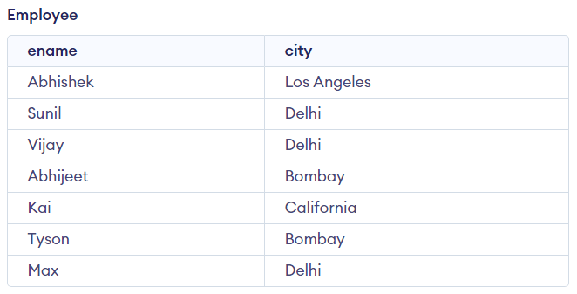

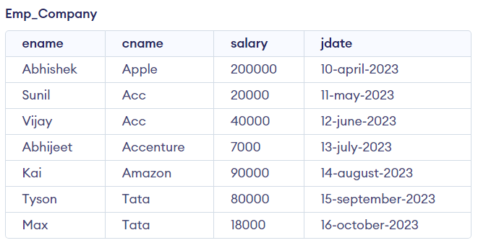

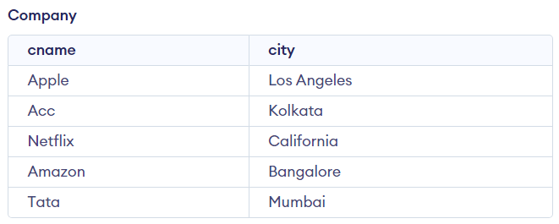

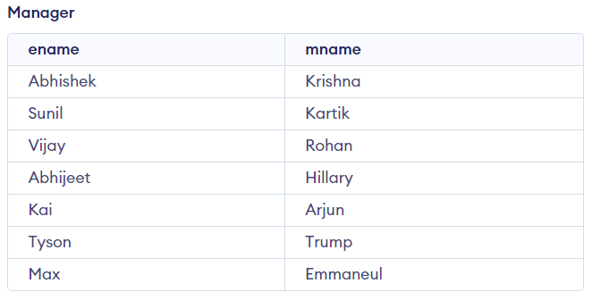

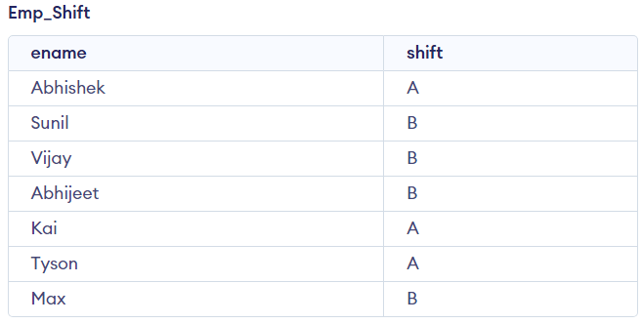

***QUERIES :-***

**Q.1]**Light the name of employee having maximum salary.

🡪

Query :-

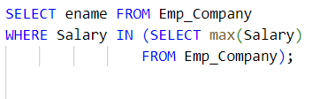

Output :-

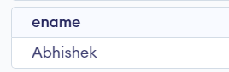

**Q.2]** List the name of employee having maximum salary in their company.

🡪

Query :-

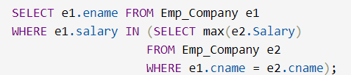

Output :-

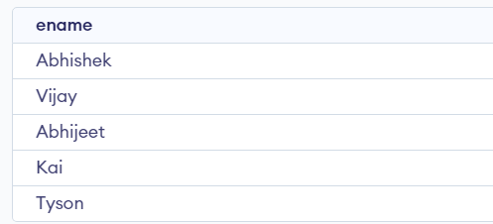

**Q.3]** Find the average salary of each company except ACC.

🡪

Query :-

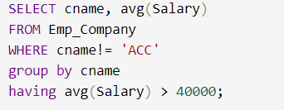

Output :-

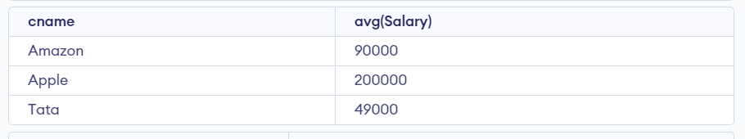

**Q.4]** Find average salary of each company except ACC.

🡪

Query :-

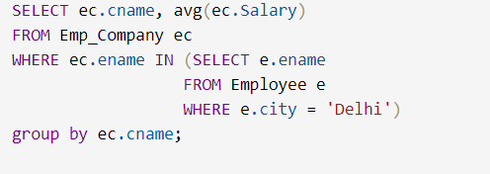

Output :-

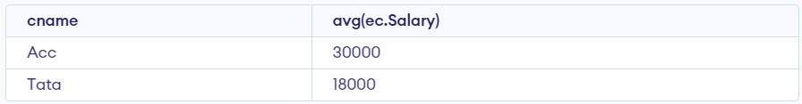

**Q.5]** Find the name of company having highest average salary.

🡪

Query :-

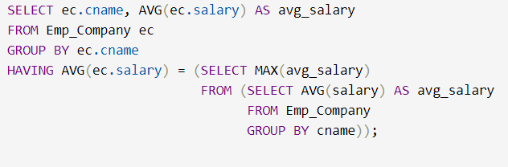

Output :-



**Q.6]** List the number of employees living in BOMBAY.

🡪

Query :-

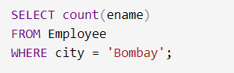

Output :-

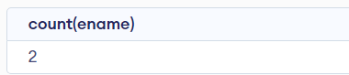

**Q.7]** List the name of employees with his living city having maximum salary in company TATA.

🡪

Query :-

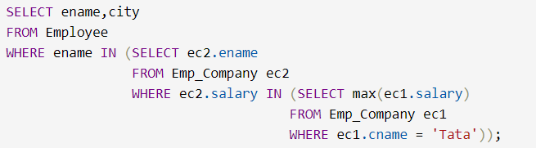

Output :-

