PRACTICAL NO. 01

PROGRAM:

a.

import pandas as pd

mtcars = pd.read_csv('C:\\Users\\Abhishek\\Desktop\\PS-2\\mtcars.csv')

# Display summary statistics

print("1] Summary Statistics for mtcars dataset:\n")

print(mtcars.describe())

# Display structure information

print("\n2] Structure Information for mtcars dataset:\n")

print(mtcars.info())

# Use the quantile() method to get the quartile values for a specific column

print("\n3] Quartile Information for mtcars dataset:\n")

print(mtcars['mpg'].quantile([0.25, 0.5, 0.75]))

b.

import pandas as pd

iris = pd.read_csv('C:\\Users\\Abhishek\\Desktop\\PS-2\\iris.csv')

# Use subset() function to select only rows where Sepal.Width > 3

setosa_subset = iris[iris['sepal_width'] >= 3.8]

print("1] Subset of Iris dataset with only rows where Sepal.Width > 3.8 :\n")

print(setosa_subset)

# Use aggregate() function to calculate mean sepal length for each species

aggregate_result = iris.groupby('species').mean()

print("\n2] Aggregate result - Mean sepal length and sepal width for each species:\n")

print(aggregate_result)

OUTPUT:

a.

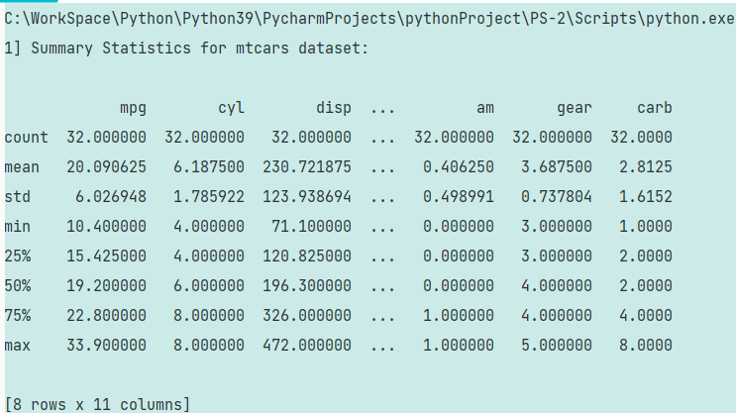

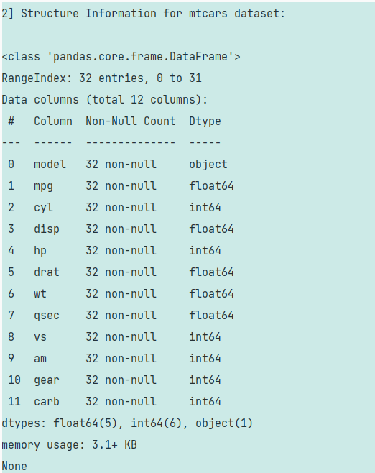

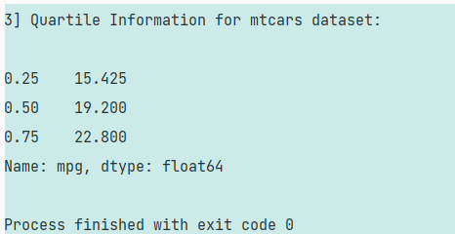

b.

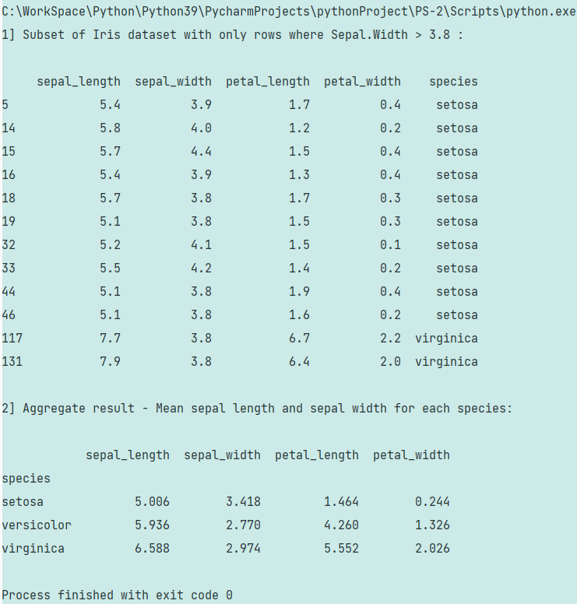

PRACTICAL NO. 01

PROGRAM:

A] ii)

import pandas as pd

# Load the cars dataset

cars = pd.read_csv('C:\\Users\\Abhishek\\Desktop\\6_SEM\\PS2\\pr1\\USA_cars_datasets.csv')

# Display basic information about the dataset

print("1] Summary Statistics for cars dataset:\n")

print(cars.describe())

# Display the structure of the dataset

print("\n2] Structure Information for cars dataset:\n")

print(cars.info())

# Display quartiles of the numerical columns

print("\n3] Quartile Information for cars dataset:\n")

print(cars['mileage'].quantile([0.25, 0.5, 0.75]))

OUTPUT:

A] ii)

