Building a Secure Web Application
Student Handout
Web Programming | PHP and MySQL
This lesson focuses on how to build a web application securely from the moment a user enters data until that data is processed, stored in the database, and displayed back in the browser. It applies the security risks previously discussed and the MySQL techniques learned in earlier lessons.

Learning Objectives
- Explain the basic flow of a secure PHP-MySQL web application.
- Apply server-side input validation and prepared statements.
- Use secure password handling and session management.
- Differentiate authentication from authorization.
- Prevent common attacks such as SQL injection, XSS, and CSRF.
- Apply database security practices such as transactions, constraints, and least privilege.

1. What Is a Secure Web Application?
A secure web application protects its users, data, and server from unauthorized access, manipulation, disclosure, or destruction. Security should be included during development, not added only after the system is finished.

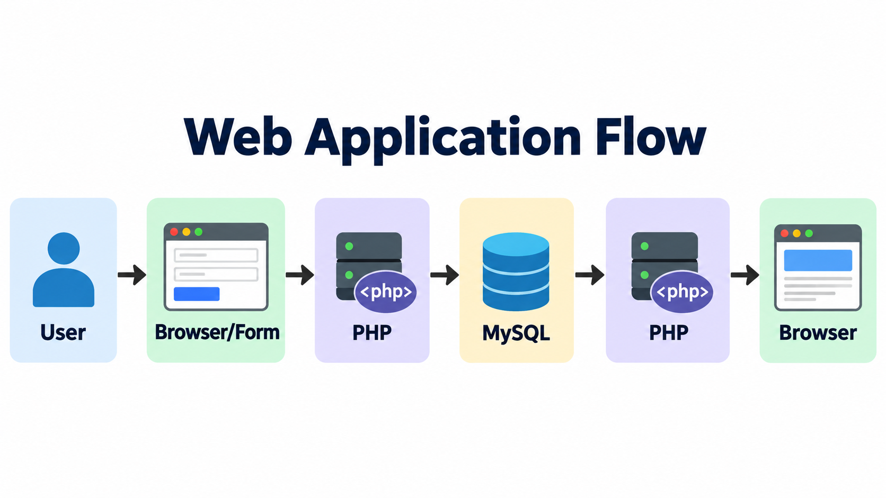
Every part of this flow must be protected. Data coming from the browser is considered untrusted until the server checks it.

2. Use Defense in Depth
Defense in depth means using several layers of protection instead of relying on only one security control. If one layer fails, another layer can still reduce the damage.
- Validate input on the server.
- Use prepared statements for database queries.
- Hash passwords.
- Protect sessions.
- Check user permissions.
- Encode output before showing untrusted data in HTML.
- Use secure database accounts and integrity controls.
- Hide technical error details from users.
- Use HTTPS in deployment.

3. Validate User Input
Never trust data simply because it came from your own form. A user can bypass the form and send a request directly to the server. Important validation must be performed in PHP.
$email = filter_input(INPUT_POST, 'email', FILTER_VALIDATE_EMAIL);
$age = filter_input(INPUT_POST, 'age', FILTER_VALIDATE_INT);
if ($email === false || $age === false || $age < 1) {
exit('Invalid input.');
}
Client-side validation improves user experience. Server-side validation provides the actual security check.

4. Prevent SQL Injection
SQL injection happens when untrusted input is combined directly with an SQL statement. The attacker may be able to change the intended query.

Unsafe Example
$username = $_POST['username'];
$sql = "SELECT * FROM users WHERE username = '$username'";

Safer Example Using PDO Prepared Statements
$stmt = $pdo->prepare(
'SELECT id, username, password_hash, role FROM users WHERE username = ?'
);
$stmt->execute([$username]);
$user = $stmt->fetch(PDO::FETCH_ASSOC);
Prepared statements keep the SQL command separate from the user-supplied value. This is one of the most important protections against SQL injection.

5. Store Passwords Securely
Passwords should never be stored as plain text. PHP provides built-in functions for secure password hashing and verification.
// Registration
$hash = password_hash($_POST['password'], PASSWORD_DEFAULT);
// Login
if ($user && password_verify($_POST['password'], $user['password_hash'])) {
// Login successful
}
The database stores the password hash, not the original password.

6. Protect Sessions
After a user logs in, the session identifies that authenticated user. If a session ID is stolen or reused, another person may impersonate the user.
session_start();
if ($loginSuccessful) {
session_regenerate_id(true);
$_SESSION['user_id'] = $user['id'];
$_SESSION['role'] = $user['role'];
}
- Regenerate the session ID after successful login.
- Use secure cookie settings when HTTPS is enabled.
- Destroy the session during logout.
- Do not store passwords or unnecessary sensitive data in session variables.

7. Authentication vs. Authorization
Authentication answers: Who are you? Authorization answers: What are you allowed to do? A user may be logged in but still not have permission to open an administrator page.
session_start();
if (!isset($_SESSION['user_id'])) {
http_response_code(401);
exit('Login required.');
}
if (($_SESSION['role'] ?? '') !== 'admin') {
http_response_code(403);
exit('Access denied.');
}
Hiding a button or link is not enough. Permission checks must be performed on the server.

8. Prevent Cross-Site Scripting (XSS)
XSS can occur when untrusted data is inserted into a page and the browser interprets it as HTML or script. When displaying ordinary user text inside HTML, encode it before output.
echo htmlspecialchars(
$comment,
ENT_QUOTES | ENT_SUBSTITUTE,
'UTF-8'
);
Validation checks whether data is acceptable. Output encoding controls how data is safely displayed.

9. Protect Important Requests from CSRF
Cross-Site Request Forgery (CSRF) attempts to make a logged-in browser perform an action that the user did not intentionally request. A common defense is to use an unpredictable CSRF token for state-changing requests.
if (empty($_SESSION['csrf_token'])) {
$_SESSION['csrf_token'] = bin2hex(random_bytes(32));
}
if (!hash_equals($_SESSION['csrf_token'], $_POST['csrf_token'] ?? '')) {
http_response_code(403);
exit('Invalid request.');
}

10. Apply Security Inside MySQL
PHP security and MySQL security should support each other. Some protections belong in the application, while others belong in the database.
MySQL Feature | How It Helps | Example
Constraints | Reject invalid or inconsistent data. | NOT NULL, UNIQUE, foreign keys
Transactions | Keep multi-step operations complete or reversible. | Order + order items
Stored Procedures | Centralize selected database operations. | Controlled update routine
Triggers | Automatically respond to selected database events. | Audit selected changes
Privileges | Limit what the web application account can do. | No unnecessary DROP or GRANT

11. Use Transactions for Related Operations
A transaction is useful when several database changes must succeed together. If one step fails, the application can roll back the earlier changes.
try {
$pdo->beginTransaction();
// Execute related INSERT/UPDATE statements here.
$pdo->commit();
} catch (Throwable $e) {
if ($pdo->inTransaction()) {
$pdo->rollBack();
}
throw $e;
}

12. Handle Errors Securely
Detailed PHP and database errors are useful during development, but they should not be displayed to normal users in production. Error messages may reveal table names, file paths, SQL statements, or other technical information.
try {
// Database operation
} catch (Throwable $e) {
error_log($e->getMessage());
http_response_code(500);
echo 'Something went wrong. Please try again later.';
}

13. Secure Deployment Practices
- Use HTTPS.
- Do not expose database credentials in public files.
- Disable detailed error display in production.
- Keep PHP, MySQL, libraries, and the operating system updated.
- Use a dedicated least-privilege database account.
- Protect backups and logs.
- Monitor suspicious login attempts and unusual application activity.

14. Example: Secure Login Flow
1. The user submits a username and password over HTTPS.
2. PHP validates the expected input.
3. PHP uses a prepared SELECT statement to retrieve the account.
4. PHP uses password_verify() to check the password.
5. PHP regenerates the session ID after successful login.
6. Protected pages check authentication and authorization.
7. Data displayed in HTML is safely encoded.
8. Technical errors are logged instead of displayed to the user.

15. Secure Coding Quick Reference
Avoid | Use Instead
SQL built by concatenating user input | Prepared statements
Plain-text passwords | password_hash() / password_verify()
Client-side validation only | Server-side validation
Hiding admin links only | Server-side authorization
Raw user content in HTML | Context-appropriate output encoding
Database root account | Dedicated least-privilege account
Partial multi-step updates | Transactions
Detailed error messages to users | Generic message + private logs

16. Security Checklist
☐ Input is validated on the server.
☐ SQL statements use parameters/prepared statements.
☐ Passwords are securely hashed.
☐ Sessions are regenerated after login.
☐ Authorization is checked for protected pages/actions.
☐ Untrusted output is encoded safely.
☐ State-changing forms use appropriate CSRF protection.
☐ Database accounts use least privilege.
☐ Important operations use transactions when needed.
☐ Production errors do not expose sensitive details.
☐ HTTPS is enabled for deployed systems.

17. Review Questions
1. Why must server-side validation still be used when a form already has HTML validation?
2. How do prepared statements help prevent SQL injection?
3. Why should passwords be hashed?
4. What is the difference between authentication and authorization?
5. Why should the session ID be regenerated after login?
6. What problem does htmlspecialchars() help reduce when displaying user text?
7. When is a database transaction useful?
8. Why should a web application avoid using the MySQL root account?
9. Why should detailed database errors not be shown to users?
10. Give three security controls that should be present before deploying a PHP-MySQL application.

Key Takeaway
A secure web application protects the entire request flow. Input must be validated, database queries must be parameterized, passwords and sessions must be protected, permissions must be checked, output must be handled safely, and the database and server must be configured securely.

