# JavaScript for Front-End Retake-Exam – Elements

Your task is to write the Front-End part of an application which extracts data from a Firebase database, and renders it into HTML.Your application **MUST** be done without browser refreshing (SPA).

There are a few simple tasks. Those little tasks will ultimately combine into the functionality you need for the application itself.

Create 4 **.js** files which you will use for your problems:

* **sample-data.js**
* **jquery-data.js**
* **events.js**
* **app.js**

## Rendering Sample Data – 20 pts

Write **3 JavaScript functions** which receive an **associative array** (**object**), and **render** the **data** from it.

The **first object** looks like this:

elements: {

element1: {

name: {element1Name},

creatures: [

{

name: {creature1Name},

power: {creatur1Power},

...

},

....

]

},

element2: {

name: {element2Name},

creatures:[

. . .

]

},

. . .

]}

The **properties** of the elements object are:

* The elementName is a **simple string**
* The creatures is a collection of **key-value pairs**.
  + The **key** is a **string**.
  + The **value** is a key’s property.
  + The value is a **simple string**.

The **second object** looks like this:

creatures: [

{

name: “creture name as string”,

power: “creature power as string”

. . .

}

The creature object looks like this:

0: {

name: “creature name”,

power: “creature power”,

ultimate: “creature ultimate”,

region: “creature region”,

image: “creature img(url)”,

}

The **properties** of the creatures object are:

* name is a **simple string**
* power is a **simple string**
* ultimate is a **simple string**
* region is a **simple string**
* image is a simple string(url)

All of the objects will have **ABSOLUTELY ALL OF THEIR PROPERTIES**. There will be **NO** objects with **missing properties**.

Now that you are familiar with all the data, you should render it. The rendering is not complicated, just print it on the console with console.log()...

You will have to write **3 functions** which produce **3 different outputs** and receive different parameters.

### renderAllElements() function – 5 pts

Write a JavaScript function - renderAllElements() which accepts the elements object, and renders **ONLY** the **NAMES** of all elements inside.

The output format is:

{element1name}

{element2name}

. . .

### renderSingleElement() function – 5 pts

Write a JavaScript function - renderSingleElement() which accepts a element object, and renders the **name** of the element and thecreatures inside.

The output format is:

{elementName}

Creatures:

<--{creature1Name}-->

<--{creature2Name}-->

. . .

### renderSingleCreature() function – 10 pts

Write a JavaScript function - renderSingleCreature() which accepts the whole creatures object and a creatureName, and renders all properties of the creature with that **name**.

The output format is:

name:{creatureName}

power: {creaturePower}

ultimate: {creatureUltimate}

region: {creatureRegion}

Note:Don’t display IMAGE property !

See the examples below for more information.

### Example

|  |
| --- |
| sample-data.js |
| **let *elements*** = {  **"elements"**:{  **"air"**: {  **name**: **"Air"**,  **creatures**: [  {  **name**: **"Archangel"**,  **power**: **"Power: 2000"**,  **ultimate**: **"Ultimate: Wind Justice"**,  **region**: **"Region: Heaven's Kingdom"**,  **image**: **"archangel.jpg"** },  {  **name**: **"Elemental"**,  **power**: **"Power: 3500"**,  **ultimate**: **"Ultimate: Tunder Storm"**,  **region**: **"Region: Tunders"**,  **image**: **"air-elemental.png"** }  ]  },  **"fire"**: {  **name**: **"Fire"**,  **creatures**: [  {  **name**: **"Fire Guardian"**,  **power**: **"Power: 1000"**,  **ultimate**: **"Ultimate: Fire Ball"**,  **region**: **"Region: Dark Dungeon"**,  **image**: **"fire-guardian.jpg"** },  {  **name**: **"Diablo"**,  **power**: **"Power: ~"**,  **ultimate**: **"Ultimate: Blast Wave"**,  **region**: **"Region: Molten Core"**,  **image**: **"diablo.jpg"** }  ]  }  }  *renderAllElements*(***elements***);  *renderSingleElement*(***elements***[0]);  *renderSingleCreature*(***elements***[0][**"creatures"**], **"Archangel"**); |

### Output

|  |  |  |
| --- | --- | --- |
| renderAllElements() | renderSingleElement() | renderSingleCreature() |
| *air*  *fire* | *air*  *Creatures:*  *Archangel*  *Elemental* | *Archangel*  *Power: 2000*  *Ultimate: Wind Justice*  *Region: Heaven's Kingdom* |

|  |
| --- |
| sample-data.js |
| **function** *renderAllElements*(elements) {  *//****TODO: Implement me ...***  }  **function** *renderSingleElement*(element) {  *//****TODO: Implement me ...***  }  **function** *renderSingleCreature*(creatures, creatureName) {  *//****TODO: Implement me ...***  } |

## Rendering Data in HTML – 30 pts

In order for the HTML to look tidy and well formed, CSS needs to be applied, which suggests some specific element hierarchy and classes. Check the template and make sure your function renders the object correctly. You can see input and output below.

Create your functions for this task inside the jquery-data.js file, and implement them so that they render the data inside the jquery-data.html file.

You already have some functions which render some data, you can probably use at least 50% of the code you used in the previous problem. Check in your solution from the previous problem, what can be **REUSED** in this problem.

### Render Elements in HTML – 10 pts

You will be given a elements object like the one in the **previous task**. **Render** the **names** of the **elements**, and render them in the .container element, like they are **presented** in the **output HTML**.

#### Example

|  |
| --- |
| jquery-data.js |
| **let *elements*** = {  **"elements"**:{  **"air"**: {  **name**: **"Air"**,  **creatures**: [  {  **name**: **"Archangel"**,  **power**: **"Power: 2000"**,  **ultimate**: **"Ultimate: Wind Justice"**,  **region**: **"Region: Heaven's Kingdom"**,  **image**: **"archangel.jpg"**  } ]  },  **"fire"**: {  **name**: **"Fire"**,  **creatures**: [  {  **name**: **"Fire Guardian"**,  **power**: **"Power: 1000"**,  **ultimate**: **"Ultimate: Fire Ball"**,  **region**: **"Region: Dark Dungeon"**,  **image**: **"fire-guardian.jpg"**  } ]  },  **"water"**: {  **name**: **"Water"**,  **creatures**: [  {  **name**: **"Mermaid"**,  **power**: **"Power: 675"**,  **ultimate**: **"Ultimate: Allure"**,  **region**: **"Region: Ocean Abbys"**,  **image**: **"mermaid.jpg"** }  ]  },  **"earth"**: {  **name**: **"Earth"**,  **creatures**: [  {  **name**: **"Forest God"**,  **power**: **"Power: 5000"**,  **ultimate**: **"Ultimate: Nature's Grasp"**,  **region**: **"Region: Cursed Forest"**,  **image**: **"forest-god.jpg"** }  ]  }  }  };    *renderAllElementsInHTML*(***elements***); |
|  |

#### Input

|  |
| --- |
| jquery-data.html |
| <!DOCTYPE **html**> <**html lang="en"**> <**head**>  <**meta charset="UTF-8"**>  <**title**>Title</**title**>   <**link rel="stylesheet" href="style.css"**>  <**script src="https://ajax.googleapis.com/ajax/libs/jquery/3.2.1/jquery.min.js"**></**script**> </**head**> <**body**>  <**main id="elementsContainer"**>   <**div class="container"**></**div**>  <**script src="jquery-data.js"**></**script**>  **</main**>  </**body**>  </**html**> |
|  |

#### Output

|  |
| --- |
| jquery-data.html |
| <!DOCTYPE **html**> <**html lang="en"**> <**head**>  <**meta charset="UTF-8"**>  <**title**>Title</**title**>   <**link rel="stylesheet" href="style.css"**>  <**script src="https://ajax.googleapis.com/ajax/libs/jquery/3.2.1/jquery.min.js"**></**script**> </**head**> <**body**> <**main id="elementsContainer"**>   <**h1**>Choose Your Destiny</**h1**>  <**div class="container"**>  <**div class="containers"**>  <**div id="air" class="first clickable"**></**div**>  <**div id="fire" class="second clickable"**></**div**>  </**div**>  <**div class="containers"**>  <**div id="water" class="third clickable"**></**div**>  <**div id="earth" class="fourth clickable"**></**div**>  </**div**>  </**div**>  <**script src="jquery-data.js"**></**script**>  </**main**></**body**></**html**> |

If you do everything correctly, you should see this:

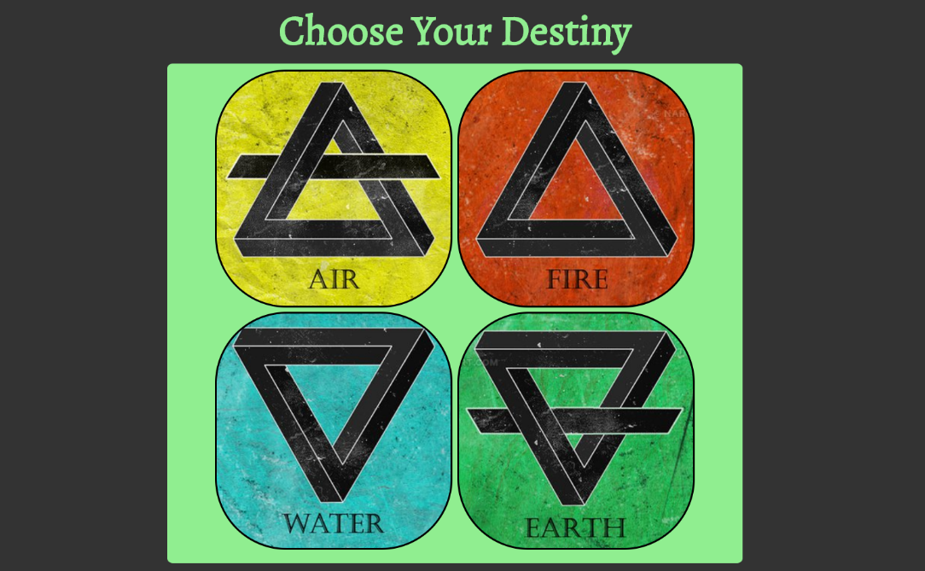

### Render Single Element In HTML – 20 pts

You will be given a single element object like the one in the **previous task**. Render the name of the element in the .elementInfoTitle element,button for back in **.back-button** and **render** the **names** of the **creatures**, like radio buttons in **.creatures**, picture of the single **creature** in **#creature-image** and info of the creature in **#right-after-click** like they are **presented** in the **output HTML**.

#### Example

|  |
| --- |
| jquery-data.js |
| **let *elements*** = {  **"elements"**:{  **"air"**: {  **name**: **"Air"**,  **creatures**: [  {  **name**: **"Archangel"**,  **power**: **"Power: 2000"**,  **ultimate**: **"Ultimate: Wind Justice"**,  **region**: **"Region: Heaven's Kingdom"**,  **image**: **"archangel.jpg"** }]  }  }}  *renderSingleElementInHTML*(***element***); |

#### Input

|  |
| --- |
| jquery-data.html |
| <!DOCTYPE **html**> <**html lang="en"**> <**head**>  <**meta charset="UTF-8"**>  <**title**>Title</**title**>   <**link rel="stylesheet" href="style.css"**>  <**script src="https://ajax.googleapis.com/ajax/libs/jquery/3.2.1/jquery.min.js"**></**script**> </**head**> <**body**> <**header**>  </**header**> <**main id="elementsContainer"**>   <**h1**>Choose Your Destiny</**h1**>  <**div class="container"**>  <**div class="containers"**>  <**div id="air" class="first clickable"**></**div**>  <**div id="fire" class="second clickable"**></**div**>  </**div**>  <**div class="containers"**>  <**div id="water" class="third clickable"**></**div**>  <**div id="earth" class="fourth clickable"**></**div**>  </**div**>  </**div**> </**main**>  <**div id="elementInfo"**>  <**h1 id="elementInfoTitle"**>Air</**h1**>  <**div class="back-button"**>    </**div**>  <**section class="second-layout"**>  <**div class="first-after-click"**>  <**ul class="creatures"**>    </**ul**>  </**div**>  <**div class="center-after-click"**>    </**div**>  <**div id="right-after-click"**>  </**div**>  </**section**>  </**div**>  **<script>src="jquery-data.js"**></**script**> </**body**> </**html**> |

#### Output

|  |
| --- |
| jquery-data.html |
| <!DOCTYPE **html**> <**html lang="en"**> <**head**>  <**meta charset="UTF-8"**>  <**title**>Title</**title**>   <**link rel="stylesheet" href="style.css"**>  <**script src="https://ajax.googleapis.com/ajax/libs/jquery/3.2.1/jquery.min.js"**></**script**> </**head**> <**body**> <**header**>  </**header**> <**main id="elementsContainer"**>   <**h1**>Choose Your Destiny</**h1**>  <**div class="container"**>  <**div class="containers"**>  <**div id="air" class="first clickable"**></**div**>  <**div id="fire" class="second clickable"**></**div**>  </**div**>  <**div class="containers"**>  <**div id="water" class="third clickable"**></**div**>  <**div id="earth" class="fourth clickable"**></**div**>  </**div**>  </**div**> </**main**>  <**div id="elementInfo"**>  <**h1 id="elementInfoTitle"**>Air</**h1**>  <**div class="back-button"**>  <**button id="backToElements"**>Back to Elements</**button**>  </**div**>  <**section class="second-layout"**>  <**div class="first-after-click"**>  <**ul class="creatures"**>  <**li**>  <**input class="radio-button checked" name="selector" type="radio" value="Archangel"**>  <**label**>Archangel</**label**>  </**li**>  <**li**>  <**input class="radio-button" name="selector" type="radio" value="Elemental"**>  <**label**>Elemental</**label**>  </**li**>  <**li**>  <**input class="radio-button" name="selector" type="radio" value="Hippogryph"**>  <**label**>Hippogryph</**label**>  </**li**>  </**ul**>  </**div**>  <**div class="center-after-click"**>  <**img id="creature-image" src="archangel.jpg" alt=""**>  </**div**>  <**div id="right-after-click"**>  <**p id="creature-name"**> </**p**>  <**p id="creature-power"**> </**p**>  <**p id="creature-ultimate"**> </**p**>  <**p id="creature-region"**> </**p**>  </**div**></**section**></**div**>  **script src="jquery-data.js"**></**script**> </**body**> </**html**> |

If you do everything correctly, you should see this:

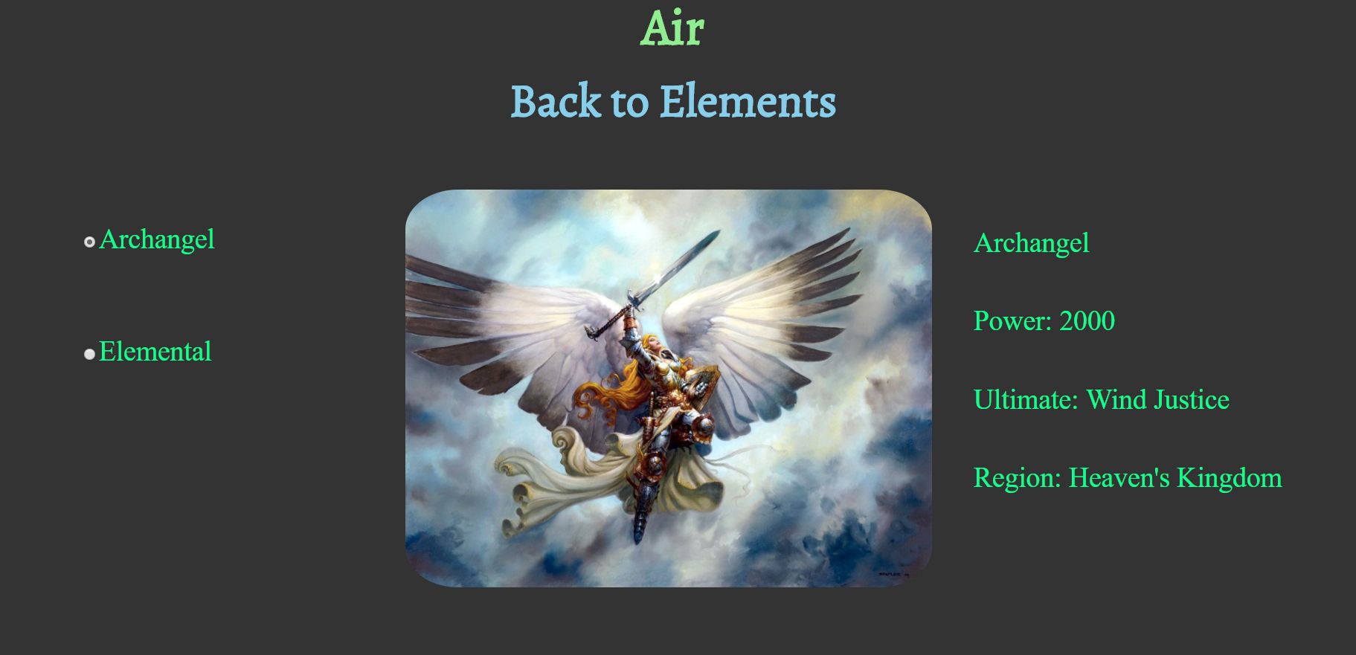

**JQuery** may be used in this problem. It is **ADVISED** that you use **JQuery**, but **native DOM manipulation** is also allowed.

|  |
| --- |
| jquery-data.js |
| **function** *renderAllElementsInHTML*(elements) {  *//****TODO: Implement me ...*** }  **function** *renderSingleElementInHTML*(element) {  *//****TODO: Implement me ...*** } |

## Capture Click Events – 30 pts

Now let’s complete some tasks of handling click events. Write your code in events.js.

### Element Click Event – 10 pts

Render all elements (**ONLY** the **elements NAMES**) by **REUSING** the code from the **previous task**, into events.html.

Your task is to **attach** a click event to **#air,#fire,#water,#earth**, which hides all other #{elementName} elements and **RENDERS** the **ELEMENT NAME** as title,**back** button, radio buttons for **all creatures** in **current element**  **picture**, and **info** about **selected creature**.

**HINT**: Use the functionality from the **previous task** if its ok for you.

A Element-Click.GIF has been added to the resources, which displays this functionality.

### Back Click Event – 10 pts

If you **click on the** #backToElements , it should **SHOW** all of the elements again, and it should **CLEAR** and **HIDE** the rendered data in the #elementInfo element.

### Creature Click Event – 10 pts

Your task is to **attach** a click event to each creature, which:

* **RENDERS and CHANGE** the **CREATURE DATA** from the **CLICKED CREATURE**, into a #rightAfterClick and change the picture of **CLICKED CREATURE** into a **.center-after-click #creature-image.**

**HINT**: Use previous functionality if it possible.

A Creature-Click.GIF has been added to the resources, which displays this functionality.

### Example

|  |
| --- |
| events.js |
| **let *elements*** = {  **"elements"**:{  **"air"**: {  **name**: **"Air"**,  **creatures**: [  {  **name**: **"Archangel"**,  **power**: **"Power: 2000"**,  **ultimate**: **"Ultimate: Wind Justice"**,  **region**: **"Region: Heaven's Kingdom"**,  **image**: **"archangel.jpg"**  } ]  },  **"fire"**: {  **name**: **"Fire"**,  **creatures**: [  {  **name**: **"Fire Guardian"**,  **power**: **"Power: 1000"**,  **ultimate**: **"Ultimate: Fire Ball"**,  **region**: **"Region: Dark Dungeon"**,  **image**: **"fire-guardian.jpg"**  } ]  },  **"water"**: {  **name**: **"Water"**,  **creatures**: [  {  **name**: **"Mermaid"**,  **power**: **"Power: 675"**,  **ultimate**: **"Ultimate: Allure"**,  **region**: **"Region: Ocean Abbys"**,  **image**: **"mermaid.jpg"** }  ]  },  **"earth"**: {  **name**: **"Earth"**,  **creatures**: [  {  **name**: **"Forest God"**,  **power**: **"Power: 5000"**,  **ultimate**: **"Ultimate: Nature's Grasp"**,  **region**: **"Region: Cursed Forest"**,  **image**: **"forest-god.jpg"** }  ]  }  } };  *attachCreatureInfo*(***elements, creatures***); |

|  |
| --- |
| events.html |
| <**html lang="en"**><**head**>  <**meta charset="UTF-8"**>  <**title**>Title</**title**>   <**link rel="stylesheet" href="style.css"**>  <**script src="https://ajax.googleapis.com/ajax/libs/jquery/3.2.1/jquery.min.js"**></**script**> </**head**> <**body**> <**header**>  </**header**> <**main id="elementsContainer" class="no-display"**>   <**h1**>Choose Your Destiny</**h1**>  <**div class="container"**>  <**div class="containers"**>  <**div id="air" class="first clickable"**></**div**>  <**div id="fire" class="second clickable"**></**div**>  </**div**>   </**div**> </**main**><**div id="elementInfo"**>  <**h1 id="elementInfoTitle"**>Air</**h1**>  <**div class="back-button"**>  <**button id="backToElements"**>Back to Elements</**button**>  </**div**>  <**section class="second-layout"**>  <**div class="first-after-click"**>  <**ul class="creatures"**>  <**li**>  <**input class="radio-button checked" name="selector" type="radio" value="Archangel"**>  <**label**>Archangel</**label**>  </**li**>  <**li**>  <**input class="radio-button" name="selector" type="radio" value="Elemental"**><**label**>Elemental</**label**>  </**li**>  </**ul**>  </**div**>  <**div class="center-after-click"**>  <**img id="creature-image" src="archangel.jpg" alt=""**>  </**div**>  <**div id="right-after-click"**>  <**p id="creature-name"**> </**p**>  <**p id="creature-power"**> </**p**>  <**p id="creature-ultimate"**> </**p**>  <**p id="creature-region"**> </**p**>  </**div**>  </**section**> </**div**>  <**script src="jquery-data.js"**></**script**> </**body**></**html**> |

### Auto Checked Radio Button Event(Bonus event) – 5 pts

**IT IS NOT NECESSARY!**

Your task is to **attach** a **auto check** event to first **creature** (first radio button) after **click on single element**.

Example:

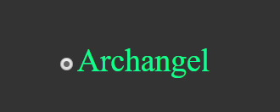

|  |
| --- |
| script.js |
| **function** *ElementClickEvent*(element) {  *//****TODO: Implement me...*** }  **function** *BackClickEvent*(elements) {  *//****TODO: Implement me...*** }  **function** *attachCreatureInfo*(elements, creatures) {  *//****TODO: Implement me...*** } |

## Obtaining Data with AJAX – 20 pts

You have been tasked to extract data about **elements** from a Firebase database, and render it into the **HTML** into a specific format.

You see where we are going? All the tasks you’ve done so far, combine in order to implement a complete application. Check your previous code, and **REUSE EVERYTHING POSSIBLE**.

* **1st**, send a **GET** request extract all elements, but **RENDER** **ONLY** the **ELEMENTS NAMES**. Render them in the **.container** **.containers** like the given HTML example in the previous problems. Then attach their **click events**.
* **2nd**, when single element is **clicked**, you should send **another** **GET request** to **LOAD** the elements’s creatures in **.left-after-click**.
* **3rd**, when a single creature is **clicked**, send **another GET request** to **LOAD** the creatures’s picture and creature’s data. **Render** the **picture** in a #creature-image and **data** render to **#right-after-click.**

The **following URL’s** are for the **Firebase data**:

* **All Elements**
* **https://js-retake.firebaseio.com/elements.json**
* **Single Element**
  + https://js-retake.firebaseio.com/{elementName}.json
* **Single Creature**
* **https://js-retake.firebaseio.com/{elementName}/creatures/{creatureIndex}.json**

**REUSE all functionality** from the **previous tasks**.

Write your code in the app.js file.

You will see several **screenshots** below which **describe** the **functionality**.

Here is the final HTML file you will need.

|  |
| --- |
| index.html |
| <!DOCTYPE **html**> <**html lang="en"**> <**head**>  <**meta charset="UTF-8"**>  <**title**>Title</**title**>   <**link rel="stylesheet" href="style.css"**>  <**script src="https://ajax.googleapis.com/ajax/libs/jquery/3.2.1/jquery.min.js"**></**script**> </**head**> <**body**> <**header**>  </**header**> <**main id="elementsContainer"**>  <**h1**>Choose Your Destiny</**h1**>  <**div class="container"**>  <**div class="containers"**>   </**div**>  <**div class="containers"**>   </**div**>  </**div**> </**main**> <**div id="elementInfo" class="no-display"**>  <**h1 id="elementInfoTitle"**></**h1**>  <**div class="back-button"**>  <**button id="backToElements"**>Back to Elements</**button**>  </**div**>  <**section class="second-layout"**>  <**div class="first-after-click"**>  <**ul class="creatures"**>   </**ul**>  </**div**>  <**div class="center-after-click"**>   </**div**>   <**div id="right-after-click"**>   </**div**>  </**section**> </**div**> <**script src="app.js"**></**script**> </**body**> </**html**> |

### Screenshots

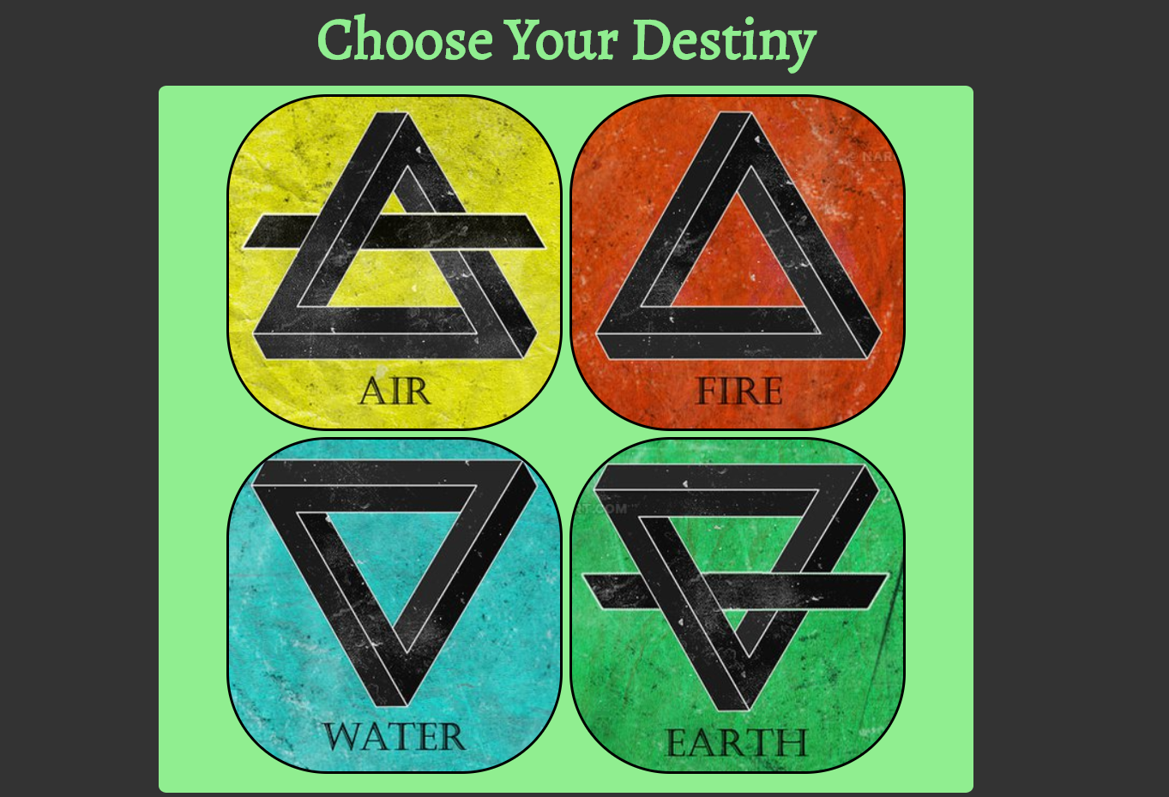

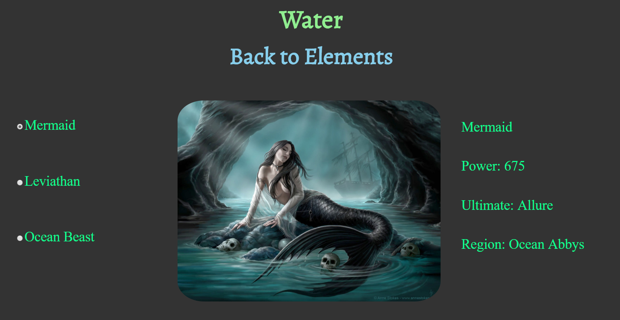

You will also be given a **GIF** in the **resources** which shows you the whole process.Your application will be checked thoroughly for mistakes and errors in the code. Make sure you implement everything correctly. Check your code at least **3 TIMES** before submitting it to ensure that everything is correct. Sometimes just because it looks correct, does not mean it is correct.