C:\Users\Gaby\Desktop\AI_Lunar\.venv\Scripts\python.exe C:\Users\Gaby\Desktop\AI_Lunar\Testare_model.py
=== Test 1: Puncte aleatoare (Model vs Ground Truth) ===
[info] DEM nativ: 92160x46080 px (~0.00391°/pixel). FINEST_RESOLUTION recomandat ≈ 29338.
Lat | Lon | Real (m) | AI (m) | Eroare (m)
-----------------------------------------------------------------
1.10 | 91.35 | -3751.5 | -3742.0 | 9.53
-79.50 | 128.27 | -3535.9 | -3546.0 | 10.06
67.36 | 27.87 | -1237.7 | -1224.0 | 13.71
48.34 | 86.27 | -192.7 | -164.5 | 28.16
-51.50 | 131.33 | -670.5 | -709.0 | 38.46
-2.06 | -80.37 | -159.1 | -130.2 | 28.83
25.87 | -127.25 | 3004.0 | 3106.0 | 102.04
27.62 | -21.73 | -1944.8 | -1934.0 | 10.82
-70.96 | -80.28 | 2077.2 | 2050.0 | 27.21
23.61 | 116.48 | 428.8 | 390.0 | 38.79

Eroare medie absolută (MAE) pe acest eșantion: 30.76 m
Eroare maximă: 102.04 m

=== Test 3: Evaluare statistică globală (RMSE) ===
[info] DEM nativ: 92160x46080 px (~0.00391°/pixel). FINEST_RESOLUTION recomandat ≈ 29338.
RMSE calculat pe 50000 puncte noi: 42.35 metri
=== Test 2: Generare profil topografic ===
[info] DEM nativ: 92160x46080 px (~0.00391°/pixel). FINEST_RESOLUTION recomandat ≈ 29338.

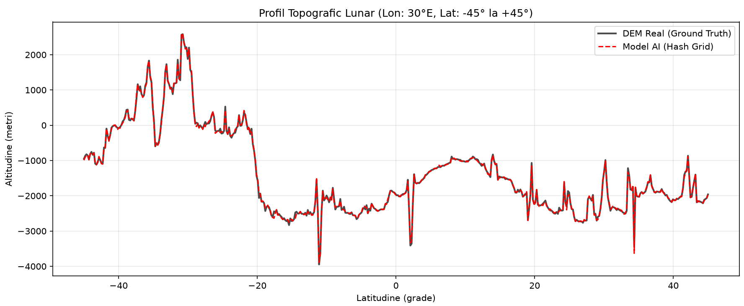

AI Lunar

C:\Users\Gaby\Desktop\AI_Lunar\.venv\Scripts\python.exe C:\Users\Gaby\Desktop\AI_Lunar\Testare_model_2.py
Device: cuda
Fisier de training potrivit checkpoint-ului: Fine_tuning_lunar_model
[fp32] lunar_altitude_contact_bands_finetuned.pt | 130.5 MB pe disc | metrica salvata la training=12.58 m (sqrt-Huber, nu RMSE real)
[fp16] lunar_altitude_contact_bands_fp16_finetuned.pt | 65.5 MB pe disc | metrica salvata la training=12.58 m (sqrt-Huber, nu RMSE real)
[info] DEM nativ: 92160x46080 px (~0.00391°/pixel).
[info] Benzi: centre [-90.0, 90.0]°, ±10.0° fiecare -> 11.1% din suprafata totala.
[memorie] embeddings fp32: 130.0 MB | deployment fp16: 65.5 MB

=== set 'uniform' (n=2000000) ===
metrica fp32 fp16
RMSE_m 23.3503 23.3510
MAE_m 9.9505 9.9518
bias_m 0.0770 0.0735
P50_m 6.8539 6.8555
P90_m 21.3110 21.3138
P95_m 28.2181 28.2235
P99_m 47.4905 47.4924
P99.9_m 97.4736 97.4816
max_m 4664.9818 4666.1629
R2 0.9998 0.9998
<1m_% 8.3380 8.3307
<2m_% 16.5168 16.5058
<5m_% 38.6412 38.6386
<10m_% 64.9880 64.9847
<25m_% 93.1475 93.1465
<50m_% 99.1586 99.1591
fp16 vs fp32 (diferenta directa): RMS=0.18393 m | P99.9=0.8172 m | max=5.1012 m
banda -90° (n=999905): fp32: RMSE=18.199 MAE=10.000 | fp16: RMSE=18.197 MAE=10.002
banda +90° (n=1000095): fp32: RMSE=27.554 MAE=9.901 | fp16: RMSE=27.556 MAE=9.902

=== set 'focus' (n=1000000) ===
metrica fp32 fp16
RMSE_m 30.7892 30.7902
MAE_m 10.3026 10.3039
bias_m -0.0051 -0.0072
P50_m 6.9372 6.9392
P90_m 21.3640 21.3782
P95_m 28.2621 28.2655
P99_m 47.8478 47.8623
P99.9_m 127.0739 127.1138
max_m 6594.6512 6592.0326
R2 0.9997 0.9997
<1m_% 8.2827 8.2824
<2m_% 16.3813 16.3742
<5m_% 38.2562 38.2480
<10m_% 64.6259 64.6234
<25m_% 93.0978 93.0983
<50m_% 99.1338 99.1349
fp16 vs fp32 (diferenta directa): RMS=0.19411 m | P99.9=0.9109 m | max=6.0408 m

=== Test gradient (pas = 1.0 px DEM) ===
lon: GT_slope_RMS_m=12.294 | fp32_slope_RMSE_m=9.941 | fp16_slope_RMSE_m=9.941
lat: GT_slope_RMS_m=14.803 | fp32_slope_RMSE_m=5.848 | fp16_slope_RMSE_m=5.848

Gata. Grafice + metrics.json in ./eval_out/

Process finished with exit code 0

