Proiect Linux:

**Given 2 folders named: Financials and NAS_IN, present in Desktop, execute the following:**

1. **Manually create the folders with the following permissions:**

**- User has Read, Write, Execute**

**- Group has Read & Execute**

**- Others have nothing**

1. **Manually create a file in NAS_IN named banking_data.txt with full rights for everyone, that contains the following:**

**Value$ Name1 Name2 Car (See example below)**

**3. Create a bash script that will:**

**Automatically create 3 files in Financials folder: (money.txt, name.txt, car.txt)**

**Then the script should be able to output them into the files as it follows:**

* **Move only the first column values into money.txt**
* **Move only second and third column values into name.txt**
* **Move only third column values into car.txt**
* **Create a backup folder inside Financials folder and copy the files there with the name : m.txt, n.txt, c.txt**

**- Print each file from backup folder to the terminal in the end**

Creare banking_data:

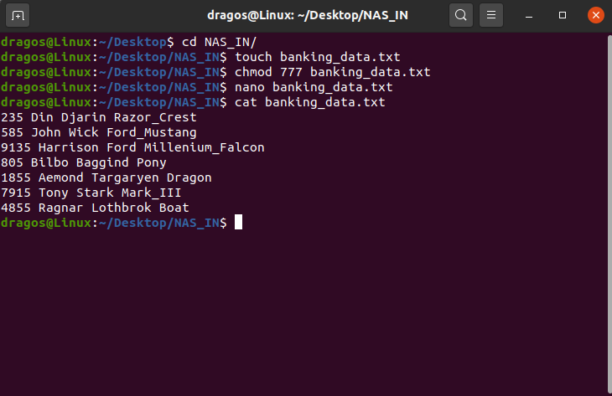

Creare foldere:

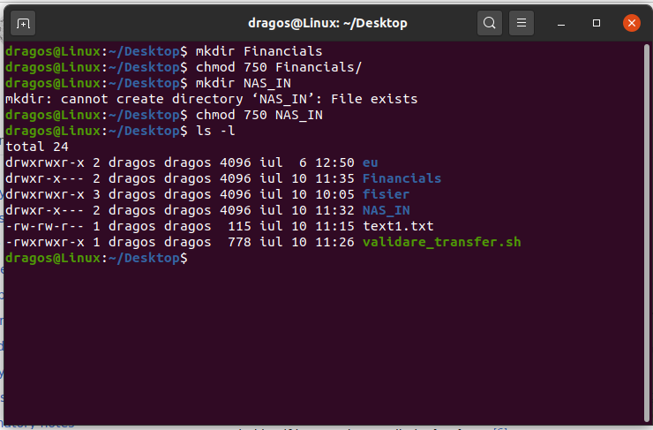

Script(denumit script.sh):

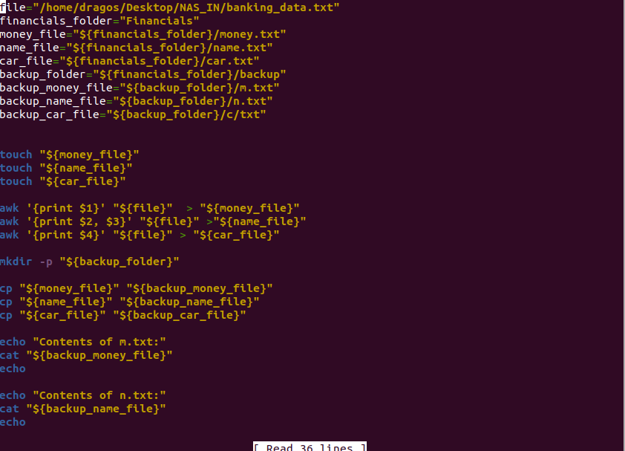

Rezultat:



Structura dupa rulare:

