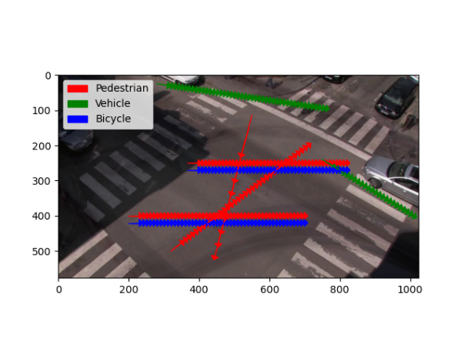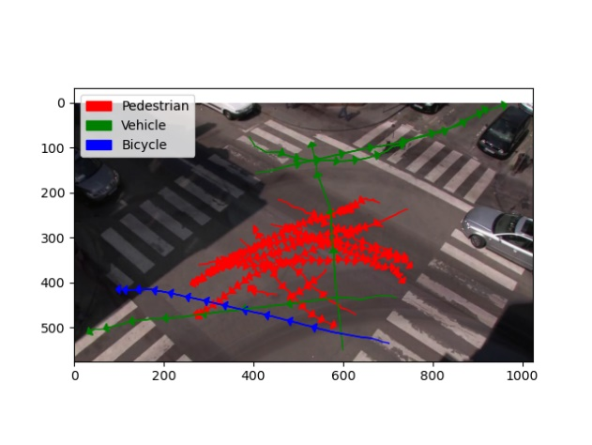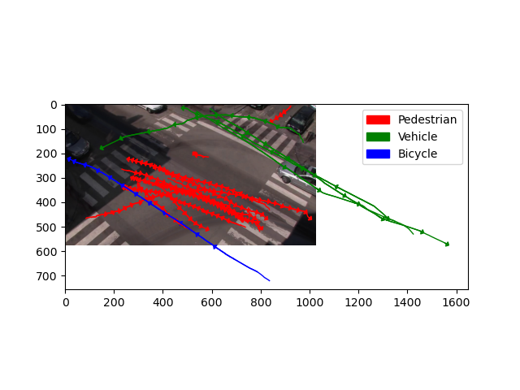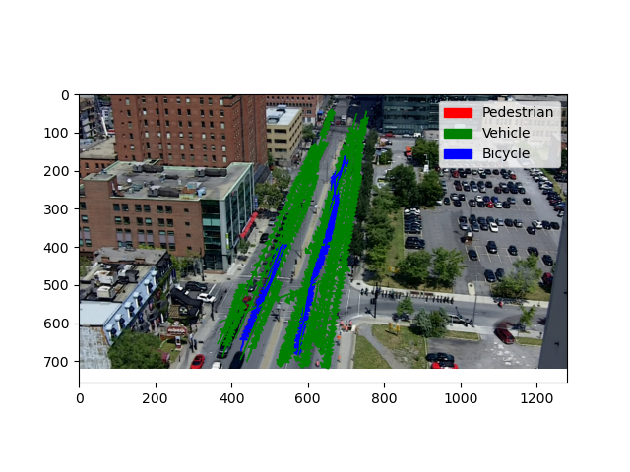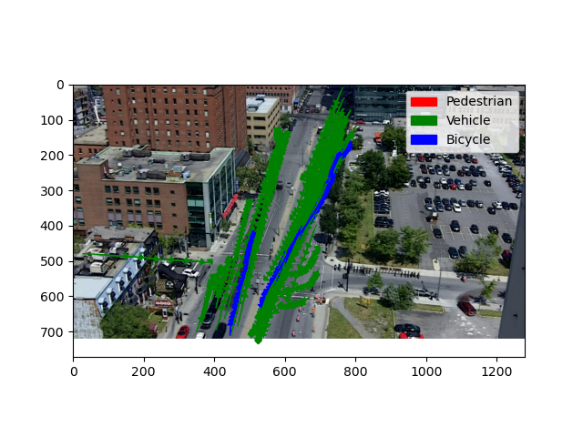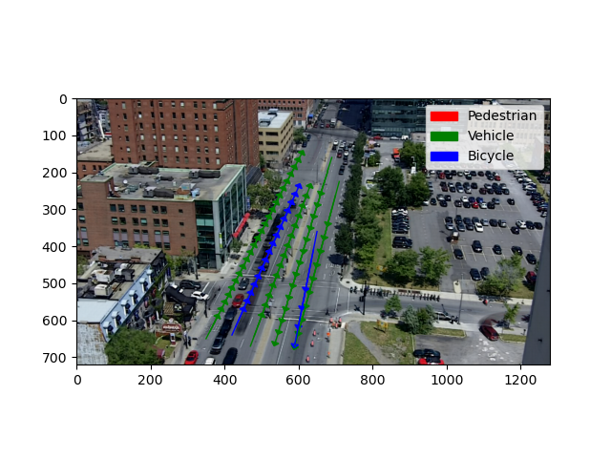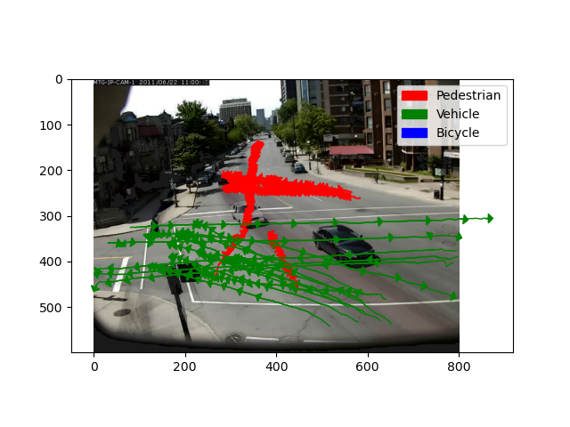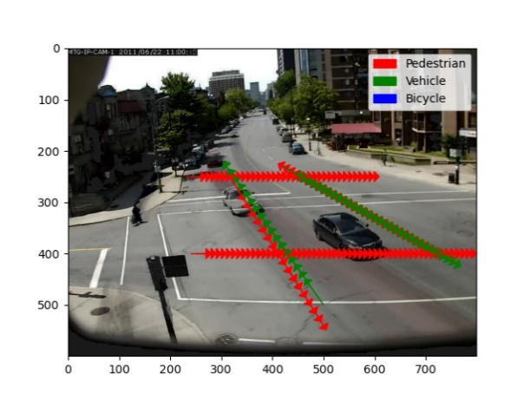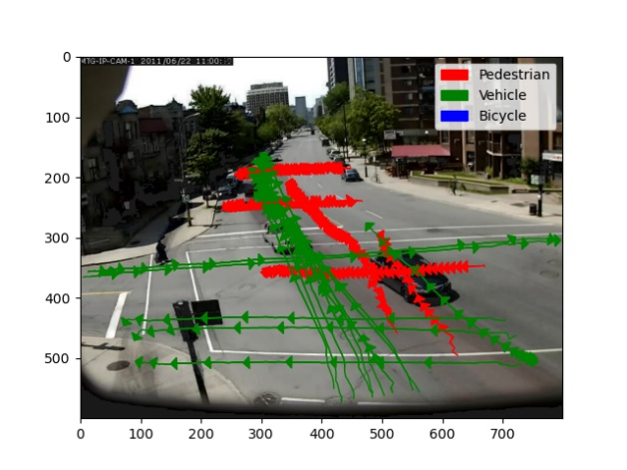Appendix A

Figure 3: Rouen abnormal data

Figure 2: Rene abnormal data

Figure 1: Sherbrooke abnormal data

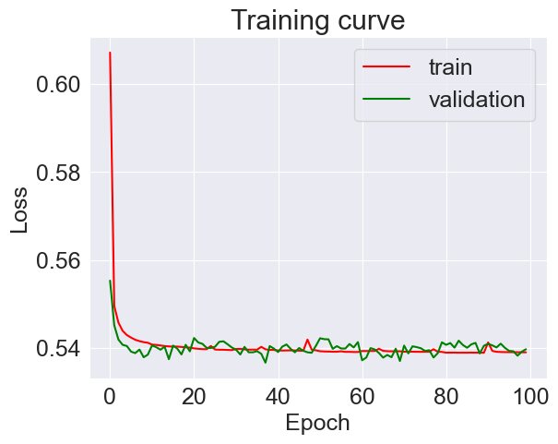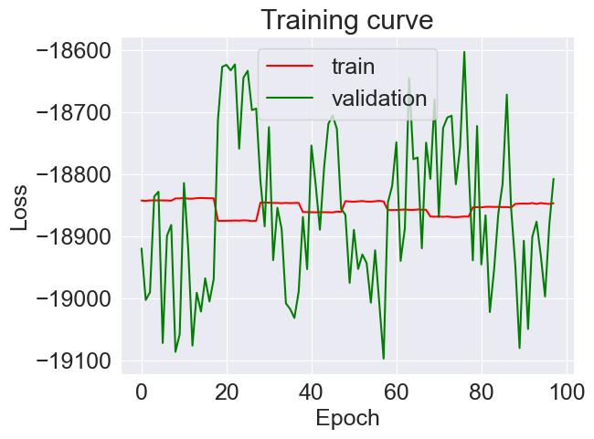Appendix B

Figure 4: Effects of normalization on the training performance of the network. Without normalization (left plot) the model is not learning since the loss is not decreasing with each epoch. On the right however, when data is normalized, the loss function decreases so the network is learning.

Appendix C

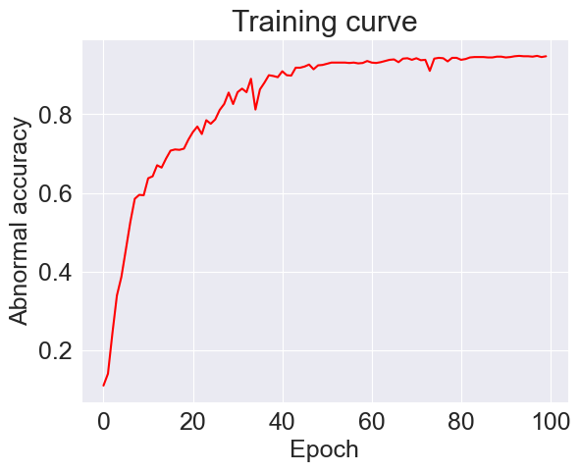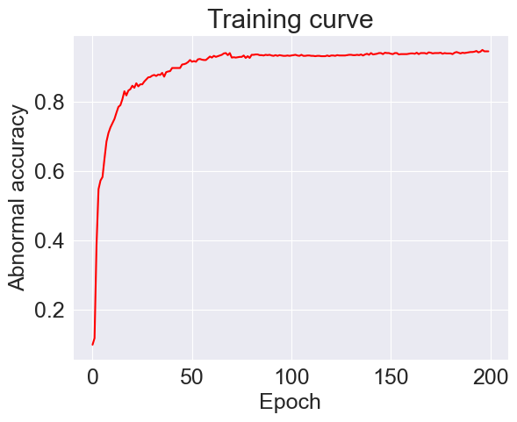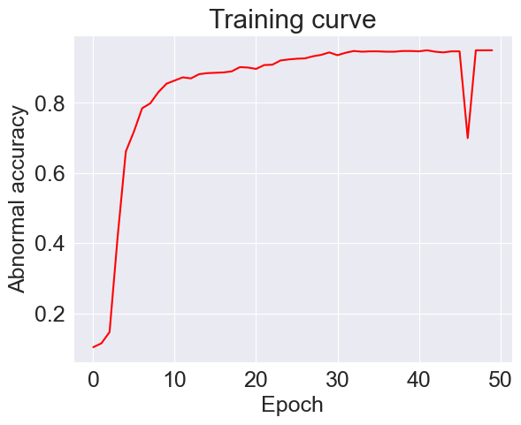

Figure 7: Accuracy of models using cross validation with k=5 (left), k=10 (middle), k=20 (right). Results are similar but training with 20 folds takes significantly more time.

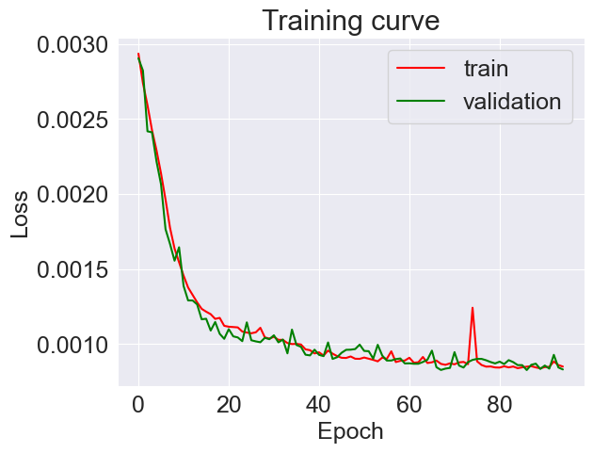Appendix D

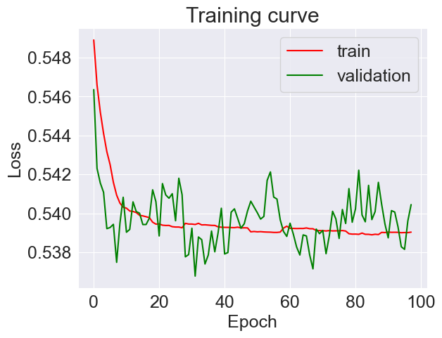

Figure 6: Mean Square Error loss (right) produces a smoother curve for the loss function, compared to Binary Cross Entropy loss (left), which produces a lot of spikes, especially in validation. Results are similar but MSE is preferred