Task 0:
Understand the concept of entropy from both the thermodynamic and information theory points of view.
Research proper documentation on the matter and find out the equations for Boltzmann Entropy and Shannon Entropy.

Implement a 3d particle simulation inside of a cube.
The number of particles inside of the cube should be controllable interactively via a slider. Initially, particles (represented as small 3d spheres) will be scattered randomly inside the cube. Their initial velocity vectors will be set up randomly as well. Collisions between particles and with the inside walls of the cube need to be handled. We consider the cube as being split into n * n * n smaller subcubes. The purpose is to compute the entropy of each of the subcubes using either the Boltzmann or Shannon techniques or both and to use a colour spectrum to depict each subcube's entropy in real time.

You can choose any framework and computing programming language you like to solve the task.

Thermodynamic entropy
In thermodynamics, entropy is the cost paid for converting energy into work / the degree of randomness or disorder in a physical system.
- The second law: total entropy of an isolated system can never decrease over time. Everything naturally moves from a state of order to a state of disorder (the idea of a drop of ink spreading in water)
- The microscopic view: Ludwig Boltzmann – entropy is related to the nr of ways you can rearrange the particles of a system (microstates) without changing its overall look (macrostates).
- Boltzmann entropy formula:
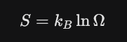

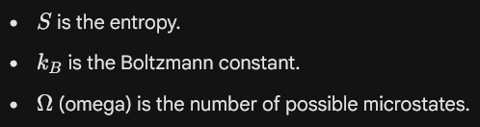

Information Theory Entropy
In the 1940s, Claude Shannon adapted the concept to describe the "surprisal" or information content of a message. Here, entropy isn't about heat; it's about uncertainty.
- High Entropy: A message where the outcome is hard to predict (e.g., a fair coin flip). You gain a lot of information by learning the result because you couldn't have guessed it.
- Low Entropy: A message where the outcome is predictable (e.g., a two-headed coin). You gain very little information because you already knew what was going to happen.
- Shannon’s entropy formula:
