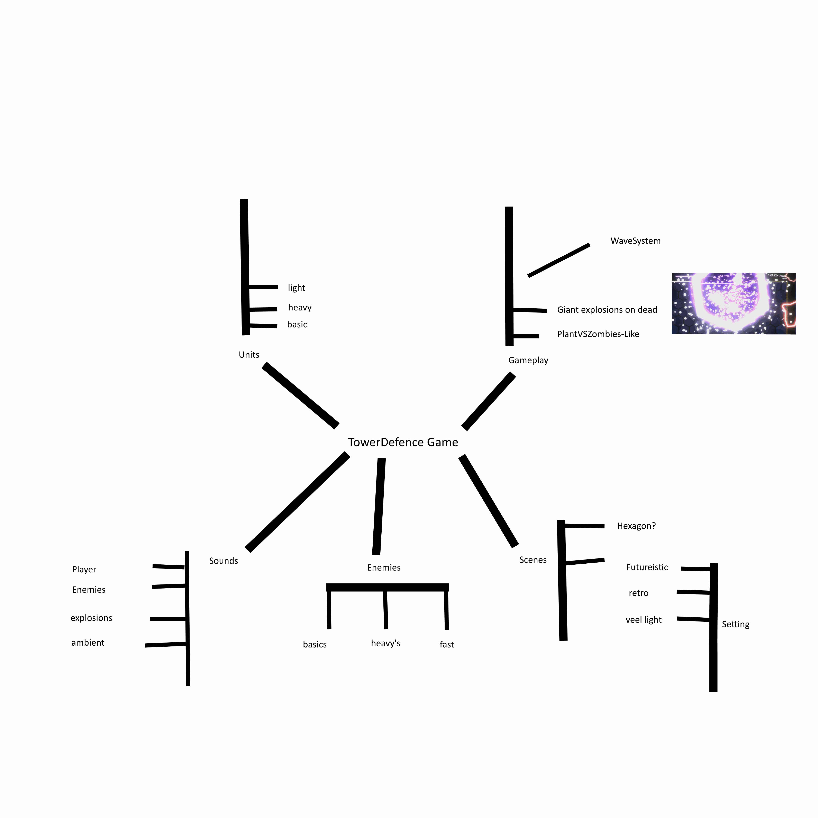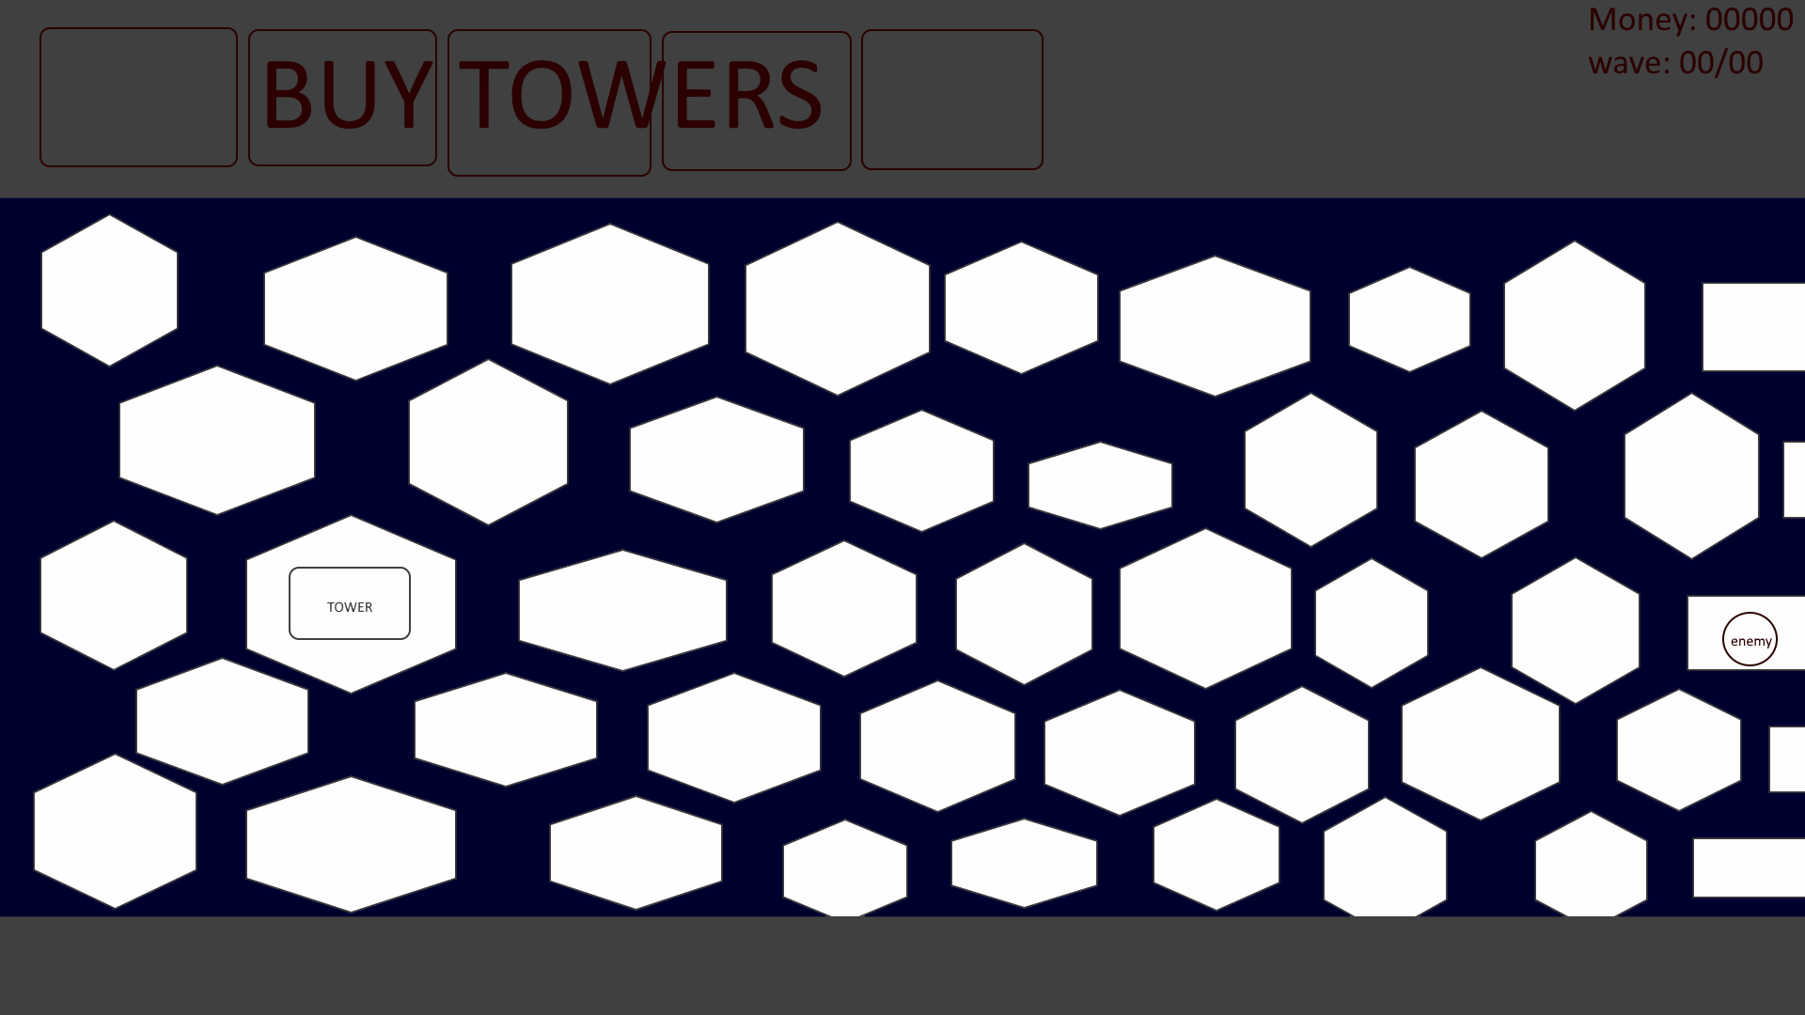

It basically has the plant vs zombies system. Enemies come from the right and you and your towers shoot the enemies before they reach the base.