The Portfolio of Ben Edwards

Introduction:
Welcome to my portfolio:
MY name is Ben Edwards and I have studied at Pembrokeshire college for my BTEC diploma and am waiting to graduate from the University of South Wales for my BEng qualification in Electrical and Electronic Engineering. Enclosed in this document will be examples of my academic work including my final year project.
This portfolio will showcase multiple projects of mine that will highlight technical and engineering abilities that I have conducted in my academic past. This will also include sections presenting my plans as well as aspirations I desire to pursue in the course of my future career.
In the course of my education, I was able to complete all of the coursework and assignments presented to me, including a thesis on the simulation of self-mixing interferometry, which will be covered more in depth in a dedicated section.
Related files and documents to each module mentioned in this portfolio can be found, where available, within the zip file that this document was found in.

Career Plans:
I plan to take my career into a path that includes the development of neural network systems after learning about it from a close friend. As a result, I took up a course on Coursera by Laurence Moroney. This has only increased my interest in learning how neural networks are constructed and prompted me to plan on acquiring multiple qualifications, thus becoming a valuable addition to a project.
As of yet, there is no particular subject that can be used in conjunction with neural networks that I have gravitated towards. So hopefully, over the course of my future career, I will be given the opportunity to observe and take part in various projects that I will begin to take a great interest in and hopefully specialise in that area.

Final Year Thesis Project:
My final year Thesis had the title of ‘Simultaneous Measurement of absolute distance and displacement using self-mixing interferometry’. To explain this project in short, the displacement is the distance of the vibration of an object, like a speaker, and the absolute distance is the physical distance between the target speaker and the laser source. The laser being used to measure these distances using the process of self-mixing modulation.
Self-mixing modulation occurs when the light is reflected off of the target and re-enters the cavity of the laser source which, when modulated with the frequency that the speaker is vibrating at, will produce ‘fringes’ that can then be halved and multiplied by the laser wavelength to calculate the displacement value. To calculate the absolute distance a different method would be needed involving an ‘injection current waveform’ at the input of the laser source supply. This will create a similar process, but instead of the modulation being driven by the speaker vibration it would be driven by the slight change in laser colour from the injection current. This change in colour produces this effect due to the change in wavelength, as each colour will produce its own wavelength. This will then create fringes in the signal which can be observed with an oscilloscope and multiplied by the wavelength to give the absolute distance.
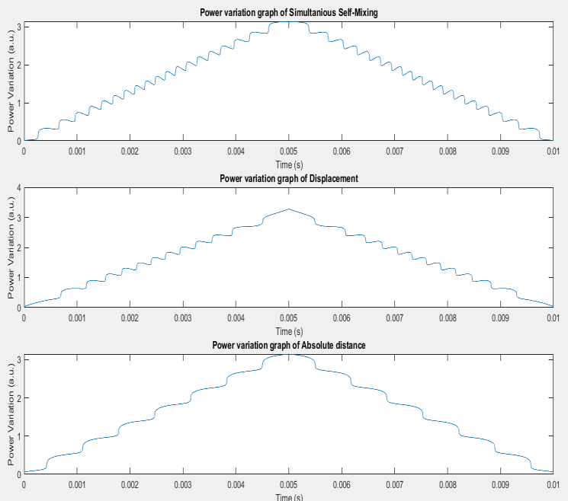
Figure 1 Absolute distance, displacement, and self-mixing waveforms with fringes
The aim of this thesis was to simultaneously measure these values, which would mean to have the fringes from each modulation method be combined into a single waveform signal. I was unable to do this as there was no clear way to distinguish between the fringes and separate them into their respective absolute distance and displacement groups.
As this was a simulation project, I had to use the mathematical simulation programming software MATLAB to write a script that would allow for this process to be simulated.

Machine Learning introduction with TensorFlow and Python (In Progress):
Currently I am in the process of studying Machine learning with Tenserflow with a course on Coursera by Laurence Moroney. I am currently on track to finishing the second section of the course which entails the process of training the network to recognise 28x28 pixel images of items of clothing. This section teaches how to organise these images by using a greyscale image with an assigned number in a 28x28 format to define the depth of the dark and light pixels before being normalised for easier processing. Flattening the image into a linear array then follows suit before training the network is then followed.
In the first section, the course taught the basic fundamental information on how the code for a neural network is typically structured and the rule that a neural networks job is to take the data set and the answer in order to calculate and work out the rules. Doing this will allow the network to use these newly created rules and apply them to situations that would typically be too difficult to define in an algorithm by a human. Using this information, I was able to create a network that would tell me the cost of a house which increased in price with the number of rooms it had. For example, the house starts at 50k + 50k per room. The network was able to accurately predict the total cost of a house with 7 rooms at 400k.
I found this course to be extremely interesting / investing and I cannot wait to continue to dive deeper into the world of neural networks where I hope a strong future career path is waiting for me.

Rocket society:
The Rocket society was a club with a previous history from past students. The lecturers of my course had first brought this to light of the class to recruit new members. I volunteered for this as I wanted to learn more about how rockets operated during flight and the preparation needed before a launch.
We were taught how to use a piece of software called ‘OpenRocket’ where I would then design the shape, the rocket type and the materials of our rocket while also selecting the weight of the payload. The payload weight would represent the combined weight of the nano satellite and the circuitry required to monitor the rockets speed, altitude, and GPS location. Using this software, a simulation of the flight could then be running to calculate the probable height and speed of the rocket.
With the design of the rocket and a motor selected, the aim of this society was to reach an altitude of 6000 feet where the electronics would cut the motor and a parachute would be deployed to safely land the rocket where we would then recover it.
My objective was to write the program for these sensers where the information would then be relayed back to our control laptop on the ground. However, unfortunately, I was unable to complete this task because the launch had to be cancelled due to covid that year and all our production had to be halted.

University Course Modules:

C Programming Year 1:
During this module we were introduced to the foundation of C programming which included concepts such as variables, if statements and logic functions, including learning how switch statements are used, learning how to shift bits, and using pointers to point at a specified value. I was taught how to approach programming from an efficiency perspective. An easy example of this would be using switch statements over a long list of ‘if else’ statements as ‘if’ statements have to check each argument one at a time, wasting processing power.
For the assignment in this module, I was tasked with writing multiple functions that would conduct a specified task, which these functions could then be accessed inside the program by navigating a custom menu in a command prompt window constructed using switch statements.
These tasks included…
- A series of logic gates would be simulated using AND plus OR operators which the user can then select from the custom menu before being prompted to input binary inputs for input A and input B.
- A Mathematical equation was then tasked to be completed where the user would create two arrays of numbers and the elements of one array would then be multiplied by the respective element of the second array using a pointer before then being summed together.
- Using switch statements, the following task was to then simulate the process of a set of CPU instructions using the skills acquired from the previous tasks.
- The final and optional task required the use of a brand-new software development environment called e2 studio. This program is used to write programs for an embedded system. This task was only a simple introduction to the new development environment by requesting that I produce a clock program that would loop indefinitely if left unattended.
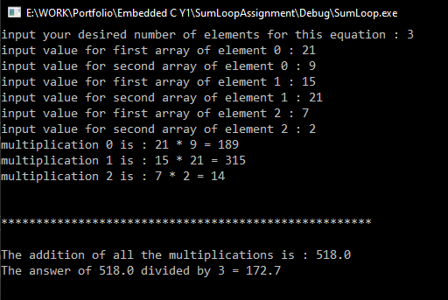
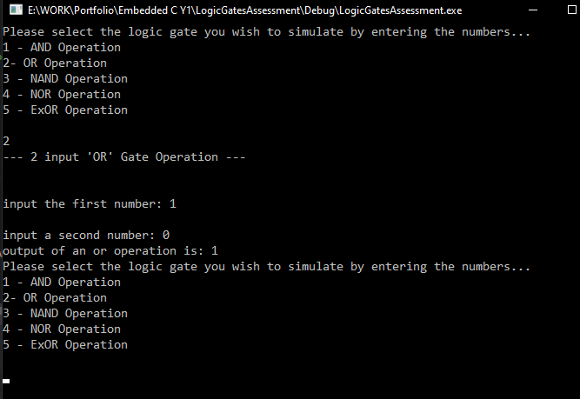
Figure 2 Sum Function Program
Figure 3 Logic Gates Algorithm Program

Embedded Programming in C Year 2:
This Embedded module was taken in my second year of university and went into further depth of the e2 studio development environment. Throughout this module I was provided a microprocessor development board called the Rx63N which I had spent the year learning about.
In this module, I was taught about how to create a delay in the program clock loop that would be converted to a delay in seconds. This would allow for the future use of incrementing seconds in clocks and timers for this module’s assignment.
The module also taught me the relationships between physical interactive components and the signal being received and transmitted by the embedded processor. An example of this would be the occurrence of a double bounce every time a button is pressed causing unwanted actions in the case of a stopwatch program, this would only sometimes stop the timer when the button is pressed leading to an unreliable system. A solution to this problem would be to implement a delay function.
The tasks for the assignment included…
- A stopwatch or countdown timer where the user can set and reset the starting time for the countdown on an LCD screen with the ability to pause and resume the count. When the timer reaches zero then there will be a flashing LED as an alarm.
- The count-up timer will count up in seconds from zero with the ability to start and stop the count-up with a single button as before, using the third button to reset the timer again.
- A chess clock is then next for this where the same time is set for both players as before in the stopwatch function. However, each players timer will be alternating their countdown, triggering the switch when the player makes a move and presses a button to end their turn. When one of the timers counts down completely, there will be an alarm in the form of a flashing LED once more.

Engineering Applications
In this module I would practice my soldering skills by soldering a cube using rigid wires and soldering wires across a PCB board. After moving on from this I then soldered THD components to a PCB I had designed in Proteus, a circuit designing program. After producing a bill of materials for the encoder and decoder PCBs I had designed, they would then be sent off to the technicians where they would be printed a week later.
After practicing my soldering skills and retrieving the new printed PCB, I then began to construct the Encoder/Decoder and tested the device with a 5V supply.
This module has helped me to learn the basic structure and processes of manufacturing a PCB from the design element to the bill of materials, the printing and then finally bringing it all together for the soldering process and testing.
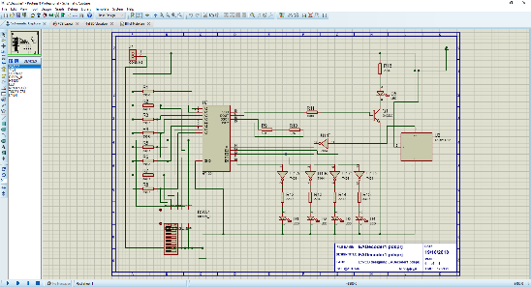
Figure 4Circuit Design for the Decoder

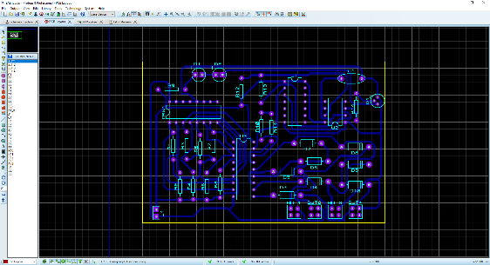
Figure 5 PCB and trace design for the Decoder

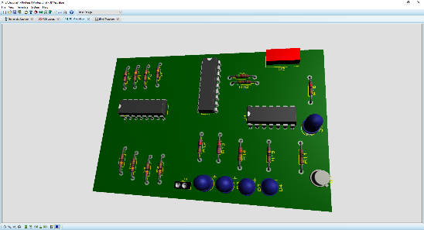
Figure 6 A 3D representation of the Decoder

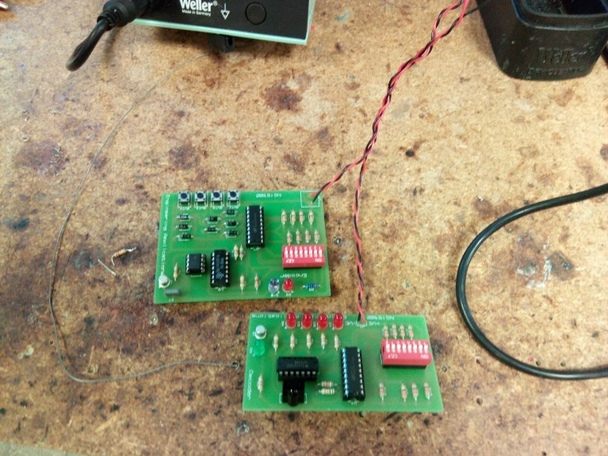
Figure 7 The completed and soldered Decoder and Encoder circuits

Analogue and Digital Electronics First and Second Year:
The first year of this module had a heavy emphasis on the simulation of analogue and digital circuit designs. This simulation was conducted in the simulation program known as Multisim. Here, I would be able to use real world industry components in a simulation setting and accommodates for any real-world fluctuations in component values.
The assignment involved the simulation of…
- An inverting Operational amplifier system
- A non-Inverting Op-Amp
- A half wave rectifier circuit that converts an AC supply into a DC supply
- A full wave rectifier circuit that converts an AC supply into a DC supply more efficiently
- A logic gate simulation where a series of logic gate functions are recreated using only NAND gates.
- A full adder circuit using D type flip flops that add together two digital binary numbers into a binary output number. This was conducted using a 4-bit and an 8-bit adder circuits.
- And a synchronous counter circuits that have the ability to count up and down and reset when the counter reaches a certain set value using logic gates to trigger this.
The second year involved more practical circuit building and testing on a breadboard and oscilloscope, with the majority of simulations once more which included…
- Simulating and building a Class A and B amplifier circuits recording my results.
- Simulating low pass, high pass filters and measuring their results using a bode plot graph.
- Finally, I Then designed and simulated a state machine for a vending machine system.

Analogue and Digital Communications
This module had me use a series of electronic signal and audio modules to experiment and test the modulation effects of FM modulation, AM modulation and shift keying. In groups of three, we would work together to set up the system and take various measurements using an oscilloscope. This process would take us a few hours per assigned task booklet. I then finished the module by using Simulink to simulate these different modulation schemes.
The total tasks included…
- Creating new waveforms using Harmonic signals in the lab
- Recreating and testing Amplitude modulation in the lab
- Recreating and testing Frequency modulation in the lab
- Looking and simulating analogue and digital modulation systems in Simulink

Figure 8 Amplitude modulation sine wave
Figure 9 Harmonically created Triangle waveform.

Figure 10 FM modulated signal in Simulink.
Figure 11 Signal noise ratio at 50dB

Mathematics for Engineers
In this module I was being taught different techniques that would be required of me throughout my university course as a developing engineer. But the last half of this course required me to learn and use the MATLAB software and programming language to preform calculations quickly and efficiently on complex formulas that would otherwise be impossible to do without a computer.
For this I had to work through a workbook for weeks before taking an hour-long practical test to see how much of that knowledge I had retained through this exercise.

Electrical Principles and Analytical methods:
This module furthered my understanding of MATLAB by delving more in depth and applying engineering problems for me to solve. These engineering problems involved the design and structure of a control machines theory using transfer functions, root locus and PID controllers.
As well as preforming all these tasks by programming them in MATLAB, I had also used Simulink to create a visual block diagram that would be simulated to provide a result for the designed control system. This was the prime environment to experiment and study the effects of the PID system and how the change in k gain values effected the output of the system.
This was also used in my Power, Machines, and control module where I had to design a PID system that provided a step response suitable for controlling an aircraft roll pitch and yaw.

