PROJECT 3: SIEM DEPLOYMENT
“SECURITY OPERATIONS REPORT”
Compiled by: Gberemor Solomon
TechCrush no. CYBE/2026/TC-7/0747
Class: Cyber Security Class B, Cohort 7
Team Members: CYBE/2026/TC-7/0590, CYBE/2026/TC-7/0452, CYBE/2026/TC-7/0747
Date: 21 July,2026

INTRODUCTION
Our team was asked to act as a newly formed security operations centre (SOC) for an organization with no central oversight into its network. We were tasked with deploying a security information and event management (SIEM) solution from the ground up, using wazuh, and proving it could collect logs from real systems and detect real attacks.
This report shows how we deployed the wazuh SIEM, connected two endpoints: “ubuntu linux machine” and “windows 10 machine.” We however, simulated three different attacks against those endpoints, and analysed the logs triggered to confirm that our SIEM could detect them.

THE PROJECT AIMS
- Deploy a central wazuh manager and connect endpoint agents to it
- Ingest windows event logs and linux syslogs/authentication logs
- Simulate at least three real-world attack vectors against our own endpoints
- Detect and analyze the logs and alerts generated by those attacks
- Produce a formal incident report for one of the simulated attacks

ARCHITECTURAL TOPOLOGY
The diagram below shows the full layout of our the “SIEM” workplace. The wazuh server, which runs the manager indexer, and dashboard, sits at the centre and is connected to two endpoints over a virtual box host only network.
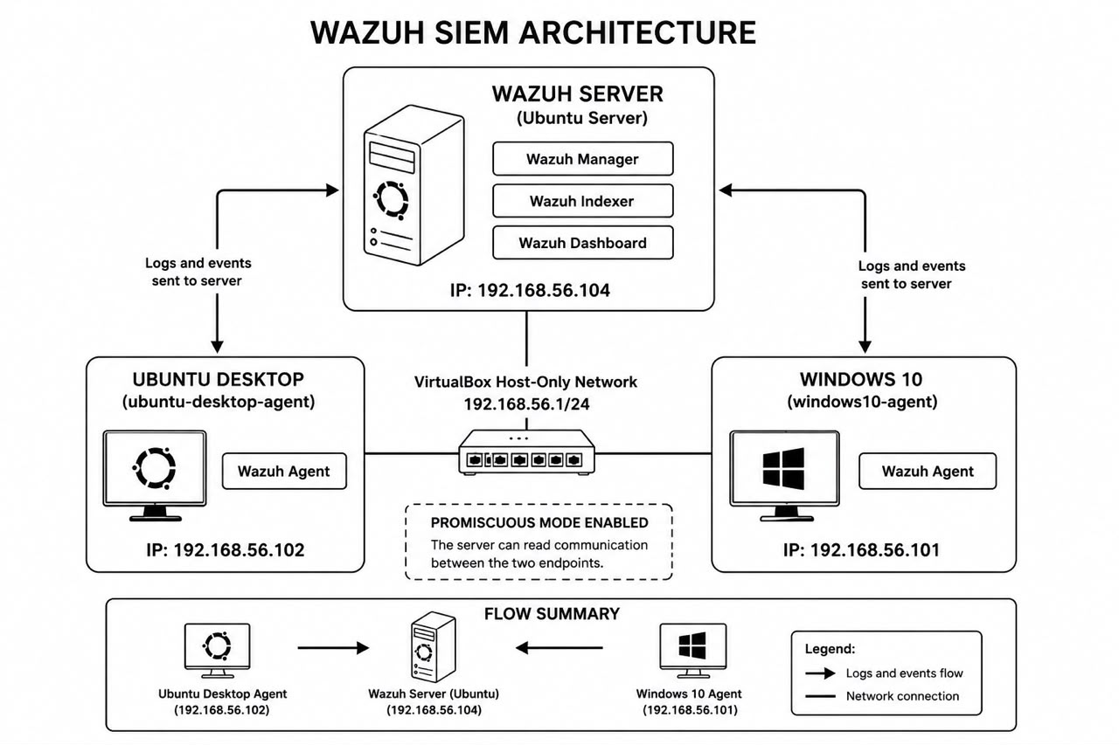
This network diagram shows the wazuh server and both connected endpoints, with the IP addresses
Here, the wazuh server runs on ubuntu server at IP 192.168.56.104. It is connected to two endpoints: the ubuntu desktop agent at IP 192.168.56.102, and the windows 10 agent at IP 192.168.56.101. Both endpoints send their logs and events to the server over the 192.168.56.1/24 network agent. The promiscuous mode is enabled on the network so the server can read traffic between the two endpoints.

THE INFRASTRUCTURE and LOGS INGESTION
We started building our infrastructure on July 17, 2026. Here, we deployed the wazuh manager on an ubuntu server,hostname, “ubuntu server” and connected it to two endpoints, an ubuntu desktop machine, hostname, “ubuntu lab” and a window 10 machine, so both could forward their logs to a single centralised dashboard.

THE INSTALLATION PROCESS
We used oracle virtualbox to create three virtual server to act as the wazuh manager the “ubuntu desktop machine, the windows 10 machine and the last two acted as our endpoints.
We first installed the Wazuh manager on the ubuntu server. After installation, we checked that the wazuh manager service was running properly using the command sudo systemctl status wazuh manager. The service showed as active and running, with all its core processes, such as wazuh analysisd, wazuh remoted, and wazuh log collector, working correctly.
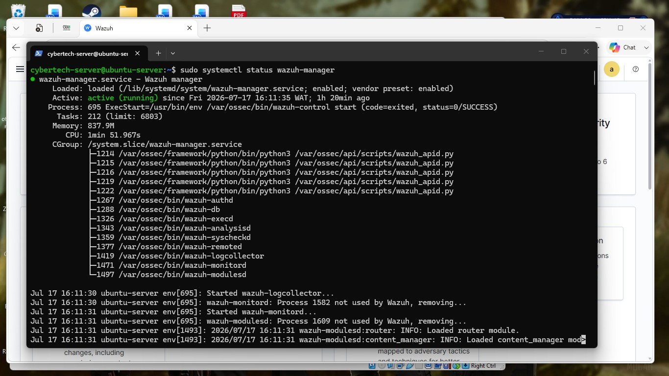
This is the terminal output confirming that the wazuh manager service is active and running
We then installed the wazuh agent on both endpoints and connected them to the manager. Then after installation, we confirmed that both agents were active. The wazuh endpoints summary dashboard show two active agents: ubuntu desktop agent (ID 001, IP 192.168.56.102, running uuntu 22.04.5 LTS) and windows10 agent (ID 002, IP 192.168.56.101, running windows 10 Pro). Both agents were on version 4.14.6 and connected to the same manager node.
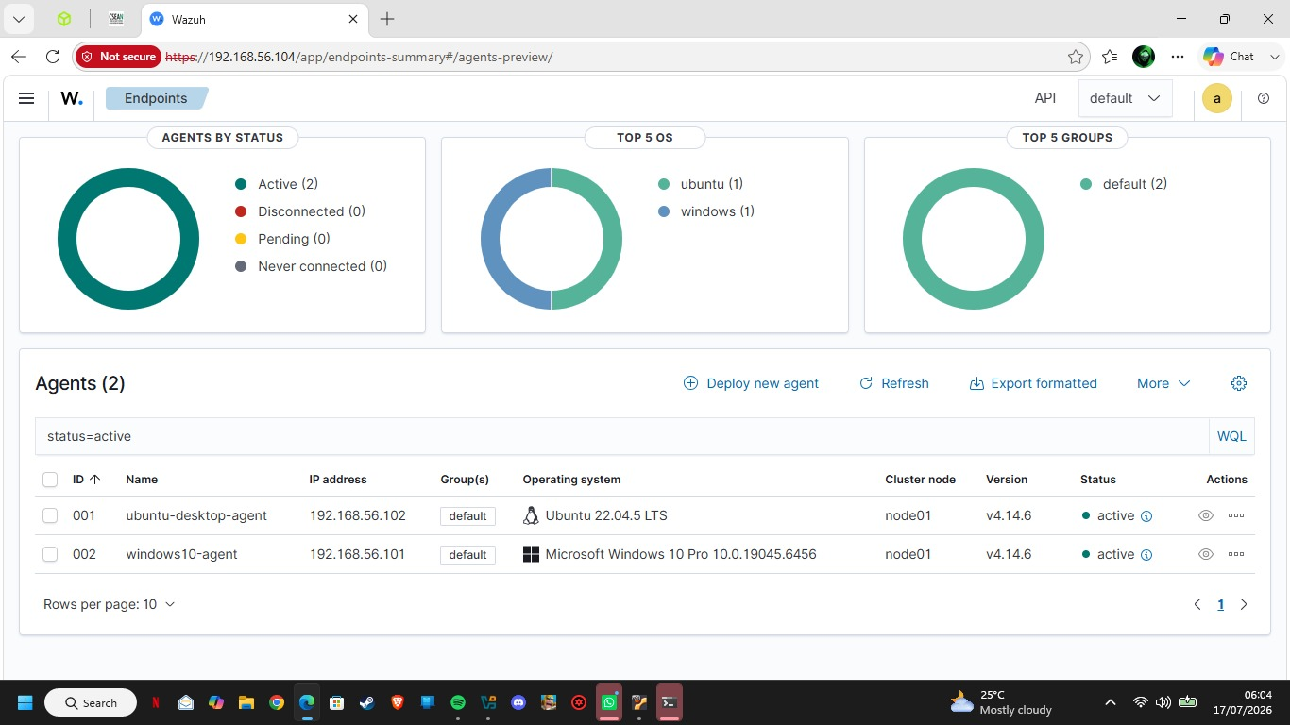
Here is the wazuh endpoints summary dashboard showing both agents as active

TELEMETRY CONFIGURATION
On the ubuntu endpoint, we edited the agent configuration file “ossec.config” to collect the important log files. We then added log sources for the authentication log “/var/log/auth.log”, the system log “/var/log/syslog”, the package installation log “/var/log/dpkg.log”, and the active-responses log. After saving the file, we restarted the agent using sudo systemctl restart wazuh agent and confirmed it was active and running again.
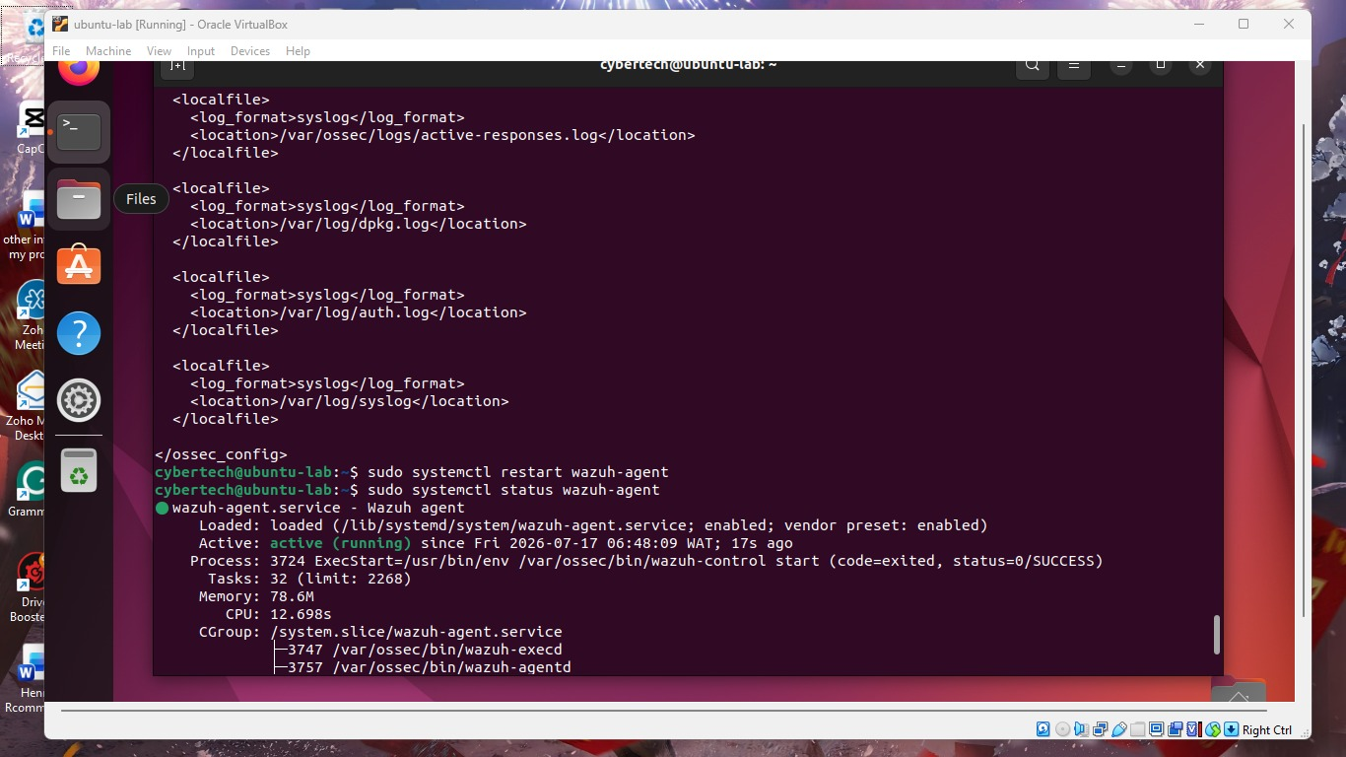
The ubuntu agent ossec.conf showing configured log sources, and the agent service running after restart
Then on the windows endpoint, we edited the ossec.conf file to collect windows event logs. We configured three log channels: “Application, security (with a filter to remove unimportant, noisy event IDs), and System.” This allowed the windows agent to forward important system, application, and security events to the wazuh manager.
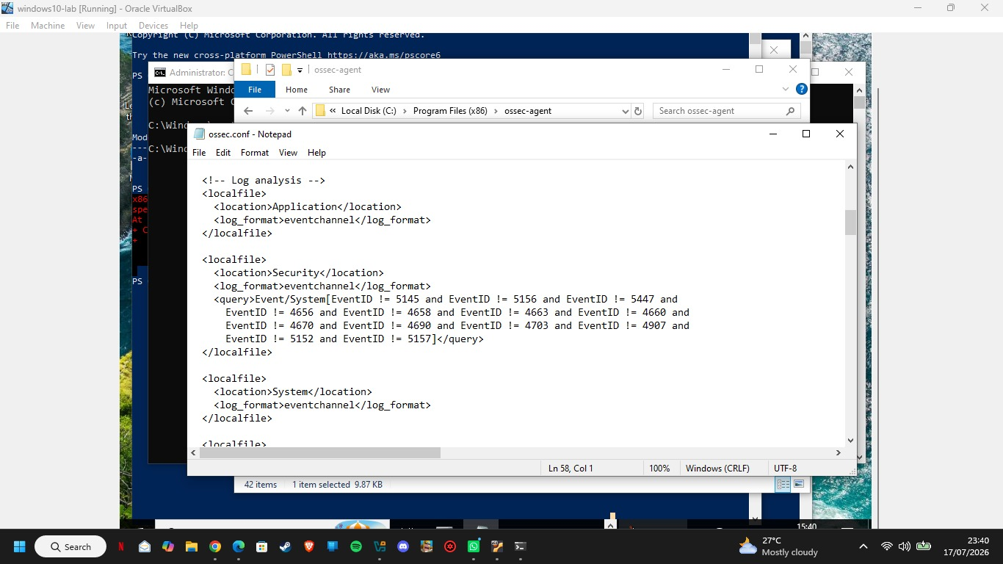
This is the windows agent ossec.conf showing the application, security, and system log channels configuration

PROOF OF INGESTION
After configuration, we confirmed that both endpoints were sending logs correctly by checking the wazuh threat hunting dashboard.
For the ubuntu endpoint (ubuntu desktop agent), the dashboard recorded 560 total alerts for the week, with 6 authentication failures and 50 successful authentications. The most common alert groups included syslog, pam, sudo, and apparmor.
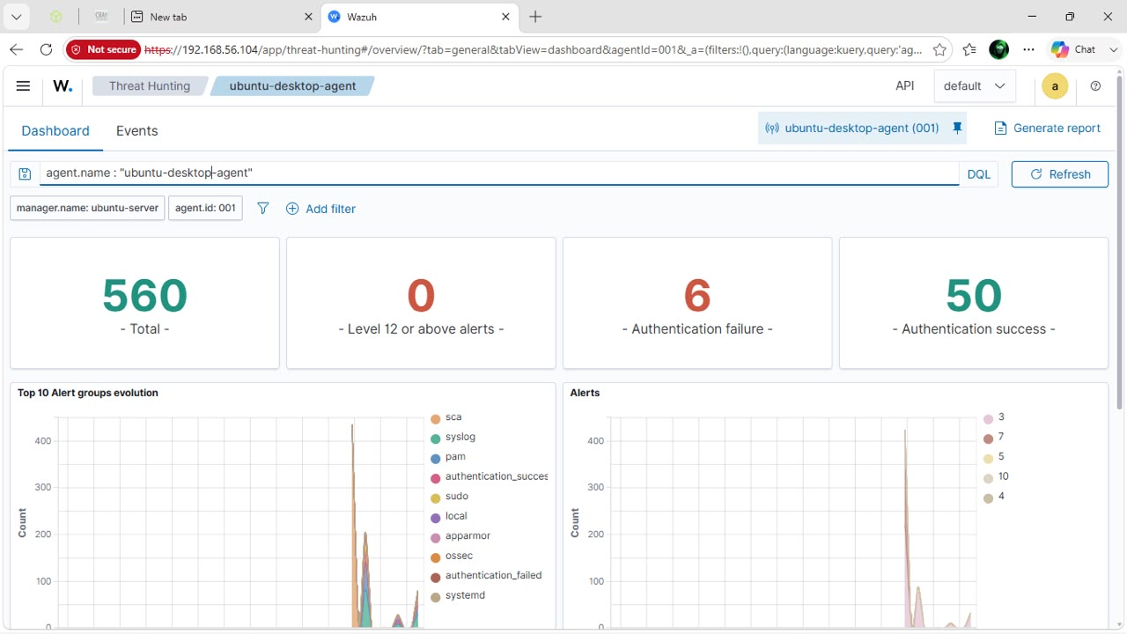
This screenshot is the wazuh dashboard for ubuntu desktop agent showing total alerts and authentication activities
For the windows endpoint, “windows10 agent”, the dashboard recorded 992 total alerts for the week, with 0 authentication failures and 6 successful authentications. The most common alert groups included windows, windows application, windows security, and policy changed.
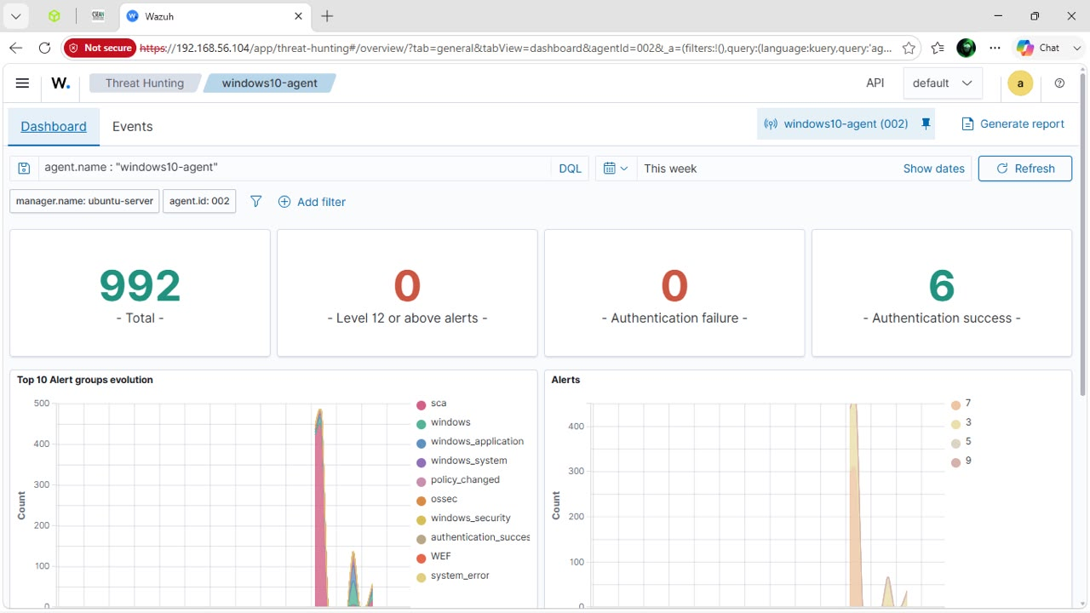
Here is the wazuh dashboard for windows10 agent showing total alerts and authentication activities.
We also checked the raw event logs for both agents under the events tab. For the ubuntu agent, we could see real log entries such as PAM login sessions, sudo attempts, and Apparmor denials, confirming that authentication logs and syslogs were being received rightfully.
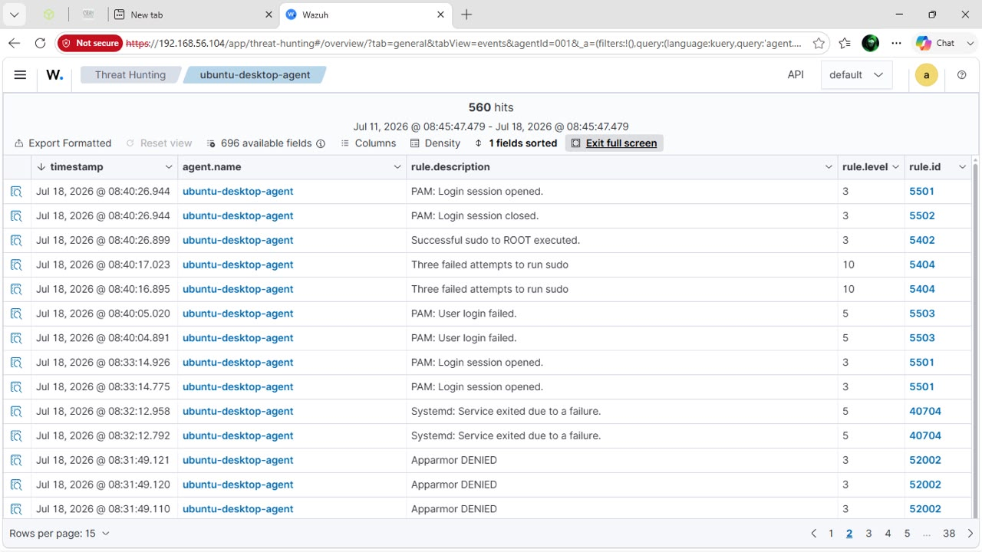
This is the raw event log entries received from the ubuntu endpoint, including PAM and sudo activity
For the windows agent, we could see entries related to CIS benchmark checks and system services, confirming that wndows event logs were being received correctly.
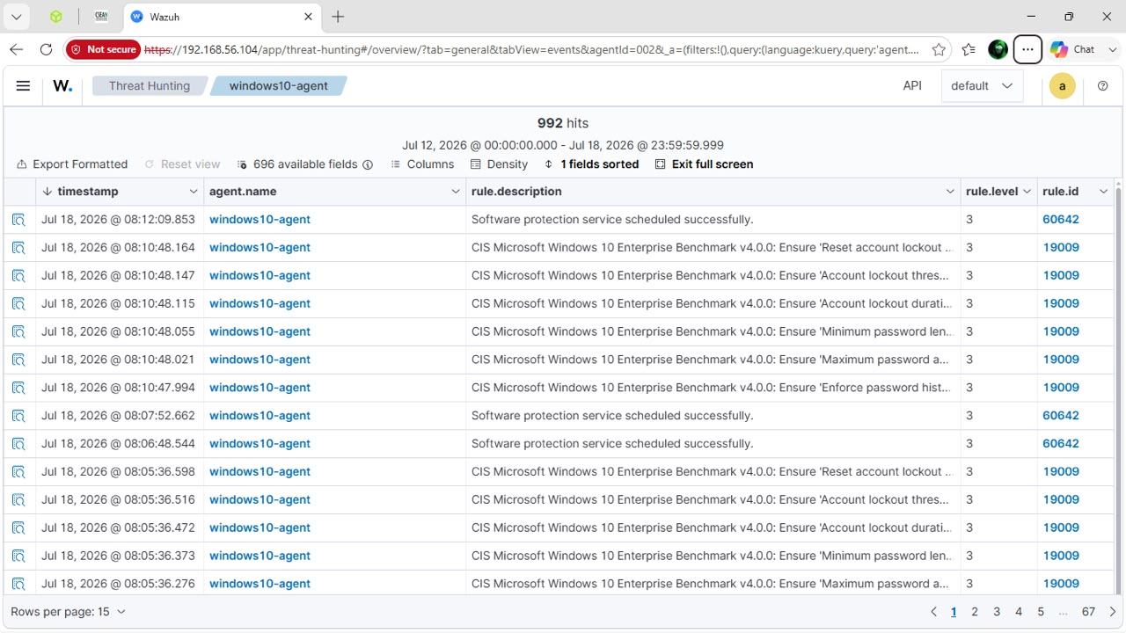
The raw event log entries received from the windows endpoint, including CIS benchmark checks
Then we finally ran a Configuration assessment (SCA) scan on both endpoints to check their security settings against CIS benchmarks. The ubuntu endpoint scored 42% against the CIS ubuntu linux 22.04 LTS benchmark (76 passed, 101 failed, 30 not applicable), and the windows endpoint scored 27% against the CIS microsoft windows 10 enterprise benchmark (115 passed, 297 failed, 12 not applicable). This confirmed that the Wazuh manager was actively analyzing both endpoints, not just collecting their logs.
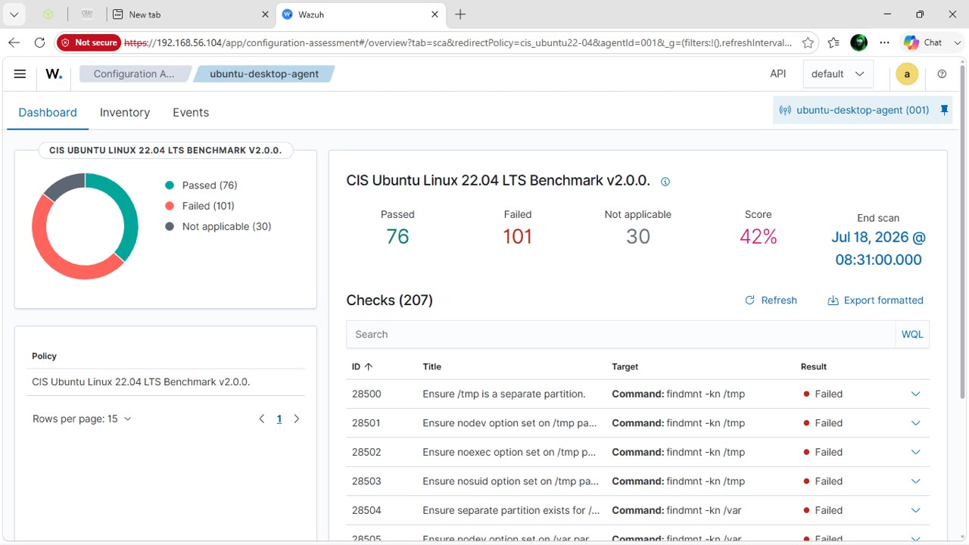
This screenshot shows the CIS benchmark configuration assessment results for the Ubuntu endpoint
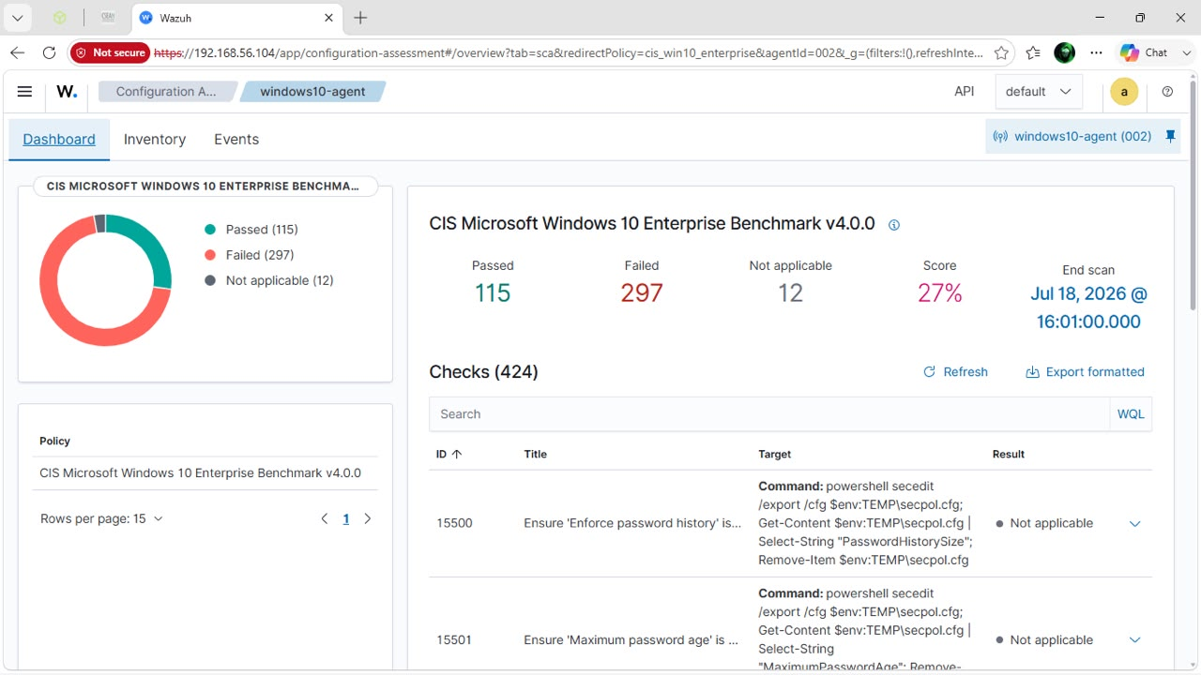
Here is the CIS benchmark configuration assessment results for the windows endpoint

ATTACK SIMULATION

Between July 18 and July 19, 2026, our team acted as the adversary and carried out three attacks against our own endpoints: an SSH bruteforce attempt on the ubuntu machine, a hidden administrator account created on the windows machine, and an attempt to clear the windows security log, to check whether wazuh could detect each one.

The attack: “SSH bruteforce” (Linux endpoint)
On July 18, 2026, starting around 21:45, we attempted to log in to the ubuntu desktop agent host 192.168.56.102 over SSH multiple times using the wrong password for the cybertech account, to simulate an attacker trying to guess valid credentials. After multiple failed attempts, one login attempt succeeded.
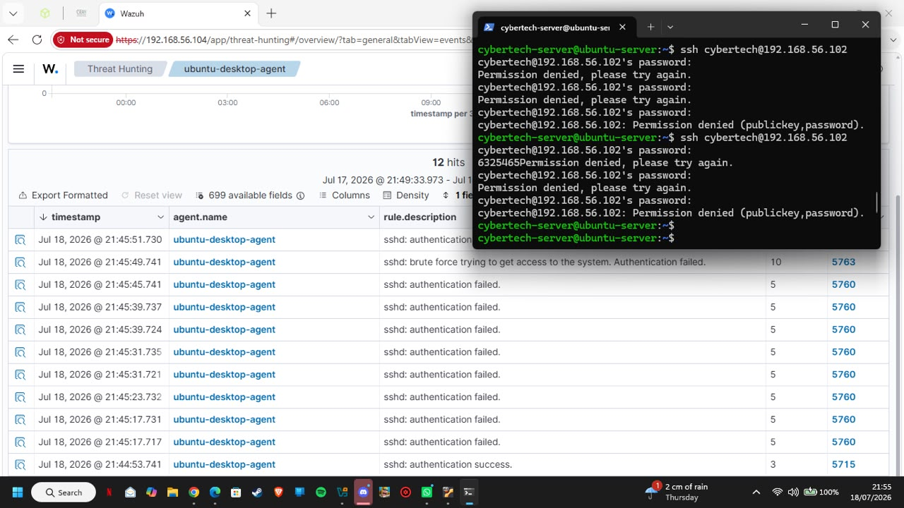
Our terminal showing repeated failed SSH login attempts, followed by a successful login
Wazuh detected the repeated failed logins and correctly classified the activity as a bruteforce attempt, mapping it to MITRE ATT&CK technique T1110 Bruteforce under the “credential access tactic.”
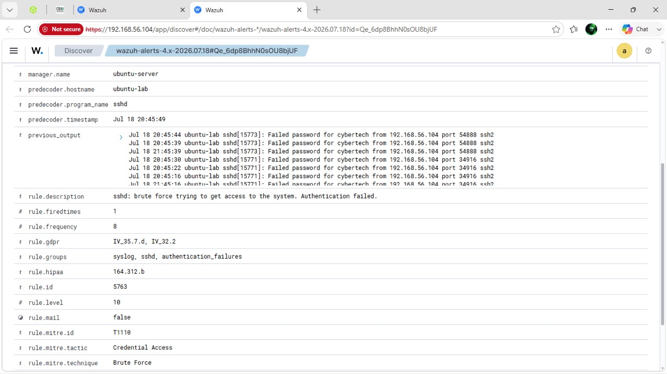
The wazuh alert detail showing the bruteforce detection and its MITRE ATT&CK mapping

The attack: “hidden local administrator account creation.” [windows endpoint]
On July 19, 2026, at 09:30, on the windows10 agent host, we created a hidden local account (hiddenadmin1) using the command net user hiddenadmin1 p@ssw0rd123 /add, then added it to the local administrators group using net local group administrators hiddenadmin1 /add. This simulates an attacker planting a backdoor account for future access.
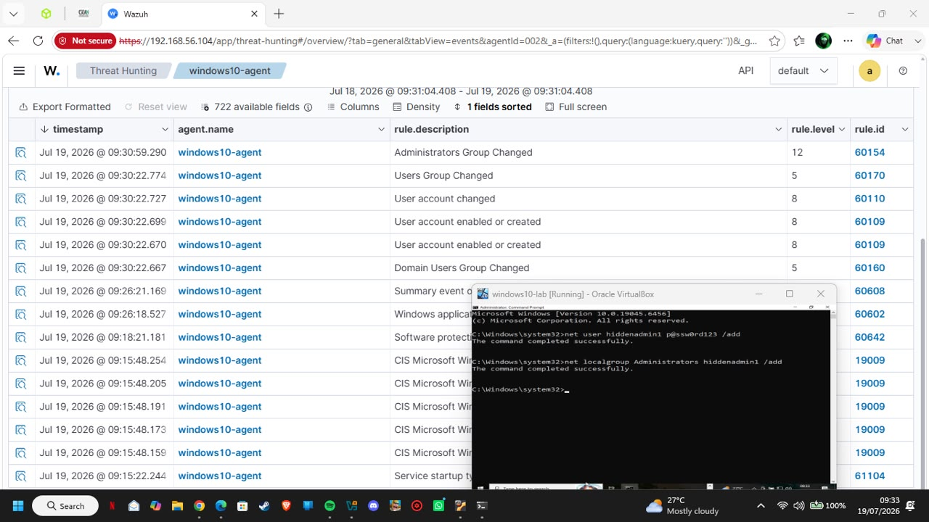
This is the command execution creating the hidden account and adding it to the administrators group, with the resulting wazuh alerts
Here,wazuh detected both actions: the creation of the account triggered an alert for 'user account enabled or created, and adding it to the administrators group triggered a higher severity alert for “administrators group changed.” Wazuh mapped this to MITRE ATT&CK technique T1098 (account manipulation) under the persistence tactic.
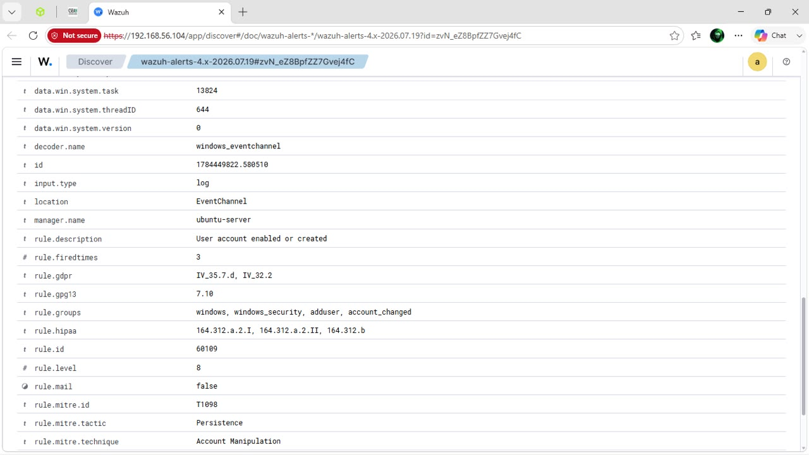
Here is the wazuh alert detail showing the account manipulation detection and its MITRE ATT&CK mapping

The attack: “clearing windows event logs. (defence evasion)
Later that day, on the same windows10 agent host, we simulated an attacker covering their tracks. We deleted the hidden account, then attempted to clear the Windows security event log. Our first attempt used the clear command, which is not valid in windows command prompt. We then used the correct windows command, wevtutil cl security, which successfully cleared the log at 09:45.
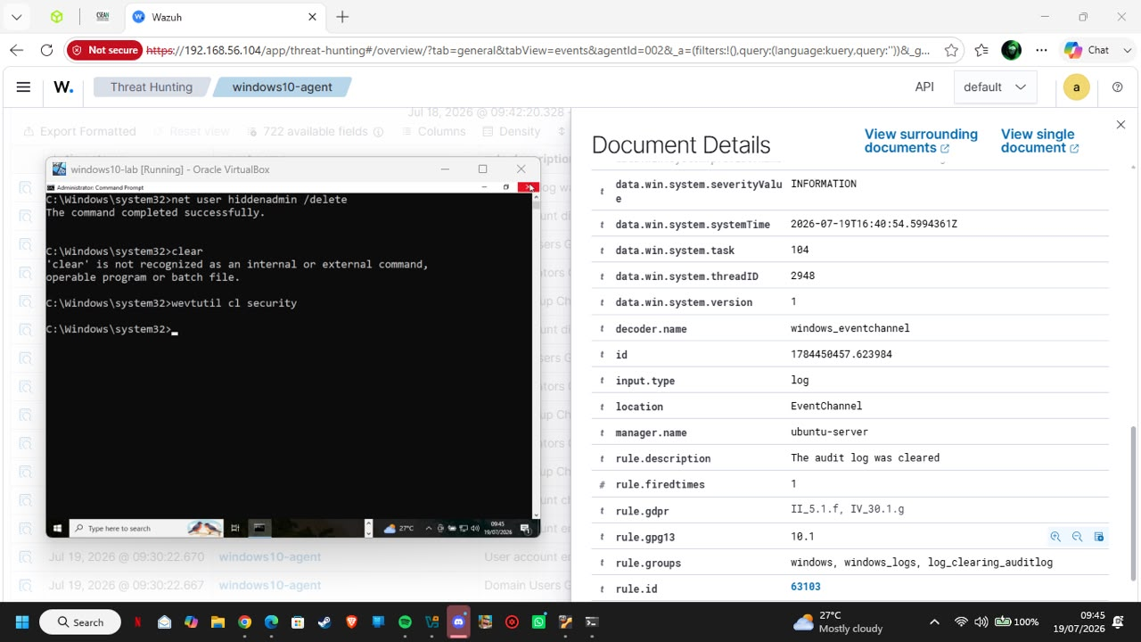
The terminal showing the account deletion and the command used to clear the windows security logs
Even though the log was cleared, Wazuh still detected the clearing action itself, generating an alert stating “The audit log was cleared,” along with the account name and computer name responsible for the action. This shows that Wazuh can catch defence evasion attempts, not just the original attack.
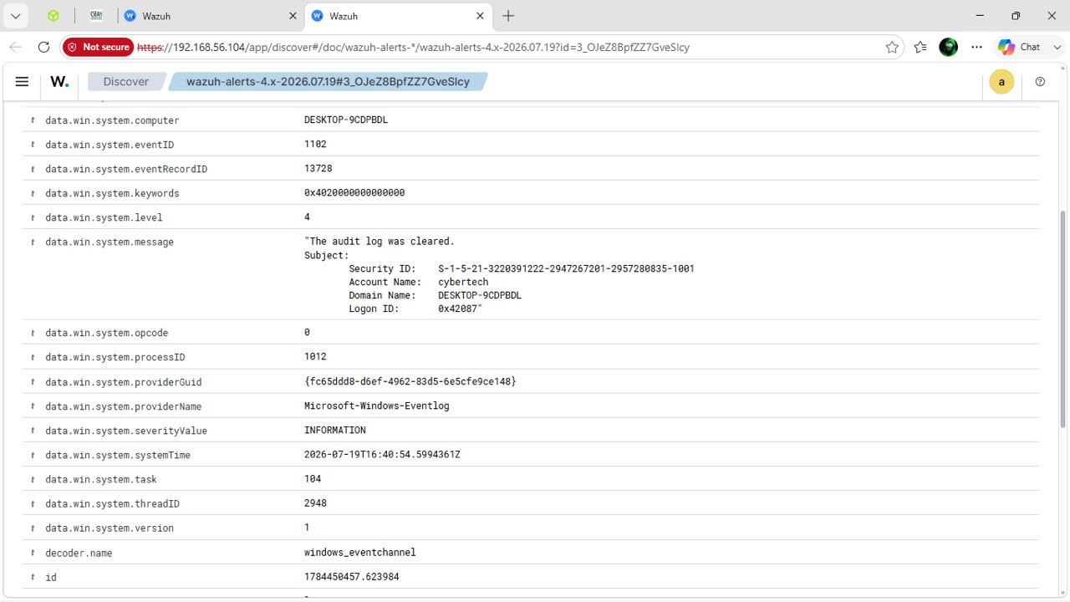
The Wazuh alert detail confirming detection of the Security log being cleared

Detection engineering and formal incident report
All the three simulated attacks were successfully detected by wazuh. For a deeper, formal analysis, our team selected the hidden local administrator account attack, since it best demonstrates an attacker gaining a persistent foothold rather than just a single suspicious action.

Selected incident
Hidden local administrator account creation on the windows 10 endpoint (windows10 agent).

MITRE ATT&CK mapping
Tactic: “persistence”
Technique: T1098 account manipulation
Raw log evidence
Wazuh recorded two key events for this incident. The first was rule ID 60109 "user account enabled or created", severity level 8, generated when the hiddenadmin1 account was created. The second was rule ID 60154 "administrators group changed", severity level 12, generated when the account was added to the local administrators group. Both events are shown in the screenshots under the hidden local administrator account creation attack above.

The attack timeline
At 09:29:00 The attacker gains local access to the windows10 agent host assumed foothold; no prior phishing or RDP step was simulated in this lab.
09:30:22 The attacker runs net user hiddenadmin1 p@ssw0rd123 /add, creating a hidden local account. wazuh generates rule 60109 ("User account enabled or created," level 8).
09:30:59 The attacker runs net localgroup administrators hiddenadmin1 /add, elevating the account to local administrator. Wazuh generates Rule 60154 "administrators grou59 changed," level 12.
Post incident - If left undetected, the account would remain as a hidden, privileged backdoor available for future access. In our lab, the same session later included an attempt to remove the account and clear the security log, which wazuh also detected as seen in the windows security logs clearing attack above.

Remediation/ recommendations
- Restrict local account creation: limit who can run net user and net localgroup by enforcing this through group policy, so only authorized administrators can create or modify accounts.
- Enable real-time alerting on wazuh rules 60109 and 60154 so a SOC analyst is notified immediately when a new account is created or added to an administrator group.
- Regularly audit local administrators group membership on all endpoints to catch unauthorized additions early.
- Protect windows event logs from tampering, e.g by forwarding logs to a separate, write protected location, so clearing a local log does not destroy the evidence.
- Use an EDR or application whitelisting tool to block execution of account-management commands like net user and net localgroup by unauthorized users or processes.
- Require multi-factor authentication (MFA) for any action that changes administrator group membership.

Challenges and resolutions
During the SSH brute-force test, our first several login attempts returned “permission denied" because we were not yet using the correct password for the target account. We resolved this by confirming the correct test credentials, after which the repeated failed attempts were correctly logged and later followed by a successful login, which triggered wazuh's bruteforce detection rule.
During the log clearing test, our first command, clear, failed because it is a linux/powershell command and is not recognized in the windows command prompt. We then resolved this by using the correct windows equivalent, wevtutil cl security, which successfully cleared the Security log and was still picked up by wazuh.

Conclusion
Our team successfully deployed a working wazuh SIEM environment from scratch, connected one linux and one windows endpoint, and confirmed that logs from both systems were being collected and analyzed correctly. We simulated three different attack vectors: SSH bruteforce, hidden administrator account creation, and windows security log clearing, and wazuh successfully detected all three, correctly mapping two of them to their MITRE ATT&CK techniques.
This confirms that our SIEM deployment meets the goal set by the CISO. It can ingest data from company operating systems and reliably detect real world attack behaviour. One limitation we noted is that both endpoints scored low on their CIS benchmark scans (behaviour ubuntu, 27% for windows), meaning the underlying systems still have many hardening gaps. Future work should focus on remediating these configuration weaknesses in addition to monitoring for attacks.

