Images and drawing
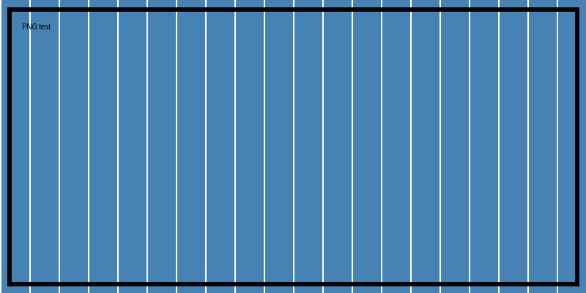
Figure 1: A captioned PNG
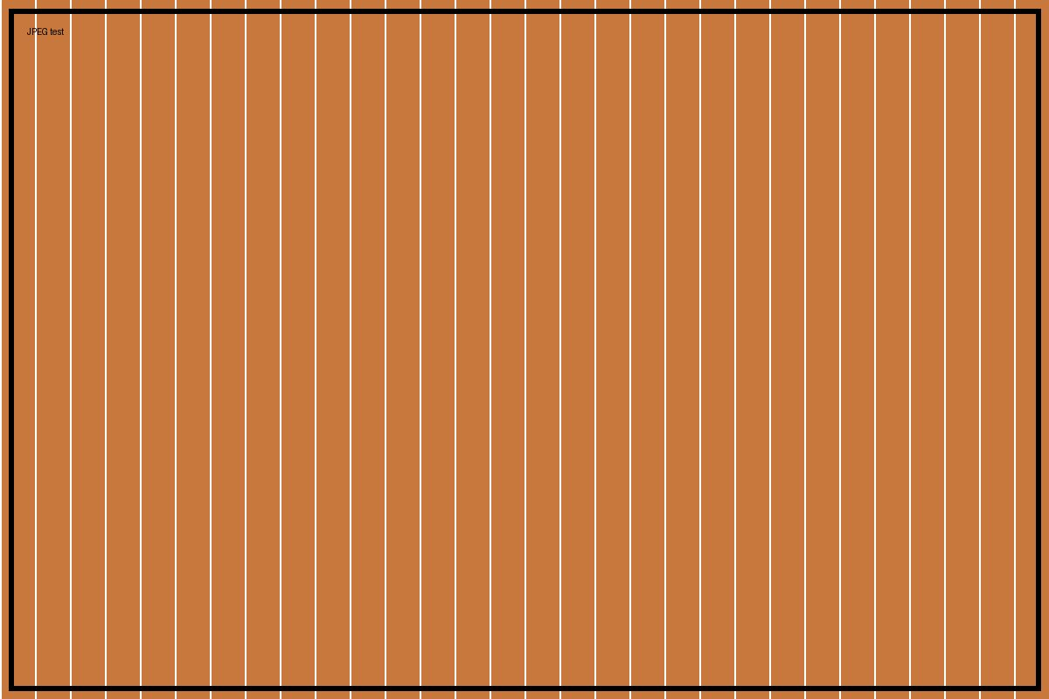
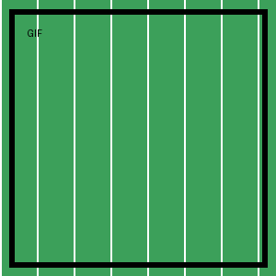
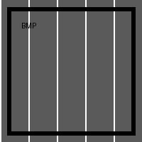

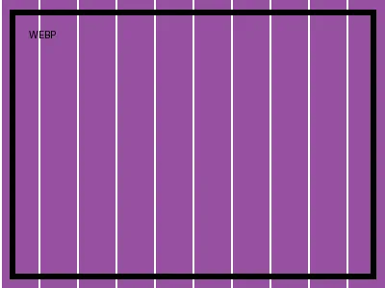
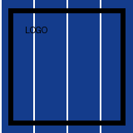
Floating picture wrapped square. Surrounding text. Surrounding text. Surrounding text. Surrounding text. Surrounding text. Surrounding text. Surrounding text. Surrounding text. Surrounding text. Surrounding text. Surrounding text. Surrounding text.
Floating picture wrapped tight. Surrounding text. Surrounding text. Surrounding text. Surrounding text. Surrounding text. Surrounding text. Surrounding text. Surrounding text. Surrounding text. Surrounding text. Surrounding text. Surrounding text.
Floating picture wrapped through. Surrounding text. Surrounding text. Surrounding text. Surrounding text. Surrounding text. Surrounding text. Surrounding text. Surrounding text. Surrounding text. Surrounding text. Surrounding text. Surrounding text.
Floating picture wrapped top-bottom. Surrounding text. Surrounding text. Surrounding text. Surrounding text. Surrounding text. Surrounding text. Surrounding text. Surrounding text. Surrounding text. Surrounding text. Surrounding text. Surrounding text.
Floating picture wrapped behind text. Surrounding text. Surrounding text. Surrounding text. Surrounding text. Surrounding text. Surrounding text. Surrounding text. Surrounding text. Surrounding text. Surrounding text. Surrounding text. Surrounding text.
Floating picture wrapped in front of text. Surrounding text. Surrounding text. Surrounding text. Surrounding text. Surrounding text. Surrounding text. Surrounding text. Surrounding text. Surrounding text. Surrounding text. Surrounding text. Surrounding text.
Absolutely positioned, rotated picture relative to the page.

End of images.

