Chapter one 1
Chapter two 1
Bibliography 2

Chapter one
Today: 30.9.2026 г.
Now: 2:50
Author: Audit Author
Title: Fields audit document
File name: Document6
This sentence holds the bookmarked phrase target phrase here.
Cross reference to it: target phrase
It is on page 1

Chapter two
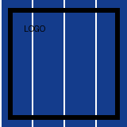
Figure 1: Figure number 1
Figure 2: Figure number 2
External hyperlink: example documentation
Unsafe link: a local file link
A claim with a citation (Tester, 2024)

Bibliography
Tester, A. (2024). Synthetic Book of Testing.

