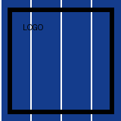
Pictures as Word writes them
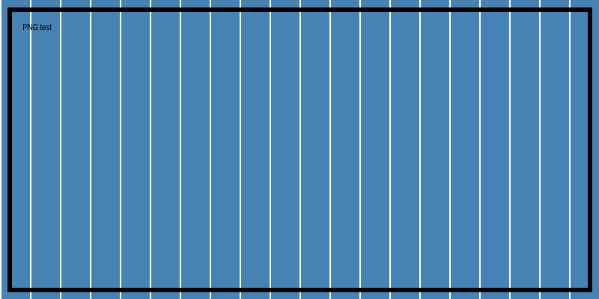
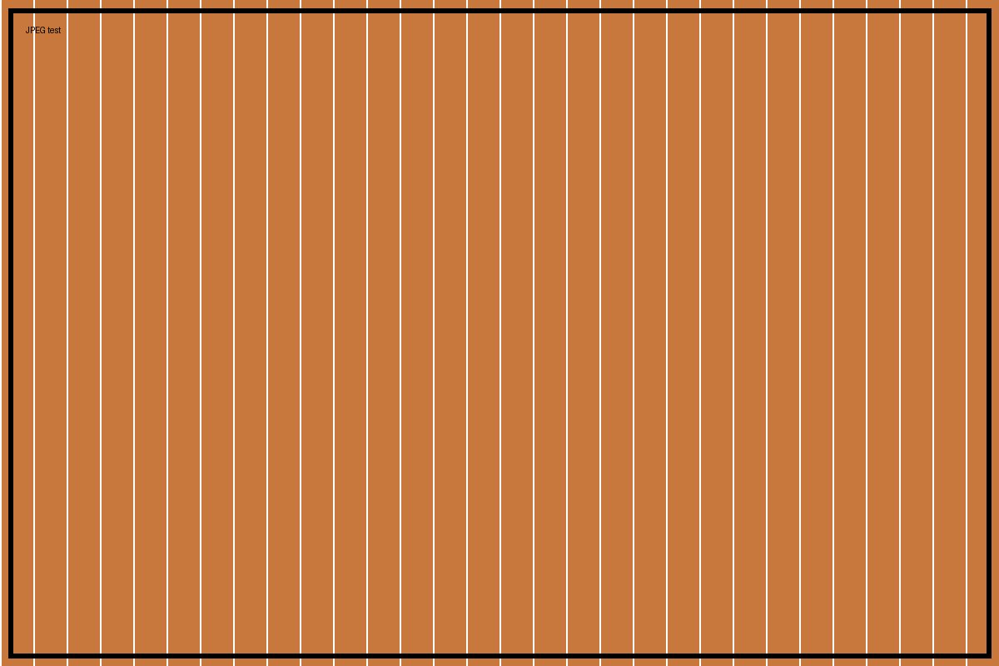
Text flows around the picture placed 2 cm from the margin. Text flows around the picture placed 2 cm from the margin. Text flows around the picture placed 2 cm from the margin. Text flows around the picture placed 2 cm from the margin. Text flows around the picture placed 2 cm from the margin. Text flows around the picture placed 2 cm from the margin.
The paragraph the floating picture is anchored to.
- Open the box
- Close it
A picture in a cell: | Beside it.

