ALTERNATIVE FIGURES

**Figure 2**. Sex-assortativity (measured by Newman’s r, shown in colors) can amplify the effect of sex-traits on M:F case bias. Sex-traits (vertical columns) are infectious period (IP), susceptibility (SUS), and transmissibility (TRA). M:F case bias is measured as the ratio of male to female recoveries (SIR, SLIR) or infections at equilibrium (SIRS, SLIRS). The grey dashed line indicates equal levels of male and female infections and the red dashed line shows the global M:F case bias for TB. Sex-traits are incorporated by holding respective overall parameter rates constant but increasing the male parameter by the value on the x-axis relative to the female trait. Figure generated with 100 simulations of epidemics on Sah networks with $τ=0.075, R_{0}≈2.5.$

SUPPLEMENTAL FIGURES

Figure R0. Comparison between analytically calculated $R_{0}$ (Kiss, Miller, Simon 2017) and simulated epidemic size on non-assorted and assorted networks. Horizontal grey line shows where $R_{0}=1$ and where ending epidemic size > $I_{0}$. Vertical grey line approximately where $R_{0}=1$. Results are consistent for SIR and SLIR models. No sex-trait heterogeneity is included in these simulated data. Other parameters: $γ=0.5, { I}_{0}=10.$ For the SLIR model, .

Figure NET_TYPE. Assortativity had similar effects on male-bias in Sah and rewired networks despite rewired networks being variable in other network statistics as assortativity is increased (shown in Figure S1). The M:F case bias, sex-traits, and relative male:female values of sex-traits are the same as in Figure 1. Figure generated with 100 SLIR simulations of epidemicswith $τ=0.075$ and $R_{0}≈2.5$.

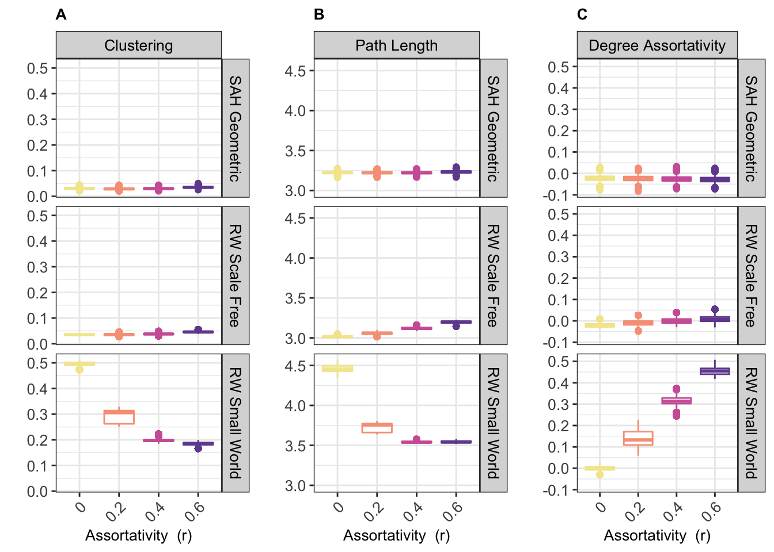

Figure NET_STR. We simulated TB spread on networks with varying assortativity generated by rewiring edges or with an algorithm developed by Sah et al. (2017). As assortativity increased, we measured changes in clustering (A), average path length (B), and degree assortativity (C) which can impact epidemic dynamics. The rewired small-world networks were especially vulnerable to disruptions in key network structures. Sah network structures were not affected by increases in assortativity.

{}

Figure POWER. Rewired scale-free networks maintained power-law degree distributions.

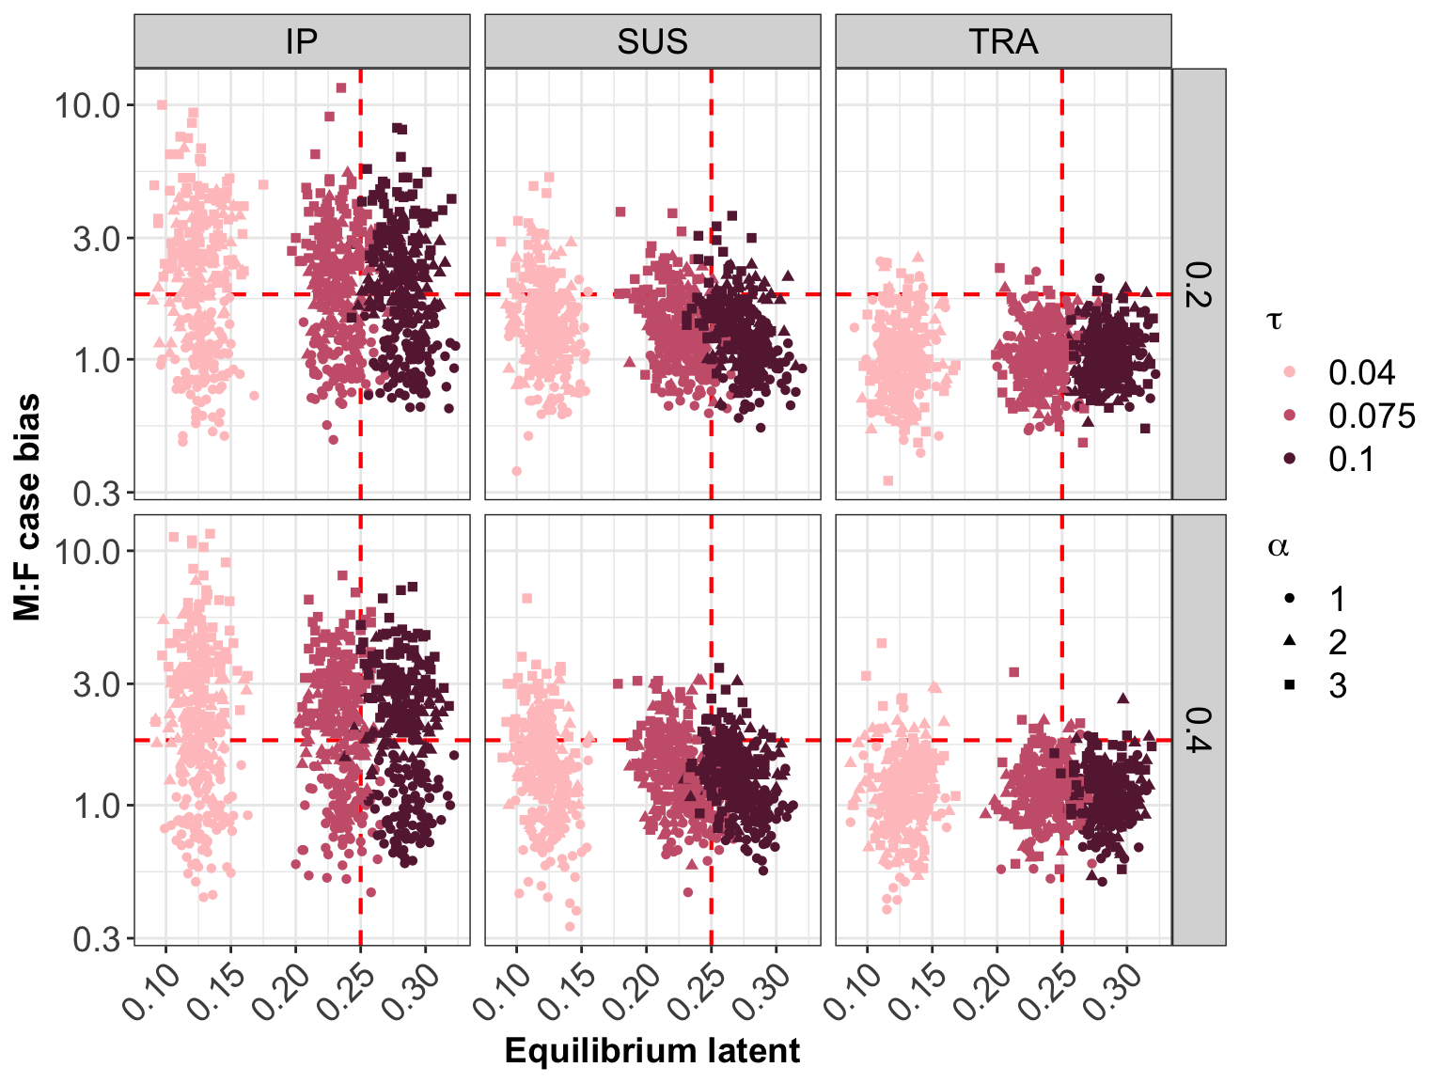

Figure LATENT. Globally, one-quarter of the world’s population has latent TB infection (x-axis), the ratio of male:female case notifications is 1.8 (y-axis), and estimates of sex-assortativity suggest values from 0.2-0.4 (horizontal facets). The plot explores parameter combinations that are consistent with these three data points. Point color shows overall infection rate and point shape shows strength of sex-traits (vertical facets). Simulations from SLIRS model on Sah network.