SUPPLEMENTAL INFORMATION

Description of the rewiring algorithm

Rewired networks were initialized as small-world or scale-free networks because these networks resemble patterns of clustering and high-degree network hubs found in real-world social networks. Small world networks were initialized as a ring with edges to 5 nearest neighbors being rewired with probability 0.05 according to the Watts Strogatz algorithm (Watts and Strogatz 1998). Scale free networks were initialized with linear preferential attachment and 5 edges were added each step according to the Barabasi Albert algorithm (Barabasi and Albert 1999).

Small world and scale free networks were then rewired to generate sex-assorted networks using Algorithm 1.

Algorithm 1. Sex-assorted network rewiring algorithm.

1. Simulate a network, G, of size N with nodes notated as $v_{1,..N}$
2. Randomly assign sex to each vertex $v_{i}$
3. Randomly rewire 20% of edges occurring between-sex
4. Check that the network is still a single component, if not, reject rewiring and return to step 3
5. Check for multiple edges or self-edges, and randomly rewire those edges
6. Continue process until the desired level of assortativity was reached within a small range of error $(ϵ=0.05)$

SUPPLEMENTAL FIGURES

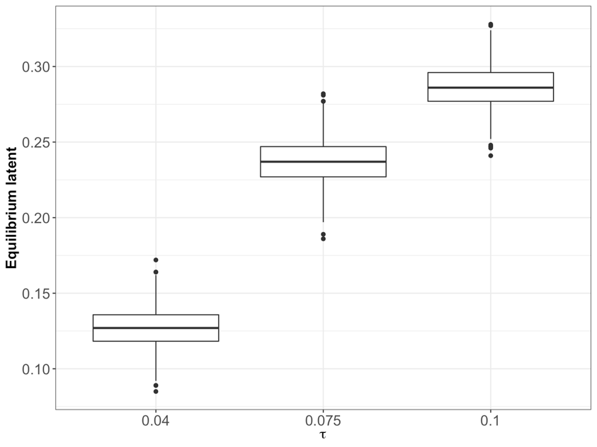

Figure S1. Equilibrium proportion of individuals with latent infection in the SLIRS model increases with the transmission rate. No sex-trait heterogeneity is included in plotted data ($α=1$). Other parameters: 1/latent period (months): $σ=0.1$; 1/infectious period (months): $γ=0.5,$ number of initially infected individuals: 5.

Figure S2. Comparison between analytically calculated $R_{0}$ (Kiss, Miller, Simon 2017) and simulated epidemic size on non-assorted and assorted networks. Horizontal grey line shows where $R_{0}=1$ and where ending epidemic size > $I_{0}$. Vertical grey line approximately where $R_{0}=1$. Results are consistent for SIR and SLIR models. No sex-trait heterogeneity is included in plotted data. Other parameters: $γ=0.5, { I}_{0}=10.$ For the SLIR model, .

Figure S3. Assortativity had similar effects on male-bias in Sah and rewired networks despite rewired networks being variable in other network statistics as assortativity is increased (shown in Figure S1). The M:F case bias, sex-traits, and relative male:female values of sex-traits are the same as in Figure 1. Figure generated with 100 SLIR simulations of epidemicswith $τ=0.075$ and $R_{0}≈2.5$.

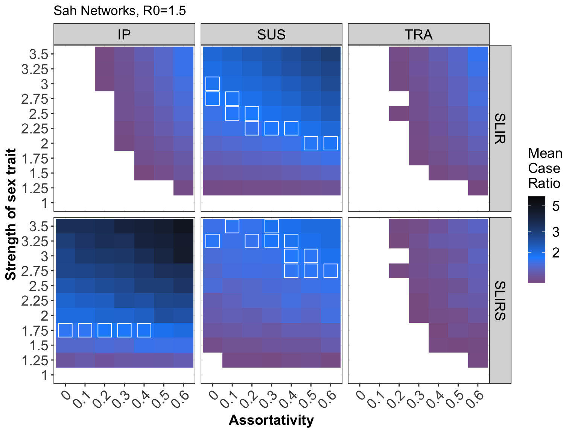

FigureS4. Same as Figure 2 in main paper but shown for SLIR and SLIRS. Interaction effects of sex-assortativity and sex-traits on M:F case bias (shown in color). Sex-traits (vertical columns) are infectious period (IP), susceptibility (SUS), and transmissibility (TRA). M:F case bias is measured as the ratio of male to female recoveries (SLIR) or infections at equilibrium (SLIRS). Only parameter combinations leading to mean M:F case bias greater than 1.1 are colored (white boxes show mean M:F case bias from 1.7 to 1.9). Sex-traits are incorporated by holding respective overall parameter rates constant but increasing the male parameter by the value on the x-axis relative to the female trait. Figure generated with 250 simulations of epidemics on Sah networks with $τ=0.075, R_{0}≈2.5.$

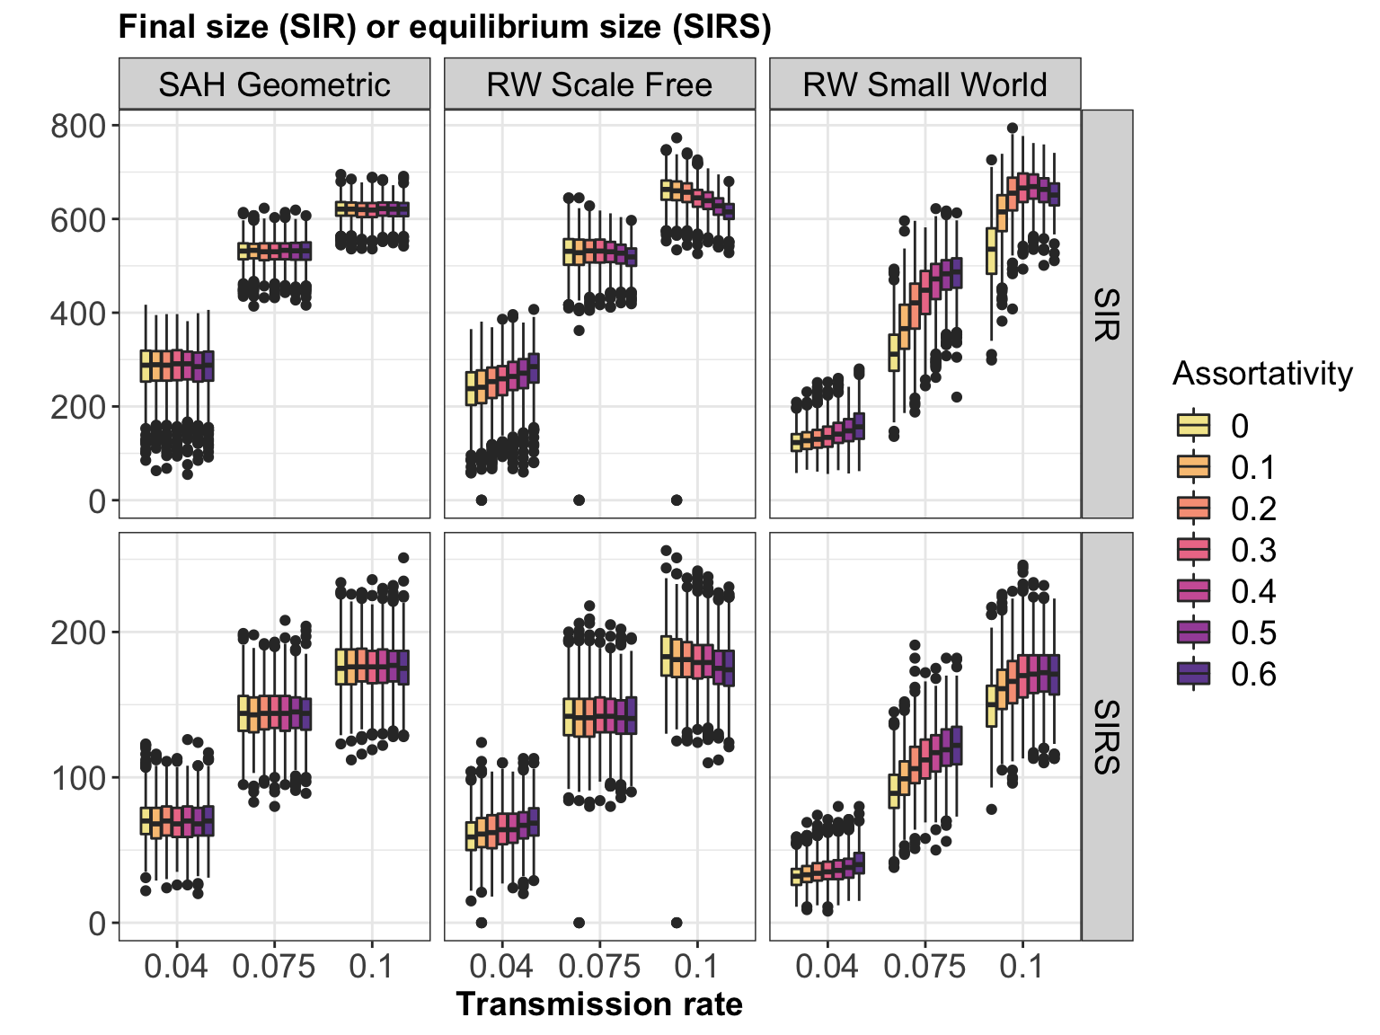

Figure S5. The effect of assortativity on the final size or equilibrium prevalence of SIR and SIRS epidemics depends on underlying network type. Results are shown for outbreaks with no differences in male and female sex-traits. Figure generated with 250 simulations of epidemics.

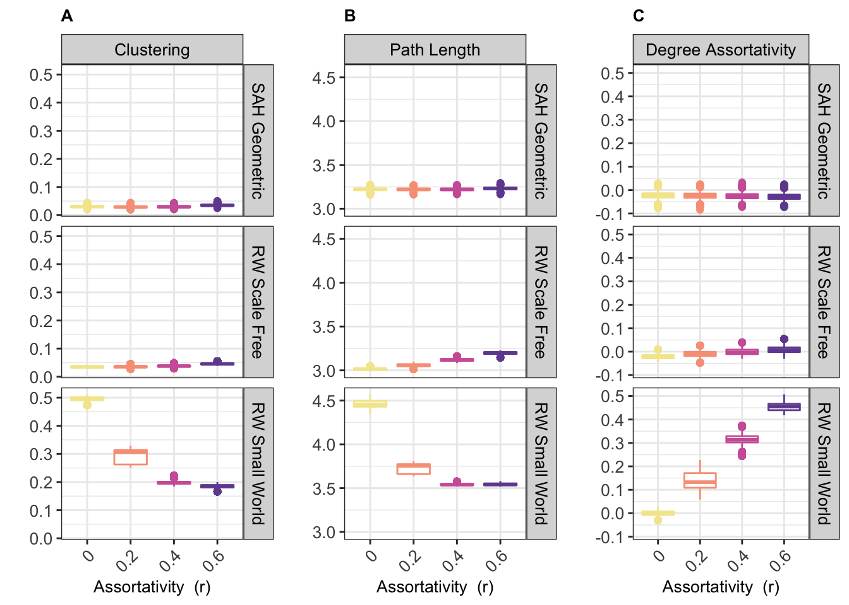

Figure S6. We simulated TB spread on networks with varying assortativity generated by rewiring edges or with an algorithm developed by Sah et al. (2017). As assortativity increased, we measured changes in clustering (A), average path length (B), and degree assortativity (C) which can impact epidemic dynamics. The rewired small-world networks were especially vulnerable to disruptions in key network structures. Sah network structure­­­s were not affected by increases in assortativity.

REFERENCES

Barabasi, AL, and R Albert. 1999. “Emergence of Scaling in Random Networks.” *Science* 286 (5439): 509–12.

Watts, D J, and S H Strogatz. 1998. “Collective Dynamics of ‘Small-World’ Networks.” *Nature* 393 (6684). Nature Publishing Group: 440–42. doi:10.1038/30918.

­­­­