Homework #3, CSC4501

Due date: Nov 20, 10:30am, in the classroom

1. Describe how packet loss can occur at output ports. Can this loss be prevented by increasing the switch fabric speed?
   1. If the queue grows larger than the outgoing line can handle, there is no way to prevent packet loss
2. Compare and contrast the link-state and distance-vector routing algorithms.
   1. Distance vector algorithms rely on advertising the cost of their connections to their neighbors. They never have a complete picture of the network. Link state routers have a complete view of the network and send information about direct links to the whole network.
3. Is it necessary that every autonomous system use the same intra-AS routing algorithm? Why or why not?
   1. No. Each network is only responsible for sharing link information. They do not have to gather the information in the same way.
4. Compare and contrast the advertisements used by RIP and OSPF.
   1. RIP is distance vector, while OSPF is link state based. RIP advertises the shortest path, while OSPF advertises its direct links.
5. How does BGP use the NEXT-HOP attribute? How does it use the AS-PATH attribute?
   1. Next hop is the ip of the next router in the chain to reaching the destination. AS-PATH is a list of AS numbers that a route has traveled to get to a destination.
6. Consider the network below.
   1. Suppose that this network is a datagram network. Show the forwarding table in router A, such that all traffic destined to host H3 is forwarded through interface 4.

|  |  |  |
| --- | --- | --- |
| To H3 | To H1 | To H2 |
| Via 4 | Via 1 | Via 2 |

* 1. Suppose that this network is a datagram network. Can you write down a forwarding table in router A, such that all traffic from H1 destined to host H3 is forwarded through interface 4, while all traffic from H2 destined to host H3 is forwarded through interface 3? (Hint: this is a trick question.)

You cannot define multiple routes to the same destination  
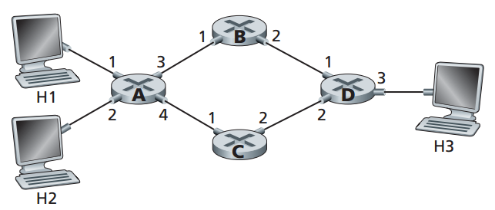

|  |  |  |  |
| --- | --- | --- | --- |
| Prefix Match | Interface | Range | # |
| 00 | 0 | 00000000-00111111 | 64 |
| 010 | 1 | 01000000-01011111 | 32 |
| 011 | 2 | 01100000-01111111 | 32 |
| 10 | 2 | 10000000-10111111 | 64 |
| 11 | 3 | 11000000-11111111 | 64 |

1. Consider a datagram network using 8-bit host addresses. Suppose a router uses longest prefix matching and has the following forwarding table. For each of the four interfaces, give the associated range of destination host addresses and the number of addresses in the range.
2. Rewrite this forwarding table, which uses longest prefix matching, using the a.b.c.d/x notation instead of the binary string notation.

|  |  |
| --- | --- |
| Prefix Math | Interface |
| 232.87.128.0/11 | 0 |
| 232.87.24/8 | 1 |
| 232. 87.24/11 | 2 |
| Otherwise | 3 |

1. Consider the following network. Use Dijkstra’s algorithm with a table similar to Table 4.3 in the book to do the following:
   1. Compute the shortest path from *x* to all network nodes.
   2. Compute the shortest path from *t* to all network nodes.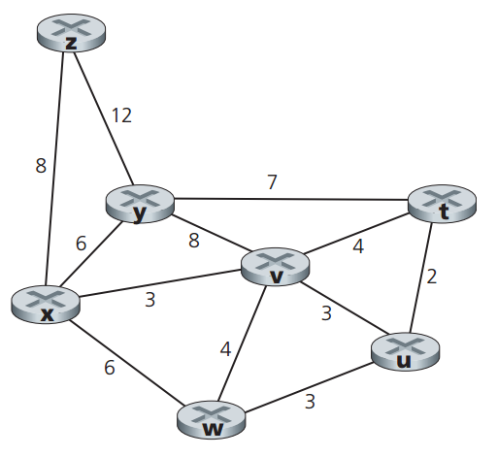
2. Consider the network shown below, and assume that each node initially knows the costs to each of its neighbors. Consider the distance-vector algorithm, and show the distance table entries at node *x*.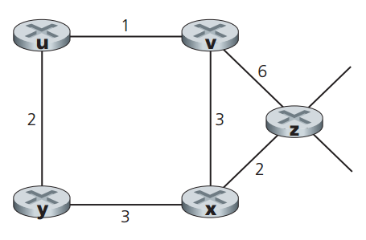
3. Consider the network shown below. Suppose AS3 and AS2 are running OSPF for their intra-AS routing protocol. Suppose AS1 and AS4 are running RIP for their intra-AS routing protocol. Suppose eBGP and iBGP are used for the inter-AS routing protocol. Initially suppose there is no physical link between AS2 and AS4.
   1. Router 2c learns about prefix *x* from which routing protocol: OSPF, RIP, eBGP, or iBGP? iBGP then eBGP
   2. Router 2a learns about *x* from which routing protocol? eBGP then iBGP
   3. Router 1c learns about *x* from which routing protocol? eBGP
   4. Router 1d learns about *x* from which routing protocol? RIP then RIP or iBGP
   5. Repeat the above four questions but with the assumption that there is a physical link between AS2 and AS4 (the dotted line).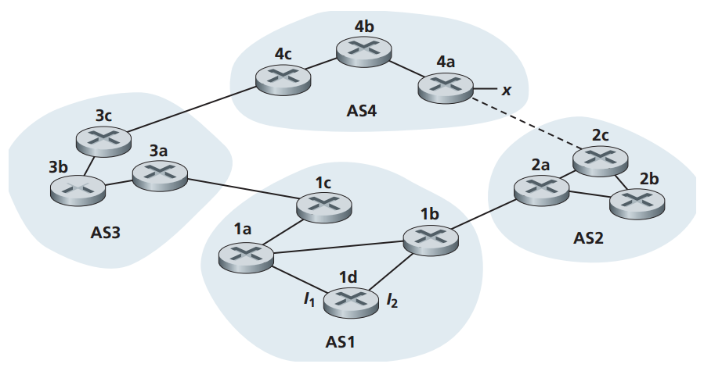
4. Referring to the previous problem, once router 1d learns about *x* it will put an entry (*x*, *I*) in its forwarding table. Again, initially assume there is no physical link between AS2 and AS4.
   1. Will *I* be equal to *I*1 or *I*2 for this entry? Explain why.
   2. Now suppose that there is a physical link between AS2 and AS4 (the dotted line). Suppose router 1d learns that *x* is accessible via AS2 as well as via AS3. Will *I* be set to *I*1 or *I*2? Explain why.
   3. Now suppose there is another AS, called AS5, which lies on the path between AS2 and AS4 (not shown in diagram). Suppose router 1d learns that *x* is accessible via AS2-AS5-AS4 as well as via AS3-AS4. Will *I* be set to *I*1 or *I*2? Explain why.