SAYE Monthly Progress REPORT

INSTRUCTIONS

Cluster Lead/Business Facilitator: Please refer to the original proposal, Annual, Quarterly and Monthly work plans, and Monitoring, Evaluation, Research and Learning Plan (MERL) when answering these questions. Upon completion, please email the Progress narrative Report to your supervisor.

GENERAL INFORMATION

Project Title | SAYE PROJECT
Organization Name | HEIFER
Cluster Coordinator | Name: | Charles Ochom
 | Phone Number: | 0772063030
 | Email: | Charles.Ochom@heifer.org
Project Start | October 2023 |  | Project End | 31st March 2029
Reporting Month | {{meta.month}} |  | Reporting Period/Quarter |  | {{meta.quarter}}

REPORTING PERIOD SUMMARY

1.1 EXECUTIVE SUMMARY
Executive Summary of Implementation status
During the month of June 2026, the cluster profiled 2,210 individuals across 121 new SHGs, including 1,322 females, 819 males and 69 persons with disabilities (PWDs). Overall June outreach reached 3,184 youth (1,845 female and 106 PWDs).

June production support focused on horticulture establishment and livestock distribution. A total of 909 youth established 162.04 acres of horticulture across 115 groups, while 9,006 birds were distributed to 94 youth in 31 SHGs and 226 goats to 35 youth in 17 SHGs in Luuka.
Horticulture and poultry sales generated UGX 441,607,400 during June, comprising UGX 84,879,500 from horticulture (66,147 kg and 408 pieces harvested) and UGX 356,727,900 from bird sales involving 28,314 birds.
ISLA activity in June reached 9,426 savers across the four districts. Total savings amounted to UGX 44,471,705 while loan disbursements totaled UGX 36,789,900.
The cluster mobilized UGX 447,594,700 in local leverage during June across Iganga, Jinja, Luuka and Mayuge districts.

1.2 OUTREACH ACTUALS
Please provide an update on the following engagement and outreach measures for this reporting period. To be completed by the partner MEL staff.
Summary of Outreach Actuals

Youth | Reporting period: June 2026
 | Month Target | Month Actual | Quarter Target | Quarter Actual | Quarter % Actual | YTD actual
Total Profiled: | 2,400 | 2210 | 7200 | 8752 | 122% | 21113
Total Outreach: | 2,526 | 3,184 | 7575 | 9611 | 127% | 17,908
Total Female (70%): | 1768 | 1845 | 5304 | 5586 | 105% | 10452
Total Youth 16-35: | 2,526 | 3,184 | 7575 | 9611 | 127% | 17908
Total Youth with Disabilities (3%): | 76 | 106 | 228 | 372 | 163% | 762
Total Female PWDs | 53 | 66 | 159 | 187 | 118% | 383
Total Refugees or Displaced Persons: | 0 | 0 | 0 | 0 | 0 | 0
Total Rural: | 2,526 | 3,184 | 7575 | 9611 | 127% | 17908
Total Urban: | 0 | 0 | 0 | 0 | 0
Total Youth in Work-Primary (70%): | 1768 | 1757 | 5304 | 5499 | 104% | 10366
Total Female Youth in Work - Primary (70%) | 1238 | 984 | 3,714 | 3160 | 85% | 5892
Total PWDs in work- primary (3%) | 53 | 59 | 159 | 195 | 123% | 409
Total PWDs females in work- Primary | 37 | 33 | 113 | 92 | 81% | 180
Total youth in work - Secondary
Total youth in work Females-Secondary
Total enterprises supported
Total Women Led enterprises supported
Total Youth Led enterprises supported

As per the table above, the cluster reached 3,184 participants in June against a target of 2,526 (126% for the month) and profiled 2,210 new participants against a target of 2,400 (92%). Cumulatively, quarter-to-date outreach stood at 9,611 against a quarter target of 7,575 (127%).
2. REPORTING PROGRESS AND OUPUTS
This section presents progress, challenges, and risks in the delivery of planned activities, based on monthly plan and targets.
2.1 PROGRESS UPDATE (BY OUTPUT AREA, per the approved workplan)
Skills Development

Output 1.2: Community and virtual mobilisation promoted

1.2.2 Organise youth into viable business groups and producer organisations
A total of 121 new SHGs with 2,210 profiled participants (1,322 females, 819 males and 69 PWDs) were recorded during June across the cluster districts. This reflected continued mobilization and profiling of youth groups across Iganga, Jinja, Mayuge and Luuka.

Table showing group formation and participants profiling breakdown per district

June |  |  |  |  | April- June 2026
District | No of SHGs | No of Youth | Female | PWD | No of SHGs | No of Youth | Female | PWD
Iganga | {{prof.m.iganga.shgs}} | {{prof.m.iganga.youth}} | {{prof.m.iganga.female}} | {{prof.m.iganga.pwd}} | {{prof.q.iganga.shgs}} | {{prof.q.iganga.youth}} | {{prof.q.iganga.female}} | {{prof.q.iganga.pwd}}
Jinja | {{prof.m.jinja.shgs}} | {{prof.m.jinja.youth}} | {{prof.m.jinja.female}} | {{prof.m.jinja.pwd}} | {{prof.q.jinja.shgs}} | {{prof.q.jinja.youth}} | {{prof.q.jinja.female}} | {{prof.q.jinja.pwd}}
Mayuge | {{prof.m.mayuge.shgs}} | {{prof.m.mayuge.youth}} | {{prof.m.mayuge.female}} | {{prof.m.mayuge.pwd}} | {{prof.q.mayuge.shgs}} | {{prof.q.mayuge.youth}} | {{prof.q.mayuge.female}} | {{prof.q.mayuge.pwd}}
Luuka | {{prof.m.luuka.shgs}} | {{prof.m.luuka.youth}} | {{prof.m.luuka.female}} | {{prof.m.luuka.pwd}} | {{prof.q.luuka.shgs}} | {{prof.q.luuka.youth}} | {{prof.q.luuka.female}} | {{prof.q.luuka.pwd}}
Overall total | {{prof.m.total.shgs}} | {{prof.m.total.youth}} | {{prof.m.total.female}} | {{prof.m.total.pwd}} | {{prof.q.total.shgs}} | {{prof.q.total.youth}} | {{prof.q.total.female}} | {{prof.q.total.pwd}}

Output 1.3: Appropriate soft, technical, and agribusiness skills delivered
1.3.2 Provide soft, technical, and agribusiness skills

VBHCD (Heifer Cornerstone, Group Dynamics and Leadership Training
Detailed disaggregation for this subsection was not provided in the June performance source report used to populate this template.

Table showing Heifer cornerstones, group dynamics and leadership training breakdown per district

June |  |  |  | April- June 2026
District | No of Youth | Female | PWD | No of Youth | Female | PWD
Iganga | {{vbhcd.m.iganga.youth}} | {{vbhcd.m.iganga.female}} | {{vbhcd.m.iganga.pwd}} | {{vbhcd.q.iganga.youth}} | {{vbhcd.q.iganga.female}} | {{vbhcd.q.iganga.pwd}}
Jinja | {{vbhcd.m.jinja.youth}} | {{vbhcd.m.jinja.female}} | {{vbhcd.m.jinja.pwd}} | {{vbhcd.q.jinja.youth}} | {{vbhcd.q.jinja.female}} | {{vbhcd.q.jinja.pwd}}
Mayuge | {{vbhcd.m.mayuge.youth}} | {{vbhcd.m.mayuge.female}} | {{vbhcd.m.mayuge.pwd}} | {{vbhcd.q.mayuge.youth}} | {{vbhcd.q.mayuge.female}} | {{vbhcd.q.mayuge.pwd}}
Luuka | {{vbhcd.m.luuka.youth}} | {{vbhcd.m.luuka.female}} | {{vbhcd.m.luuka.pwd}} | {{vbhcd.q.luuka.youth}} | {{vbhcd.q.luuka.female}} | {{vbhcd.q.luuka.pwd}}
Overall total | {{vbhcd.m.total.youth}} | {{vbhcd.m.total.female}} | {{vbhcd.m.total.pwd}} | {{vbhcd.q.total.youth}} | {{vbhcd.q.total.female}} | {{vbhcd.q.total.pwd}}

PSRP
Detailed disaggregation for this subsection was not provided in the June performance source report used to populate this template.

June |  |  |  | April- June 2026
District | No of Youth | Female | PWD | No of Youth | Female | PWD
Iganga | {{unknown}} | {{unknown}} | {{unknown}} | {{unknown}} | {{unknown}} | {{unknown}}
Jinja | {{unknown}} | {{unknown}} | {{unknown}} | {{unknown}} | {{unknown}} | {{unknown}}
Mayuge | {{unknown}} | {{unknown}} | {{unknown}} | {{unknown}} | {{unknown}} | {{unknown}}
Luuka | {{unknown}} | {{unknown}} | {{unknown}} | {{unknown}} | {{unknown}} | {{unknown}}
Overall total | {{unknown}} | {{unknown}} | {{unknown}} | {{unknown}} | {{unknown}} | {{unknown}}

Gender and safeguarding training
Detailed disaggregation for this subsection was not provided in the June performance source report used to populate this template.

Table showing gender and safeguarding training breakdown per district

June |  |  |  | April- June 2026
District | No of Youth | Female | PWD | No of Youth | Female | PWD
Iganga | {{gender.m.iganga.youth}} | {{gender.m.iganga.female}} | {{gender.m.iganga.pwd}} | {{gender.q.iganga.youth}} | {{gender.q.iganga.female}} | {{gender.q.iganga.pwd}}
Jinja | {{gender.m.jinja.youth}} | {{gender.m.jinja.female}} | {{gender.m.jinja.pwd}} | {{gender.q.jinja.youth}} | {{gender.q.jinja.female}} | {{gender.q.jinja.pwd}}
Mayuge | {{gender.m.mayuge.youth}} | {{gender.m.mayuge.female}} | {{gender.m.mayuge.pwd}} | {{gender.q.mayuge.youth}} | {{gender.q.mayuge.female}} | {{gender.q.mayuge.pwd}}
Luuka | {{gender.m.luuka.youth}} | {{gender.m.luuka.female}} | {{gender.m.luuka.pwd}} | {{gender.q.luuka.youth}} | {{gender.q.luuka.female}} | {{gender.q.luuka.pwd}}
Overall total | {{gender.m.total.youth}} | {{gender.m.total.female}} | {{gender.m.total.pwd}} | {{gender.q.total.youth}} | {{gender.q.total.female}} | {{gender.q.total.pwd}}

Life skills, sexual and reproductive health, social perception, nutrition and mental health trainings.
Detailed disaggregation for this subsection was not provided in the June performance source report used to populate this template.
Table showing nutrition training breakdown per district

June |  |  |  | April- June 2026
District | No of Youth | Female | PWD | No of Youth | Female | PWD
Iganga | {{nutrition.m.iganga.youth}} | {{nutrition.m.iganga.female}} | {{nutrition.m.iganga.pwd}} | {{nutrition.q.iganga.youth}} | {{nutrition.q.iganga.female}} | {{nutrition.q.iganga.pwd}}
Jinja | {{nutrition.m.jinja.youth}} | {{nutrition.m.jinja.female}} | {{nutrition.m.jinja.pwd}} | {{nutrition.q.jinja.youth}} | {{nutrition.q.jinja.female}} | {{nutrition.q.jinja.pwd}}
Mayuge | {{nutrition.m.mayuge.youth}} | {{nutrition.m.mayuge.female}} | {{nutrition.m.mayuge.pwd}} | {{nutrition.q.mayuge.youth}} | {{nutrition.q.mayuge.female}} | {{nutrition.q.mayuge.pwd}}
Luuka | {{nutrition.m.luuka.youth}} | {{nutrition.m.luuka.female}} | {{nutrition.m.luuka.pwd}} | {{nutrition.q.luuka.youth}} | {{nutrition.q.luuka.female}} | {{nutrition.q.luuka.pwd}}
Overall total | {{nutrition.m.total.youth}} | {{nutrition.m.total.female}} | {{nutrition.m.total.pwd}} | {{nutrition.q.total.youth}} | {{nutrition.q.total.female}} | {{nutrition.q.total.pwd}}

Table showing social perception change training breakdown per district

June |  |  |  | Jan- March
District | No of Youth | Female | PWD | No of Youth | Female | PWD
Iganga | {{social.m.iganga.youth}} | {{social.m.iganga.female}} | {{social.m.iganga.pwd}} | {{social.q.iganga.youth}} | {{social.q.iganga.female}} | {{social.q.iganga.pwd}}
Jinja | {{social.m.jinja.youth}} | {{social.m.jinja.female}} | {{social.m.jinja.pwd}} | {{social.q.jinja.youth}} | {{social.q.jinja.female}} | {{social.q.jinja.pwd}}
Mayuge | {{social.m.mayuge.youth}} | {{social.m.mayuge.female}} | {{social.m.mayuge.pwd}} | {{social.q.mayuge.youth}} | {{social.q.mayuge.female}} | {{social.q.mayuge.pwd}}
Luuka | {{social.m.luuka.youth}} | {{social.m.luuka.female}} | {{social.m.luuka.pwd}} | {{social.q.luuka.youth}} | {{social.q.luuka.female}} | {{social.q.luuka.pwd}}
Overall total | {{social.m.total.youth}} | {{social.m.total.female}} | {{social.m.total.pwd}} | {{social.q.total.youth}} | {{social.q.total.female}} | {{social.q.total.pwd}}

Table showing life skills training breakdown per district

June |  |  |  | April- June 2026
District | No of Youth | Female | PWD | No of Youth | Female | PWD
Iganga | {{life.m.iganga.youth}} | {{life.m.iganga.female}} | {{life.m.iganga.pwd}} | {{life.q.iganga.youth}} | {{life.q.iganga.female}} | {{life.q.iganga.pwd}}
Jinja | {{life.m.jinja.youth}} | {{life.m.jinja.female}} | {{life.m.jinja.pwd}} | {{life.q.jinja.youth}} | {{life.q.jinja.female}} | {{life.q.jinja.pwd}}
Mayuge | {{life.m.mayuge.youth}} | {{life.m.mayuge.female}} | {{life.m.mayuge.pwd}} | {{life.q.mayuge.youth}} | {{life.q.mayuge.female}} | {{life.q.mayuge.pwd}}
Luuka | {{life.m.luuka.youth}} | {{life.m.luuka.female}} | {{life.m.luuka.pwd}} | {{life.q.luuka.youth}} | {{life.q.luuka.female}} | {{life.q.luuka.pwd}}
Overall total | {{life.m.total.youth}} | {{life.m.total.female}} | {{life.m.total.pwd}} | {{life.q.total.youth}} | {{life.q.total.female}} | {{life.q.total.pwd}}

Table showing mental health and wellness training breakdown per district

June |  |  |  | April- June 2026
District | No of Youth | Female | PWD | No of Youth | Female | PWD
Iganga | {{mental.m.iganga.youth}} | {{mental.m.iganga.female}} | {{mental.m.iganga.pwd}} | {{mental.q.iganga.youth}} | {{mental.q.iganga.female}} | {{mental.q.iganga.pwd}}
Jinja | {{mental.m.jinja.youth}} | {{mental.m.jinja.female}} | {{mental.m.jinja.pwd}} | {{mental.q.jinja.youth}} | {{mental.q.jinja.female}} | {{mental.q.jinja.pwd}}
Mayuge | {{mental.m.mayuge.youth}} | {{mental.m.mayuge.female}} | {{mental.m.mayuge.pwd}} | {{mental.q.mayuge.youth}} | {{mental.q.mayuge.female}} | {{mental.q.mayuge.pwd}}
Luuka | {{mental.m.luuka.youth}} | {{mental.m.luuka.female}} | {{mental.m.luuka.pwd}} | {{mental.q.luuka.youth}} | {{mental.q.luuka.female}} | {{mental.q.luuka.pwd}}
Overall total | {{mental.m.total.youth}} | {{mental.m.total.female}} | {{mental.m.total.pwd}} | {{mental.q.total.youth}} | {{mental.q.total.female}} | {{mental.q.total.pwd}}

Table showing sexual and reproductive health training breakdown per district

June |  |  |  | April- June 2026
District | No of Youth | Female | PWD
Iganga | {{srh.m.iganga.youth}} | {{srh.m.iganga.female}} | {{srh.m.iganga.pwd}} | {{srh.q.iganga.youth}} | {{srh.q.iganga.female}} | {{srh.q.iganga.pwd}}
Jinja | {{srh.m.jinja.youth}} | {{srh.m.jinja.female}} | {{srh.m.jinja.pwd}} | {{srh.q.jinja.youth}} | {{srh.q.jinja.female}} | {{srh.q.jinja.pwd}}
Mayuge | {{srh.m.mayuge.youth}} | {{srh.m.mayuge.female}} | {{srh.m.mayuge.pwd}} | {{srh.q.mayuge.youth}} | {{srh.q.mayuge.female}} | {{srh.q.mayuge.pwd}}
Luuka | {{srh.m.luuka.youth}} | {{srh.m.luuka.female}} | {{srh.m.luuka.pwd}} | {{srh.q.luuka.youth}} | {{srh.q.luuka.female}} | {{srh.q.luuka.pwd}}
Overall total | {{srh.m.total.youth}} | {{srh.m.total.female}} | {{srh.m.total.pwd}} | {{srh.q.total.youth}} | {{srh.q.total.female}} | {{srh.q.total.pwd}}

1.3.2.4 Facilitate delivery of Agri business and entrepreneurship skills to 144,000 youth and young women

Horticulture Production
During June, 909 youth in 115 groups established 162.04 acres of horticulture across the cluster. Horticulture sales in the month generated UGX 84,879,500 from 66,147 kg and 408 pieces harvested.
Table showing harvest and sales breakdown per district

June |  |  |  | April- June 2026
District | Tomatoes | Watermelon | Sales Amount | Tomatoes | Watermelon | Sales Amount
 | Kgs | Pcs | UGX | Kgs | Pcs | UGX
Iganga | {{hort.m.iganga.tomatoes_kg}} | {{hort.m.iganga.watermelon_pcs}} | {{hort.m.iganga.sales}} | {{hort.q.iganga.tomatoes_kg}} | {{hort.q.iganga.watermelon_pcs}} | {{hort.q.iganga.sales}}
Jinja | {{hort.m.jinja.tomatoes_kg}} | {{hort.m.jinja.watermelon_pcs}} | {{hort.m.jinja.sales}} | {{hort.q.jinja.tomatoes_kg}} | {{hort.q.jinja.watermelon_pcs}} | {{hort.q.jinja.sales}}
Mayuge | {{hort.m.mayuge.tomatoes_kg}} | {{hort.m.mayuge.watermelon_pcs}} | {{hort.m.mayuge.sales}} | {{hort.q.mayuge.tomatoes_kg}} | {{hort.q.mayuge.watermelon_pcs}} | {{hort.q.mayuge.sales}}
Luuka | {{hort.m.luuka.tomatoes_kg}} | {{hort.m.luuka.watermelon_pcs}} | {{hort.m.luuka.sales}} | {{hort.q.luuka.tomatoes_kg}} | {{hort.q.luuka.watermelon_pcs}} | {{hort.q.luuka.sales}}
Overall total | {{hort.m.total.tomatoes_kg}} | {{hort.m.total.watermelon_pcs}} | {{hort.m.total.sales}} | {{hort.q.total.tomatoes_kg}} | {{hort.q.total.watermelon_pcs}} | {{hort.q.total.sales}}

Poultry production
During June, 9,006 birds were distributed to 94 youth across 31 SHGs in Iganga, Jinja and Mayuge, while cluster bird sales in the month reached 28,314 birds worth UGX 356,727,900.
Table showing the poultry birds distribution breakdown per district

June |  |  |  | April- June 2026
District | No of Birds | No of SHGs | Number of Youth | No of Birds | No of SHGs | Number of Youth
Iganga | {{poultrydist.m.iganga.animals}} | {{poultrydist.m.iganga.shgs}} | {{poultrydist.m.iganga.youth}} | {{poultrydist.q.iganga.animals}} | {{poultrydist.q.iganga.shgs}} | {{poultrydist.q.iganga.youth}}
Jinja | {{poultrydist.m.jinja.animals}} | {{poultrydist.m.jinja.shgs}} | {{poultrydist.m.jinja.youth}} | {{poultrydist.q.jinja.animals}} | {{poultrydist.q.jinja.shgs}} | {{poultrydist.q.jinja.youth}}
Mayuge | {{poultrydist.m.mayuge.animals}} | {{poultrydist.m.mayuge.shgs}} | {{poultrydist.m.mayuge.youth}} | {{poultrydist.q.mayuge.animals}} | {{poultrydist.q.mayuge.shgs}} | {{poultrydist.q.mayuge.youth}}
Luuka | {{poultrydist.m.luuka.animals}} | {{poultrydist.m.luuka.shgs}} | {{poultrydist.m.luuka.youth}} | {{poultrydist.q.luuka.animals}} | {{poultrydist.q.luuka.shgs}} | {{poultrydist.q.luuka.youth}}
Overall total | {{poultrydist.m.total.animals}} | {{poultrydist.m.total.shgs}} | {{poultrydist.m.total.youth}} | {{poultrydist.q.total.animals}} | {{poultrydist.q.total.shgs}} | {{poultrydist.q.total.youth}}

Table showing the poultry birds rebooking breakdown per district

June |  |  |  | April- June 2026
District | No of Birds | No of SHGs | Number of Youth | No of Birds | No of SHGs | Number of Youth
Iganga | {{unknown}} | {{unknown}} | {{unknown}} | {{unknown}} | {{unknown}} | {{unknown}}
Jinja | {{unknown}} | {{unknown}} | {{unknown}} | {{unknown}} | {{unknown}} | {{unknown}}
Mayuge | {{unknown}} | {{unknown}} | {{unknown}} | {{unknown}} | {{unknown}} | {{unknown}}
Overall total | {{unknown}} | {{unknown}} | {{unknown}} | {{unknown}} | {{unknown}} | {{unknown}}

Table showing the poultry birds sales breakdown per district

June |  |  |  |  | April- June 2026
District | No of SHGs | Number of Youth | Number poultry birds | Amount UGX | No of SHGs | Number of Youth | Number poultry birds | Amount UGX
Iganga | {{poultrysales.m.iganga.shgs}} | {{poultrysales.m.iganga.youth}} | {{poultrysales.m.iganga.birds}} | {{poultrysales.m.iganga.amount}} | {{poultrysales.q.iganga.shgs}} | {{poultrysales.q.iganga.youth}} | {{poultrysales.q.iganga.birds}} | {{poultrysales.q.iganga.amount}}
Jinja | {{poultrysales.m.jinja.shgs}} | {{poultrysales.m.jinja.youth}} | {{poultrysales.m.jinja.birds}} | {{poultrysales.m.jinja.amount}} | {{poultrysales.q.jinja.shgs}} | {{poultrysales.q.jinja.youth}} | {{poultrysales.q.jinja.birds}} | {{poultrysales.q.jinja.amount}}
Mayuge | {{poultrysales.m.mayuge.shgs}} | {{poultrysales.m.mayuge.youth}} | {{poultrysales.m.mayuge.birds}} | {{poultrysales.m.mayuge.amount}} | {{poultrysales.q.mayuge.shgs}} | {{poultrysales.q.mayuge.youth}} | {{poultrysales.q.mayuge.birds}} | {{poultrysales.q.mayuge.amount}}
Luuka | {{poultrysales.m.luuka.shgs}} | {{poultrysales.m.luuka.youth}} | {{poultrysales.m.luuka.birds}} | {{poultrysales.m.luuka.amount}} | {{poultrysales.q.luuka.shgs}} | {{poultrysales.q.luuka.youth}} | {{poultrysales.q.luuka.birds}} | {{poultrysales.q.luuka.amount}}
Total | {{poultrysales.m.total.shgs}} | {{poultrysales.m.total.youth}} | {{poultrysales.m.total.birds}} | {{poultrysales.m.total.amount}} | {{poultrysales.q.total.shgs}} | {{poultrysales.q.total.youth}} | {{poultrysales.q.total.birds}} | {{poultrysales.q.total.amount}}

Goat production
During June 2026, a total of 226 goats were distributed to 35 youth in 17 SHGs in Luuka district, supporting entry into the goat value chain.
Table showing the Goats distribution breakdown

June |  |  |  | April- June 2026
District | No of Goats | No of SHGs | Number of Youth | No of Goats | No of SHGs | Number of Youth
Luuka | {{goatdist.m.luuka.animals}} | {{goatdist.m.luuka.shgs}} | {{goatdist.m.luuka.youth}} | {{goatdist.q.luuka.animals}} | {{goatdist.q.luuka.shgs}} | {{goatdist.q.luuka.youth}}
Overall total | {{goatdist.m.total.animals}} | {{goatdist.m.total.shgs}} | {{goatdist.m.total.youth}} | {{goatdist.q.total.animals}} | {{goatdist.q.total.shgs}} | {{goatdist.q.total.youth}}

Access to Market

Outcome 2. Increased growth of youth-led agriculture and service-based enterprises
2.1.1 Support the development of Youth Agri-hubs to offer BDS and market access for youth

Detailed disaggregation for this subsection was not provided in the June performance source report used to populate this template.

Agri hub data for the month and quarter

Innovative and inclusive finance
Output 2.3: Formal and informal access to finance strengthened

2.3.1 Develop and strengthen community-based informal savings and loan associations (ISLAs) (how many mobilised, trained, how many savings + value of savings, and have accessed loans and value of loans)
Detailed disaggregation for this subsection was not provided in the June performance source report used to populate this template.
Table showing ISLA training breakdown per district

March |  |  |  | April- June 2026
District | No of Youth | Female | PWD | No of Youth | Female | PWD
Iganga | {{islatrain.m.iganga.youth}} | {{islatrain.m.iganga.female}} | {{islatrain.m.iganga.pwd}} | {{islatrain.q.iganga.youth}} | {{islatrain.q.iganga.female}} | {{islatrain.q.iganga.pwd}}
Jinja | {{islatrain.m.jinja.youth}} | {{islatrain.m.jinja.female}} | {{islatrain.m.jinja.pwd}} | {{islatrain.q.jinja.youth}} | {{islatrain.q.jinja.female}} | {{islatrain.q.jinja.pwd}}
Mayuge | {{islatrain.m.mayuge.youth}} | {{islatrain.m.mayuge.female}} | {{islatrain.m.mayuge.pwd}} | {{islatrain.q.mayuge.youth}} | {{islatrain.q.mayuge.female}} | {{islatrain.q.mayuge.pwd}}
Luuka | {{islatrain.m.luuka.youth}} | {{islatrain.m.luuka.female}} | {{islatrain.m.luuka.pwd}} | {{islatrain.q.luuka.youth}} | {{islatrain.q.luuka.female}} | {{islatrain.q.luuka.pwd}}
Overall total | {{islatrain.m.total.youth}} | {{islatrain.m.total.female}} | {{islatrain.m.total.pwd}} | {{islatrain.q.total.youth}} | {{islatrain.q.total.female}} | {{islatrain.q.total.pwd}}

A total of 9,426 savers recorded savings of UGX 44,471,705 in June, while loans worth UGX 36,789,900 were accessed across the four districts.
Table showing ISLA Saving breakdown per district

June |  |  |  | April- June 2026
District | No of Youth | Amount saved | Loan amount | No of Youth | Amount saved | Loan amount
Iganga | {{isla.m.iganga.savers}} | {{isla.m.iganga.saved}} | {{isla.m.iganga.loans}} | {{isla.q.iganga.savers}} | {{isla.q.iganga.saved}} | {{isla.q.iganga.loans}}
Jinja | {{isla.m.jinja.savers}} | {{isla.m.jinja.saved}} | {{isla.m.jinja.loans}} | {{isla.q.jinja.savers}} | {{isla.q.jinja.saved}} | {{isla.q.jinja.loans}}
Mayuge | {{isla.m.mayuge.savers}} | {{isla.m.mayuge.saved}} | {{isla.m.mayuge.loans}} | {{isla.q.mayuge.savers}} | {{isla.q.mayuge.saved}} | {{isla.q.mayuge.loans}}
Luuka | {{isla.m.luuka.savers}} | {{isla.m.luuka.saved}} | {{isla.m.luuka.loans}} | {{isla.q.luuka.savers}} | {{isla.q.luuka.saved}} | {{isla.q.luuka.loans}}
Overall total | {{isla.m.total.savers}} | {{isla.m.total.saved}} | {{isla.m.total.loans}} | {{isla.q.total.savers}} | {{isla.q.total.saved}} | {{isla.q.total.loans}}

Table showing access to finance from SACCO and banks breakdown per district

June |  |  |  | April- June 2026
District | No of Youth | Amount Received in loans | Amount repaid | No of Youth | Amount saved | Loan amount
Iganga | {{unknown}} | {{unknown}} | {{unknown}} | {{unknown}} | {{unknown}} | {{unknown}}
Jinja | {{unknown}} | {{unknown}} | {{unknown}} | {{unknown}} | {{unknown}} | {{unknown}}
Mayuge | {{unknown}} | {{unknown}} | {{unknown}} | {{unknown}} | {{unknown}} | {{unknown}}
Luuka | {{unknown}} | {{unknown}} | {{unknown}} | {{unknown}} | {{unknown}} | {{unknown}}
Overall total | {{unknown}} | {{unknown}} | {{unknown}} | {{unknown}} | {{unknown}} | {{unknown}}

5. Communication (Documentation, Publication and Publishing)
The June performance source report did not include a separate communication, documentation or publication narrative update.

6. Monitoring, Evaluation and Learning

6.3. Organise quarterly planning and review meetings with partners and project participants.

District and cluster review meetings
The June performance source report did not provide a separate narrative on district and cluster review meetings. Key implementation results were instead summarized in the performance sections and annexes.

7. Learning and Adaptation (share at least 3 lessons learned during the reporting period. Lessons are insights derived from both successful and unsuccessful experiences based on what does and does not work while implementing the project)
1. Job tracking will now be going forward be taken as one of the routine activities planned by the cluster to avoid emergency like what the cluster had during the month where the team had to job track over 11,000 participants. The activity caused tensions and disrupted the implementation of other crucial activities including mobilisation of the young people are resources for production.
2. Following the field monitoring visit and interaction with the participants, it has been realised that the major reason for delay or failure of the young people to pay commitment fees especially on horticulture lack or improper way of CBA delivery. All the front-line team members will be taken through the effective CBA delivery process including the CAEs from the side of the PSA.

  - FACTORS THAT CONTRIBUTED TO THE ABOVE ACHIEVEMENTS:

- Joint planning and follow-up across the districts and cluster continued to support coordinated implementation and reporting in June.
- Direct follow-up with field staff and producer groups contributed to stronger reporting on profiling, production support, sales, ISLA and leverage during June.
- Intentional allocation of responsibilities to the front-line team and close performance follow-up supported delivery of the June 2026 results.

2.3 Project Challenges
Please outline 3 key project and/or implementation challenges that occurred during this reporting period. If more rows are needed copy and paste the Challenge as well as the table below it.

Challenge | Contributing factor | Management Approach
Slow pace of young people transitioning into production especially on horticulture value chain. | Limited access to land by the young people which is a major factor in horticulture production.  Lack of commitment fees form some participants | The team has deliberately widened the mobilisation scope including working with Agri hub and local leaders.  The cluster has also engaged SAYE leadership to shift some target numbers from horticulture to poultry in the districts of Jinja, Iganga and Mayuge  Encourage groups to begin saving right from onset and encourage them to borrow and use savings to pay commitment fees.
Poor coordination during mobilisation and onboarding of the participants during the profiling process by FSME, CURAD and Heifer leading to participants fir for example for production being profiled in value addition and the other way round. | Desire to have the targets met by all the consortium partners and lack of the clear referral mechanism in the field. | Improved coordination especially among the front-line team members who should be able to refer participants to the consortium partner best fit to work with while engaging in mobilisation in the field.

3.0 SHARED AGGREGATE MEASURES
*Please share a spreadsheet with data disaggregation you have on the Measures Actuals reported below
3.1 Data Disaggregation for measurement of Actuals (please focus on the KPI targets and actuals achieved as per the planned activity)

KPI | Target | Actual | Variance | Explanations
No. youth reached | 2526 | {{kpi.reached}}
Female youth reached | 1768 | {{kpi.female}}
Youth with disabilities reached | 76 | {{kpi.pwd}}
Primary jobs created
Secondary jobs created
SHGs formed | 96 | {{kpi.shgs}}
SHGs registered
No. youth in production | 2506 | 1043
Volume of produce Poultry |  | {{kpi.poultry_produce}}
Volume of produce horticulture |  | {{kpi.hort_produce}}
Volume of sale poultry |  | {{kpi.poultry_sales}}
Volume of sales horticulture |  | {{kpi.hort_sales}}
Local leverage |  | {{kpi.leverage}}
ISLA groups formed |  | {{kpi.isla_groups}}
No. youth accessing loans |  | {{kpi.loan_youth}}
Total Saving Amount |  | {{kpi.saved}}
Total Loan Amount |  | {{kpi.loans}}
Agri hubs formed | 0
VBHCD Training (Cornerstone, PSRP) |  | 11,127
Animal management |  | 2384
Crop management |  | 2384
Gender and safeguarding |  | 1190
Nutrition |  | 312
Social perception change |  | 183
Life skills |  | 474
Mental Health and Wellness |  | 311
Sexual and reproductive health |  | 89

3.2 Narrative Summary: Refer to 2. REPORTING PROGRESS AND OUPUTS

Please provide an explanation for this table above, focusing on activities implemented and how these outputs occurred.
Please also identify initiatives which may have had ripple effects beyond the targeted groups. For example, over time a program targeting young women or men may have an outreach or involvement of their families or communities, or our activities influencing other players along the value chain.
Some outputs may also relate specifically to how the program strengthens resilience – the capacity of individuals, communities, institutions and systems to survive (absorb shocks and maintain stability). Refer to
3.3. CONCLUSION (recaps the main points, insights, or results discussed in the report without introducing new information, communicate why the findings matter for the project, project stakeholders, donors, or target communities; provides actionable recommendations or outline next steps plans based on the status/ findings and with a reflective note or forward-looking statement that reinforces commitment or sets the tone for future collaboration.

3.4 Collaboration Update
Please provide an update of your engagement and collaboration with partnership project stakeholders (e.g. consortium partners, government officials/organizations, community groups, civil society organizations, academic institutions, private sector organizations, etc.) during this reporting period
The cluster continued to engage local government and field-level stakeholders across the four districts in support of mobilization, production support, savings groups and youth agribusiness activities during June.

4. PARTNERSHIP UPDATE
4.1 Risk Update
Please provide an update of any issues or risks not previously defined which are starting to emerge and which may have an impact on your work, particularly the ability to deliver activities or MEL plan. Include measures which have been identified to mitigate any potential risks. Please write any new risks to the Summary of Risk field. Material risks affect the future of the project should be discussed with the Program Lead.
This section describes the anticipated risks at the program and organization levels throughout delivery. Revise if any update is required.
* *Program level risk due to unintended consequences, conflict of interest and market distortion
Likelihood:
Risk Impact:
Anticipated Mitigation Steps:
Residual Risk:
Summary of Risk:

Program level risk due to limited external evidence that the program will achieve the desired outcomes

Likelihood:
Risk Impact:
Anticipated Mitigation Steps:
Residual Risk:
Summary of Risk:
Safeguarding Risks
Likelihood:
Risk Impact:
Anticipated Mitigation Steps:
Residual Risk:
Summary of Risk:
Risks to the active participation of young women
Likelihood:
Risk Impact:
Anticipated Mitigation Steps:
Residual Risk:
Summary of Risk:

Unintended Consequences
Please outline any unintended consequences that could occur during program implementation that could impact vulnerable groups (e.g., social-cultural issues affecting young women, teenage/young mothers, youth with disabilities, refugee youths, IDPs), and the plan to mitigate these consequences.
Likelihood:
Risk Impact:
Anticipated Mitigation Steps:
Residual Risk:
Summary of Risk:

4.2 Partnership Changes
Please provide a summary of any changes to the partnership if any.
N/A
5.0 PRIORITY ACTIVITIES FOR NEXT REPORTING PERIOD AS PER QUARTERLY WORK PLAN
Please provide a summary of key activities you plan to implement in the next reporting period. This should particularly address the activities to be undertaken as per the project implementation plan and Gantt chart.
Planned Activity for July 2026 | Targets | Expected outputs
Mobilise and form SHGs | 280 | 280 SHGs formed
Train the newly formed SHGs on VBHCD (leadership and Heifer Cornerstones) | 240 | 240 new SHGs trained and establish leadership
Train the new SHGs in ISLA | 240 | 240 new SHGs trained in ISLA and 50% start saving within the month
Mobilise SHGs for horticulture production | 86 | 86 SHGs mobilised, ready with land to start of the production
Mobilise SHGs for poultry production | 120 | 120 SHGs mobilised, ready with structures and commitment fees to start the business
Follow up training of SHGs in goat management | 38 | 38 SHGs equipped with knowledge and skills in goat rearing and running successful goat rearing business
Facilitate linkage between SHGs and SACCOs (Nakanyonyi to access credit fund | 80 | 80 SHGs start the process or get the accounts with SACCOs to access the Credit Fund.
Identify and train Agri hub champions from SHGs to mobilise young people to form Agri hubs | 120 | 120 Agri hub champions trained and support the Agri hub formation process.
Facilitate Agri hub registration processes (putting together documentation for registration and formalization)-physical support visits by the DCO | 4 | 4 Agri hubs supported to register with the Ministry of Trade and Cooperatives.
Conduct exposure learning visits for Agri hub leaders | 8 | 8 Agri hubs supported to have exposure learning and improve governance and business operations
Hold review meetings with PSA (horticulture, poultry and goats | 3 | Meetings held with 3 PSA with focus on mobilisation and engaging young people into production.

6.0 | FINANCIAL INFORMATION
The information contained in this section is utilized to make management decisions, particularly as it is related to future work plan. It provides a valuable and timely snapshot of financial conditions, and complements. This section should be compiled by the finance focal staff. In addition, separate finance report must be compiled and provided separately while submitting the monthly progress report.

a. Total Project Quarter Budget
b. Total Expenditure incurred during the month

IMPACT STORIES – Please provide at least 2 impact stories from the young people participating in the project activities. Continuous updates and follow ups on the same participants should be provided on a quarterly basis. You are required to share 2 new impact stories and at the same time update the stories reported previously.
Diversification to attain financial independence
Today, we share the story of Mwanja Latifu, a participant from the Nawaninji Youth Development and Transport Association in Nawaninji Sub-county Iganga district. Latifu’s journey began last year through horticulture production, where he cultivated tomatoes on a quarter acre of land. From this, he was able to generate enough income to fully repay the loan he had invested in farm inputs and still secure a profit of UGX 500,000.
Motivated by this success, Latifu diversified part of his earnings into poultry farming, currently rearing 150 Sasso birds. He has ambitions to scale up his enterprise by constructing a structure that can accommodate up to 1,000 birds. With continued support from the SAYE project and the Agri-hub, he is confident in achieving this goal.
Today, Latifu continues to grow his agribusiness by combining horticulture where he currently has half acre garden of tomatoes and poultry production, demonstrating resilience, vision and the potential to be financially independent.
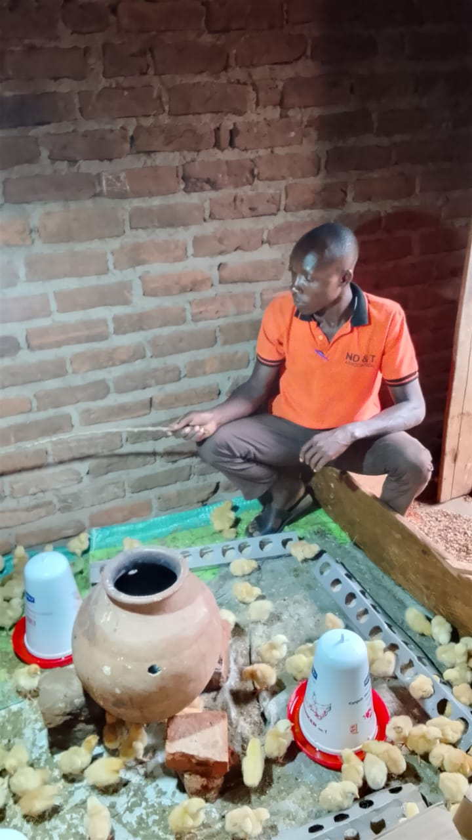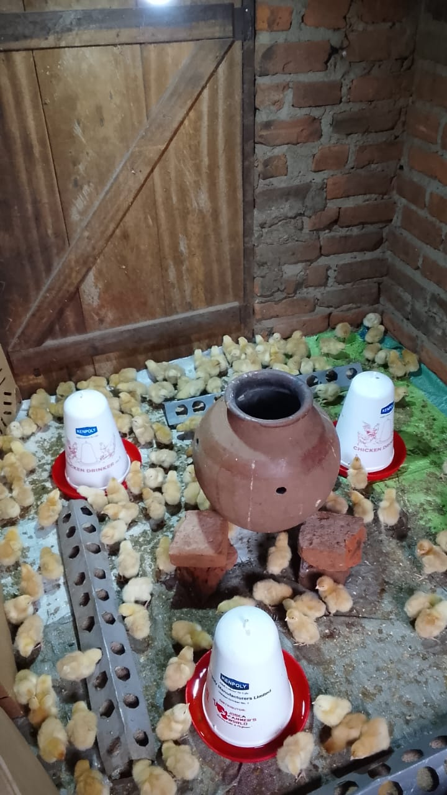
A photo showing Latif in his project of 150 Sasso birds in Nawaninji S/C in Iganga district.

March 2026 Activity Field Photos
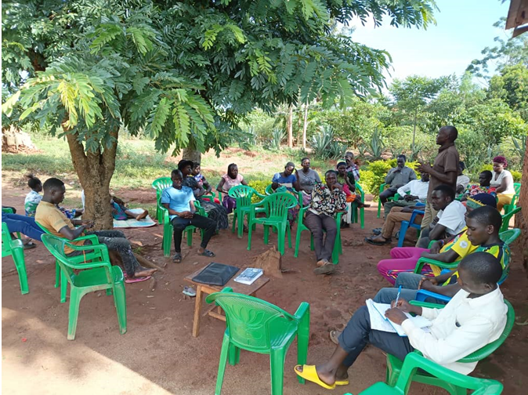
The new CF Tadeo during a leadership and group dynamics training session in Bukatube S/C Mayuge district
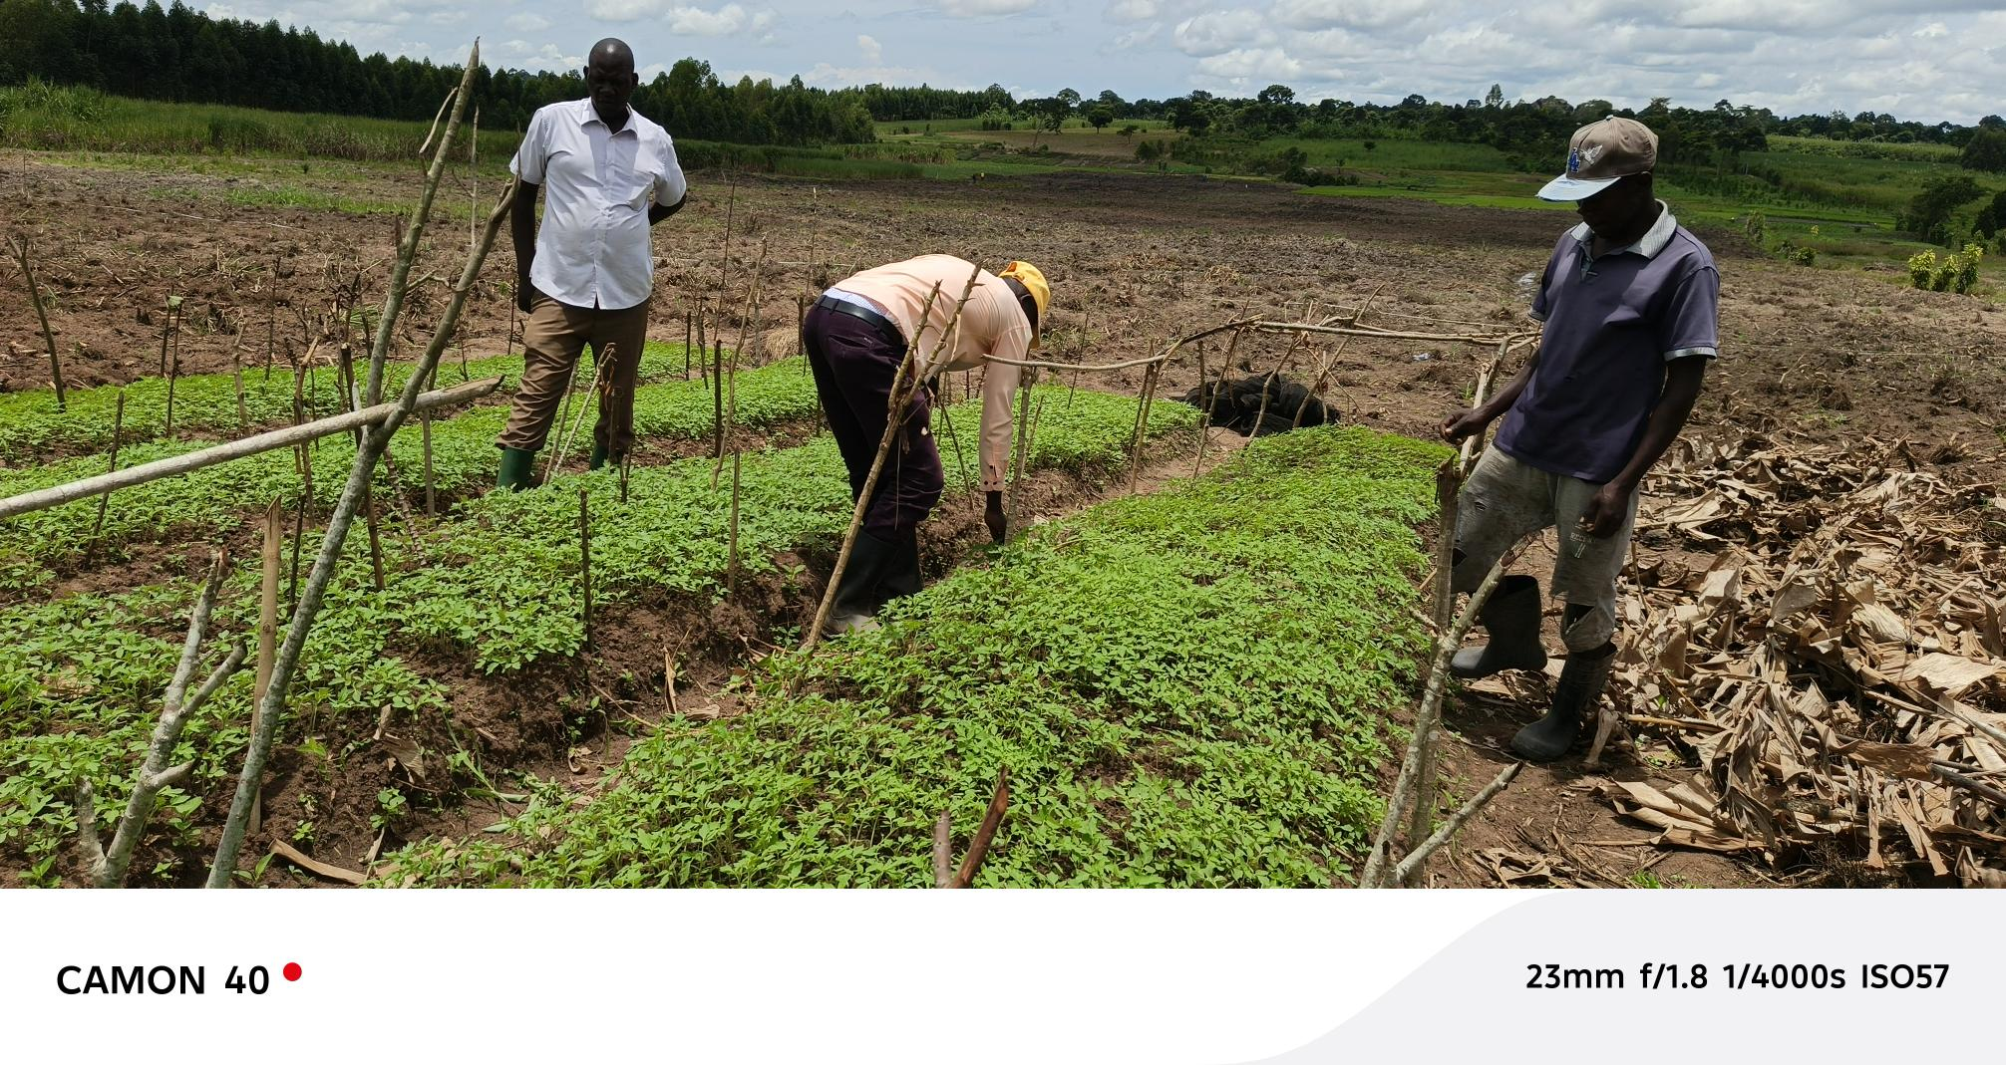
Tomato nursery bed at Mpungwe Block Farm in Mayuge District being hardened for transplanting.
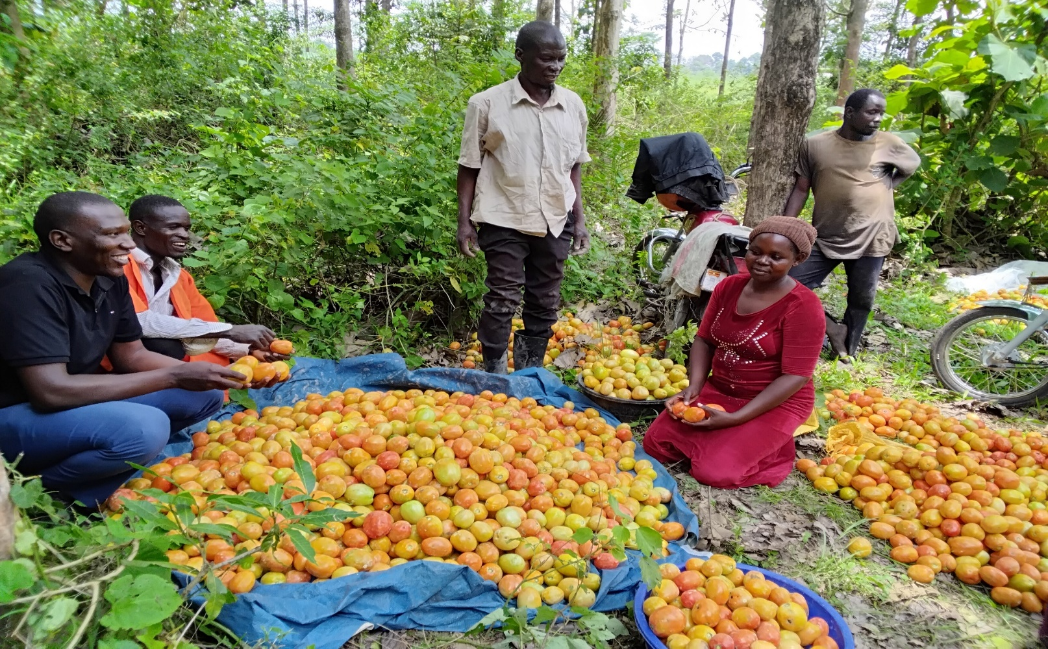
Captioned is CF with participants who went into production last year and now harvesting at Kiwanyi Akanabala youth group Iganga district.
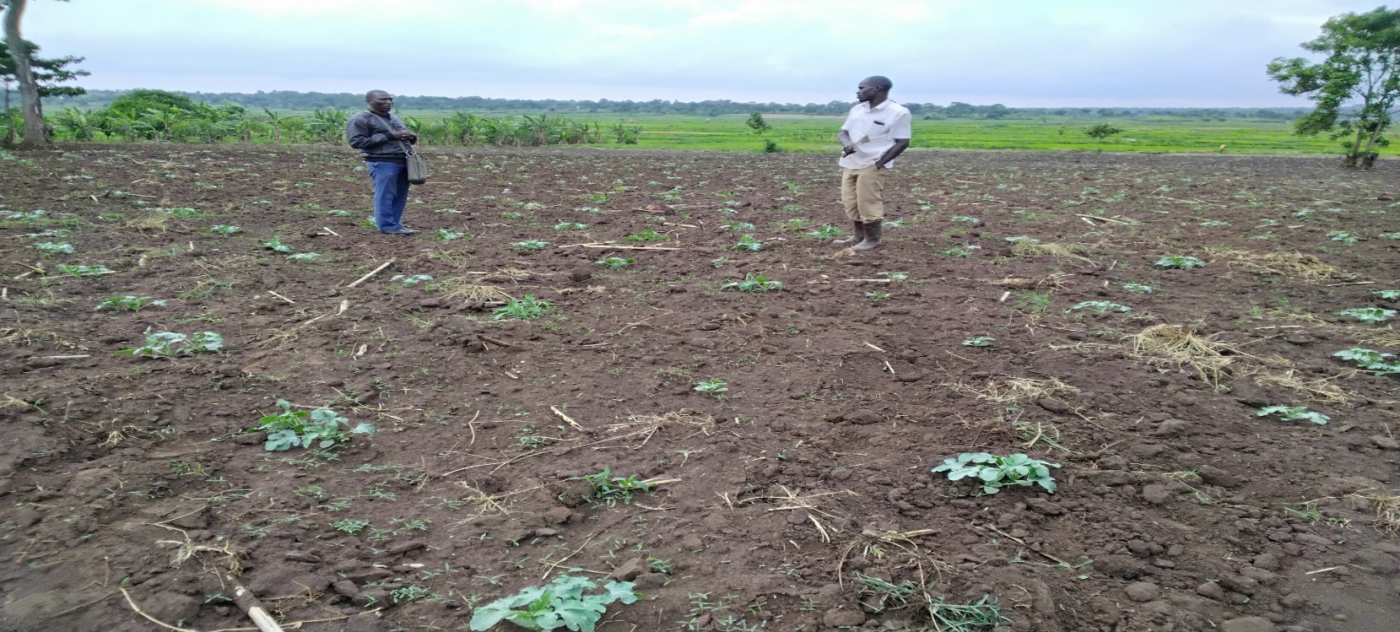Captioned is the CF with Kintu Joshua a participant of Nawangaiza11 Twezimbe who established 2 acres of watermelon as sustainable job in Iganga district.
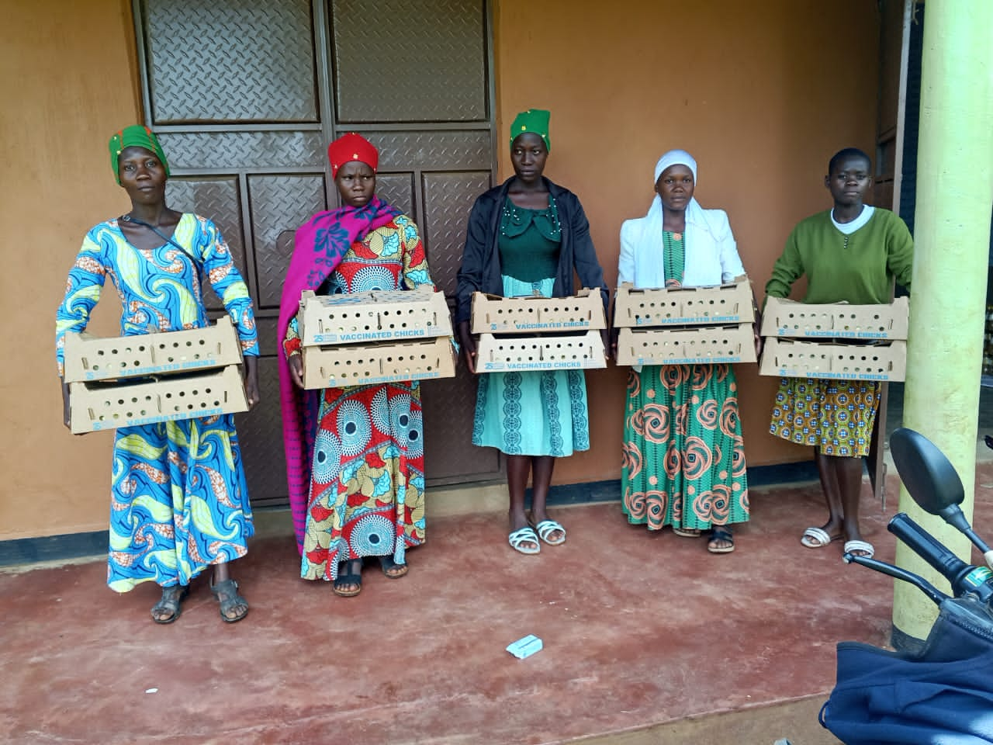
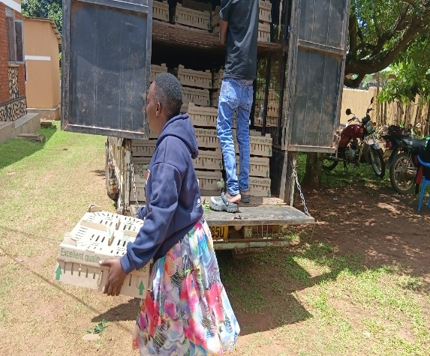 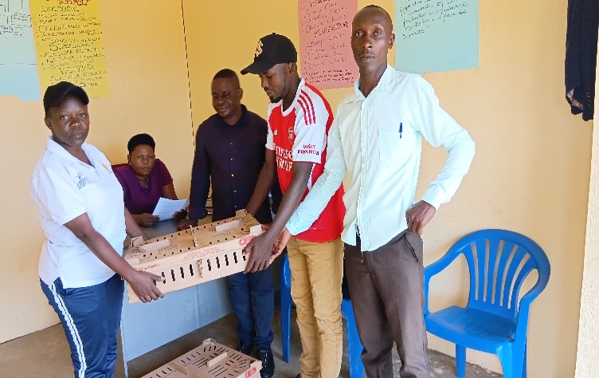 Photos Photo showing CF during the distribution of the poultry birds with J&C at Namingalwe Agrihub in Iganga district.
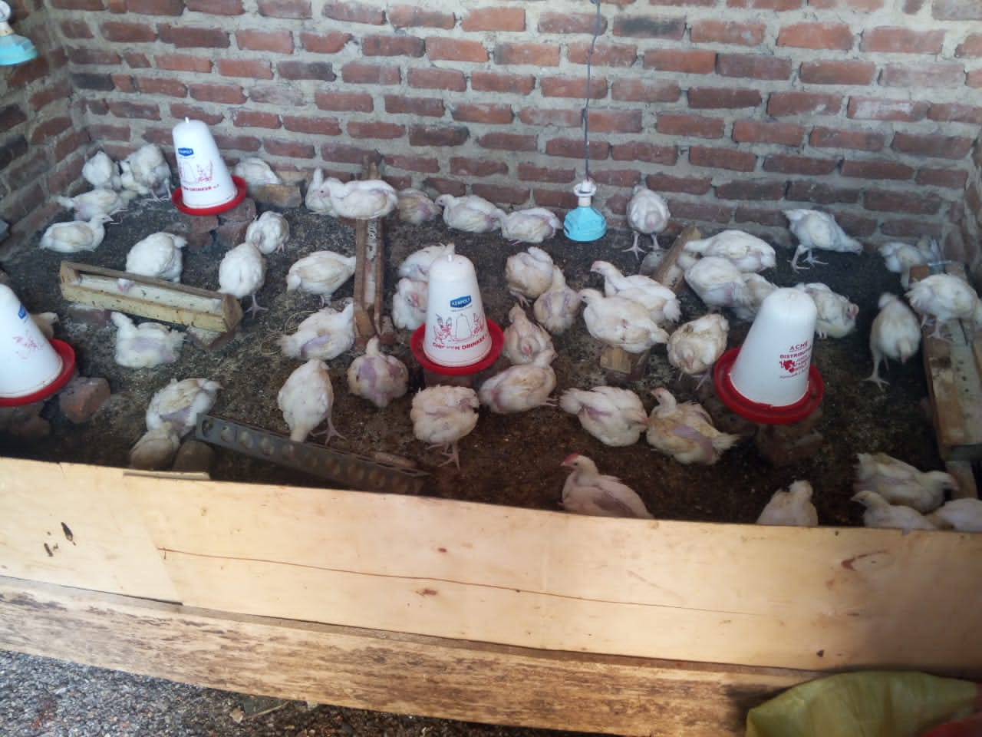

Participants of Join Hands in Poultry are receiving Sasso chicks at Busakira Agrihub in Mayuge district and right are the chicks oof one participant during the monitoring exercise.
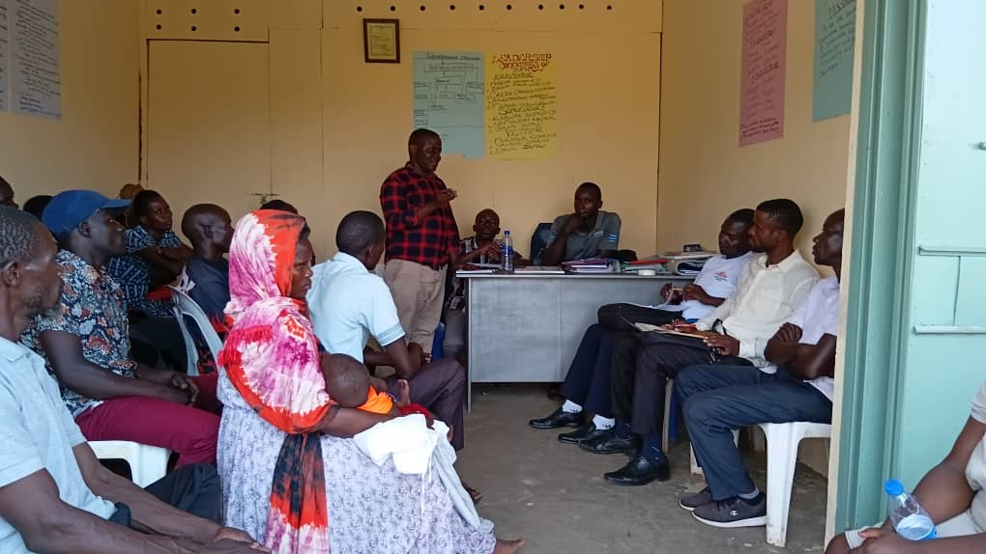
The team from Bukanga Agaliwamu SACCO engaging with Namungalwe Agrihub leadership on mobilisation of participants to access finance for their business growth.

