HW5

Junyu Wang

## First inspection of the data

source("~/personal/school/stats133/stat133/HW5/data_clean_preprocess.R")

## Warning: NAs introduced by coercion

## Warning: NAs introduced by coercion

str(raw_weather_data)

## 'data.frame': 11192 obs. of 21 variables:  
## $ id : Factor w/ 11192 levels "196009230ram",..: 1 2 4 6 3 5 7 11 8 9 ...  
## $ home_team : Factor w/ 40 levels "Arizona Cardinals",..: 21 11 14 33 3 29 11 14 10 3 ...  
## $ home_score : int 21 28 14 19 20 24 25 28 28 42 ...  
## $ away_team : Factor w/ 40 levels "Arizona Cardinals",..: 35 31 8 26 40 10 29 13 31 8 ...  
## $ away_score : int 43 35 17 21 0 41 27 9 20 7 ...  
## $ temperature : int 66 72 60 72 62 61 77 53 54 54 ...  
## $ wind_chill : int NA NA NA NA NA NA NA NA NA NA ...  
## $ humidity : num 78 80 76 44 80 77 50 78 78 76 ...  
## $ wind_mph : int 8 16 13 10 9 9 11 16 15 9 ...  
## $ weather : Factor w/ 8364 levels "-0 degrees- relative humidity 58%- wind 8 mph- wind chill -15",..: 6489 7332 5338 7239 5786 5561 7770 3872 4066 4056 ...  
## $ date : Factor w/ 2099 levels "1/1/1967","1/1/1978",..: 1918 1934 1951 1951 1951 1951 2026 360 360 360 ...  
## $ temperature2: num 66 72 60 72 62 61 77 53 54 54 ...  
## $ humidity2 : num 78 80 76 44 80 77 50 78 78 76 ...  
## $ wind2 : num 8 16 13 10 9 9 11 16 15 9 ...  
## $ year : num 1960 1960 1960 1960 1960 1960 1960 1960 1960 1960 ...  
## $ monthnum : num 9 9 9 9 9 9 9 10 10 10 ...  
## $ month : Factor w/ 7 levels "August","December",..: 7 7 7 7 7 7 7 6 6 6 ...  
## $ decade : Factor w/ 6 levels "1960s","1970s",..: 1 1 1 1 1 1 1 1 1 1 ...  
## $ total_score : int 64 63 31 40 20 65 52 37 48 49 ...  
## $ diff_score : int -22 -7 -3 -2 20 -17 -2 19 8 35 ...  
## $ home_win : logi FALSE FALSE FALSE FALSE TRUE FALSE ...

head(raw_weather_data)

## id home_team home_score away_team  
## 1 196009230ram Los Angeles Rams 21 St. Louis Cardinals  
## 2 196009240dal Dallas Cowboys 28 Pittsburgh Steelers  
## 3 196009250gnb Green Bay Packers 14 Chicago Bears  
## 4 196009250sfo San Francisco 49ers 19 New York Giants  
## 5 196009250clt Baltimore Colts 20 Washington Redskins  
## 6 196009250phi Philadelphia Eagles 24 Cleveland Browns  
## away_score temperature wind_chill humidity wind_mph  
## 1 43 66 NA 78 8  
## 2 35 72 NA 80 16  
## 3 17 60 NA 76 13  
## 4 21 72 NA 44 10  
## 5 0 62 NA 80 9  
## 6 41 61 NA 77 9  
## weather date temperature2  
## 1 66 degrees- relative humidity 78%- wind 8 mph 9/23/1960 66  
## 2 72 degrees- relative humidity 80%- wind 16 mph 9/24/1960 72  
## 3 60 degrees- relative humidity 76%- wind 13 mph 9/25/1960 60  
## 4 72 degrees- relative humidity 44%- wind 10 mph 9/25/1960 72  
## 5 62 degrees- relative humidity 80%- wind 9 mph 9/25/1960 62  
## 6 61 degrees- relative humidity 77%- wind 9 mph 9/25/1960 61  
## humidity2 wind2 year monthnum month decade total_score diff_score  
## 1 78 8 1960 9 September 1960s 64 -22  
## 2 80 16 1960 9 September 1960s 63 -7  
## 3 76 13 1960 9 September 1960s 31 -3  
## 4 44 10 1960 9 September 1960s 40 -2  
## 5 80 9 1960 9 September 1960s 20 20  
## 6 77 9 1960 9 September 1960s 65 -17  
## home_win  
## 1 FALSE  
## 2 FALSE  
## 3 FALSE  
## 4 FALSE  
## 5 TRUE  
## 6 FALSE

## Weather Information

Remove % in column humidity and convert such values to numeric format

head(raw_weather_data$humidity)

## [1] 78 80 76 44 80 77

Extract the temperature from column weather, and create a column temperature2 with these values.

head(raw_weather_data$temperature2)

## [1] 66 72 60 72 62 61

Extract the humidity values from column weather, and create a column humidity2 with these values.

head(raw_weather_data$humidity2)

## [1] 78 80 76 44 80 77

Extract the wind speed values from column weather, and create a column wind2 with these values.

head(raw_weather_data$wind2)

## [1] 8 16 13 10 9 9

Check new columns coincide with the pre-existing ones:

summary(raw_weather_data$temperature)

## Min. 1st Qu. Median Mean 3rd Qu. Max.   
## -7.00 46.00 59.00 56.69 72.00 96.00

summary(raw_weather_data$temperature2)

## Min. 1st Qu. Median Mean 3rd Qu. Max.   
## -7.00 46.00 59.00 56.69 72.00 96.00

summary(raw_weather_data$humidity)

## Min. 1st Qu. Median Mean 3rd Qu. Max. NA's   
## 0.00 57.00 69.00 67.21 79.00 100.00 1907

summary(raw_weather_data$humidity2)

## Min. 1st Qu. Median Mean 3rd Qu. Max. NA's   
## 0.00 57.00 69.00 67.21 79.00 100.00 1907

summary(raw_weather_data$wind_mph)

## Min. 1st Qu. Median Mean 3rd Qu. Max. NA's   
## 1.00 7.00 10.00 10.21 13.00 32.00 1845

summary(raw_weather_data$wind2)

## Min. 1st Qu. Median Mean 3rd Qu. Max. NA's   
## 1.00 7.00 10.00 10.21 13.00 32.00 1845

## Data information

Create a column year that contains the number of the year.

head(raw_weather_data$year)

## [1] 1960 1960 1960 1960 1960 1960

Create a column monthnum that contains the number of the month.

head(raw_weather_data$monthnum)

## [1] 9 9 9 9 9 9

Create a column month that contains the name of the corresponding month as factor.

head(raw_weather_data$month)

## [1] September September September September September September  
## Levels: August December Feburary January November October September

Create a column decade that indicates the corresponding decade of each played game.

head(raw_weather_data$decade)

## [1] 1960s 1960s 1960s 1960s 1960s 1960s  
## Levels: 1960s 1970s 1980s 1990s 2000s 2010s

## Scores Information

Create a column total_score that contains the total number of scored points in each game.

head(raw_weather_data$total_score)

## [1] 64 63 31 40 20 65

Create a column diff_score that indicates the difference of home_score and away_score.

head(raw_weather_data$diff_score)

## [1] -22 -7 -3 -2 20 -17

Create a column home_win that shows whether home_score is greater than away_score.

head(raw_weather_data$home_win)

## [1] FALSE FALSE FALSE FALSE TRUE FALSE

## Basic Exploration

Inspect variables home_score, away_score, temperature, wind_mpg

summary(raw_weather_data$home_score)

## Min. 1st Qu. Median Mean 3rd Qu. Max.   
## 0.0 14.0 21.0 22.1 28.0 72.0

summary(raw_weather_data$away_score)

## Min. 1st Qu. Median Mean 3rd Qu. Max.   
## 0.00 13.00 19.00 19.35 27.00 62.00

summary(raw_weather_data$temperature)

## Min. 1st Qu. Median Mean 3rd Qu. Max.   
## -7.00 46.00 59.00 56.69 72.00 96.00

summary(raw_weather_data$wind_mph)

## Min. 1st Qu. Median Mean 3rd Qu. Max. NA's   
## 1.00 7.00 10.00 10.21 13.00 32.00 1845

Visually inspect variables home_score, away_score, temperature, humidity and wind_mph.

hist(raw_weather_data$home_score)

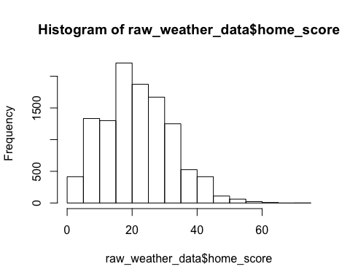

hist(raw_weather_data$away_score)

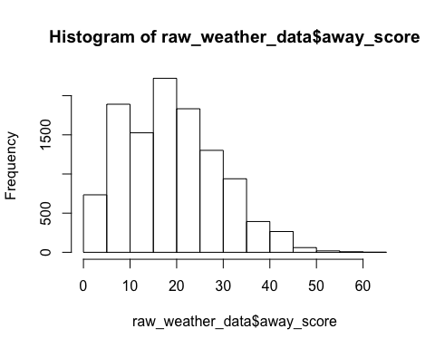

hist(raw_weather_data$temperature)

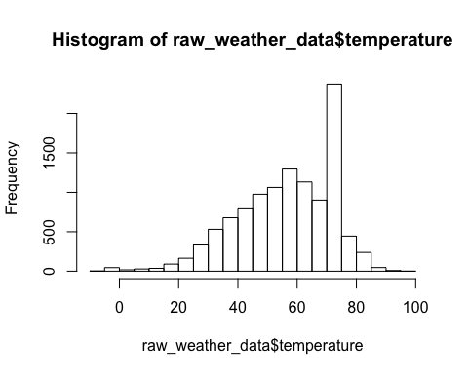

hist(raw_weather_data$humidity)

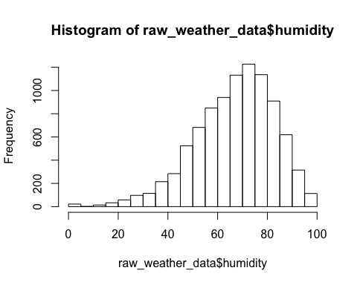

hist(raw_weather_data$wind_mph)

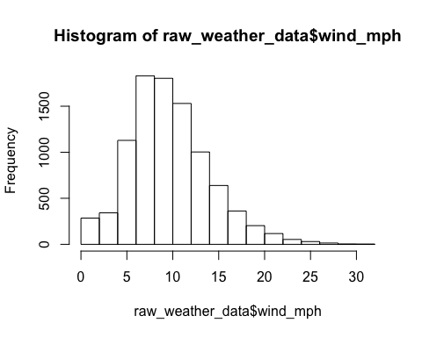

What team has the maximum home score?

team_with_max_home_score

## [1] Washington Redskins  
## 40 Levels: Arizona Cardinals Atlanta Falcons ... Washington Redskins

What team has the maximus away score?

team_with_max_away_score

## [1] Atlanta Falcons  
## 40 Levels: Arizona Cardinals Atlanta Falcons ... Washington Redskins

What is the most common home score?

m_common_home_score

## 17   
## 816

What is the most common away score?

m_common_away_score

## 17   
## 917

What has been the maximum temperature in a game?

max_temp

## [1] 96

What was the date of the maximum temperature?

date_max_temp

## [1] 9/8/2013  
## 2099 Levels: 1/1/1967 1/1/1978 1/1/1984 1/1/1989 1/1/1995 ... 9/9/2013

What has been the minimum temperature in a game?

min_temp

## [1] -7

What was the date of the minimum temperature?

date_min_temp

## [1] 1/20/2008  
## 2099 Levels: 1/1/1967 1/1/1978 1/1/1984 1/1/1989 1/1/1995 ... 9/9/2013

How many games have been played with a temperature of 90 degrees or more?

games_with_high_temp

## [1] 15

How many games have been played with a temperature below 0 degrees (do not include 0)?

games_with_low_temp

## [1] 7

What is the most common temperature?

m_common_temp

## 72   
## 1926

Make a bar chart with the frequency table of temperatures. Is there anything that catches your attention?

barplot(temp_freq)

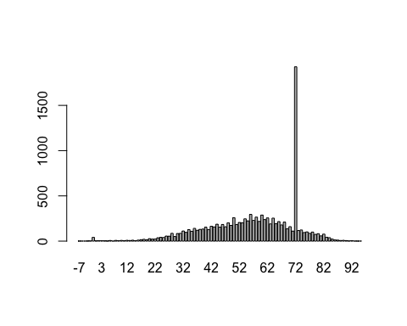

The frequency of temperature 72 is much higher than the rest of temperatures.

## Data Files

Export data for all games with selected columns.

head(cleaned_data)

## id home_team home_score away_team  
## 1 196009230ram Los Angeles Rams 21 St. Louis Cardinals  
## 2 196009240dal Dallas Cowboys 28 Pittsburgh Steelers  
## 3 196009250gnb Green Bay Packers 14 Chicago Bears  
## 4 196009250sfo San Francisco 49ers 19 New York Giants  
## 5 196009250clt Baltimore Colts 20 Washington Redskins  
## 6 196009250phi Philadelphia Eagles 24 Cleveland Browns  
## away_score total_score diff_score home_win date year month  
## 1 43 64 -22 FALSE 9/23/1960 1960 September  
## 2 35 63 -7 FALSE 9/24/1960 1960 September  
## 3 17 31 -3 FALSE 9/25/1960 1960 September  
## 4 21 40 -2 FALSE 9/25/1960 1960 September  
## 5 0 20 20 TRUE 9/25/1960 1960 September  
## 6 41 65 -17 FALSE 9/25/1960 1960 September  
## decade temperature humidity wind_mph  
## 1 1960s 66 78 8  
## 2 1960s 72 80 16  
## 3 1960s 60 76 13  
## 4 1960s 72 44 10  
## 5 1960s 62 80 9  
## 6 1960s 61 77 9

Export data for games during each decade with selected columns.

print("files are correctly generated")

## [1] "files are correctly generated"

## Data Analysis

source("~/personal/school/stats133/stat133/HW5/data_analysis.R")

## 1. Does play at home really have an advantage for the home team?

## Number of More Home victories per year

ggplot(data = result, aes(years, diffs)) +  
 geom_bar(color = "#000000", fill = "#515252", stat = "identity") +  
 ggtitle("Difference between home wins and home loses by year") +  
 ylab("Difference") +  
 scale_x_continuous(name = "Year",  
 breaks = years) +  
 theme(axis.text.x = element_text(angle= 90))

## Warning: Stacking not well defined when ymin != 0

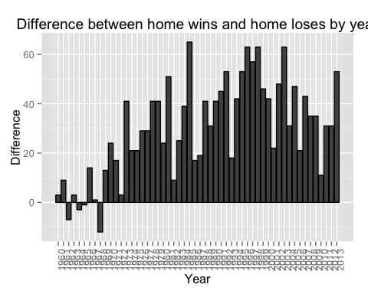

## Average score points per year

ggplot(data = avgs) +   
 geom_line(aes(x = years, y = avg_homescore), color = "#DB5FE4", size = 1.5) +  
 geom_line(aes(x = years, y = avg_awayscore), color = "#5FE4DB", size = 1.5) +  
 geom_point(aes(x = years, y = avg_homescore), color = "#DB5FE4", size = 3.0) +   
 geom_point(aes(x = years, y = avg_awayscore), color = "#5FE4DB", size = 3.0) +   
 ggtitle("Average score points per year") +   
 ylab("scores")

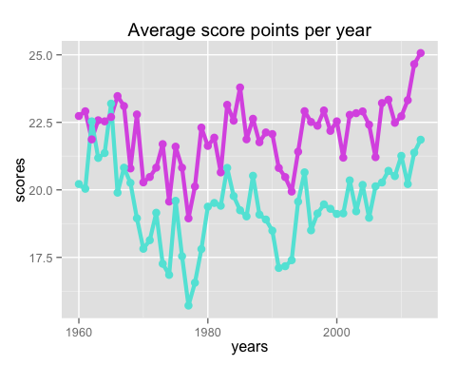

Other type of analysis for this conclusion: We can also conduct a t-test for null hypothesis stating that difference in home victories and away team victories = 0 each year. We can set up a one-side t-test and reject the null if p-value is smaller than the significance level.

## 2. Has the total number of scored points per game changed over time?

ggplot(data = avg_scores) +  
 geom_line(aes(x = years, y = avg_totalscore), color = "#000000", size = 1.5) +  
 geom_point(aes(x = years, y = avg_totalscore), color = "#000000", size = 3.0) +  
 ggtitle("Average total scored points per year")

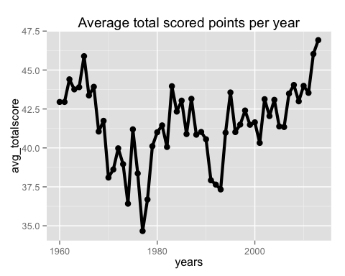

Other type of analysis for this conclusion: We can conduct a significance test for null hypothesis stating that scores each year is the same so expected value for each year's score = total scores of all years / number of years. We can set up a chi-square test and reject the null if test statistic is larger than corresponding critical score.