**OSDDiskFormat MDT & Configuration Manager**

**Setup Guide**

The intended use is to enable a ‘dynamic’ method of handing deployments when physical devices have one or many hard drives.

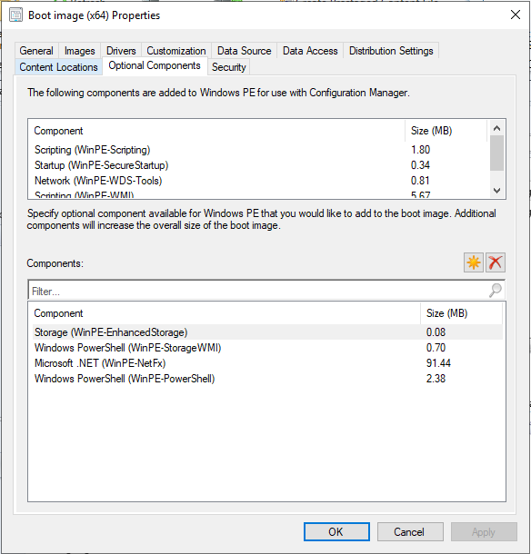

1. Boot Image: Add the ‘**Optional Compontents** ‘

**Storage (WinPE-EnhancedStorage)**

**Windows PowerShell (WinPE-StorageWMI)**

**Microsoft .NET (WinPE-NetFx)**

**Windows PowerShell (WinPE-PowerShell)**

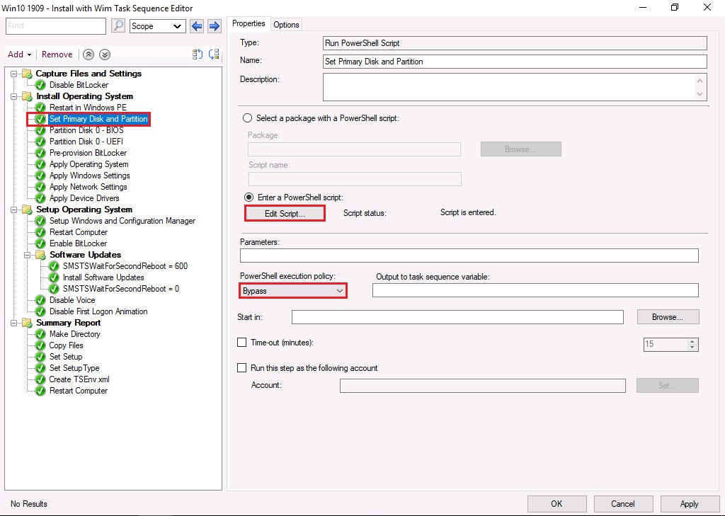

1. OSDDiskFormat: Add the ‘**Run Powershell Script**’ to the task sequence before the step ‘**Partition Disk**’.

**Type:** Run PowerShell Script

**Edit Script:** Copy the contents of Powerscript OSDDiskFormat.ps1

**PowerShell Execution Policy:** Bypass

The script will identify the total number of hard drives and order them by the ‘**BusType**’ technology and ‘**Size**’. The default configuration sets the ‘latest’ BusType and ‘smallest’ size hard drive as the **Primary Disk**. (This can be reconfigured in the script)

The variable ‘**OSDDiskIndex’** will be assigned the disk number ofthe ‘**Primary Disk**’ and used in the deployment step ‘**Partition Disk 0 - BIOS**’ or ‘**Partition Disk 0 - UEFI**’ and ‘**Pre-provsion BitLocker**’

**OSDDiskIndex:** <https://docs.microsoft.com/en-us/mem/configmgr/osd/understand/task-sequence-variables#OSDDiskIndex>

Any additional disks will be automatically partitioned, ready for data disks in the OS.

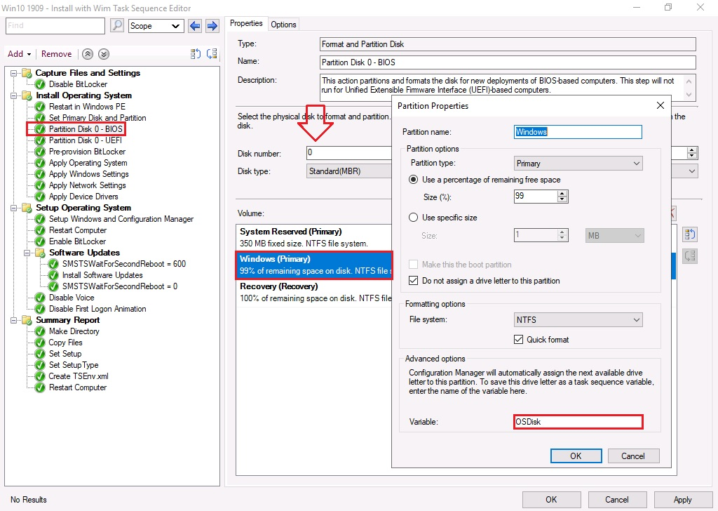

1. OSDisk BIOS: Select the ‘**Windows (Primary)’** volume and Set the ‘**Advance options Variable’** to **‘OSDisk’**.

**Variable:** OSDisk

The variable ‘**OSDisk**’ will be used in the ‘**Apply Operating System**’ to ensure the operating system gets applied to the correct hard drive.

**NOTE:** There is no need to change the ‘**Disk number’**, as this was dynamically set in **Step 2** (‘**OSDDiskIndex’).**

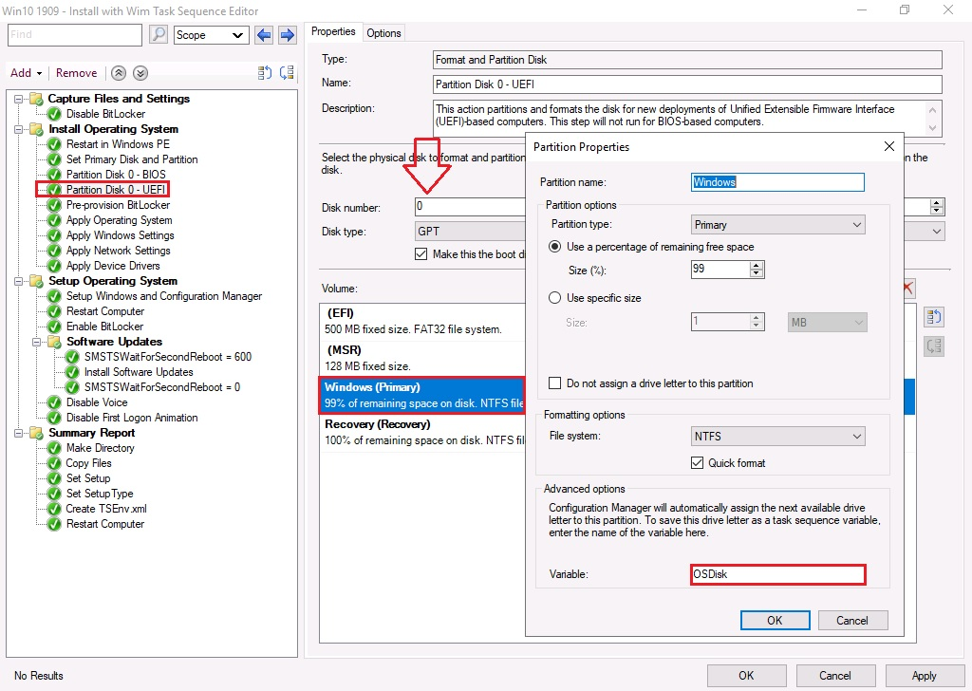

1. OSDisk UEFI: Select the ‘**Windows (Primary)’** volume and Set the ‘**Advance options Variable’** to **‘OSDisk’**.

**Variable:** OSDisk

The variable ‘**OSDisk**’ will be used in the ‘**Apply Operating System**’ to ensure the operating system gets applied to the correct hard drive.

**NOTE:** There is no need to change the ‘**Disk number’**, as this was dynamically set in **Step 2** (‘**OSDDiskIndex’).**

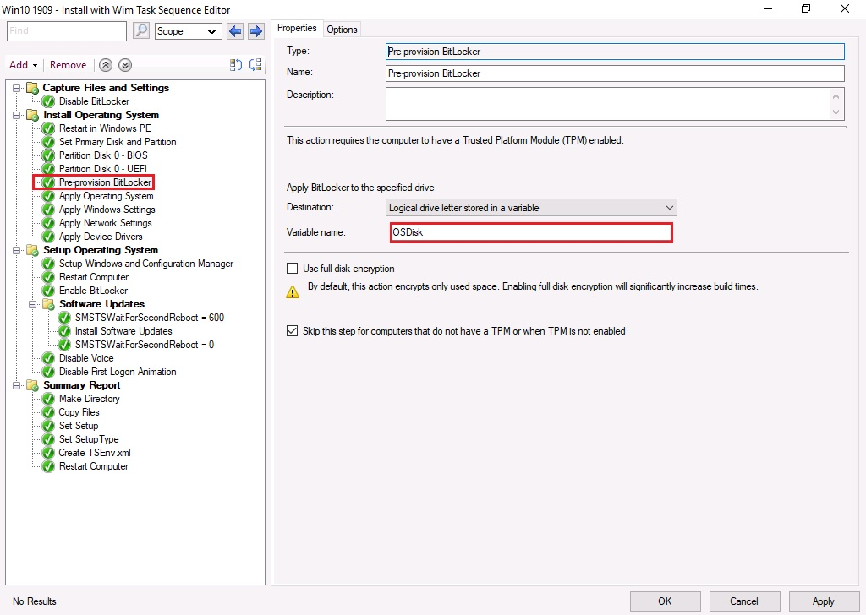

1. Pre-Provision Bitlocker: Select the ‘**Properties**’ tab and change the ‘**Destination**’ and ‘**Variable name**’ for ‘**Apply BitLocker to the specified drive’**

**Destination**: Logical driver letter stored in a variable

**Variable name:** OSDisk

**NOTE**: The Pre-Provision is applied to the Operating System as the ‘**OSDisk**’ variable was set in **Step 3** and **Step 4.**

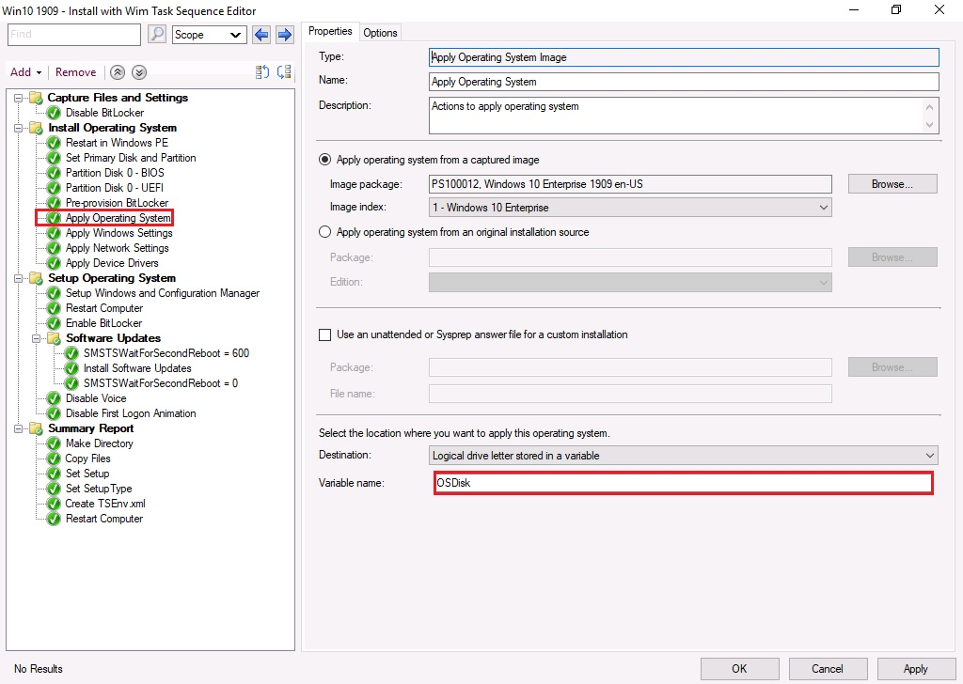

1. Apply Operating System: Select the ‘**Properties**’ tab and change the ‘**Destination**’ and ‘**Variable name**’ for ‘**Select the location where you want to apply this operating system**’

**Destination**: Logical driver letter stored in a variable

**Variable name:** OSDisk

**NOTE**: The Operating System is applied to the correct Drive as the ‘**OSDisk**’ variable was set in **Step 3** and **Step 4**

1. **Complete**