Ejercicio Hibernate

Dado el siguiente modelo:

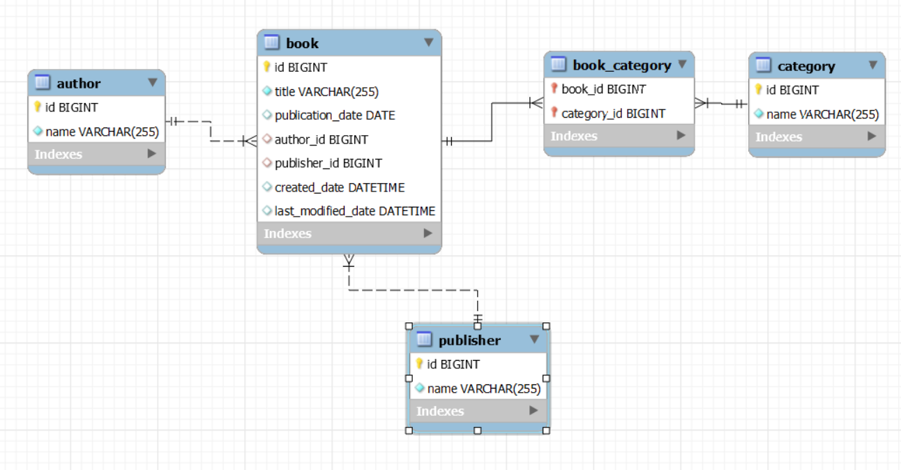

Ejercicios:
- Insertar un nuevo autor con libros asociados y un editor.
- Buscar libros con título que contenga una palabra clave.
- Buscar libros con ID mayor que un valor específico.
- Eliminar un autor y todos sus libros asociados.
- Actualizar el nombre de un autor usando una transacción.
- Manejo de fechas y búsqueda de libros publicados en un rango de fechas.

-- Creación de la base de datos
CREATE DATABASE biblioteca;
USE biblioteca;
-- Tabla Author
CREATE TABLE Author (
id BIGINT AUTO_INCREMENT PRIMARY KEY,
name VARCHAR(255) NOT NULL
);
-- Tabla Publisher
CREATE TABLE Publisher (
id BIGINT AUTO_INCREMENT PRIMARY KEY,
name VARCHAR(255) NOT NULL
);
-- Tabla Book
CREATE TABLE Book (
id BIGINT AUTO_INCREMENT PRIMARY KEY,
title VARCHAR(255) NOT NULL,
publication_date DATE,
author_id BIGINT,
publisher_id BIGINT,
created_date DATETIME,
last_modified_date DATETIME,
FOREIGN KEY (author_id) REFERENCES Author(id) ON DELETE CASCADE,
FOREIGN KEY (publisher_id) REFERENCES Publisher(id)
);
-- Tabla Category
CREATE TABLE Category (
id BIGINT AUTO_INCREMENT PRIMARY KEY,
name VARCHAR(255) NOT NULL
);
-- Tabla intermedia Book_Category para la relación Many-to-Many entre Book y Category
CREATE TABLE Book_Category (
book_id BIGINT,
category_id BIGINT,
PRIMARY KEY (book_id, category_id),
FOREIGN KEY (book_id) REFERENCES Book(id) ON DELETE CASCADE,
FOREIGN KEY (category_id) REFERENCES Category(id)
);

-- Insertar datos en la tabla Author
INSERT INTO Author (name) VALUES ('Author One');
INSERT INTO Author (name) VALUES ('Author Two');
INSERT INTO Author (name) VALUES ('Author Three');
INSERT INTO Author (name) VALUES ('Author Four');
INSERT INTO Author (name) VALUES ('Author Five');
INSERT INTO Author (name) VALUES ('Author Six');
INSERT INTO Author (name) VALUES ('Author Seven');
INSERT INTO Author (name) VALUES ('Author Eight');
INSERT INTO Author (name) VALUES ('Author Nine');
INSERT INTO Author (name) VALUES ('Author Ten');

-- Insertar datos en la tabla Publisher
INSERT INTO Publisher (name) VALUES ('Publisher One');
INSERT INTO Publisher (name) VALUES ('Publisher Two');
INSERT INTO Publisher (name) VALUES ('Publisher Three');
INSERT INTO Publisher (name) VALUES ('Publisher Four');
INSERT INTO Publisher (name) VALUES ('Publisher Five');
INSERT INTO Publisher (name) VALUES ('Publisher Six');
INSERT INTO Publisher (name) VALUES ('Publisher Seven');
INSERT INTO Publisher (name) VALUES ('Publisher Eight');
INSERT INTO Publisher (name) VALUES ('Publisher Nine');
INSERT INTO Publisher (name) VALUES ('Publisher Ten');

-- Insertar datos en la tabla Category
INSERT INTO Category (name) VALUES ('Category One');
INSERT INTO Category (name) VALUES ('Category Two');
INSERT INTO Category (name) VALUES ('Category Three');
INSERT INTO Category (name) VALUES ('Category Four');
INSERT INTO Category (name) VALUES ('Category Five');
INSERT INTO Category (name) VALUES ('Category Six');
INSERT INTO Category (name) VALUES ('Category Seven');
INSERT INTO Category (name) VALUES ('Category Eight');
INSERT INTO Category (name) VALUES ('Category Nine');
INSERT INTO Category (name) VALUES ('Category Ten');

-- Insertar datos en la tabla Book
INSERT INTO Book (title, publication_date, author_id, publisher_id, created_date, last_modified_date) VALUES
('Book One', '2020-01-01', 1, 1, NOW(), NOW()),
('Book Two', '2020-02-01', 2, 2, NOW(), NOW()),
('Book Three', '2020-03-01', 3, 3, NOW(), NOW()),
('Book Four', '2020-04-01', 4, 4, NOW(), NOW()),
('Book Five', '2020-05-01', 5, 5, NOW(), NOW()),
('Book Six', '2020-06-01', 6, 6, NOW(), NOW()),
('Book Seven', '2020-07-01', 7, 7, NOW(), NOW()),
('Book Eight', '2020-08-01', 8, 8, NOW(), NOW()),
('Book Nine', '2020-09-01', 9, 9, NOW(), NOW()),
('Book Ten', '2020-10-01', 10, 10, NOW(), NOW());

-- Insertar datos en la tabla Book_Category
INSERT INTO Book_Category (book_id, category_id) VALUES (1, 1);
INSERT INTO Book_Category (book_id, category_id) VALUES (2, 2);
INSERT INTO Book_Category (book_id, category_id) VALUES (3, 3);
INSERT INTO Book_Category (book_id, category_id) VALUES (4, 4);
INSERT INTO Book_Category (book_id, category_id) VALUES (5, 5);
INSERT INTO Book_Category (book_id, category_id) VALUES (6, 6);
INSERT INTO Book_Category (book_id, category_id) VALUES (7, 7);
INSERT INTO Book_Category (book_id, category_id) VALUES (8, 8);
INSERT INTO Book_Category (book_id, category_id) VALUES (9, 9);
INSERT INTO Book_Category (book_id, category_id) VALUES (10, 10);
-- Relaciones adicionales para algunos libros
INSERT INTO Book_Category (book_id, category_id) VALUES (1, 2);
INSERT INTO Book_Category (book_id, category_id) VALUES (2, 3);
INSERT INTO Book_Category (book_id, category_id) VALUES (3, 4);
INSERT INTO Book_Category (book_id, category_id) VALUES (4, 5);
INSERT INTO Book_Category (book_id, category_id) VALUES (5, 6);

