Ejercicio Hibernate

Dado el siguiente modelo:

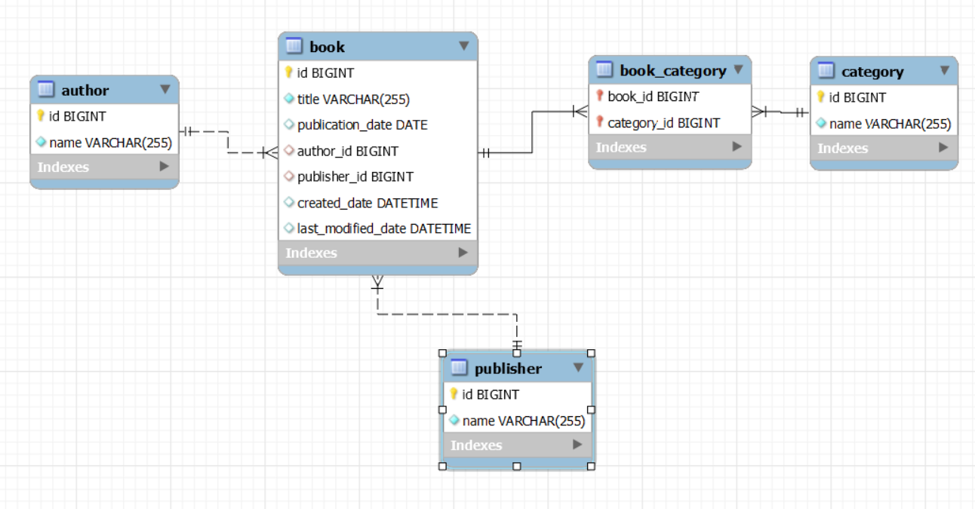

Ejercicios:

1. Insertar un nuevo autor con libros asociados y un editor.
2. Buscar libros con título que contenga una palabra clave.
3. Buscar libros con ID mayor que un valor específico.
4. Eliminar un autor y todos sus libros asociados.
5. Actualizar el nombre de un autor usando una transacción.
6. Manejo de fechas y búsqueda de libros publicados en un rango de fechas.

-- Creación de la base de datos

CREATE DATABASE biblioteca;

USE biblioteca;

-- Tabla Author

CREATE TABLE Author (

id BIGINT AUTO_INCREMENT PRIMARY KEY,

name VARCHAR(255) NOT NULL

);

-- Tabla Publisher

CREATE TABLE Publisher (

id BIGINT AUTO_INCREMENT PRIMARY KEY,

name VARCHAR(255) NOT NULL

);

-- Tabla Book

CREATE TABLE Book (

id BIGINT AUTO_INCREMENT PRIMARY KEY,

title VARCHAR(255) NOT NULL,

publication_date DATE,

author_id BIGINT,

publisher_id BIGINT,

created_date DATETIME,

last_modified_date DATETIME,

FOREIGN KEY (author_id) REFERENCES Author(id) ON DELETE CASCADE,

FOREIGN KEY (publisher_id) REFERENCES Publisher(id)

);

-- Tabla Category

CREATE TABLE Category (

id BIGINT AUTO_INCREMENT PRIMARY KEY,

name VARCHAR(255) NOT NULL

);

-- Tabla intermedia Book_Category para la relación Many-to-Many entre Book y Category

CREATE TABLE Book_Category (

book_id BIGINT,

category_id BIGINT,

PRIMARY KEY (book_id, category_id),

FOREIGN KEY (book_id) REFERENCES Book(id) ON DELETE CASCADE,

FOREIGN KEY (category_id) REFERENCES Category(id)

);

-- Insertar datos en la tabla Author

INSERT INTO Author (name) VALUES ('Author One');

INSERT INTO Author (name) VALUES ('Author Two');

INSERT INTO Author (name) VALUES ('Author Three');

INSERT INTO Author (name) VALUES ('Author Four');

INSERT INTO Author (name) VALUES ('Author Five');

INSERT INTO Author (name) VALUES ('Author Six');

INSERT INTO Author (name) VALUES ('Author Seven');

INSERT INTO Author (name) VALUES ('Author Eight');

INSERT INTO Author (name) VALUES ('Author Nine');

INSERT INTO Author (name) VALUES ('Author Ten');

-- Insertar datos en la tabla Publisher

INSERT INTO Publisher (name) VALUES ('Publisher One');

INSERT INTO Publisher (name) VALUES ('Publisher Two');

INSERT INTO Publisher (name) VALUES ('Publisher Three');

INSERT INTO Publisher (name) VALUES ('Publisher Four');

INSERT INTO Publisher (name) VALUES ('Publisher Five');

INSERT INTO Publisher (name) VALUES ('Publisher Six');

INSERT INTO Publisher (name) VALUES ('Publisher Seven');

INSERT INTO Publisher (name) VALUES ('Publisher Eight');

INSERT INTO Publisher (name) VALUES ('Publisher Nine');

INSERT INTO Publisher (name) VALUES ('Publisher Ten');

-- Insertar datos en la tabla Category

INSERT INTO Category (name) VALUES ('Category One');

INSERT INTO Category (name) VALUES ('Category Two');

INSERT INTO Category (name) VALUES ('Category Three');

INSERT INTO Category (name) VALUES ('Category Four');

INSERT INTO Category (name) VALUES ('Category Five');

INSERT INTO Category (name) VALUES ('Category Six');

INSERT INTO Category (name) VALUES ('Category Seven');

INSERT INTO Category (name) VALUES ('Category Eight');

INSERT INTO Category (name) VALUES ('Category Nine');

INSERT INTO Category (name) VALUES ('Category Ten');

-- Insertar datos en la tabla Book

INSERT INTO Book (title, publication_date, author_id, publisher_id, created_date, last_modified_date) VALUES

('Book One', '2020-01-01', 1, 1, NOW(), NOW()),

('Book Two', '2020-02-01', 2, 2, NOW(), NOW()),

('Book Three', '2020-03-01', 3, 3, NOW(), NOW()),

('Book Four', '2020-04-01', 4, 4, NOW(), NOW()),

('Book Five', '2020-05-01', 5, 5, NOW(), NOW()),

('Book Six', '2020-06-01', 6, 6, NOW(), NOW()),

('Book Seven', '2020-07-01', 7, 7, NOW(), NOW()),

('Book Eight', '2020-08-01', 8, 8, NOW(), NOW()),

('Book Nine', '2020-09-01', 9, 9, NOW(), NOW()),

('Book Ten', '2020-10-01', 10, 10, NOW(), NOW());

-- Insertar datos en la tabla Book_Category

INSERT INTO Book_Category (book_id, category_id) VALUES (1, 1);

INSERT INTO Book_Category (book_id, category_id) VALUES (2, 2);

INSERT INTO Book_Category (book_id, category_id) VALUES (3, 3);

INSERT INTO Book_Category (book_id, category_id) VALUES (4, 4);

INSERT INTO Book_Category (book_id, category_id) VALUES (5, 5);

INSERT INTO Book_Category (book_id, category_id) VALUES (6, 6);

INSERT INTO Book_Category (book_id, category_id) VALUES (7, 7);

INSERT INTO Book_Category (book_id, category_id) VALUES (8, 8);

INSERT INTO Book_Category (book_id, category_id) VALUES (9, 9);

INSERT INTO Book_Category (book_id, category_id) VALUES (10, 10);

-- Relaciones adicionales para algunos libros

INSERT INTO Book_Category (book_id, category_id) VALUES (1, 2);

INSERT INTO Book_Category (book_id, category_id) VALUES (2, 3);

INSERT INTO Book_Category (book_id, category_id) VALUES (3, 4);

INSERT INTO Book_Category (book_id, category_id) VALUES (4, 5);

INSERT INTO Book_Category (book_id, category_id) VALUES (5, 6);