Enhancing downscaled ocean wave conditions with Machine Learning and Wave Spectra

Leo Peach[1][2], School of Engineering and the Built Environment & Coastal and Marine Research Centre, Griffith University, Australia

Nick Cartwright, School of Engineering and the Built Environment & Coastal and Marine Research Centre, Griffith University, Australia

Guilherme Viera da Silva, Coastal and Marine Research Centre, Griffith University, Australia

Darrell Strauss, Coastal and Marine Research Centre, Griffith University, Australia

# Abstract

Machine Learning is becoming an increasingly popular and important tool for predicting ocean wave conditions, here it is applied to downscale offshore conditions to a nearshore location utilising more detailed representations of the offshore wave field via use of the 1D wave spectra. The results show additional performance can be achieved (27% reduction in Root Mean Squared Error in Significant Wave Height), particularly for extreme values when using 1D wave spectra. Though we identified that Long-Term Short-Term Memory approach applied here improved performance overall, there is not a one size fits all wave parameters. Carefully feature selection (which features to include or exclude when training a model), feature engineering (such as feature encoding and sequence selection) and model configuration continue to be key factors in achieving accurate wave conditions. Further work is needed to make better use of more detailed wave field information such as the wave spectrum to provide better datasets for data-driven approaches like machine learning.

**Keywords**: Machine Learning, Neural Network, Wave Spectra

# Introduction

The downscaling of wave heights is important for a range of maritime and coastal applications, from port operations and vessel movements to disaster management, coastal engineering, and recreation. Whether the application be hindcasting or forecasting ocean conditions, one of the challenges of accurately obtaining wave conditions at the coast is the ability to downscale predictions from oceanographic wave models to the coast quantifying additional processes that occur as waves approach the coast, such as depth induced wave breaking, refraction and diffraction. Downscaling typically involves the development of computationally expensive physics-based models (such as a phase-averaged spectral wave models), which also require good quality input data, including bathymetry to perform well. A range of other techniques for downscaling have been proposed including the Hybrid Downscaling Technique (Vieira Da Silva et al., 2018), Backward Ray Tracing (Crosby et al., 2019; Oh, 1981), Look-up tables (EA, 2016), statistical models (Hegermiller et al., 2017) and meta models (B. Gouldby et al., 2014). Each approach has it’s strengths and weaknesses, for example the Hybrid Downscaling technique is limited on the parameters it can predict and struggles in complex multimodal sea states (Peach et al., 2023) and Look-up tables perform much slower and are often only have simple relationships to cope with unseen cases (Ben Gouldby et al., 2017).

Machine Learning and Deep Learning (a class of Machine Learning) have long been applied to problem of downscaling wave conditions to the coast (Browne et al., 2007; Reikard & Rogers, 2011). Research to date provides excellent guidance of suitable approaches to downscale oceanographic wave conditions and in particular integrated wave parameters (Significant Wave Height (*Hs*), Peak Wave Period (*Tp*), Peak Wave Direction (*Dp*)) to the coast. Artificial Neural Networks (ANN’s) are perhaps one of the most typically used for such an application (Browne et al., 2007; Camus et al., 2011; Reikard & Rogers, 2011), with some newer research utilising Deep Learning (Adytia et al., 2023; Cagigal et al., 2024; Shamshirband et al., 2020). Each has demonstrated they can perform the task well, with the best performance apparent in the prediction of Hs.

Here we compare the Multi-Layer Perceptron (MLP) and Long-Term Short-Term Memory (LTSM) methods, to downscale and produce wave conditions for a point at the coast given inputs from an offshore location. MLP is a classical machine learning technique it’s a fully connected Neural Network (NN), the layers and neurons of which can be modified through model development (number of neurons, number of layers etc). The model is trained using backpropagation (utilising a training and testing dataset) and is applicable for non-linear problems. LTSM is a Deep Learning approach that also makes use of NN’s but in a more complex configuration (a type of Recurrent Neural Network), they make use of logic gates to generate long-term and short-term biases (Zhang et al., 2021). They are designed for sequence problems such as timeseries or natural language. Both approaches were selected based there appearance in the literature.

Though there is a lot of literature that focus on making predictions for integrated wave parameters (Ibarra-Berastegi et al., 2015; O’donncha et al., 2018; Y. Zhang et al., 2017) there is significantly less that have considered more detailed representations of the wave field, namely wave spectra. Only a small number of publications have looked at the more detailed parameters in order to make predictions Mooneyham et al., (2020) uses a Residual Learning Network along the US west coast, and Ricondo et al., (2023) use a maximum dissimilarity algorithm and radial basis function to downscale from a single point to several locations around Islands in the Pacific. Here we compare different data sources up to and including the 1D spectrum, filling a gap in the current knowledge base. Additionally, one of the most significant factors impacting performance in phase-averaged wave prediction systems is the performance of input wind conditions from Numerical Weather Prediction Systems (either forecast or hindcast). Machine learning has been used for bias correction and downscaling (Costa et al., 2023; Hadi Moeini et al., 2012), here we attempt to achieve both comparing increasingly complex combinations of input features including the 1D wave spectrum and wave monitoring observations.

This paper aims to identify some of the key sensitivities of downscaling wave conditions from an offshore hindcast location to a single observation point near the coast (a common application) to the selection of input feature combinations. This will be addressed by comparing machine learning performance from different commonly applied methods with first total spectrum wave parameters, then partitioned wave parameters and finally a 1D wave energy spectrum. A key outcome will be to help practitioners understand broad performance for a common use case.

# Methods

## Overview

Broadly the methodology is an extension of previous efforts to use machine learning to predict wave parameters (Peach et al. 2023; James, Zhang, and O’donncha 2018). Figure 1 provides an overview of the data extraction process and available datasets for model development and training (described in more detail in following sections), input data from offshore on the left and nearshore observed wave conditions on the right. Predictions are typically a single output parameter, therefore requiring multiple models to be developed for each integrated parameter being predicted. Whilst this adds an overhead it does allow for different model configurations for each parameter, likely leading to the best overall result.

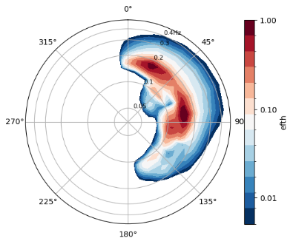

Offshore Hindcast Spectrum

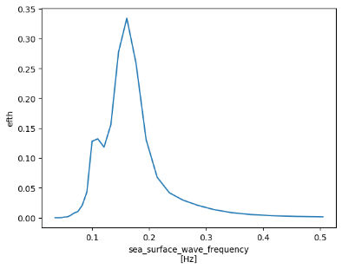

1D Spectrum

Machine Learning Models

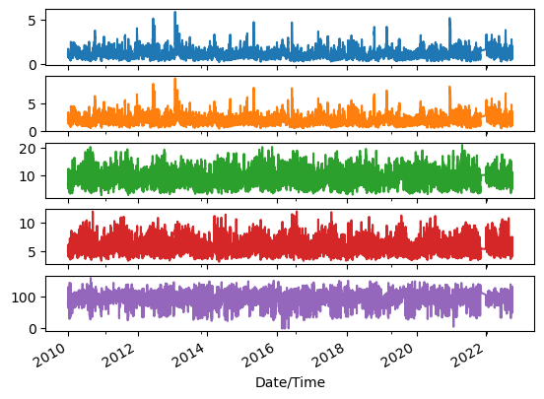

Monitoring Site Nearshore Historical Wave Observations

Integrated

Wave Parameters

Partition

Features

Labels

Predictions

Data Preparation and Feature Engineering

Figure 1: Process diagram of data preparation.

Partitioned Wave Parameters

## Datasets

Whilst a range of datasets have been used in the literature depending on the application and the approach (wave observations, phase-averaged wave model forecasts, Numerical Weather Predictions and wind observations). Here we have selected to use datasets that are typically available (Figure 1), allows the extraction of large datasets to conduct model training and testing and that can be easily replicated for other applications.

### Wave Hindcast

The wave model data used for this work is the CAWCR hindcast (Smith et al., 2021), developed by the Commonwealth Scientific and Industrial Research Organisation (CSIRO) and the Bureau of Meteorology. The hindcast uses a WaveWatch3 (v4.08) wave model driven by CSFR winds and sea ice concentration. It provides a spatial resolution of 0.4° globally and 0.06° in the Australian region and its model outputs include a two-dimensional wave spectrum for points in the Australian region.

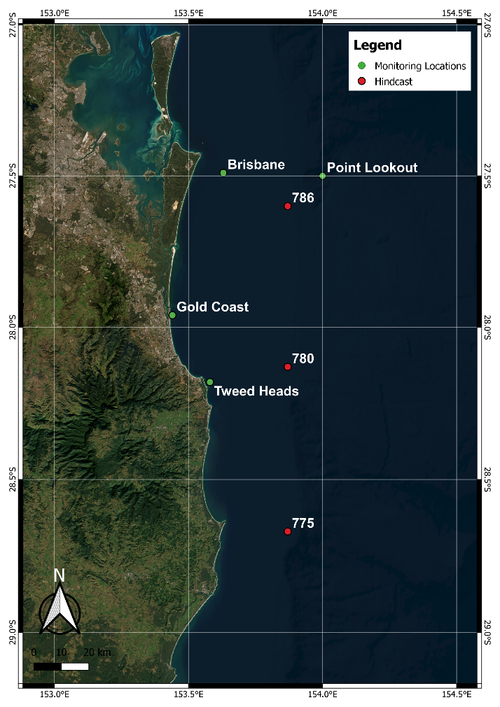

Figure 2: Wave Monitoring Locations and CAWCR Hindcast Points

From the 2-dimensional (2D) wave spectrum a 1-dimensional (1D) wave spectrum is extracted for each timestep by integrating the energy over all directions, an example spectrum is plotted in Figure 1. Integrated wave parameter information is also available for the same locations the available parameters include *Hs*, *Tp*, *Tz*, *Dp*.

Hourly data from the period 2010 to 2022 were extracted from the CAWCR hindcast for the nodes shown in Figure 1. After some brief analysis such as ensuring appropriate proximity to the target location and depth of water (excluding any nearshore effects) hindcast point 780 was selected as the nearest offshore wave hindcast point (approximately 220m depth) to the target the Gold Coast Monitoring location. Figure 3 compares the distributions of various wave parameters for the offshore hindcast location and the nearshore observations at the Gold Coast monitoring location. As expected, the significant wave height is a little different (likely due to wave transformation processes), mean period is broadly similar, arguably the most impacted wave parameter is *Dp* (again likely due to wave transformation processes). These results are typical when comparing offshore and nearshore conditions.

### Wave observations

Wave observations were sourced from the Queensland Government’s wave monitoring program. They operate a range of wave monitoring sites, both current and historic in South East Queensland. Observations are captured by wave monitoring buoys that are deployed to a monitoring location in some cases for many years or decades. There are some changes in the technology used in the buoys over the period of available data, but observations are expected to be comparable (Andrews & Peach, 2019).

The Gold Coast wave monitoring site located near Southport Spit, Gold Coast, Queensland Australia was principally used in this study because of the available length of data (with a long continuous record spanning over 10 years) and it’s proximity to the coast with a depth of approximately 17m. The length of recorded with limited gaps (only around 2739 gap of 108995 records between January 2010 and September 2022) is easier for training machine learning models. The depth is also shallow enough for nearshore wave processes to effect waves being measured by the wave monitoring buoy. Figure 4 shows Kernel Density Estimation plots for the offshore hindcast site and concurrent observed wave data some differences in *Hs* and *Dp* in particular are typical when comparing depth induced wave processes.

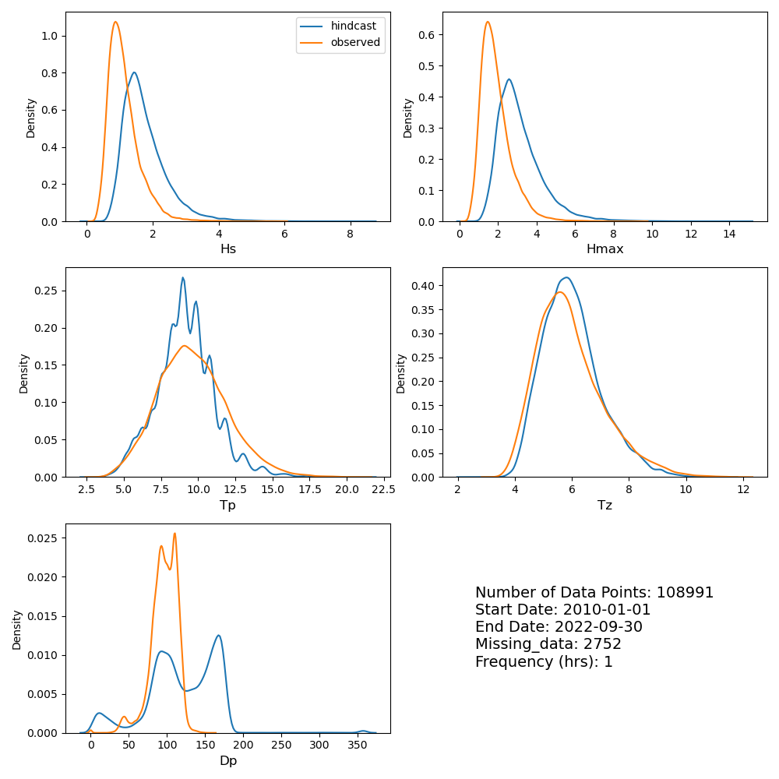

Figure 4: Kernal Density Estimation comparison between CAWCR hindcast point (780) and observations (Gold Coast Wave Monitoring Location).

## Data Preparation and Feature Engineering

Feature engineering (the manipulation of data for optimised use in machine learning models) is an important part of data science, especially with time based and directional features as in the datasets used here. A key element of data preparation was data cleaning, observed data can have a range of issues or errors, particularly when measuring waves in the marine environment over long periods. It is therefore necessary to ensure bad data which may impact a machine learning model is removed. This comes with additional challenge when considering sequential data for model training. The following data cleaning steps were undertaken based on Andrews & Peach (2019), including removing data spikes (values greater than five times the standard deviation of wave heights), removing spurious values and directional values greater than 360 and less than -1 degrees. Data gaps less than 3 hours where then filled using linear interpolation with the exception of direction which was forward filled.

The first step in data preparation for the machine learning model was to ensure that cyclical parameters were refactored the *Dp* parameter was converted into and ) components, this is common practice and is used to help overcome challenges with circular data (Gracia et al., 2021). Time parameters were treated similarly, the hour in UTC was derived for each timestep. The dataset was also decimated down to 3 hourly, this reduced the overall training dataset and allowed for previous timesteps from a longer period to be considered.

Training, testing and an independent dataset were constructed to ensure the independent performance of each machine learning approach. The independent dataset is from 2022-01-01 until the end of the available dataset (2022-09-30), around 3243 timesteps. The remaining dataset around 54496 timesteps were used to develop the machine learning models, with a split of 80% for training and 20% for testing. The available data was also scaled using standard scaling (removing the mean and scaling to variance), with training and testing data scaled independently, helping model performance and to help ensure no single feature dominates when training the models. Some models require training datasets to be in sequences, for those sequences of 12 continuous timesteps were constructed. Additionally, where gaps were present (due to gaps in the wave monitoring observations) sequences were dropped where the available number of timesteps was less than 12 continuous timesteps.

## Sensitivity Analysis

It was necessary to conduct sensitivity analysis through the creation of a baseline model, in this case XGBoost (Chen & Guestrin, 2016) was used, it’s an ensemble machine learning approach and python library with built in functions to help identify important parameters. A simplified range of the input data parameter combinations were tested. XGBoost evaluated feature importance based on the number of feature splits, weight and their impact on predictions. This sensitivity analysis revealed that directional parameters are important features and should be incorporated, including when using the 1D spectrum (which by its nature integrates them). From a physical perspective, this makes sense due to the location of the Gold Coast monitoring location (Figure 2) and the impact wave direction has on wave attenuation at that location (Vieira da Silva et al., 2018). Nearshore locations will typically have a narrower range of potential directional values due to the effects of waves as they arrive from offshore. This narrowing of predominant wave directions can be seen in Figure 4.

## Model Configuration

Two different machine learning modelling approaches were selected for comparison, Multi-layer Perception (MLP) and Long-Term Short-Term Memory (LTSM). The MLP is a classical fully connected Neural Network, the diagram for the general architecture of is described in Figure 5. This model was selected as it’s used frequently in the literature to predict wave conditions (Browne et al., 2007; James et al., 2017; Peach et al., 2023). The approach can cope with both linear and non-linear problems, works for regression problems and is simple to train.

Figure 5: Diagram of Multi-Layer Perceptron Neural Network. Input features *I* are the inputs and *O* the output.

The LTSM Neural Network is an evolution of the much simpler MLP and a sub-category of Recurrent Neural Networks. LTSM’s are more complex, and are designed specifically for timeseries problems. In this case the LTSM is constructed of LTSM cells (Figure 6). LTSM’s are able to identify long-term and short-term relationships (such as seasonality) and uses LTSM cells to understand long-term and short-term relationships between the features and labels.

Figure 6: Diagram of a Long-Term Short-Term (LTSM) cell.

### Tested Configurations

Model configurations were broadly based on (Peach et al., 2023), in particular for the MLP models. Hyper-parameter tuning is necessary to ensure best possible model performance, using the base configuration from Peach et al. (2023) a small number of configurations were tested using GridSearchCV (Pedregosa et al., 2011). Hidden layers, neurons, activation functions and solvers were all parameters used in the grid search, which identified the preferred approach based on Mean Squared Error. For brevity the final configurations are listed in Table 1.

Table 1: Final MLP Configurations from Peach et al (2023)

|  |  |  |  |  |
| --- | --- | --- | --- | --- |
| Model Name | Hidden Layers | Neurons | Activation Function | Solver |
| MLP 1 – Total | 6 | 6 | RELU | Adam |
| MLP 2 - Partitions | 6 | 6 | RELU | Adam |
| MLP 3 - Spec | 6 | 6 | RELU | Adam |

Similarly, a range of LTSM configurations were tested to tune the hyper-parameters for the problem. Additionally early stopping was also configured to help identify the best possible model and prevent over fitting (training ceased when performance didn’t significantly improve over 25 epochs). The configurations are listed below in Table 2, in this case a single configuration was used for each prediction parameter (*Hs*, *Tz* and *Dp*). Training was then undertaken for each model parameter and model weights saved independently. However, it is expected marginal performance improvements could be gained for individual parameters with unique configurations.

Table 2: Final LTSM Configurations

|  |  |  |  |  |  |
| --- | --- | --- | --- | --- | --- |
| Model Name | Hidden Layers | Neurons | Activation Function | Solver | Previous Timesteps |
| LTSM - Total | 6 | 64 | Tanh | Adam | 12 |
| LTSM - Partitioned | 9 | 64 | Tanh | Adam | 12 |
| LTSM – 1D Spec | 9 | 64 | Tanh | Adam | 12 |

## Skill Metrics

A range of skill metrics were used based on those commonly used in the field, they are principally from Bryant et al., (2016).

|  |  |  |
| --- | --- | --- |
|  |  | *Eq. i* |
|  |  | *Eq. ii* |
|  |  | *Eq. iii* |
|  |  | *Eq. iv* |
|  |  | *Eq. v* |
|  |  | *Eq. vi* |
|  |  | *Eq. vii* |

Where:

Each of the performance metrics is an estimate of performance typically used for regression problems and forecasting of numerical values. Multiple performance metrics are used in an effort to more robustly assess performance. MBE (Bias) and RMSE (Root Mean Squared Error) are typically used to assess regression performance and return a value in the unit of the prediction, 0 is a perfect score for both metrics. SI (Scatter Index) is a normalised RMSE represented as a percentage, a perfect score is 0%. The R2 (Coefficient of Determination), NSE (Nash-Sutcliffe), COR (Correlation Coefficient) and EC (Efficiency Coefficient) measures the performance of the variance and is measured between 0 and 1, with 1 a perfect score. It’s important to use a range of metrics as a single metric is unlikely to show a clear picture of performance, for example a model that both over and under predicts consistently could have a low Bias.

Though each metric is typically used for these types of regression problems it is important to note that all these performance metrics are estimates of performance, and as described in Bryant et al., (2016) can show particularly poor performance when forecasts are lagged in time, even if the shape and magnitude of the results matches the observations. This is why visualisations of model performance is also an important step in assessing the performance of any model.

# Results

The results for Hs are presented graphically in Figure 7 and all parameters through performance metrics in Table 3, 4 and 5. Overall, all the predictions made using the LTSM approach showed improved performance over the MLP for all parameters (though some metrics showed the MLP performed marginally better for *Dp*). The performing MLP used the partitioned wave parameters, whereas the best performing LTSM model used the 1D wave spectrum.

Hs performance as expected was generally much better than for other parameters (Table 3, 4 & 5), with all performance metrics across both models showing the best performance. This is consistent with other findings, which also tends to focus on this parameter due both it’s performance and significance to users.

The results for *Tz* are presented in Table 4, LTSM overall performed better than the MLP, the best performing overall is the LTSM that uses the 1D spectrum. Importantly the integrated parameter *Tz* appears to outperform all the MLP models (though the difference between the MLP 1D Spectrum and LTSM Integrated parameters is not particularly significant (only around 2% different for RMSE).

The results for *Dp* are different from *Hs* and *Tz*, as shown in Table 5, the best performing overall are the LTSM using partitioned parameters. Of note the MLP with partitioned parameters was the best performing MLP model. To calculate performance metrics for wave direction parameters due the cyclical nature of the data, in this case the direction range is narrow due to the easterly aspect of the coastline.

Figure 7: Forecast of independent data (Hs), compared with observations.

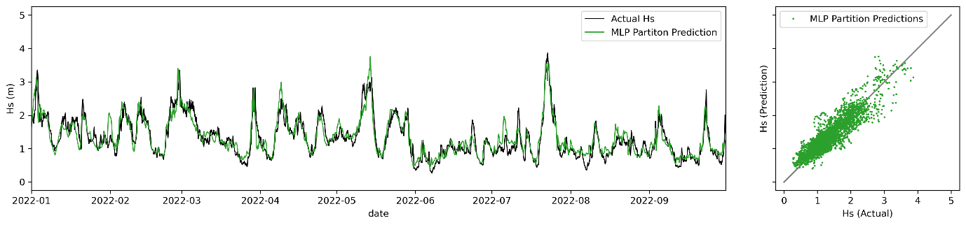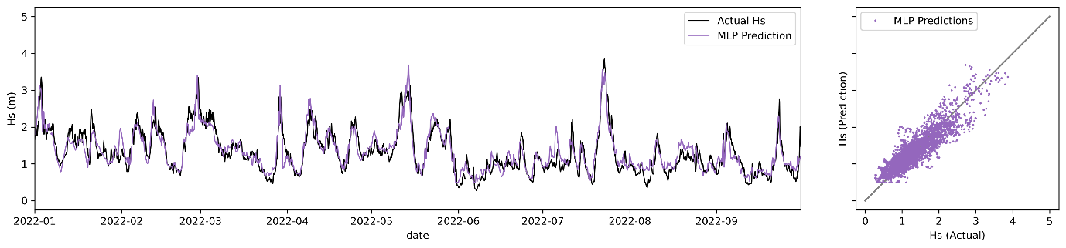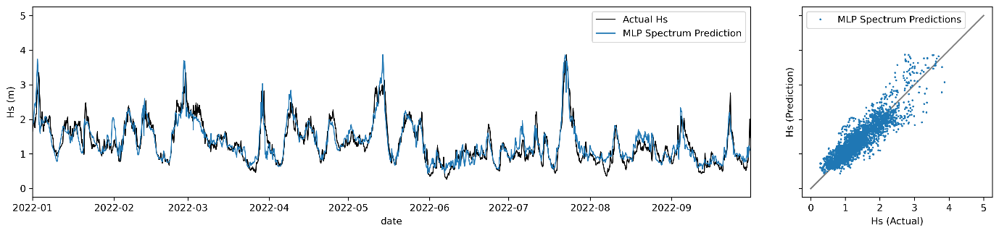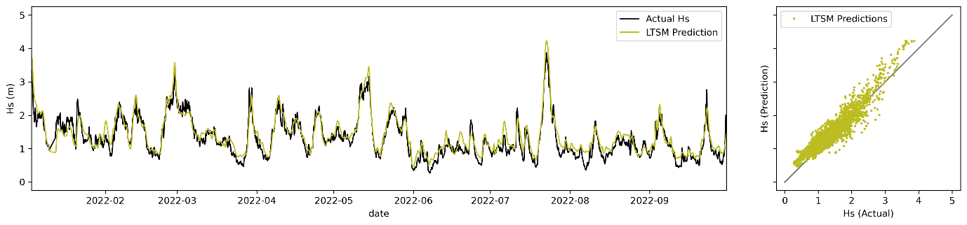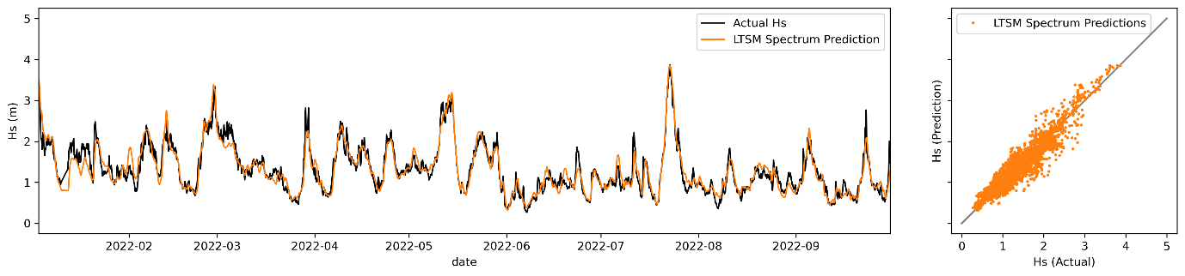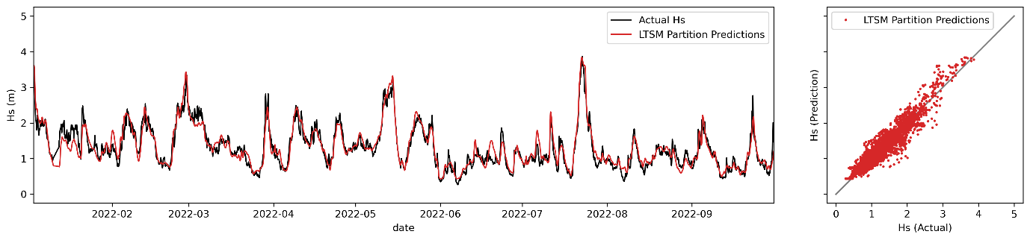

Table 3: Performance Metrics Hs

|  |  |  |  |  |  |  |  |
| --- | --- | --- | --- | --- | --- | --- | --- |
| **Model Name** | **MBE (m)** | **RMSE (m)** | **SI (%)** | **R2** | **NSE** | **COR** | **EC** |
| LTSM – 1D Spec | 0.00 | 0.19 | 14.6 | 0.89 | 0.89 | 0.94 | 0.97 |
| LTSM – Partitions | 0.01 | 0.19 | 14.8 | 0.89 | 0.89 | 0.94 | 0.97 |
| LTSM – Total | 0.09 | 0.22 | 15.0 | 0.88 | 0.86 | 0.94 | 0.96 |
| MLP – 1D Spec | 0.02 | 0.26 | 19.4 | 0.81 | 0.81 | 0.9 | 0.95 |
| MLP Partitions | 0.02 | 0.25 | 18.9 | 0.82 | 0.82 | 0.9 | 0.95 |
| MLP Total | 0.02 | 0.25 | 19.1 | 0.81 | 0.81 | 0.9 | 0.95 |

Table 4: Performance Metrics Tz

|  |  |  |  |  |  |  |  |
| --- | --- | --- | --- | --- | --- | --- | --- |
| **Model Name** | **MBE (s)** | **RMSE (s)** | **SI (%)** | **R2** | **NSE** | **COR** | **EC** |
| LTSM – 1D Spec | -0.06 | 0.73 | 11.5 | 0.64 | 0.63 | 0.8 | 0.89 |
| LTSM – Partitions | 0.0 | 0.79 | 12.4 | 0.59 | 0.58 | 0.77 | 0.87 |
| LTSM – Total | 0.03 | 0.83 | 13.1 | 0.54 | 0.53 | 0.73 | 0.85 |
| MLP – 1D Spec | -0.02 | 0.85 | 13.4 | 0.51 | 0.51 | 0.72 | 0.82 |
| MLP Partitions | 0.02 | 0.89 | 14.1 | 0.46 | 0.46 | 0.68 | 0.8 |
| MLP Total | -0.03 | 0.91 | 14.4 | 0.44 | 0.43 | 0.66 | 0.78 |

Table 5: Performance Metrics Dp

|  |  |  |  |  |  |  |  |
| --- | --- | --- | --- | --- | --- | --- | --- |
| **Model Name** | **MBE (°)** | **RMSE (°)** | **SI (%)** | **R2** | **NSE** | **COR** | **EC** |
| LTSM – 1D Spec | 1.22 | 9.29 | 9.6 | 0.58 | 0.4 | 0.76 | 0.86 |
| LTSM – Partitions | -0.43 | 8.61 | 8.8 | 0.62 | 0.62 | 0.79 | 0.87 |
| LTSM – Total | -0.23 | 8.78 | 9.0 | 0.61 | 0.61 | 0.78 | 0.87 |
| MLP – 1D Spec | -0.72 | 11.02 | 11.3 | 0.38 | 0.37 | 0.62 | 0.76 |
| MLP Partitions | -1.6 | 10.96 | 11.1 | 0.39 | 0.38 | 0.63 | 0.75 |
| MLP Total | -2.01 | 11.5 | 11.6 | 0.35 | 0.32 | 0.59 | 0.74 |

One area of difference which is often of keen interest to users of downscaled wave information is at the extremes. The Q-Q plot in Figure 8 and scatter plots in Figure 7 suggest that the LTSM is able to perform better for extreme values. In Figure 8 we selected the best performing models for LTSM and MLP respectively for easier interpretation, the LTSM (Spectral Predictions) model outperforms the MLP using partitioned wave parameters at both the lower and upper quantiles.

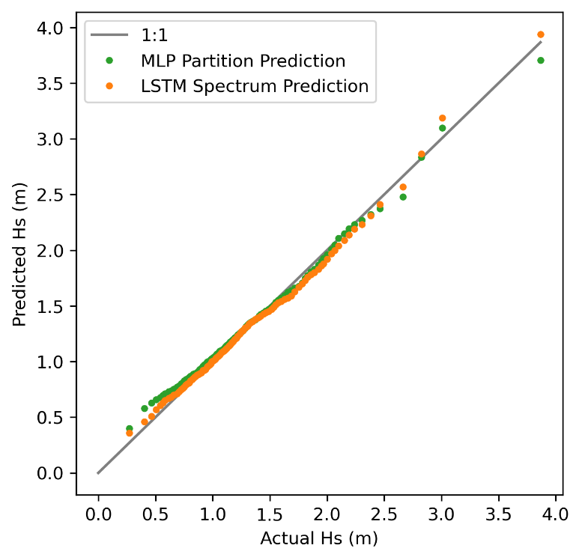

Figure 8: Q-Q plot of Hs (m) comparing the overall betwen performing MLP and LTSM models.

# Discussion

The results suggest that both the choice of machine learning approach and selected datasets play important roles in determining performance of the downscaling approach. In this case the LTSM overall offered statistically significant improvement (between 12% and 27% for the RMSE for Hs) for the prediction of some parameters (Table 3 & 4), even with less available input data (due to gaps causing a reduced number of sequences). The improvement may be because the LTSM is able account for longer term trends (such as seasonality) and short-term biases in the data, where the MLP is not able to separate out the two as easily (even with time-based features being encoded). Performance for *Hs* and *Tz* are broadly aligned with the literature, with recent efforts using deep-learning achieving similar results for short-term forecasting by Ahmed et al., (2024) who were using observational data only and predicting for the same location. The results for Dp are generally worse than other parameters (*Hs* and *Tz*), with the 1D spectrum performing worse (Table 5) than the 1D spectrum for both MLP and LTSM. The 1D spectrum likely offers no significant additional benefit as it integrates over the directions from the directional spectrum, therefore reducing the strength of those features. In addition, if features from the 1D spectrum are not useful they are likely adding unnecessary noise to the training dataset, extending training time and potentially impacting performance. Further work to explore the use of the 2D spectra may help improve performance and provide improved features to train machine learning models.

The literature suggests that machine learning approaches applied historically have achieved good performance particularly when predicting values approaching the mean, but can struggle to perform as well when predicting extreme values, as the MLP approach does here (Nielsen et al., 2024; Peach et al., 2023). Conversely the LTSM approach as applied here performs better than the MLP approach for the extreme values present in the independent dataset as shown Figure 8.

Models trained to predict Hs for example show progressive but limited improvement across the different methods as increasingly more complex features are added. For some applications the performance achieved by all approaches would meet requirements. Should more detailed nearshore information (such as partitioned wave parameters or wave spectra) be available for training from the Gold Coast monitoring location it may be possible to better refine performance for specific conditions (such as those dominated by swells or wind sea). This detail is not possible when predicting integrated wave parameters as the model detailed information is lost and the parameters provide the most information from the component of the spectrum which has the most energy.

Though the approaches are broadly applicable, one of the key constraints is the availability of spectral input data, predictions for integrated wave parameters are readily available from a range of different numerical weather prediction systems, but due to data sizes wave spectra are not. Furthermore, it would be necessary to update models that were developed using the wave spectra as and when the spectral scheme (frequency and directional bins) change. Though it would be possible to reprocess spectral data into the same form through post processing, this may miss out on any additional improvements.

Developing and training machine learning models that are more complex with larger datasets is generally more time consuming, and computationally expensive. As was found here, models developed based on the 1D spectrum are more challenging to configure and train than those developed from less or simpler input parameters. Consideration should be given to the most appropriate approach for the application. Practitioners should also consider the availability of required datasets, spectral data is typically less available than wave parameters and is much larger. Observational data is even more limited in it’s availability and for models that require sequential data like LTSM, gaps in data can be a constraint.

One of the advantages of using machine learning approaches used here when downscaling is that the model is being training straight to observations from an offshore modelled point. This is in effect both translating offshore wave conditions to the nearshore location and performing some sort of bias correction such as adjusting for slight temporal anomalies between modelled and actual conditions (though it is recognised that these are generally much smaller for hindcasts than forecasts). As pointed out in Smith et al., (2021) the performance of the CAWCR hindcast used here varies considerably at the coast, where as machine learning downscale approaches as applied here can be specifically tuned to the output for the nearshore location in question. This is also a constraint of the approach as applied here it is only able to downscale to a point location, though this can be extended using a hybrid approach as in O’donncha et al.,(2018). Whether the point location constraint is an issue depends on the end-user and application. Focussing on a point allows the practitioner to tune the machine learning models for a particular location of interest helping to achieve the best possible performance and may work well for some applications such as port operations.

# Conclusion

Machine learning offers a fast and efficient approach to downscaling offshore wave conditions to the coast. But there is not a one size fits all approach, with careful consideration needed for data preparation, machine learning model selection and configuration. We found that additional features can be extracted from the 1D wave spectrum to improve model performance, particularly for the extremes (with values of Hs error reducing over 27% RMSE compared to simple machine learning approaches). But the 1D frequency spectrum doesn’t offer the same performance benefit for all parameters as was found here with *Dp*. Of the approaches used here the LTSM overall showed the best performance, though is more challenging to train and required more careful consideration of feature selection (as was found here with *Dp*).

Overall the approaches applied here and in the literature demonstrate that machine learning can help downscale offshore wave conditions to coastal locations accurately (including extremes). The machine learning downscaling approaches have a range of applications, such as forecast and hindcast downscaling, bias correction and gap filling missing data.

The work here broadly extends the knowledge of machine learning approaches for downscaling ocean wave data and has identified further ways in which spectral data may be utilised to improve performance and overcome some of the identified deficiencies in the work here.

# Acknowledgements

The authors would like to thank the Australian Bureau of Meteorology, CSIRO for use of the CAWCR wave hindcast. Also thanks to Queensland Government Department of Environment and Science for the provision of wave observation data.

# References

Adytia, D., Saepudin, D., Tarwidi, D., Pudjaprasetya, S. R., Husrin, S., Sopaheluwakan, A., & Prasetya, G. (2023). *Modelling of Deep Learning-Based Downscaling for Wave Forecasting in Coastal Area*. 1–19.

Ahmed, A. A. M., Jui, S. J. J., AL-Musaylh, M. S., Raj, N., Saha, R., Deo, R. C., & Saha, S. K. (2024). Hybrid deep learning model for wave height prediction in Australia’s wave energy region. *Applied Soft Computing*, *150*(October 2023), 111003. https://doi.org/10.1016/j.asoc.2023.111003

Andrews, E., & Peach, L. (2019). *Wave Monitoring Equipment Comparison: A comparison between in-situ wave measurement equipment*. https://www.publications.qld.gov.au/dataset/a719a64a-bbaf-4c02-9f33-39d2ab737c90/resource/4b9a79fd-7245-42cb-b60e-c83f84d82011/fs_download/wave-monitoring-equipment-comparison.pdf

Browne, M., Castelle, B., Strauss, D., Tomlinson, R., Blumenstein, M., & Lane, C. (2007). Near-shore swell estimation from a global wind-wave model: Spectral process, linear, and artificial neural network models. *Coastal Engineering*, *54*(5), 445–460. https://doi.org/10.1016/j.coastaleng.2006.11.007

Bryant, M. A., Hesser, T. J., & Jensen, R. E. (2016). *Evaluation Statistics Computed for the Wave Information Studies (WIS)*. *July*, 1–10. https://apps.dtic.mil/sti/citations/AD1013235

Cagigal, L., Méndez, F. J., Ricondo, A., Gutiérrez-Barceló, D., Bosserelle, C., & Hoeke, R. (2024). BinWaves: An additive hybrid method to downscale directional wave spectra to nearshore areas. *Ocean Modelling*, *189*(March). https://doi.org/10.1016/j.ocemod.2024.102346

Camus, P., Mendez, F. J., & Medina, R. (2011). A hybrid efficient method to downscale wave climate to coastal areas. *Coastal Engineering*. https://doi.org/10.1016/j.coastaleng.2011.05.007

Chen, T., & Guestrin, C. (2016). XGBoost: A Scalable Tree Boosting System. *KDD ’16: Proceedings of the 22nd ACM SIGKDD International Conference on Knowledge Discovery and Data Mining*. https://doi.org/10.1145/2939672.2939785

Costa, M. O., Campos, R. M., & Guedes Soares, C. (2023). Enhancing the accuracy of metocean hindcasts with machine learning models. *Ocean Engineering*, *287*(P1), 115724. https://doi.org/10.1016/j.oceaneng.2023.115724

Crosby, S. C., Kumar, N., O’Reilly, W. C., & Guza, R. T. (2019). Regional swell transformation by backward ray tracing and SWAN. *Journal of Atmospheric and Oceanic Technology*, *36*(2), 217–229. https://doi.org/10.1175/JTECH-D-18-0123.1

EA. (2016). *Investigating coastal flood forecasting Good practice framework*. Environment Agency. www.gov.uk/government/publications

Gouldby, B., Méndez, F. J., Guanche, Y., Rueda, A., & Mínguez, R. (2014). A methodology for deriving extreme nearshore sea conditions for structural design and flood risk analysis. *Coastal Engineering*. https://doi.org/10.1016/j.coastaleng.2014.01.012

Gouldby, Ben, Wyncoll, D., Panzeri, M., Franklin, M., Hunt, T., Hames, D., Tozer, N., Hawkes, P., Dornbusch, U., & Pullen, T. (2017). Multivariate extreme value modelling of sea conditions around the coast of England. *Proceedings of the Institution of Civil Engineers - Maritime Engineering*, *170*(1), 3–20. https://doi.org/10.1680/jmaen.2016.16

Gracia, S., Olivito, J., Resano, J., Martin-del-Brio, B., de Alfonso, M., & Álvarez, E. (2021). Improving accuracy on wave height estimation through machine learning techniques. *Ocean Engineering*, *236*(December 2020). https://doi.org/10.1016/j.oceaneng.2021.108699

Hadi Moeini, M., Etemad-Shahidi, A., Chegini, V., & Rahmani, I. (2012). Wave data assimilation using a hybrid approach in the Persian Gulf. *Ocean Dynamics*, *62*, 785–797. https://doi.org/10.1007/s10236-012-0529-5

Hegermiller, C. A., Antolinez, J. A. A., Rueda, A., Camus, P., Perez, J., Erikson, L. H., Barnard, P. L., & Mendez, F. J. (2017). A multimodal wave spectrum-based approach for statistical downscaling of local wave climate. *Journal of Physical Oceanography*, *47*(2), 375–386. https://doi.org/10.1175/JPO-D-16-0191.1

Ibarra-Berastegi, G., Saénz, J., Esnaola, G., Ezcurra, A., & Ulazia, A. (2015). *Short-term forecasting of the wave energy flux: Analogues, random forests, and physics-based models*. https://doi.org/10.1016/j.oceaneng.2015.05.038

James, S. C., Zhang, Y., & O’Donncha, F. (2017). A Machine Learning Framework to Forecast Wave Conditions. *Coastal Engineering*.

Mooneyham, J., Crosby, S. C., Kumar, N., & Hutchinson, B. (2020). SWRL net: A spectral, residual deep learning model for improving short-term wave forecasts. *Weather and Forecasting*, *35*(6), 2445–2460. https://doi.org/10.1175/WAF-D-19-0254.1

Nielsen, U. D., Iwase, K., & Mounet, R. E. G. (2024). Comparing machine learning-based sea state estimates by the wave buoy analogy. *Applied Ocean Research*, *149*(April), 104042. https://doi.org/10.1016/j.apor.2024.104042

O’donncha, F., Zhang, Y., Chen, B., & James, S. C. (2018). *An integrated framework that combines machine learning and numerical models to improve wave-condition forecasts*. https://doi.org/10.1016/j.jmarsys.2018.05.006

Oh, I. S. (1981). *Water Wave Refraction with Non-Linear Theory*. https://doi.org/10.25777/760y-gq66

Peach, L., da Silva, G. V., Cartwright, N., & Strauss, D. (2023). A comparison of process-based and data-driven techniques for downscaling offshore wave forecasts to the nearshore. *Ocean Modelling*, 102168. https://doi.org/10.1016/J.OCEMOD.2023.102168

Pedregosa, F., Varoquaux, G., Gramfort, A., Michel, V., Thirion, B., Grisel, O., Blondel, M., Prettenhofer, P., Wiess, R., Dubourg, V., & Vanderplas, J. (2011). Scikit-learn: Machine Learning in Python. *Journal of Machine Learning Research*, *12*(1), 1–5. https://doi.org/10.1007/s13398-014-0173-7.2

Reikard, G., & Rogers, W. E. (2011). Forecasting ocean waves: Comparing a physics-based model with statistical models. *Coastal Engineering*, *58*, 409–416. https://doi.org/10.1016/j.coastaleng.2010.12.001

Ricondo, A., Cagigal, L., Rueda, A., Hoeke, R., Storlazzi, C. D., & Méndez, F. J. (2023). HyWaves: Hybrid downscaling of multimodal wave spectra to nearshore areas. *Ocean Modelling*, *184*(May), 102210. https://doi.org/10.1016/j.ocemod.2023.102210

Shamshirband, S., Mosavi, A., Rabczuk, T., Nabipour, N., & Chau, K. wing. (2020). Prediction of significant wave height; comparison between nested grid numerical model, and machine learning models of artificial neural networks, extreme learning and support vector machines. *Engineering Applications of Computational Fluid Mechanics*, *14*(1), 805–817. https://doi.org/10.1080/19942060.2020.1773932/FORMAT/EPUB

Smith, G. A., Hemer, M., Greenslade, D., Trenham, C., Zieger, S., & Durrant, T. (2021). Global wave hindcast with Australian and Pacific Island Focus: From past to present. *Geoscience Data Journal*, *8*(1), 24–33. https://doi.org/10.1002/gdj3.104

Vieira Da Silva, G., Murray, T., & Strauss, D. (2018). Longshore wave variability along non-straight coastlines. *Estuarine, Coastal and Shelf Science*, *212*, 318–328. https://doi.org/10.1016/J.ECSS.2018.07.022

Zhang, X., Li, Y., Gao, S., & Ren, P. (2021). Ocean wave height series prediction with numerical long short-term memory. *Journal of Marine Science and Engineering*, *9*(5). https://doi.org/10.3390/jmse9050514

Zhang, Y., James, S. C., & O’Donncha, F. (2017). An ensemble-based approach that combines machine learning and numerical models to improve forecasts of wave conditions. *OCEANS 2017 - Anchorage*, *2017*-*January*, 1–7.

1. Address: Griffith University Gold Coast Campus, Southport, Queensland, Australia
2. Leo Peach Corresponding Author: [leo.peach@griffithuni.edu.au](mailto:leo.peach@griffithuni.edu.au)