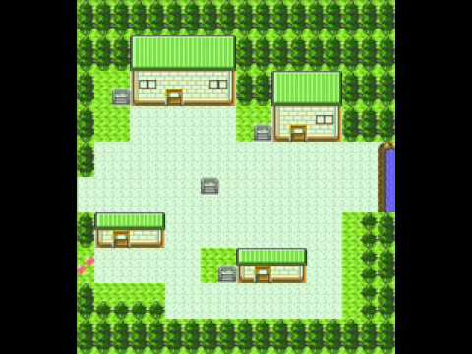Muhammad Shaheer

1. Button on the top left of screen can be clicked to stop the 8-bit audio clips playing in the back ground.
2. The first input box allows the user to type in the name of their cat.
3. When clicking on the middle button a menu open up allowing the user to select the type of item that he or she can search a barging for.
4. Start button at the bottom will take all the input values and generates the game, taking the user to a new screen.

Select the type of item…

Enter your cats name…

START

***Cat Hunt***

1. Each door is placed on a grid, once you go past the grid, it will take the user to another screen. This would be the inside of the house.
2. The up arrow (button) once clicked will open up a list showing all the item collected.
3. The hearts show live points, every time the dog catches the user inside the house the user will drop all its items and lose a health bar
4. The user can click the audio icon to mute the 8 bit audio clip

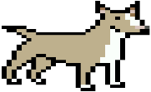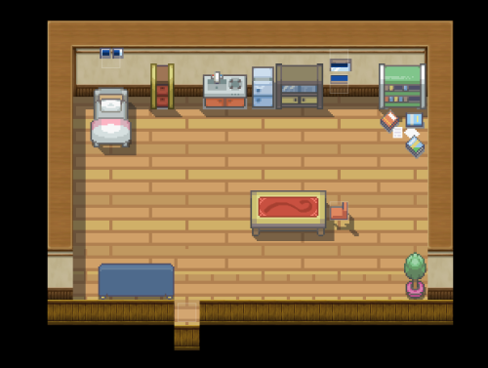

1. The food would be randomly generated in the screen and would disappear when the user walks on the item.
2. The dog would randomly moving across the screen and when it makes contact with the cat, the cat will drop everything it has and would lose a life.