**ЛАБОРАТОРНА РОБОТА № 1**

**ПОПЕРЕДНЯ ОБРОБКА ТА КОНТРОЛЬОВАНА**

**КЛАСИФІКАЦІЯ ДАНИХ**

***Мета роботи:*** використовуючи спеціалізовані бібліотеки та мову програмування Python дослідити попередню обробку та класифікацію даних.

Завдання 1.

from sklearn import preprocessing  
  
input_labels = ['red', 'black', 'red', 'green', 'black', 'yellow', 'white']  
  
encoder = preprocessing.LabelEncoder()  
encoder.fit(input_labels)  
  
  
print("\nLabel mapping: ")  
for i, item in enumerate(encoder.classes_):  
 print(item, '-->', i)  
  
test_labels = ['green', 'red', 'black']  
encoded_values = encoder.transform(test_labels)  
print(f"\nLabels = {test_labels}")  
print(f"Encoded values = {list(encoded_values)}")  
  
encoded_values = [3, 0, 4, 1]  
decoded_list = encoder.inverse_transform(encoded_values)  
print(f"\nEncoded values = {encoded_values}")  
print(f"Decoded labels = {list(decoded_list)}")

**Результат виконання:**

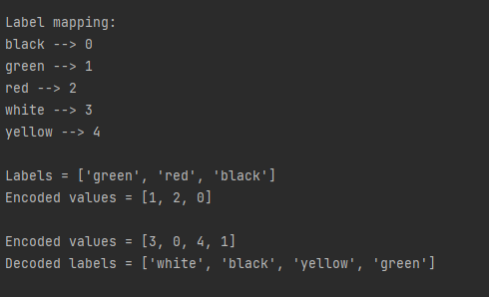

Рис.1 - Результат виконання

Завдання 2



import numpy as np  
from sklearn import preprocessing  
  
input_data = np.array([[4.6, 9.9, -3.5, -2.9, 4.1, 3.3,  
 -2.2, 8.8, -6.1, 3.9, 1.4, 2.2]])  
data_binarized = preprocessing.Binarizer(threshold=2.2).transform(input_data)  
print(f"\nBinarized data:\n{data_binarized}")  
  
print("\nBEFORE: ")  
print(f"Mean = {input_data.mean(axis=0)}")  
print(f"Std deviation = {input_data.std(axis=0)}")  
  
data_scaled = preprocessing.scale(input_data)  
print("\nAFTER: ")  
print(f"Mean = {data_scaled.mean(axis=0)}")  
print(f"Std deviation = {data_scaled.std(axis=0)}")  
  
data_scaled_minmax = preprocessing.MinMaxScaler(feature_range=(0,1))  
data_scaled_minmax = data_scaled_minmax.fit_transform(input_data)  
print(f"\nMin max scaled data:\n{data_scaled_minmax}")  
data_normalized_l1 = preprocessing.normalize(input_data, norm='l1')  
data_normalized_l2 = preprocessing.normalize(input_data, norm='l2')  
  
print(f"\nL1 normalized data:\n{data_normalized_l1}");  
print(f"\nL2 normalized data:\n{data_normalized_l2}");

**Результат виконання:**

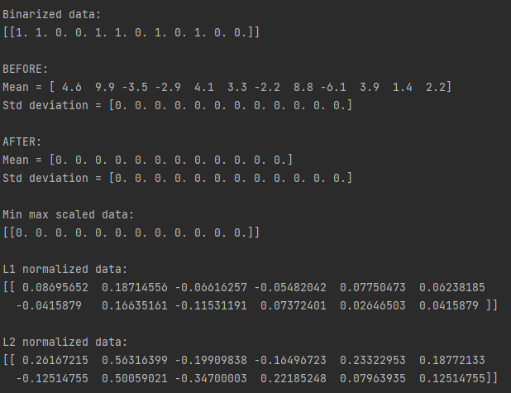

Рис.2 - Результат виконання

Завдання 3.

import numpy as np  
from sklearn import linear_model  
from utilities import visualize_classifier  
  
X = np.array([[3.1, 7.2], [4, 6.7], [2.9, 8], [5.1, 4.5],  
 [6, 5], [5.6, 5], [3.3, 0.4],  
 [3.9, 0.9], [2.8, 1],  
 [0.5, 3.4], [1, 4], [0.6, 4.9]])  
y = np.array([0, 0, 0, 1, 1, 1, 2, 2, 2, 3, 3, 3])  
  
classifier = linear_model.LogisticRegression(solver='liblinear', C=1)  
  
classifier.fit(X, y)  
  
visualize_classifier(classifier, X, y)

**Результат виконання:**

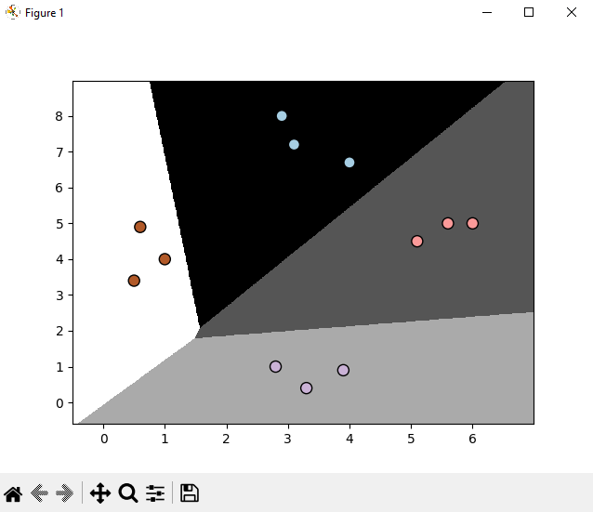

Рис.3 - Результат виконання

Завдання 4.

import numpy as np  
from utilities import visualize_classifier  
from sklearn.naive_bayes import GaussianNB  
from sklearn.model_selection import train_test_split  
from sklearn.model_selection import cross_val_score  
  
input_file = 'data_multivar_nb.txt'  
data = np.loadtxt(input_file, delimiter=',')  
X, y = data[:, :-1], data[:, -1]  
  
  
classifier = GaussianNB()  
classifier.fit(X, y)  
  
  
y_pred = classifier.predict(X)  
  
  
accuracy = 100.0 * (y == y_pred).sum() / X.shape[0]  
print(f"Accuracy of Naive Bayes classifier = {round(accuracy,2)}%")  
  
  
visualize_classifier(classifier, X, y)  
X_train, X_test, y_train, y_test = train_test_split(X, y, test_size=0.2, random_state=3)  
classifier_new = GaussianNB()  
classifier_new.fit(X_train, y_train)  
y_test_pred = classifier_new.predict(X_test)  
  
  
accuracy = 100.0 * (y_test == y_test_pred).sum()/X_test.shape[0]  
print(f"Accuracy of the new classifier = {round(accuracy, 2)}%")  
  
  
visualize_classifier(classifier_new, X_test, y_test)  
  
num_folds = 3  
accuracy_values = cross_val_score(classifier, X, y, scoring='accuracy', cv=num_folds)  
print("Accuracy: " + str(round(100 * accuracy_values.mean(), 2)) + "%")  
  
precision_values = cross_val_score(classifier, X, y, scoring='precision_weighted', cv=num_folds)  
print("Precision: " + str(round(100 * precision_values.mean(), 2)) + "%")  
  
recall_values = cross_val_score(classifier, X, y, scoring='precision_weighted', cv=num_folds)  
print("Recall: " + str(round(100 * recall_values.mean(), 2)) + "%")  
  
f1_values = cross_val_score(classifier, X, y, scoring='f1_weighted', cv=num_folds)  
print("F1: " + str(round(100 * f1_values.mean(), 2)) + "%")

**Результат виконання:**

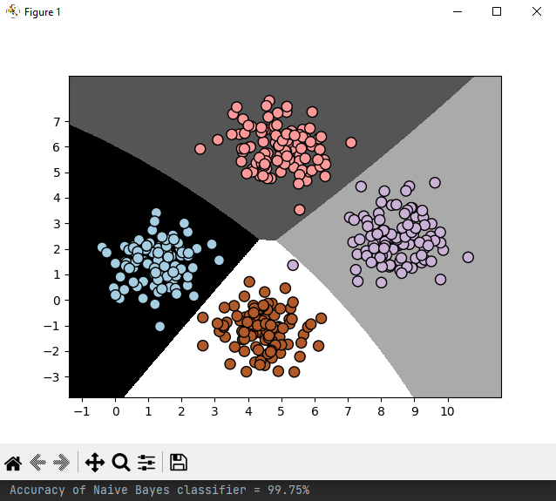

Рис.4 - Результат виконання

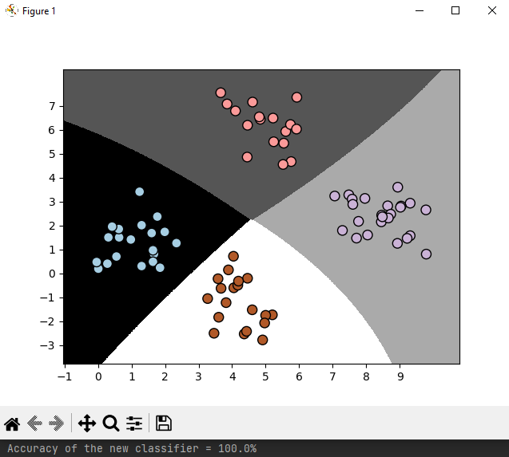

Рис.5 - Результат виконання

Завдання 5.

import pandas as pd  
import numpy as np  
import matplotlib.pyplot as plt  
  
from sklearn.metrics import confusion_matrix  
from sklearn.metrics import accuracy_score  
from sklearn.metrics import recall_score  
from sklearn.metrics import precision_score  
from sklearn.metrics import f1_score  
from sklearn.metrics import roc_curve  
from sklearn.metrics import roc_auc_score  
  
df = pd.read_csv('data_metrics.csv')  
df.head()  
thresh = 0.5  
df['predicted_RF'] = (df.model_RF >= 0.5).astype('int')  
df['predicted_LR'] = (df.model_LR >= 0.5).astype('int')  
df.head()  
  
print(confusion_matrix(df.actual_label.values, df.predicted_RF.values))  
  
  
def find_TP(y_true, y_pred):  
 # counts the number of true positives (y_true = 1, y_pred = 1)  
 return sum((y_true == 1) & (y_pred == 1))  
  
  
def find_FN(y_true, y_pred):  
 # counts the number of false negatives (y_true = 1, y_pred = 0)  
 return sum((y_true == 1) & (y_pred == 0))  
  
  
def find_FP(y_true, y_pred):  
 # counts the number of false positives (y_true = 0, y_pred = 1)  
 return sum((y_true == 0) & (y_pred == 1))  
  
  
def find_TN(y_true, y_pred):  
 # counts the number of true negatives (y_true = 0, y_pred = 0)  
 return sum((y_true == 0) & (y_pred == 0))  
  
  
print('TP:', find_TP(df.actual_label.values, df.predicted_RF.values))  
print('FN:', find_FN(df.actual_label.values, df.predicted_RF.values))  
print('FP:', find_FP(df.actual_label.values, df.predicted_RF.values))  
print('TN:', find_TN(df.actual_label.values, df.predicted_RF.values))  
  
  
def find_conf_matrix_values(y_true, y_pred):  
 # calculate TP, FN, FP, TN  
 TP = find_TP(y_true, y_pred)  
 FN = find_FN(y_true, y_pred)  
 FP = find_FP(y_true, y_pred)  
 TN = find_TN(y_true, y_pred)  
 return TP, FN, FP, TN  
  
  
def voitko_confusion_matrix(y_true, y_pred):  
 TP, FN, FP, TN = find_conf_matrix_values(y_true, y_pred)  
 return np.array([[TN, FP], [FN, TP]])  
  
  
voitko_confusion_matrix(df.actual_label.values, df.predicted_RF.values)  
  
assert np.array_equal(voitko_confusion_matrix(df.actual_label.values, df.predicted_RF.values),  
 confusion_matrix(df.actual_label.values,  
 df.predicted_RF.values)), 'my_confusion_matrix() is not correct for RF'  
assert np.array_equal(voitko_confusion_matrix(df.actual_label.values, df.predicted_LR.values),  
 confusion_matrix(df.actual_label.values,  
 df.predicted_LR.values)), 'my_confusion_matrix() is not correct for LR'  
  
print(accuracy_score(df.actual_label.values, df.predicted_RF.values))  
  
  
def koptiaiev_accuracy_score(y_true, y_pred): # calculates the fraction of samples  
 TP, FN, FP, TN = find_conf_matrix_values(y_true, y_pred)  
 return (TP + TN) / (TP + TN + FP + FN)  
  
  
assert koptiaiev_accuracy_score(df.actual_label.values, df.predicted_RF.values) == accuracy_score(  
 df.actual_label.values, df.predicted_RF.values), 'my_accuracy_score failed on RF'  
assert koptiaiev_accuracy_score(df.actual_label.values, df.predicted_LR.values) == accuracy_score(  
 df.actual_label.values, df.predicted_LR.values), 'my_accuracy_score failed on LR'  
print('Accuracy RF:%.3f' % (koptiaiev_accuracy_score(df.actual_label.values, df.predicted_RF.values)))  
  
print(recall_score(df.actual_label.values, df.predicted_RF.values))  
  
  
def koptiaiev_recall_score(y_true, y_pred):  
 # calculates the fraction of positive samples predicted correctly  
 TP, FN, FP, TN = find_conf_matrix_values(y_true, y_pred)  
 return TP / (TP + FN)  
  
  
assert koptiaiev_recall_score(df.actual_label.values, df.predicted_RF.values) == recall_score(df.actual_label.values,  
 df.predicted_RF.values), 'voitko_accuracy_score failed on RF'  
assert koptiaiev_recall_score(df.actual_label.values, df.predicted_LR.values) == recall_score(df.actual_label.values,  
 df.predicted_LR.values), 'voitko_accuracy_score failed on LR'  
  
print('Recall RF: %.3f' % (koptiaiev_recall_score(df.actual_label.values, df.predicted_RF.values)))  
print('Recall LR: %.3f' % (koptiaiev_recall_score(df.actual_label.values, df.predicted_LR.values)))  
  
precision_score(df.actual_label.values, df.predicted_RF.values)  
  
  
def koptiaiev_precision_score(y_true, y_pred):  
 # calculates the fraction of predicted positives samples that are actually positive  
 TP, FN, FP, TN = find_conf_matrix_values(y_true, y_pred)  
 return TP / (TP + FP)  
  
  
assert koptiaiev_precision_score(df.actual_label.values, df.predicted_RF.values) == precision_score(  
 df.actual_label.values, df.predicted_RF.values), 'my_accuracy_score failed on RF'  
assert koptiaiev_precision_score(df.actual_label.values, df.predicted_LR.values) == precision_score(  
 df.actual_label.values, df.predicted_LR.values), 'my_accuracy_score failed on LR'  
  
print('Precision RF: %.3f' % (koptiaiev_precision_score(df.actual_label.values, df.predicted_RF.values)))  
print('Precision LR: %.3f' % (koptiaiev_precision_score(df.actual_label.values, df.predicted_LR.values)))  
  
f1_score(df.actual_label.values, df.predicted_RF.values)  
  
  
def koptiaiev_f1_score(y_true, y_pred): # calculates the F1 score  
 recall = koptiaiev_recall_score(y_true, y_pred)  
 precision = koptiaiev_precision_score(y_true, y_pred)  
 return 2 * (precision * recall) / (precision + recall)  
  
  
assert koptiaiev_f1_score(df.actual_label.values, df.predicted_RF.values) == f1_score(df.actual_label.values,  
 df.predicted_RF.values), 'my_accuracy_score failed on RF'  
assert koptiaiev_f1_score(df.actual_label.values, df.predicted_LR.values) == f1_score(df.actual_label.values,  
 df.predicted_LR.values), 'my_accuracy_score failed on LR'  
  
print('F1 RF: %.3f' % (koptiaiev_f1_score(df.actual_label.values, df.predicted_RF.values)))  
print('F1 LR: %.3f' % (koptiaiev_f1_score(df.actual_label.values, df.predicted_LR.values)))  
print('scores with threshold = 0.5')  
  
print('Accuracy RF: % .3f' % (koptiaiev_accuracy_score(df.actual_label.values, df.predicted_RF.values)))  
print('Recall RF: %.3f' % (koptiaiev_recall_score(df.actual_label.values, df.predicted_RF.values)))  
print('Precision RF: % .3f' % (koptiaiev_precision_score(df.actual_label.values, df.predicted_RF.values)))  
print('F1 RF: %.3f' % (koptiaiev_f1_score(df.actual_label.values, df.predicted_RF.values)))  
print('')  
  
threshold = 0.75  
  
print(f'Scores with threshold = {threshold}')  
print('Accuracy RF: % .3f' % (koptiaiev_accuracy_score(df.actual_label.values, (df.model_RF >= threshold).astype('int').values)))  
print('Recall RF: %.3f' % (koptiaiev_recall_score(df.actual_label.values, (df.model_RF >= threshold).astype('int').values)))  
print('Precision RF: %.3f' % (koptiaiev_precision_score(df.actual_label.values, (df.model_RF >= threshold).astype('int').values)))  
print('F1 RF: %.3f' % (koptiaiev_f1_score(df.actual_label.values, (df.model_RF >= threshold).astype('int').values)))  
  
fpr_RF, tpr_RF, thresholds_RF = roc_curve(df.actual_label.values,df.model_RF.values)  
fpr_LR, tpr_LR, thresholds_LR = roc_curve(df.actual_label.values, df.model_LR.values)  
  
plt.plot(fpr_RF, tpr_RF, 'r-', label='RF')  
plt.plot(fpr_LR, tpr_LR, 'b-', label='LR')  
plt.plot([0, 1], [0, 1], 'k-', label='random')  
plt.plot([0, 0, 1, 1], [0, 1, 1, 1], 'g-', label='perfect')  
plt.legend()  
plt.xlabel('False Positive Rate')  
plt.ylabel('True Positive Rate')  
plt.show()  
  
auc_RF = roc_auc_score(df.actual_label.values, df.model_RF.values)  
auc_LR = roc_auc_score(df.actual_label.values, df.model_LR.values)  
print('AUC RF:%.3f' % auc_RF)  
print('AUC LR:%.3f' % auc_LR)  
  
plt.plot(fpr_RF, tpr_RF, 'r-', label='RF AUC: %.3f' % auc_RF)  
plt.plot(fpr_LR, tpr_LR, 'b-', label='LR AUC: %.3f' % auc_LR)  
plt.plot([0, 1], [0, 1], 'k-', label='random')  
plt.plot([0, 0, 1, 1], [0, 1, 1, 1], 'g-', label='perfect')  
plt.legend()  
plt.xlabel('False Positive Rate')  
plt.ylabel('True Positive Rate')  
plt.show()

Результат виконання:

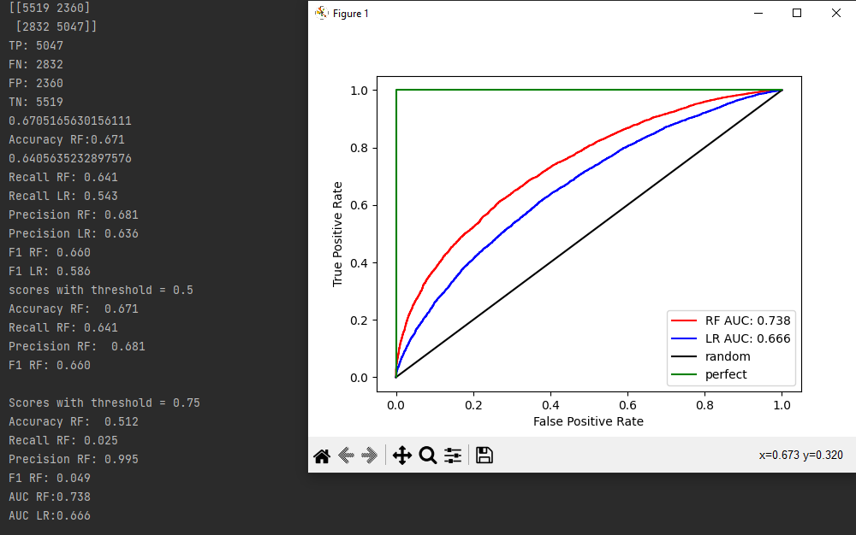

Рис. 6 - Результат виконання

Завдання 6.

import numpy as np  
from sklearn.model_selection import train_test_split  
from sklearn import svm  
from sklearn import metrics  
  
  
from utilities import visualize_classifier  
input_file = 'data_multivar_nb.txt'  
  
data = np.loadtxt(input_file, delimiter=',')  
X, y = data[:, :-1], data[:, -1]  
  
X_train, X_test, y_train, y_test = train_test_split(X, y.astype(int), test_size=0.2, random_state=3)  
  
cls = svm.SVC(kernel='linear')  
cls.fit(X_train, y_train)  
pred = cls.predict(X_test)  
print("Accuracy:", metrics.accuracy_score(y_test, y_pred=pred))  
  
print("Precision: ", metrics.precision_score(y_test, y_pred=pred, average='macro'))  
  
print("Recall", metrics.recall_score(y_test, y_pred=pred, average='macro'))  
print(metrics.classification_report(y_test, y_pred=pred))  
  
visualize_classifier(cls, X_test, y_test)

Результат виконання:

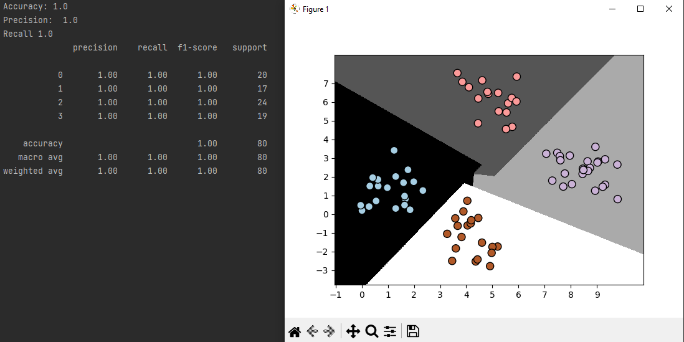

Рис. 7 - Результат виконання

**Висновок**: в ході виконання лабораторної роботи ми навчилися використовувати спеціалізовані бібліотеки та мову програмування Python для дослідження попередньої обробки та класифікації даних.