UI elements and their corresponding object names :

The main object is called “MainWindow”

It MainWindow contains :

* menu bar
* a tabcontrol for index cards
* status bar

Tabcontrol will contain :

* grid of phone numbers

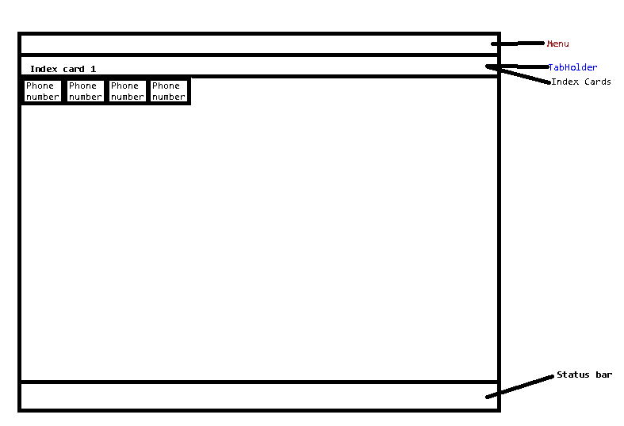

Main window will load Index cards

Index cards will load phone numbers

The status monitoring is done by index cards and not the phone number itself. This is to avoid having too many threads running.

Backend will contain :

* network handling ( new connections, reconnections, async sending, async read, async packet interpretation )
* logging
* configuration load / save